**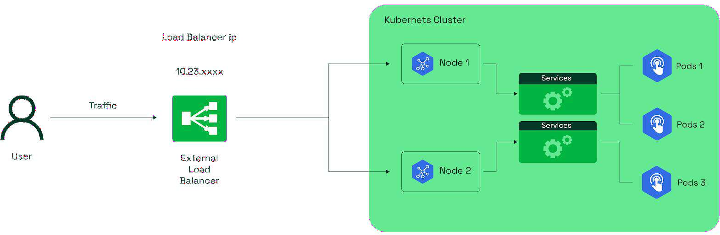****KUBERNETES PROJECT WITH LOAD BALANCER SERVICE**

### Files and Configurations Used in This Project

1. **NGINX Configuration**
   * NGINX Deployment with 3 Replicas
   * NGINX Load Balancer Service
   * NGINX Ingress
   * External Name Service
2. **Backend Configuration**
   * backend-app.js file
   * Dockerfile
   * backend-app-pod
3. **Secrets and Configurations**
   * RDS Secrets
   * RDS ConfigMaps
   * Service Account for Secrets and ConfigMaps
   * Read-Only Roles for Secrets and ConfigMaps
   * Read-Only Role-Binding for Secrets and ConfigMaps
4. **Database Clients**
   * MySQL Client
   * Oracle Client
   * PostgreSQL Client
5. **Monitoring and Logging**
   * DaemonSet (Prometheus)
   * Prometheus RBAC
   * Prometheus NodePort Exposed on Port 30090
   * Promtail DaemonSet
   * Loki DaemonSet
   * Loki NodePort Exposed on Port 30091
   * Grafana Daemon with Exposed Port 30080

### Project Summary

1. **NGINX Deployment and Services**
   * Sabse pehle NGINX ke 3 replicas ka creation aur unko Load Balancer service se expose karna.
   * Phir, Ingress service ka use karna routing ke liye.
2. **RDS Implementation**
   * Amazon RDS ko external service ke through access karna using ExternalName service. Isme aapko bata sakte hain ki aap kaise MySQL, Oracle, ya PostgreSQL ko RDS se access kar rahe hain.
3. **HTTPS Implementation with AWS ACM**
   * HTTPS ko enable karne ke liye AWS ACM service ka istemal, jo HTTP ko HTTPS me convert karta hai.
4. **Dockerfile and Custom Application Deployment**
   * Dockerfile ka use karke Node.js application (app.js) create karna, jise Amazon RDS se data fetch kar sakein or connect kar sekein.
   * Required dependencies install karke Docker image banani aur usko Docker Hub par push karna.
5. **Secrets, ConfigMaps, and RBAC**
   * Security ke liye Secrets (Amazon RDS ka password aur username store karne ke liye), ConfigMaps (ports, hostnames, database names ke liye) ka use.
   * Service Account, Role, aur Role Binding create karna jo Secrets aur ConfigMaps ke liye read-only permissions provide karein.
6. **Client Creation (MySQL, Oracle, PostgreSQL)**
   * MySQL-client, Oracle-client, aur PostgreSQL-client create karna jo RDS se data fetch kar sakein or connect kar sakein.
7. **Monitoring and Logging**
   * Prometheus DaemonSet deploy karna, RBAC configure karna aur port 30090 par expose karte hue read-only permissions dena.
   * Promtail ka use karna logs collect karne ke liye.
   * Loki ko logging backend banakar port 30091 par expose karna.
   * Grafana deploy karna jo metrics visualize karega aur port 30080 par expose hoga.

Understanding Each File

Is project me hum har YAML aur Configuration file ko samjhenge ki kaise ye Deployment, Networking ko manage karne, Security implement karne, aur Monitoring Setup karne me madad kar rahi hai.

### Achievements

1. **Successfully Deployed NGINX with Load Balancer Service**

NGINX web server ko 3 replicas ke saath deploy kiya aur Load Balancer service ka use karke expose kiya, jo high availability aur efficient traffic distribution ensure karta hai.

1. **Domain Name Configuration with Ingress**

Ingress ka use karke custom domain name set kiya, jo better routing aur easy access provide karta hai.

1. **Converted HTTP to HTTPS using AWS ACM**

AWS Certificate Manager (ACM) ka use karke SSL/TLS certificate implement kiya aur HTTPS enable kiya.

1. **External Name Service for Database Connectivity**

Amazon RDS ko ExternalName service ke through securely aur seamlessly cluster ke andar access kiya.

1. **Secrets & ConfigMaps Implementation**

Sensitive information jaise database credentials, endpoints, aur configuration settings securely manage kiye.

1. **RBAC-based Access Control**

RBAC (Role-Based Access Control) implement kiya jo Secrets aur ConfigMaps ke liye read-only access provide karta hai.

1. **Monitoring & Logging Setup**

Prometheus, Loki, aur Grafana ka use karke complete observability stack setup kiya jo system ki health aur performance track karne me madad karta hai.

Note: Sabse pehle EKS Cluster ki installation karni hai, jaise hum pehle Installation part mein kar chuke hain. Agar tumne EKS setup nahi kiya hai, toh neeche diye gaye URL ko Click aur EKS Cluster ka setup complete karo.

URL:

[https://github.com/Faikhan147/Kubernetes/blob/main/03-Installations/03-](t) [EKS-Cluster-Creation.pdf](t)

# [P](t)ROJECT -->(Stockholm Region Select Karo)

## Part 1: EKS Cluster Creation and Setup

#### Step 1: AWS Login aur EKS Cluster Create Karna

1. **AWS login karo**
2. **Search bar mein "EKS" likho** aur open karo
3. **"Create Cluster"** pe click karo
4. **Custom configuration select karo** aur **"EKS Auto Mode - New" disable karo**
5. **Cluster Configuration:**
   1. **Cluster Name:** Faisal name karo ---> (Aapka Name Likho)
   2. **Cluster IAM Role:** AmazonEKSAutoClusterRole select karo
6. **Scroll down karo, "Secrets encryption" enable karo** aur **KMS key select karo**
7. **Next** pe click karo

YE KUCH ISTARHA LAGEGA

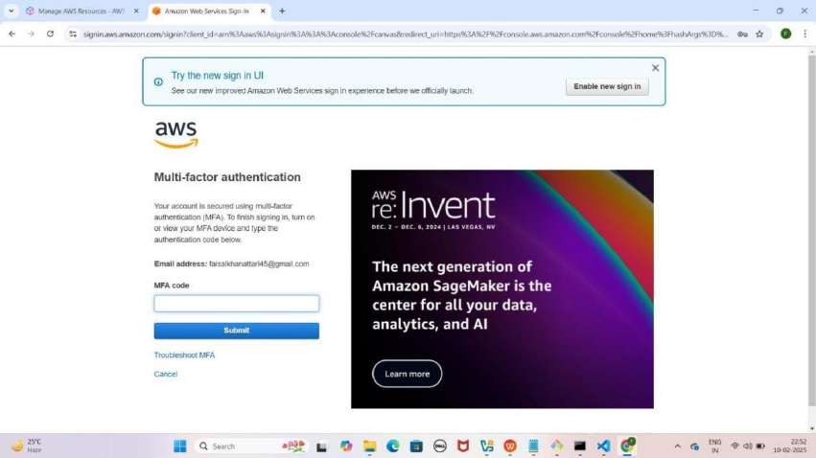

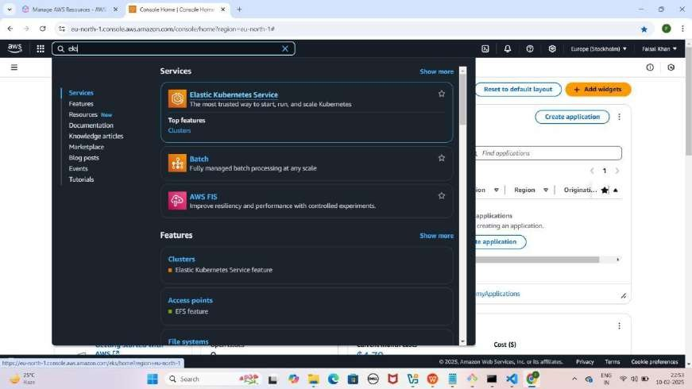

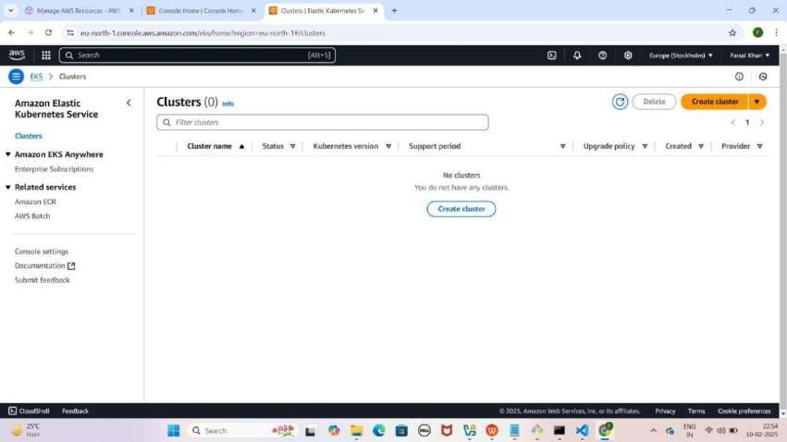

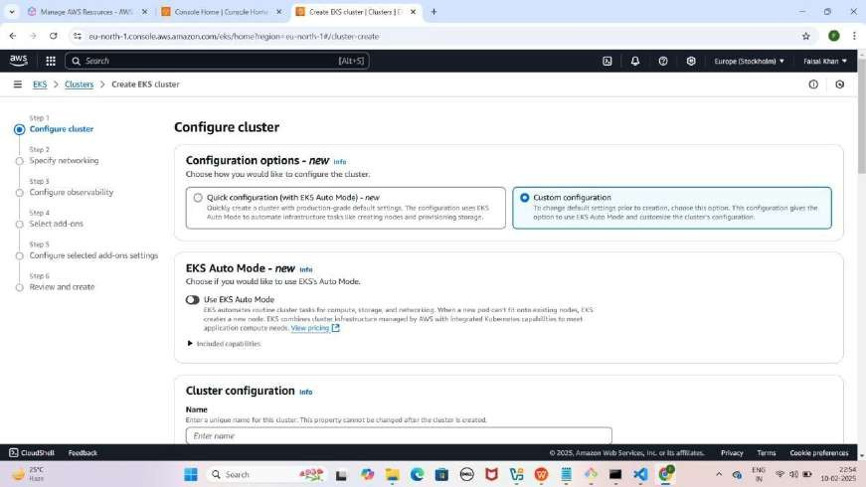

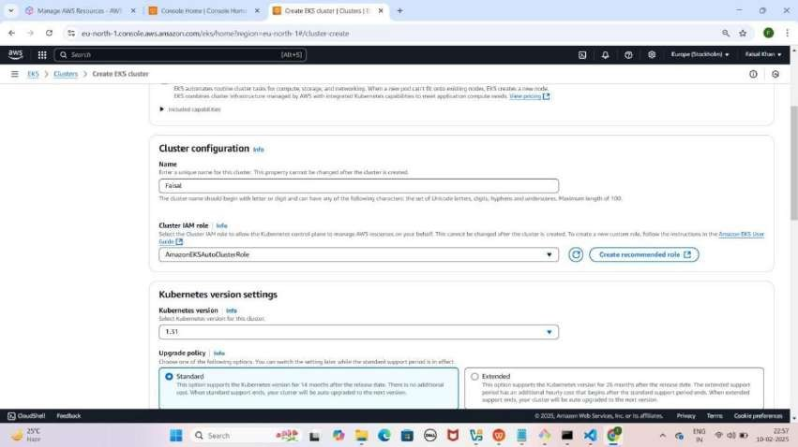

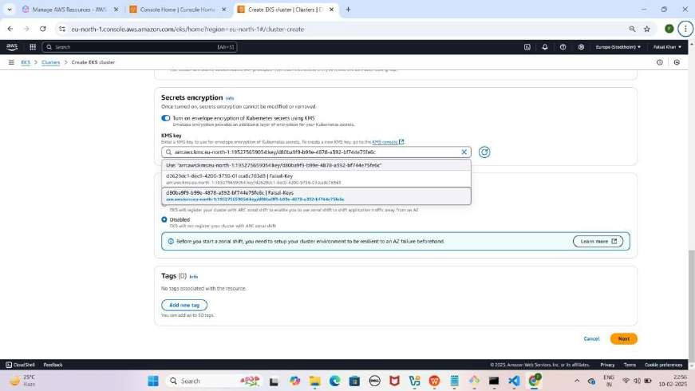

#### Step 2: Networking Configuration

1. **Specify networking section mein jao**
2. **"Additional Security Groups - Optional"** mein **"ALL-TRAFFIC- ALLOW"** select karo
3. **Next** pe click karo

YE KUCH ISTARHA LAGEGA

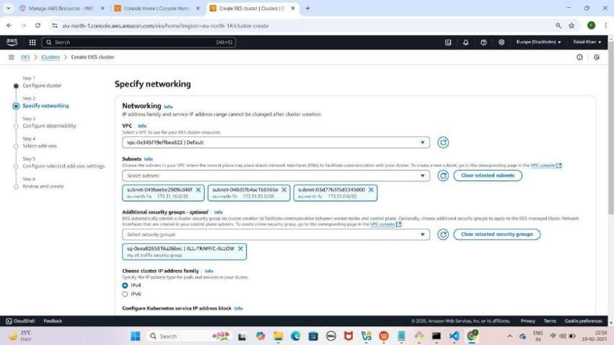

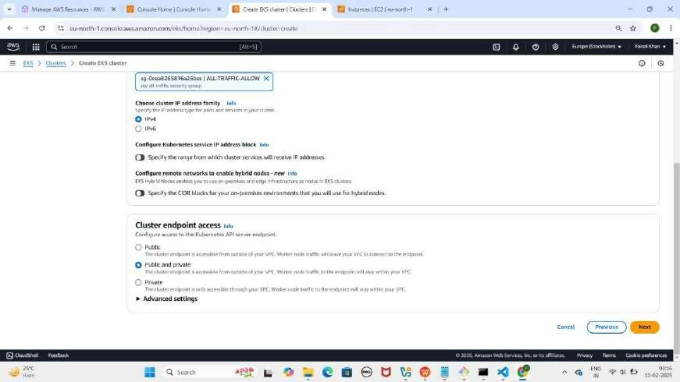

#### Step 3: Observability Configure Karna

1. **"Configure observability" section** mein
2. **"Control Plane Logs" enable karo**
3. **Next** pe click karo

YE KUCH ISTARHA LAGEGA

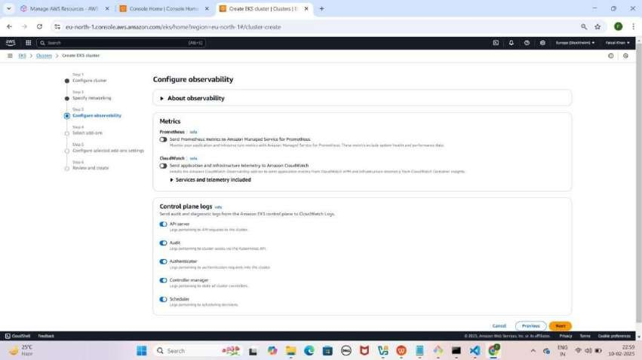

#### Step 4: Add-ons Configure Karna

1. **"Select add-ons" section** mein kuch default selected add-ons honge, unko waise hi rehne do
2. **Next** pe click karo
3. **"Amazon VPC CNI" section mein:**
4. **"Pod Identity IAM Role for Service Account: PODS-ROLE"** select karo
5. **Next** pe click karo

YE KUCH ISTARHA LEGEGA

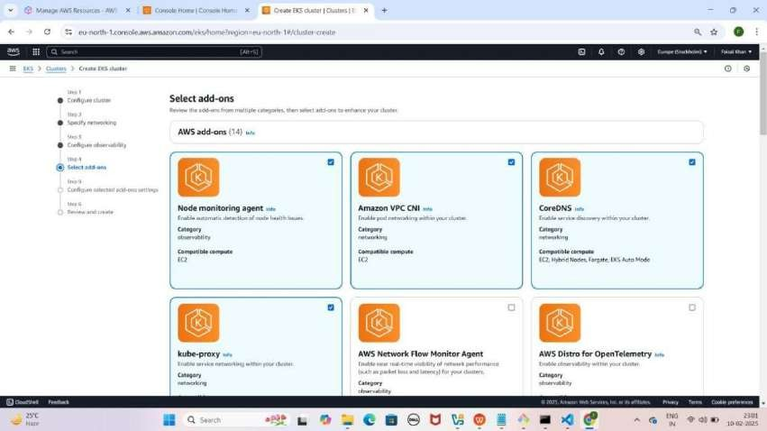

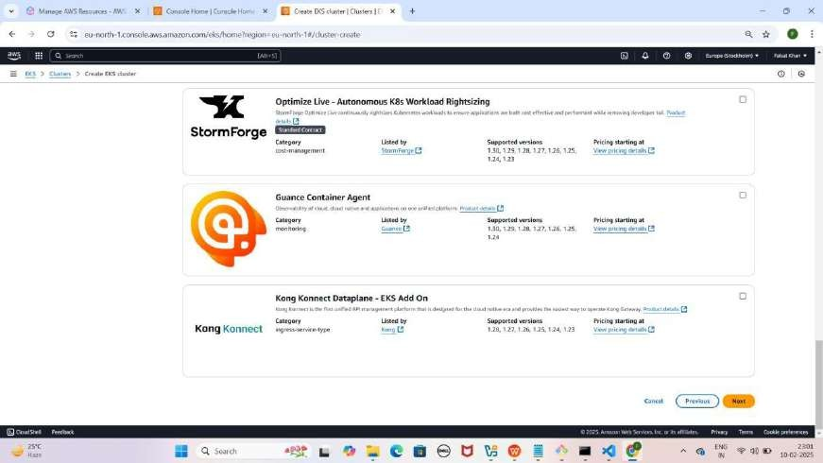

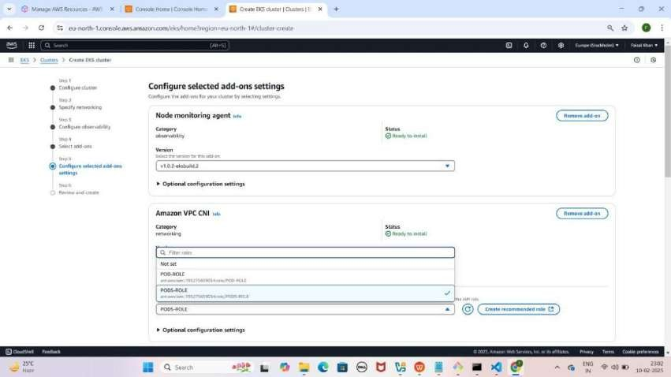

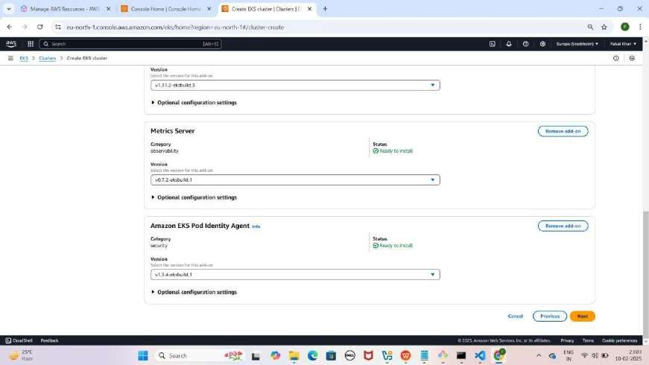

#### Step 5: Cluster Create Karna

1. **"Review and Create" section mein scroll down karo** aur **"Create" pe click karo**
2. **"Clusters" section mein jao, Status "Creating" hoga**
3. **15-20 min tak wait karo** aur **har 5 min baad refresh karo**
4. Jab **status "Active" hojaye**, tab next step karo

YE KUCH ISTARHA LAGEGA

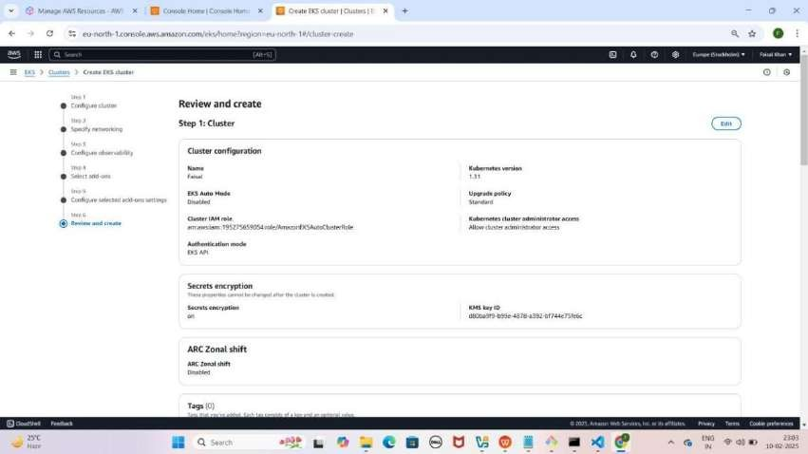

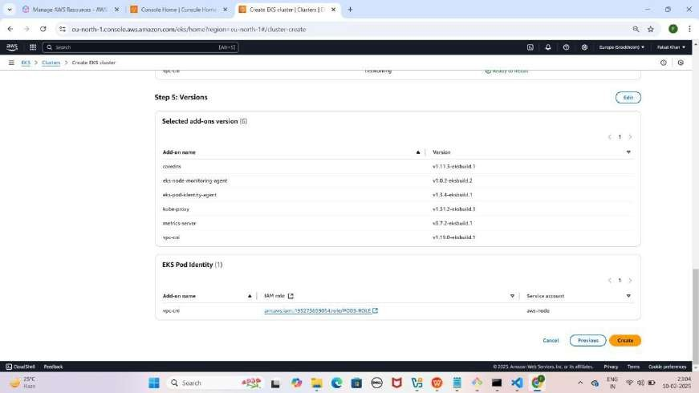

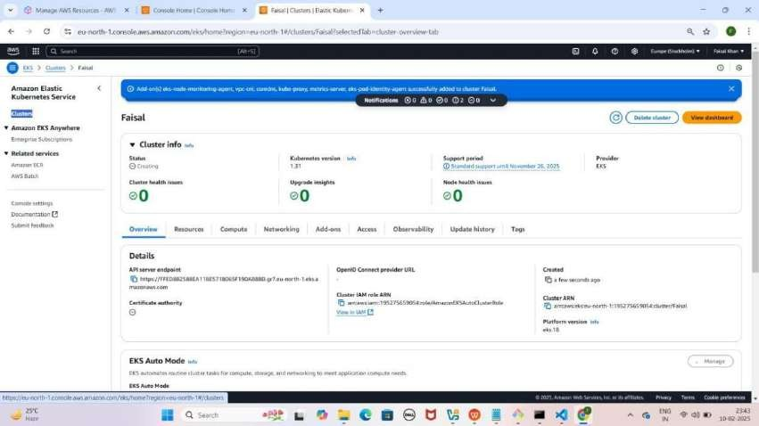

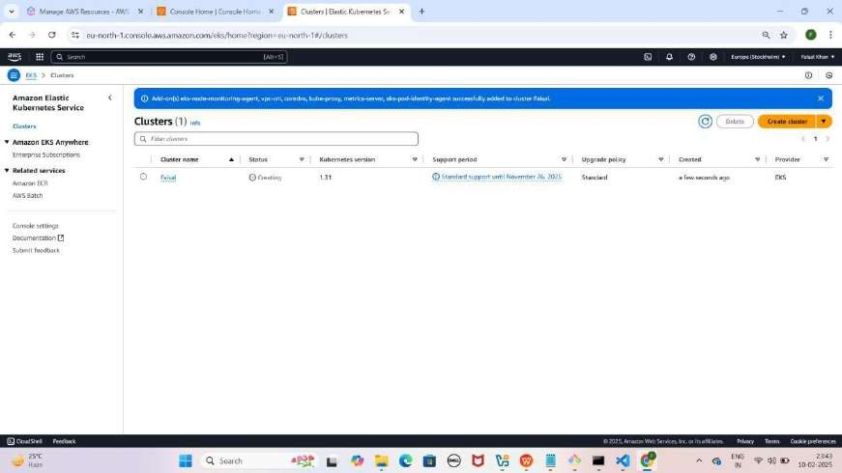

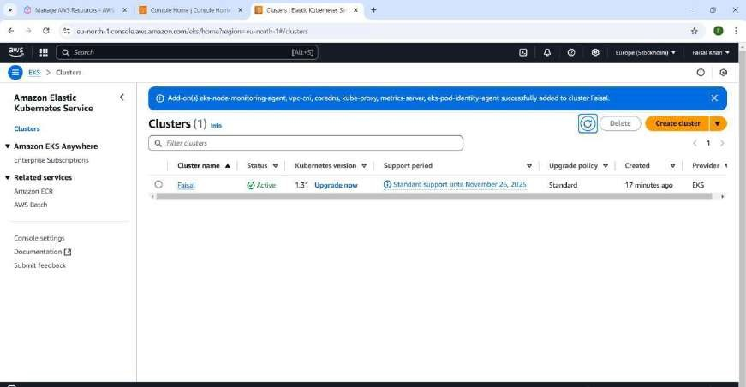

#### Step 6: Node Group Create Karna

1. **Cluster open karo, "Compute" section mein jao**
2. **"Add Node Group" pe click karo**
3. **Node Group Configuration:**
   * **Node Group Name:** Faisal-Node name karo
   * **Node IAM Role:** AmazonEKSAutoNodeRole select karo
4. **Next** pe click karo

YE KUCH ISTARHA LAGEGA

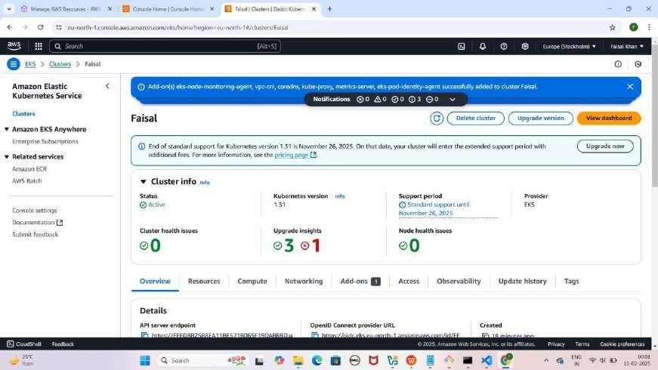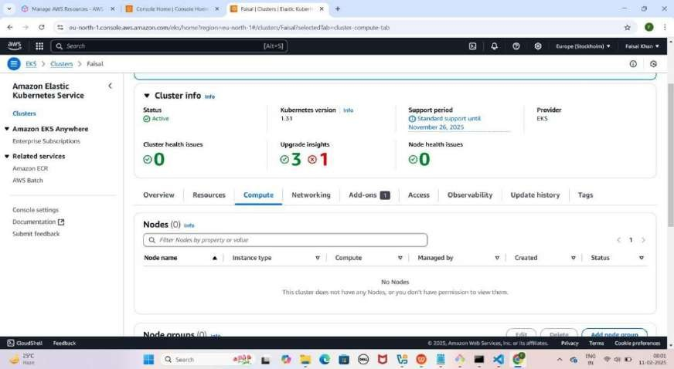

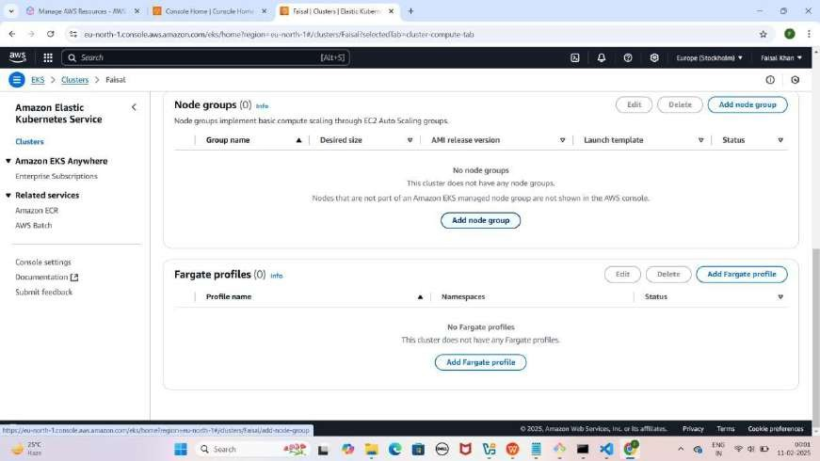

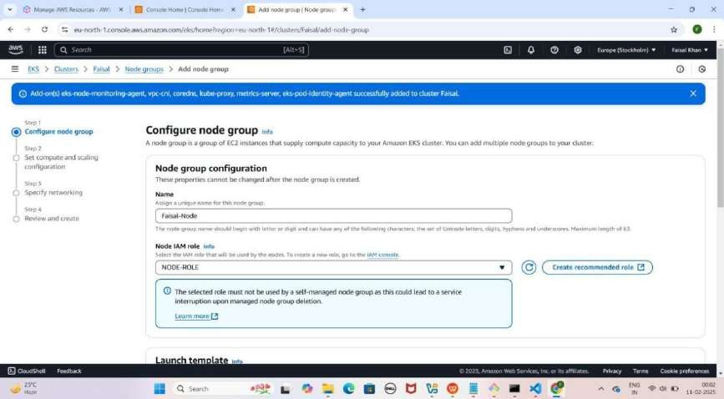

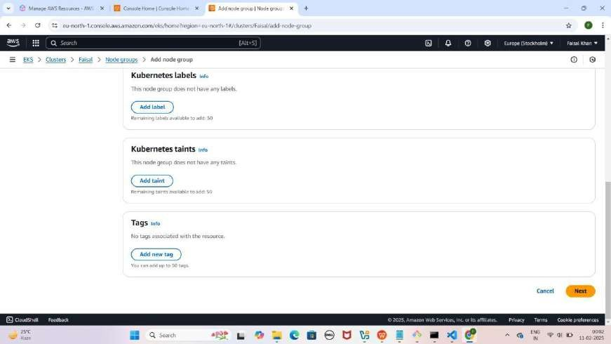

#### Step 7: Compute aur Scaling Configuration

1. **"Set Compute and Scaling Configuration" section**
   * **"t3.medium" remove karo** aur **"t3.large" add karo**
   * **Disk Size:** 100 GiB set karo
   * **Desired Size, Minimum Size, Maximum Size:** 1 rakho
   * **"Node Auto Repair" enable karo**
2. **Next** pe click karo

YE KUCH ISTARHA LAGEGA

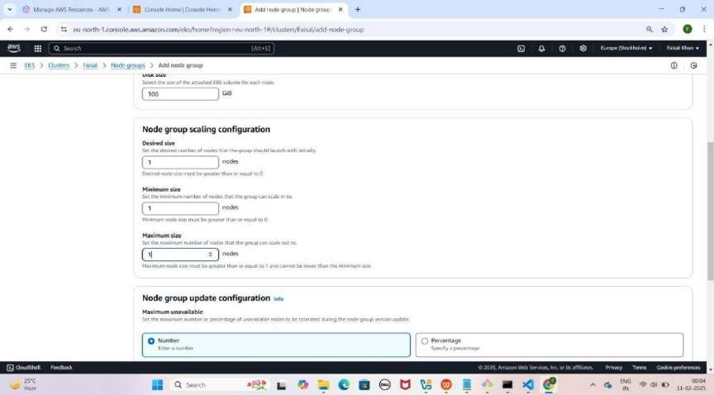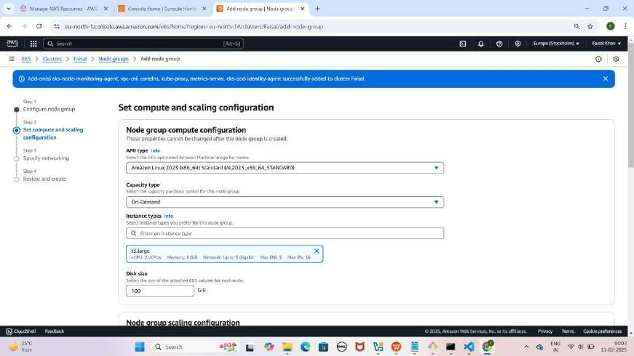

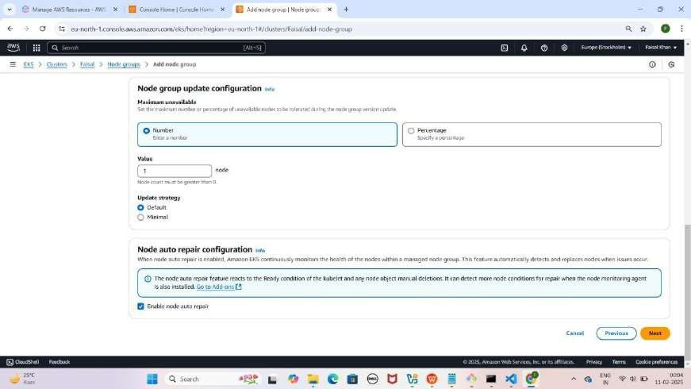

#### Step 8: Node Group ki Networking Configure Karna

1. **"Specify Networking" section**
   * **"Configure Remote Access to Nodes" enable karo**
   * **Key Pair select karo**
   * **"Additional Security Groups - Optional" mein "ALL-TRAFFIC- ALLOW" select karo**
2. **Next** pe click karo

YE KUCH ISTARHA LAGEGA

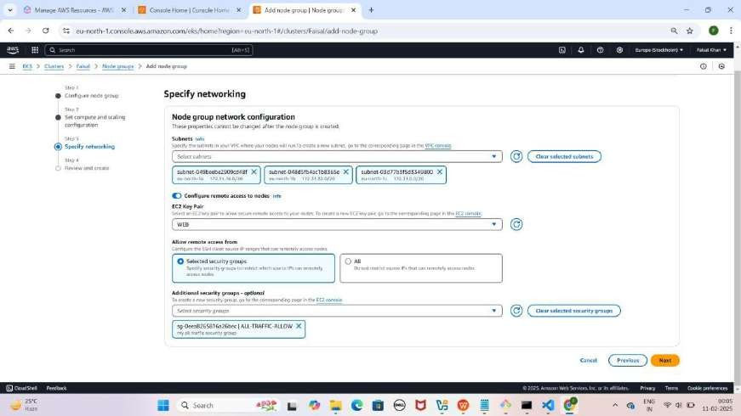

#### Step 9: Node Group Review and Create Karna

1. **"Review** and **Create**" **section** mein jao
2. **Scroll Down** karo aur "**Create**" pe **click** karo

YE KUCH ISTARHA LAGEGA

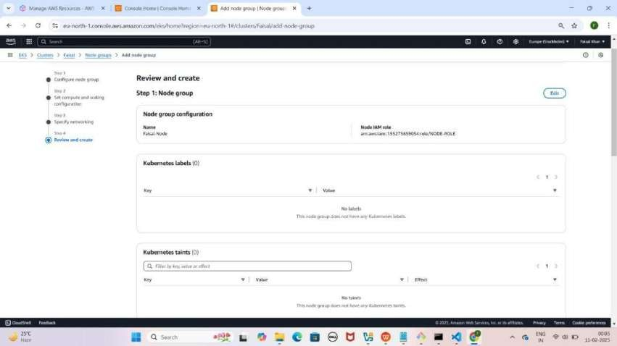

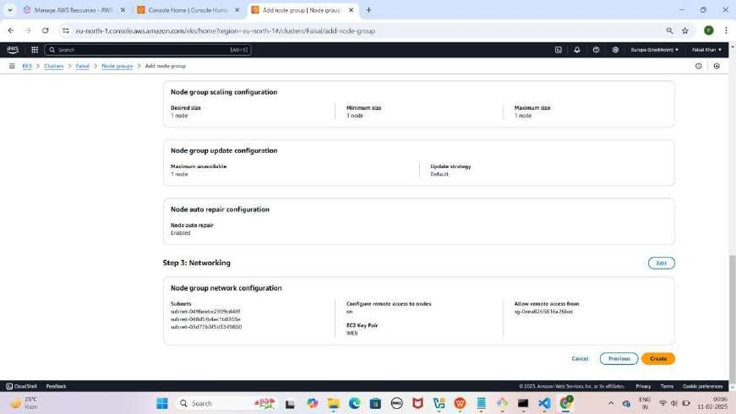

**AWS Console** open karo, search bar mein "**EC2**" likho, **Instances section** mein ek **running instance** nazar aayega, uska name "**Faisal- Node**" karo. ---> (Aapka Name Likho)

YE KUCH ISTARHA LAGEGA

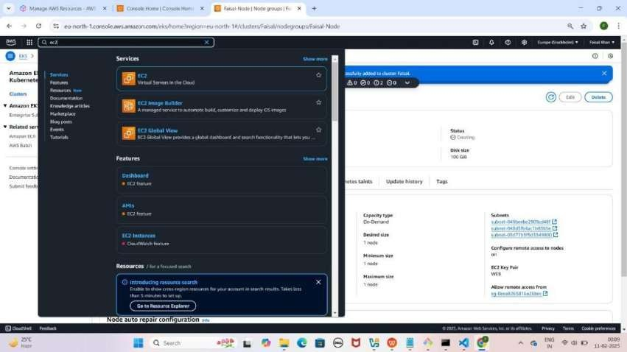

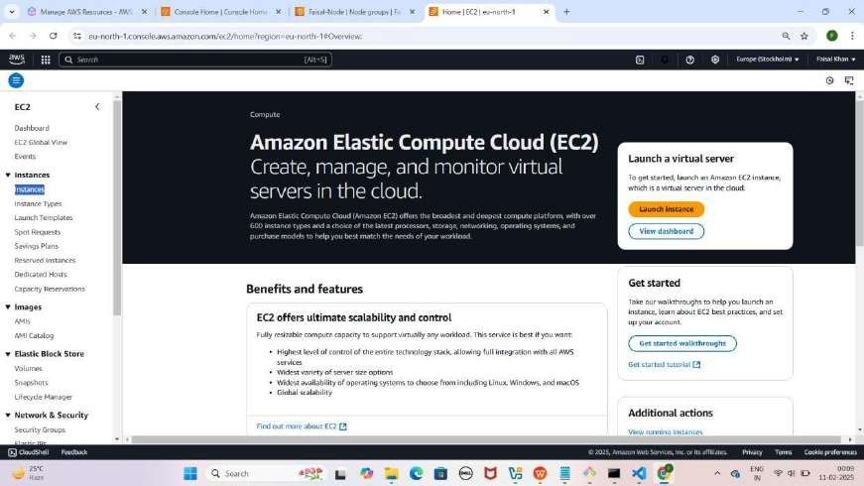

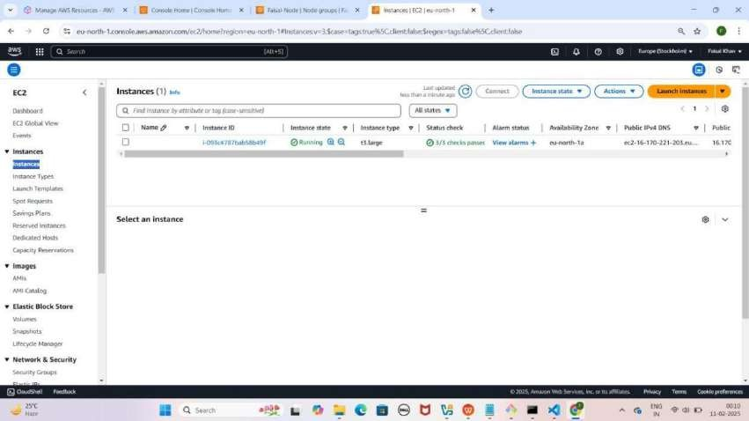

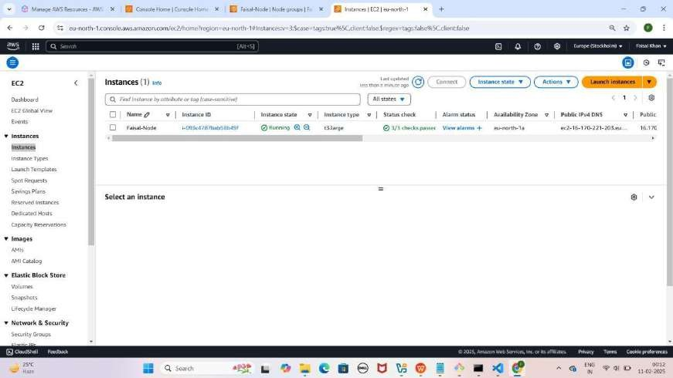

#### Step 10: Security Groups Configure Karna EKS Cluster Ke liye

1. **EKS Cluster Security Group**
   * **EKS Cluster** pe jao.
   * **Networking** section mein jao aur **Cluster Security Group** select
   * **Edit Inbound Rules** pe click karo.
   * **Default rule** delete karo aur naya rule add karo:
     + **Type:** All Traffic
     + **Source:** Anywhere IPv4
2. **Save Rules** pe **click** karo.

YE KUCH ISTARHA LAGEGA

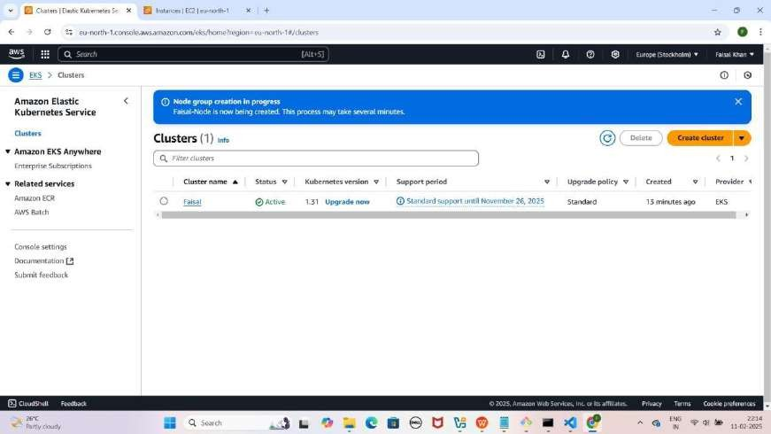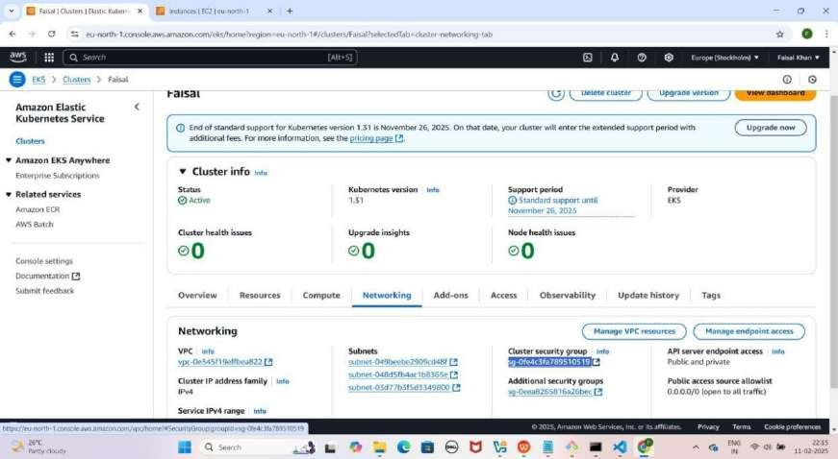

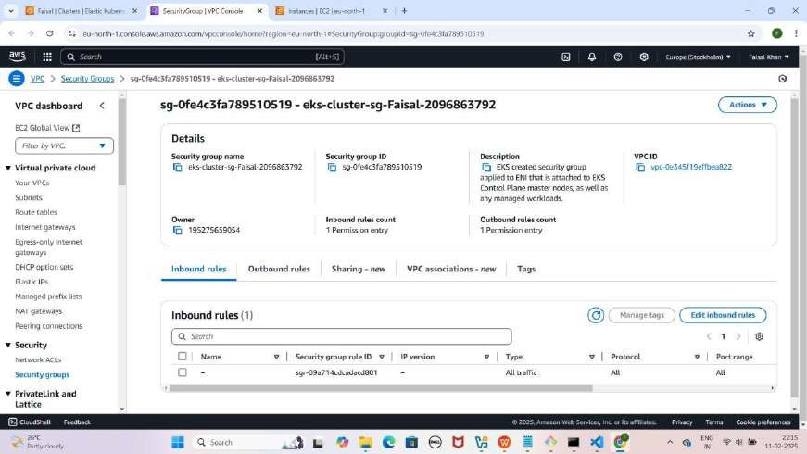

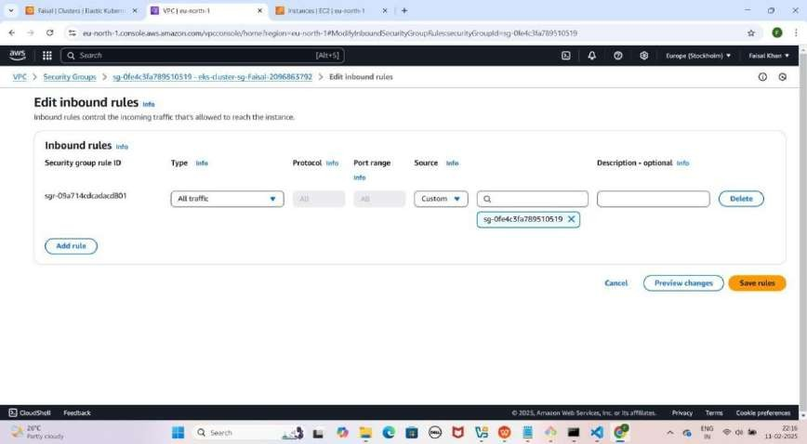

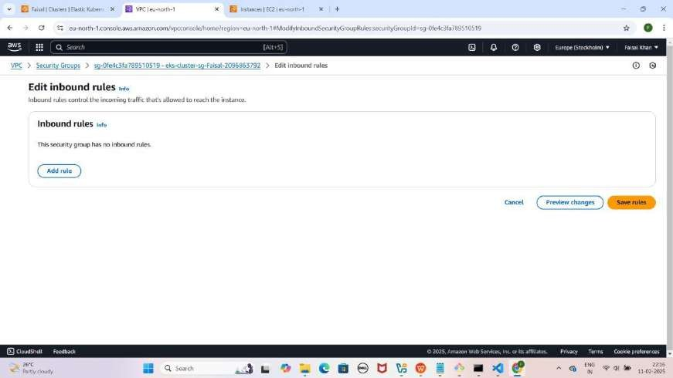

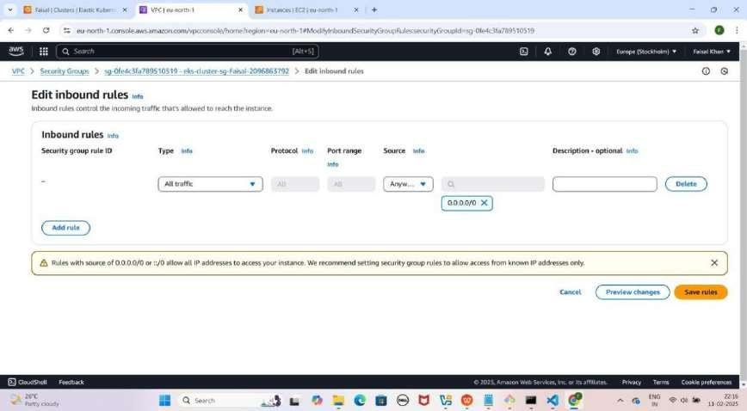

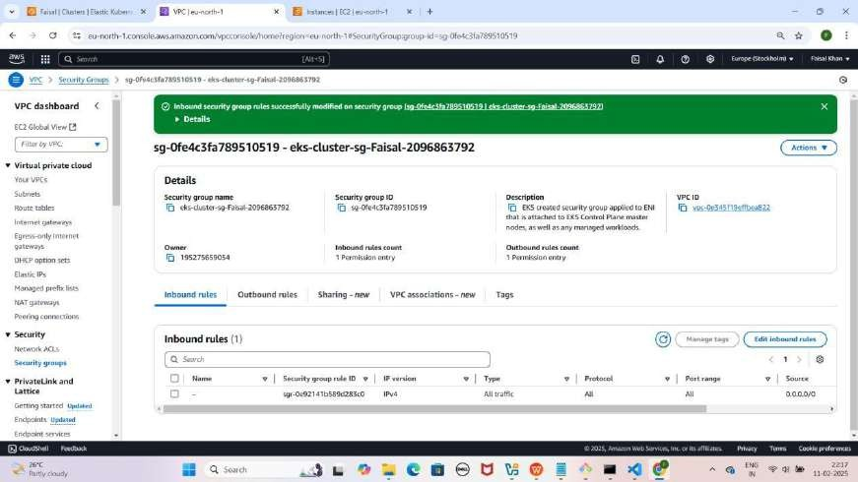

#### Step 11: Security Groups Configure Karna EKS Cluster Node Ke liye

1. **EKS Cluster Node Security Group**
   * **EC2 Instances** section mein jao.
   * **"Faisal-Node" instance** select karo.
   * **Security section mein scroll down karo aur Outbound Rules pe click karo.**
   * **Security Group ID** pe click karo.
   * **Edit Inbound Rules** pe click karo.
   * **Default rule** delete karo aur naya rule add karo:
     + **Type:** All Traffic
     + **Source:** Anywhere IPv4
2. **Save Rules** pe click karo.

YE KUCH ISTARHA LAGEGA

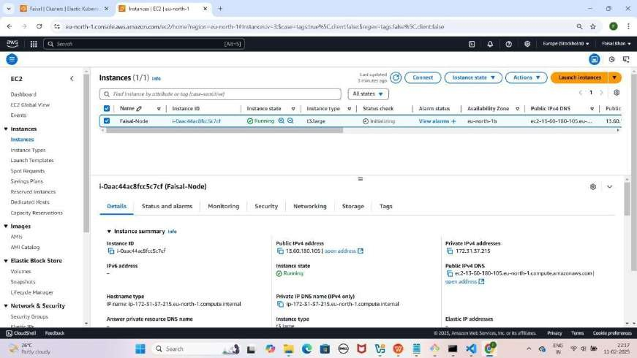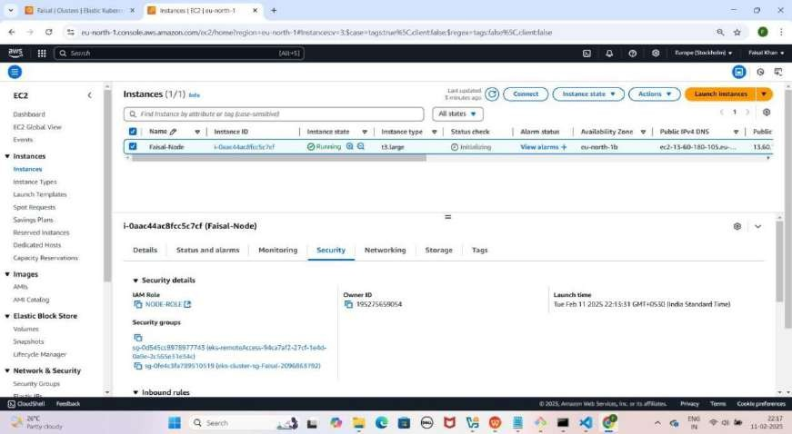

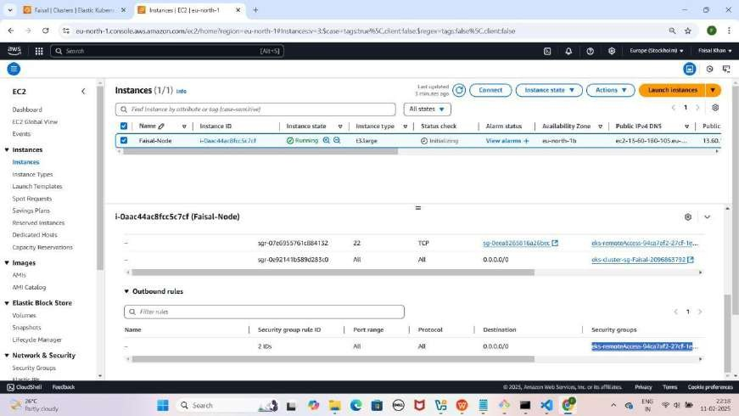

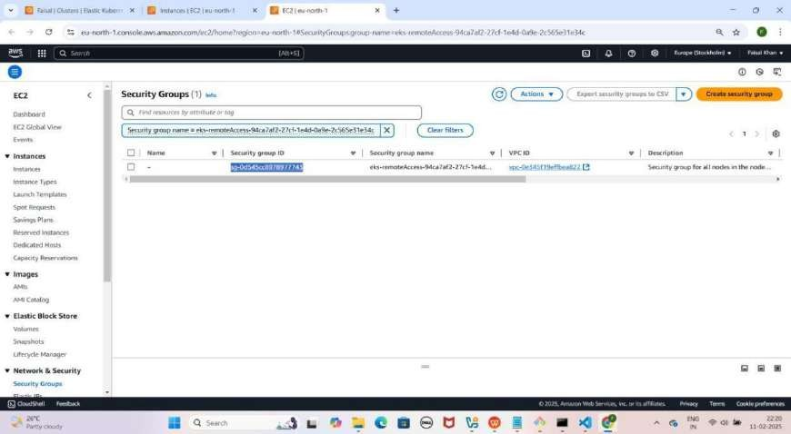

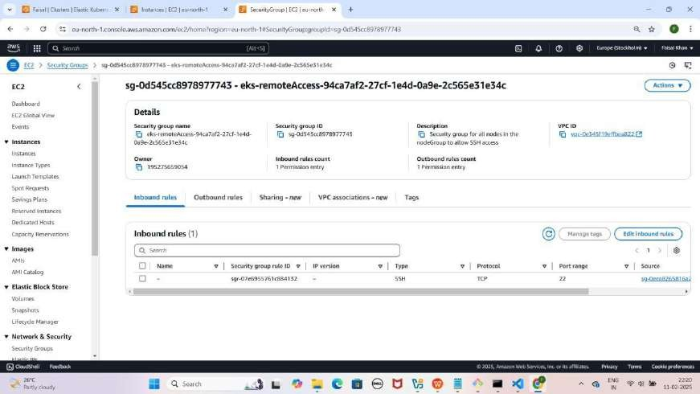

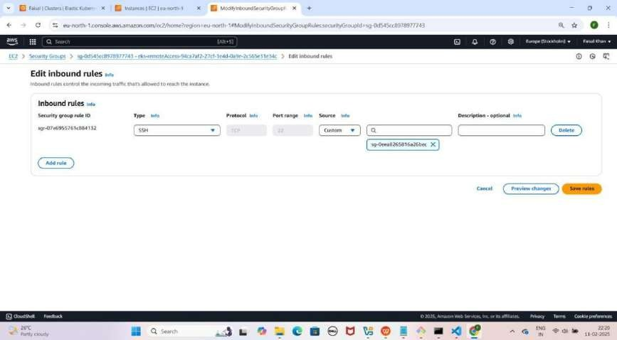

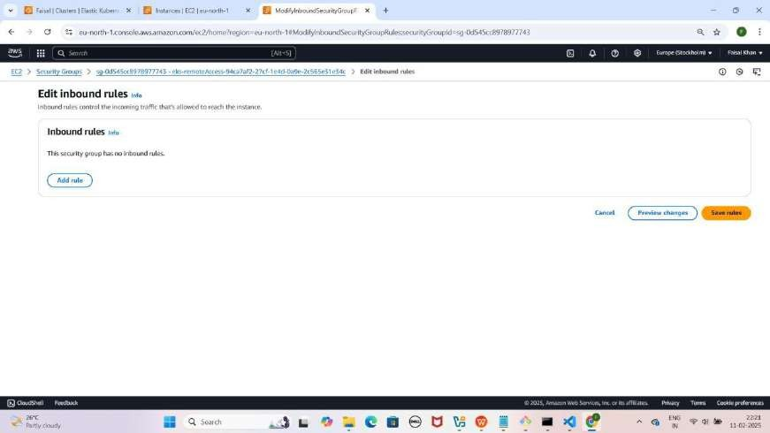

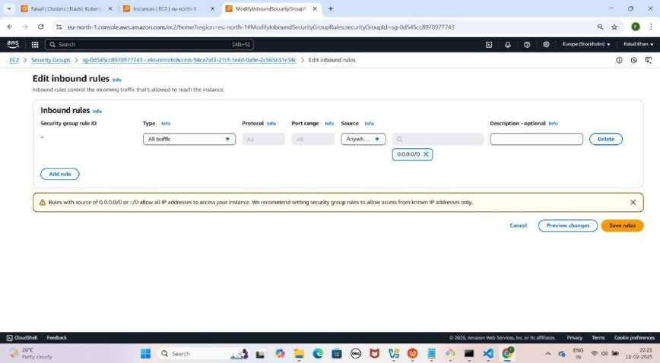

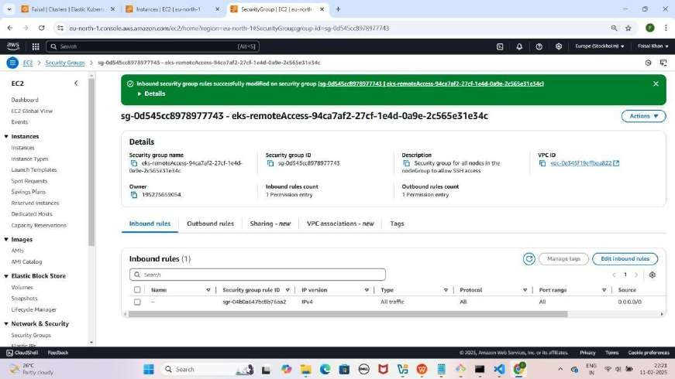

#### Step 12: Project Ki GitHub Repository Clone Karein

1. **Laptop Mein Documents Folder Mein Jao**

YE KUCH ISTARHA LEGAGA

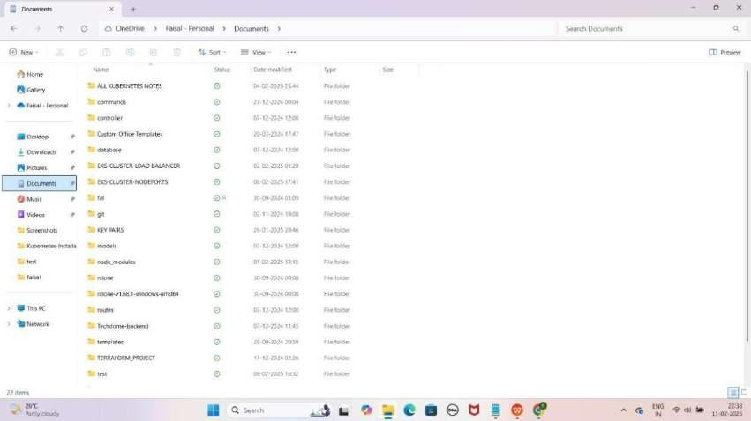

1. **PowerShell Ko "Run as Administrator" Open Karo**

YE KUCH ISTARHA LAGEGA

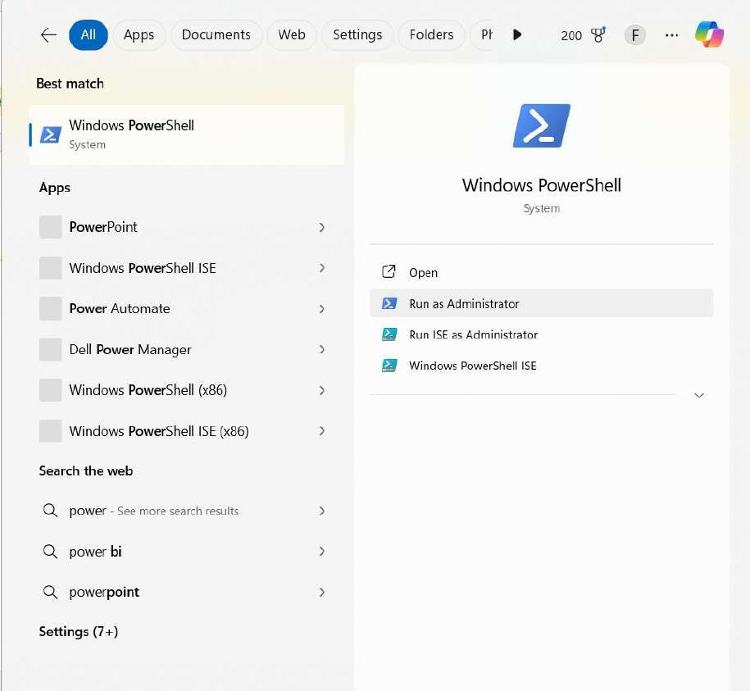

1. **PowerShell me cd command ka use karke Documents folder ka path paste karein.**

Jaisa ki mere case me, path kuch aisa hai

cd C:/Users/faisa/OneDrive/Documents

YE KUCH ISTARHA LAGEGA

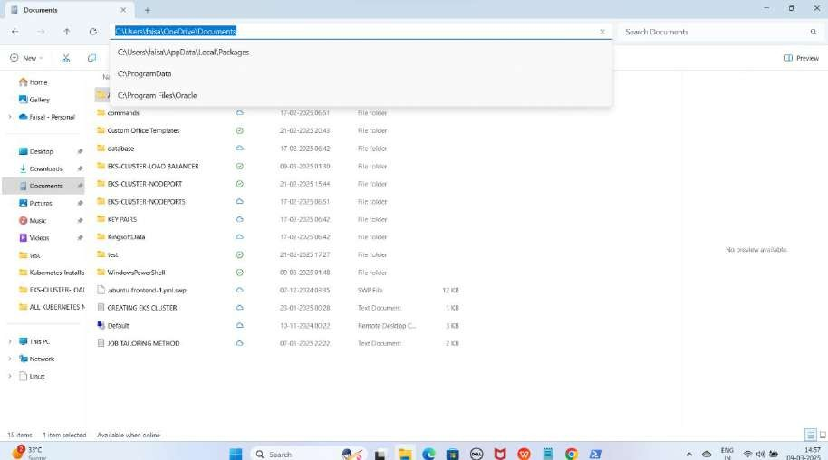

NOTE: Isse aap Documents folder me Navigate ho jaoge.

1. **GitHub Repository Clone Karo**

As it is niche diya gaya URL copy karo aur PowerShell me paste karo

git clone https://github.com/Faisalkhan45/EKS-CLUSTER-LOAD-BALANCER.git

YE KUCH ISTARHA LAGEGA

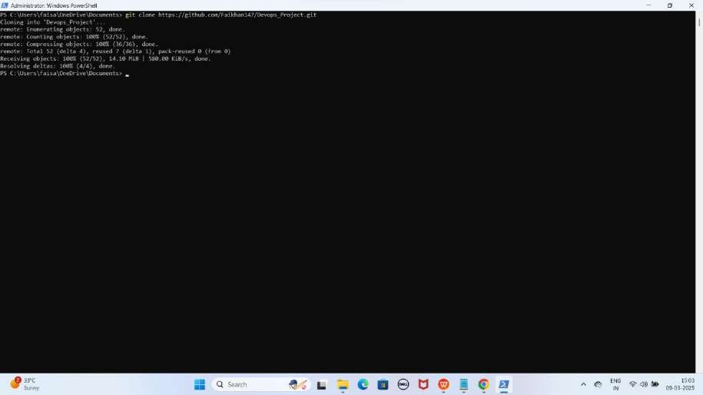

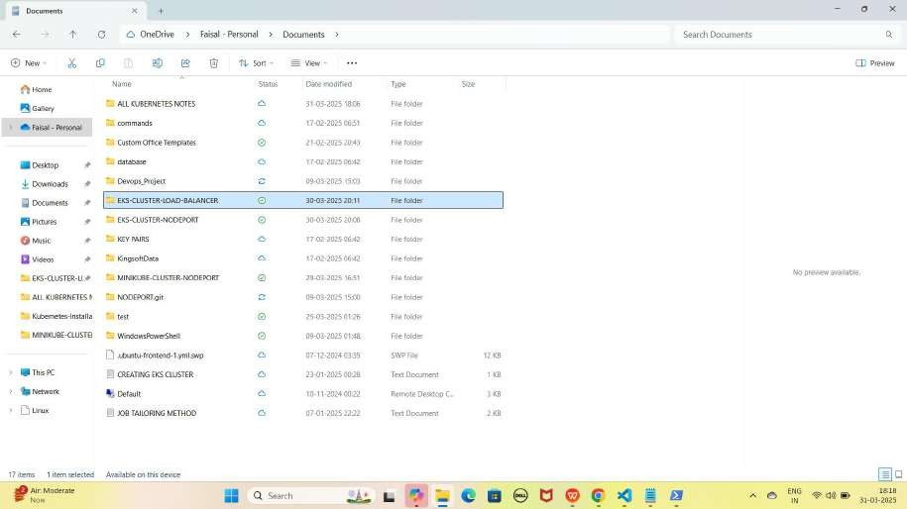

NOTE: Repository clone hone ke baad, aapko "EKS-CLUSTER-LOAD- BALANCER" naam ka folder Documents me dikhega

1. **EKS-CLUSTER-LOAD-BALANCER Folder Me Jao PowerShell me cd command ka use karo aur apna path paste karo**

Jaise ki mere case me path kuch aisa hoga

cd C:\Users\faisa\OneDrive\Documents\EKS-CLUSTER-LOAD-BALANCER YE KUCH ISTARHA LAGEGA

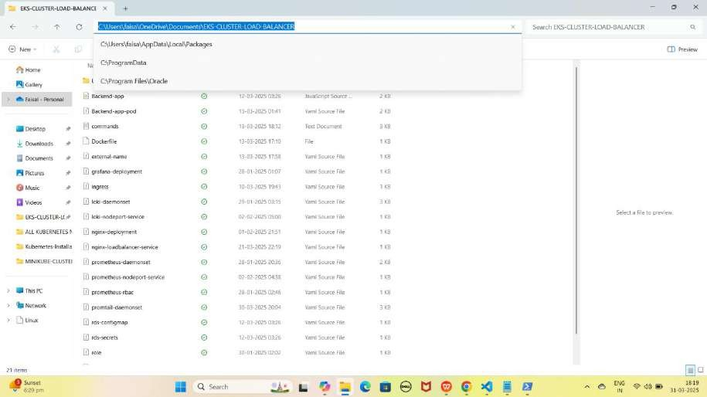

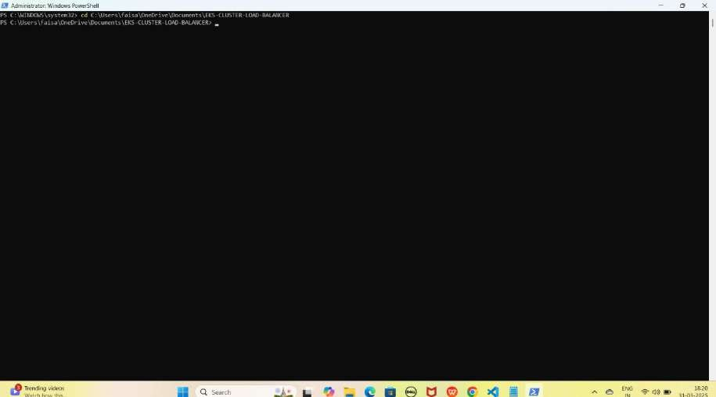

NOTE: Is command se aap PowerShell me EKS-CLUSTER-LOAD-BALANCER folder me Navigate ho jaoge.

#### Step 13: AWS CLI Configure Karo

1. **Configure karne ke liye ye command run karo**

aws configure

YE KUCH ISTARHA LAGEGA

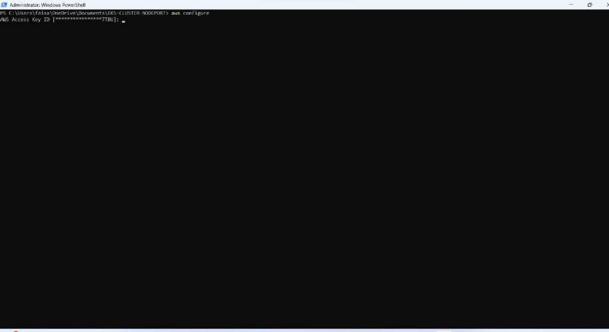

1. **Details Enter Karo**
   * **AWS Access Key ID**: XXXXXXXXXXXXXXXX
   * **AWS Secret Access Key**: XXXXXXXXXXXXXXXXXXXXXX
   * **Default Region**: eu-north-1
   * **Output Format**: text

YE KUCH ISTARHA LAGEGA

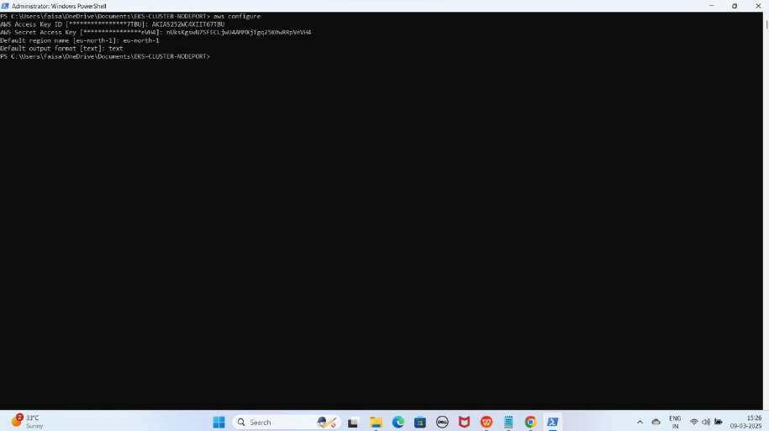

1. **EKS Clsuter se Connect karne ke liye ye command run kariye**

aws eks update-kubeconfig --name Faisal --region eu-north-1

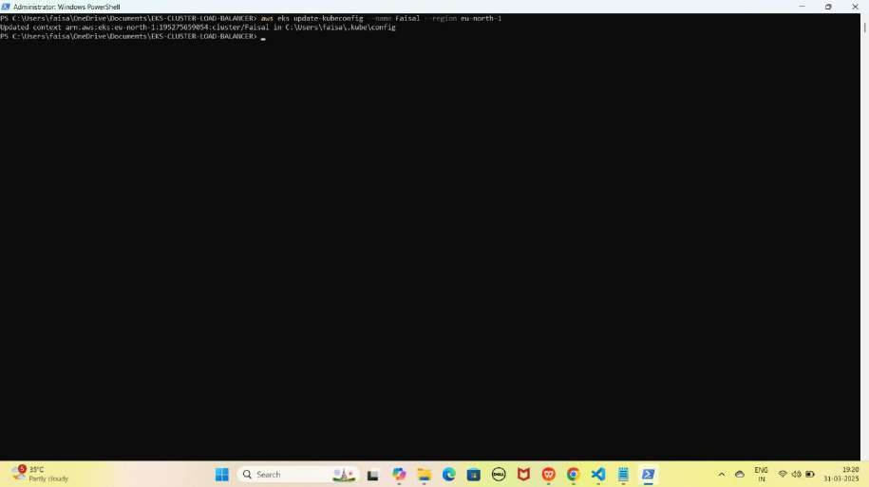YE KUCH ISTARHA LAGEGA

NOTE: Yaha par Faisal mere cluster ka name hai aap ke case me cluster ka name alag hosakta hai to according to your cluster name command aapke cluster name se Replace karo or ye hum Stockholm region me karrahe hai

#### Step 14: Nodes Check Karna

1. Check Karo Ke Node Sahi Se Ready Hai Ya Nahi

kubectl get nodes

YE KUCH ISTARHA LAGEGA

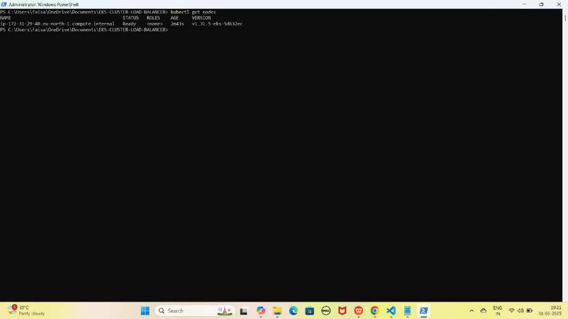

NOTE: Agar Output Mein Node "Ready" STATUS Mein Hai To Setup Complete Hai.

## Part 2: Nginx pods and Service Deployment

#### Step 1: nginx-deployment.yaml File Ka Kaam

Yeh **file NGINX ke 3 replicas create** karne ke liye use hoti hai. Isko

**Kubernetes Deployment** ke andar likha jata hai. JAISE KI:-

apiVersion: apps/v1 kind: Deployment metadata:

name: nginx-deployment spec:

replicas: 3 selector:

matchLabels:

app: nginx template:

metadata:

labels:

app: nginx spec:

containers:

- name: nginx

image: nginx:latest ports:

- containerPort: 80

#### Deployment Apply Karo

kubectl apply -f nginx-deployment.yaml

YE KUCH ISTARHA LAGEGA

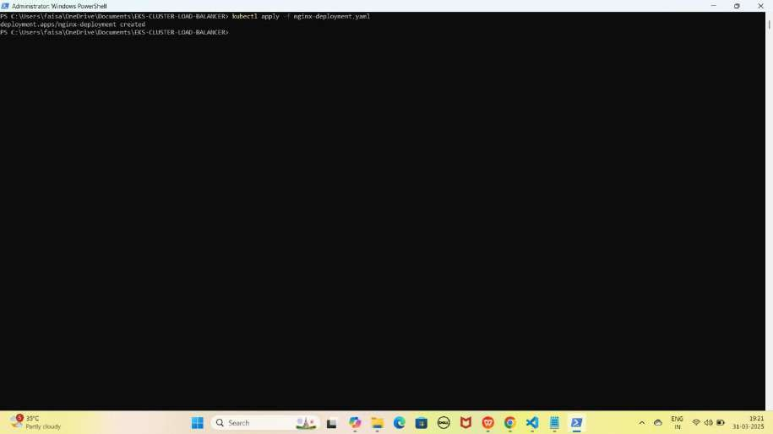

### Step 2: nginx-loadbalancer-service.yaml File Ka Kaam

Yeh **file NGINX** ko **LoadBalancer service** ke zariye **expose** karne ke liye use hoti hai, jisse hum usay **Load Balancer DNS** ke through **access** kar sakte hain.

JAISE KI:-

apiVersion: v1 kind: Service metadata:

name: nginx-service-https spec:

selector:

app: nginx ports:

- protocol: TCP port: 80

targetPort: 80 type: LoadBalancer

### Nginx Service Apply Karo

kubectl apply -f nginx-loadbalancer-service.yaml

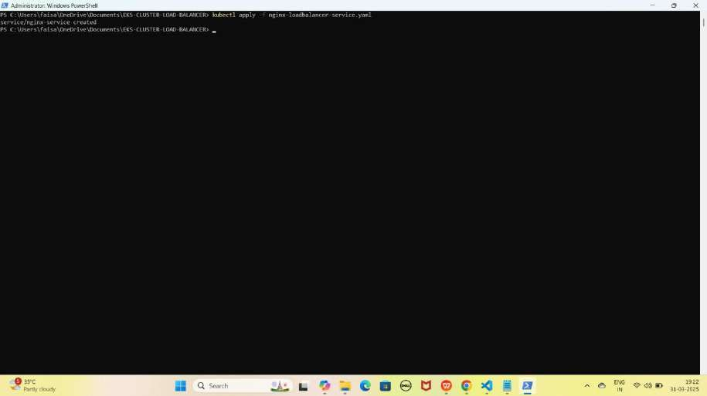YE KUCH ISTARHA LAGEGA

1. **Pods check karne ke liye ye command run kariye**

kubectl get pods

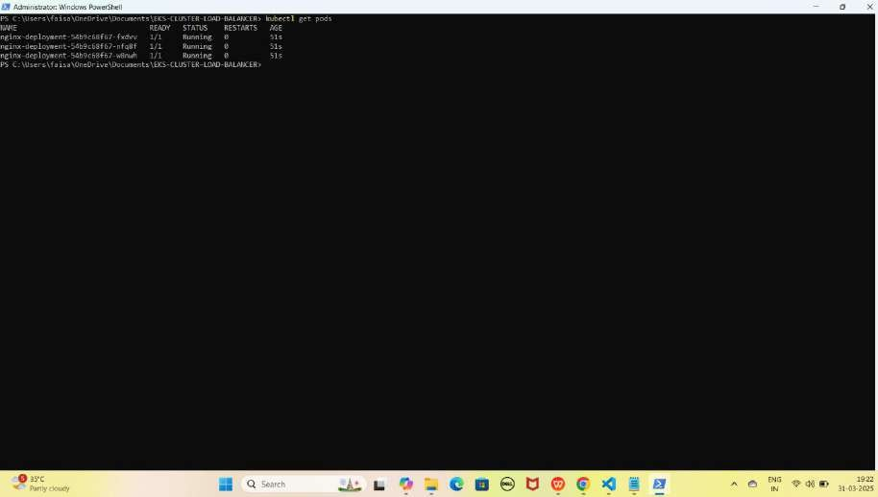YE KUCH ISTARHA LAGEGA

NOTE: Agar sabhi Pods ka STATUS Running show karraha hai to sab kuch sahi hai

1. **Serives check karne ke liye ye commad run kariye**

kubectl get services

YE KUCH ISTARHA LAGEGA

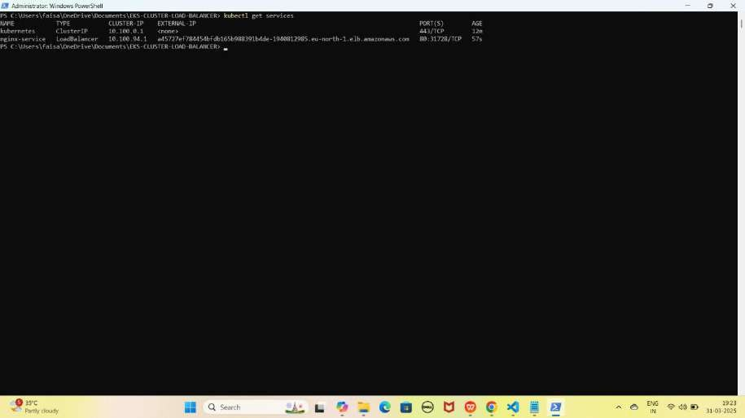

NOTE: Ab aapka Nginx expose ho chuka hai aapke Load Balancer ki DNS Name lekar browser me run kariye jaise ki kuch aisa hogi mere case me

NGINX Load Balancer DNS :

[http://a1b2c3d4e5f6g7h8-123456789.ap-south-1.elb.amazonaws.com](uj)

YE KUCH AISA LAGEGA

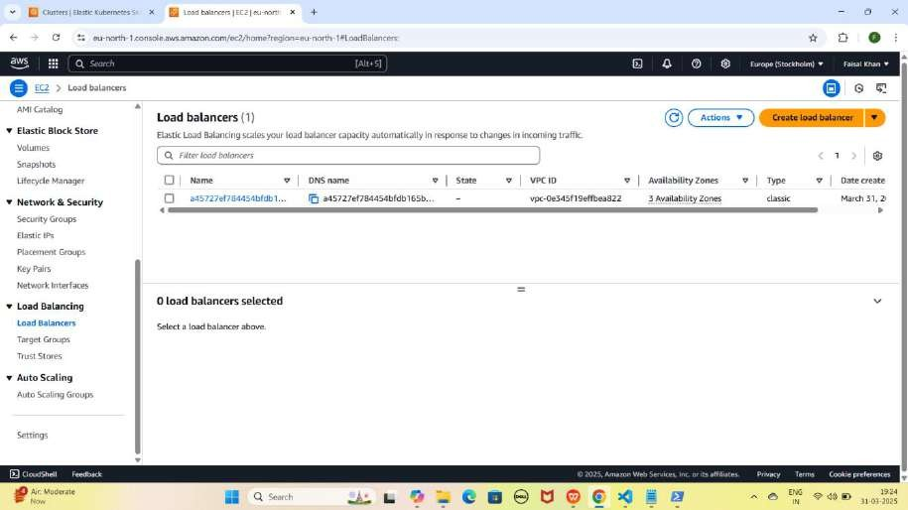

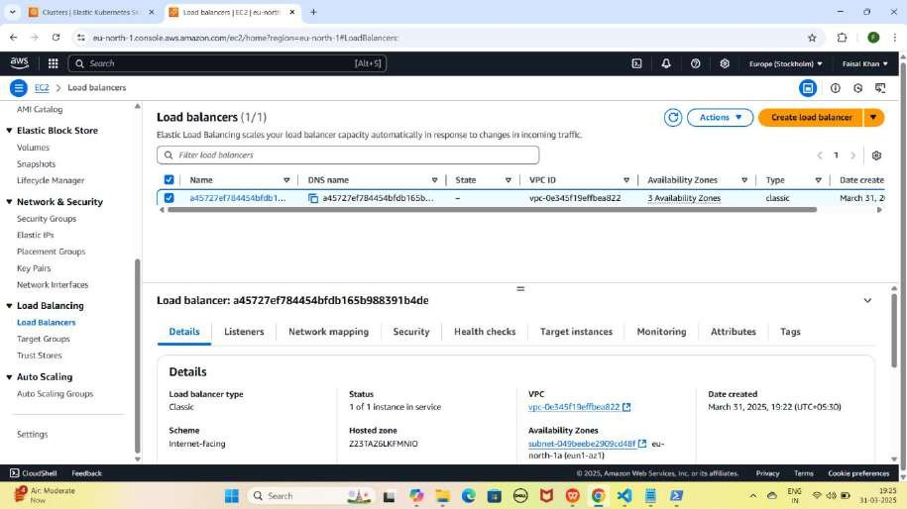

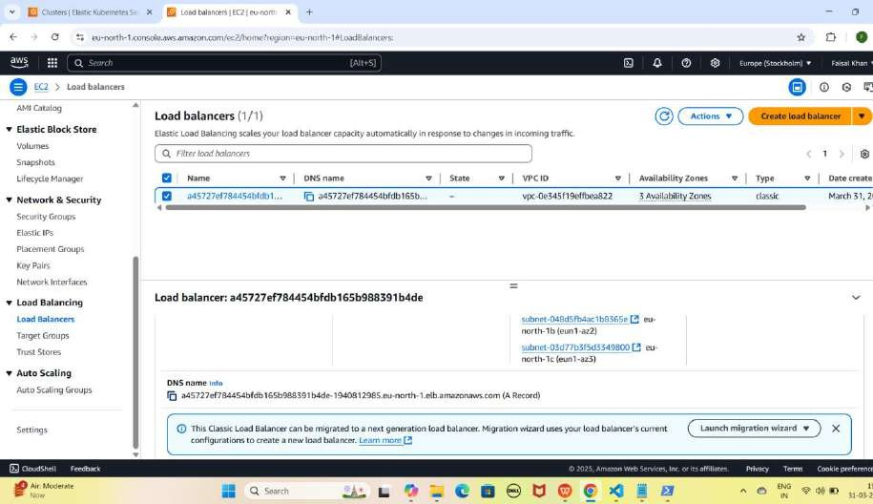

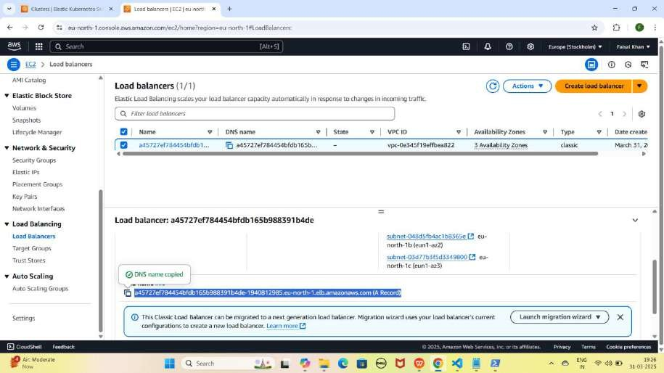

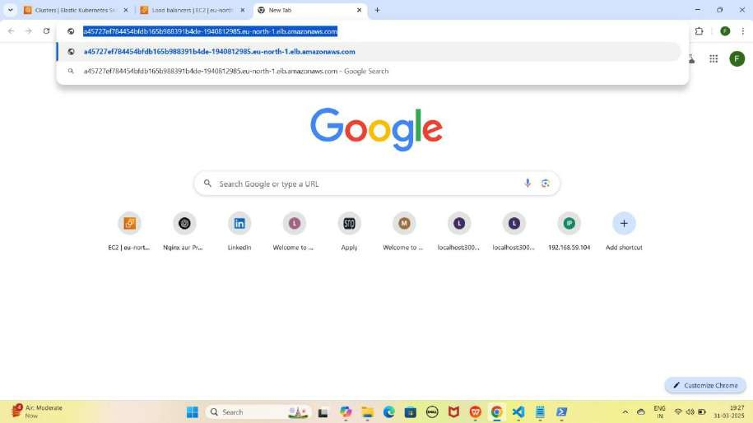

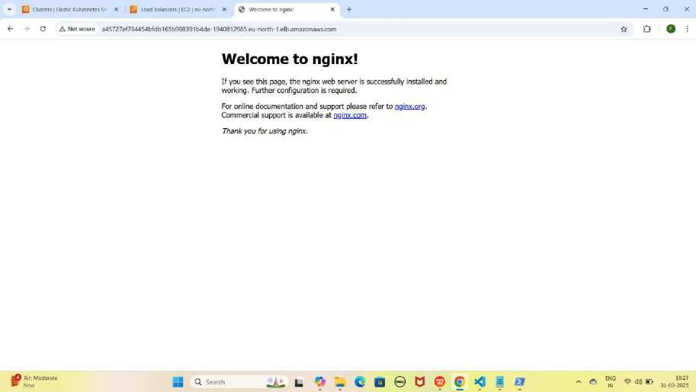

## Part 3: Registering a Domain Name on Hostinger (From Sign-Up to Purchase)

#### Step 1: Domain Name Provider Choose Karo

* Tumhe **GoDaddy, AWS (Route 53), ya Hostinger** jaisa **domain**

provider chahiye

* Main yahan **Hostinger** use kar raha hoon

#### Step 2: Hostinger Pe Domain Search Karo

* **Google** pe jao aur **"Hostinger"** search karo
* **"Domains"** pe click karo
* Search bar me apna desired **domain** likho (Jaise:

mohdfaisalkhan.tech)

* (Aapke Name se Search Karo)
* **Search button** pe **click** karo

YE KUCH ISTARHA LAGEGA

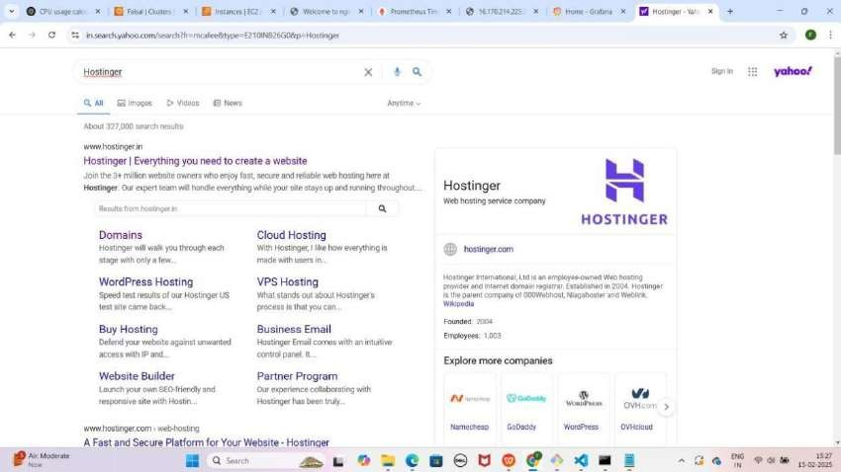

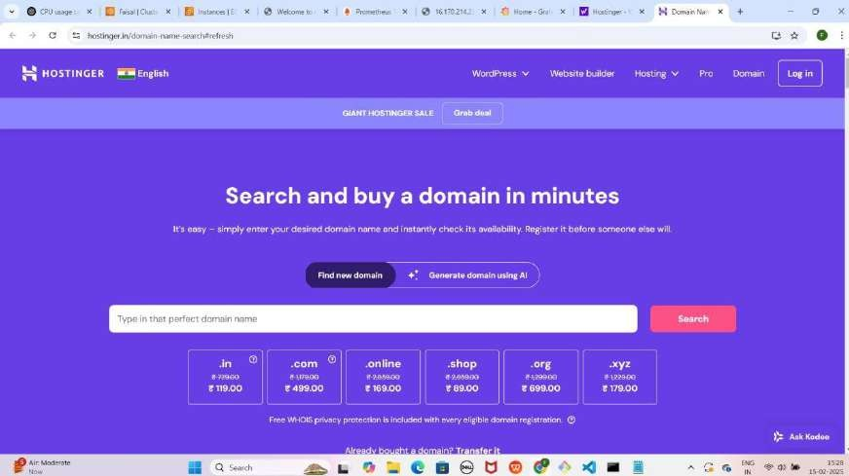

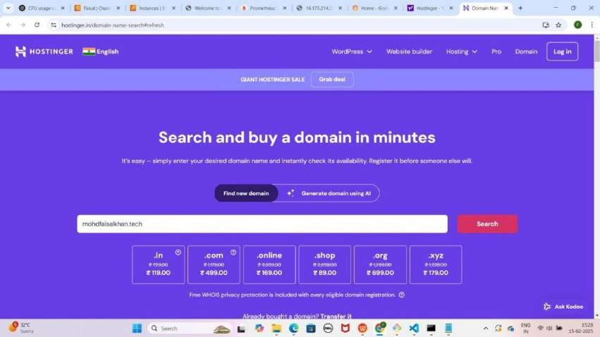

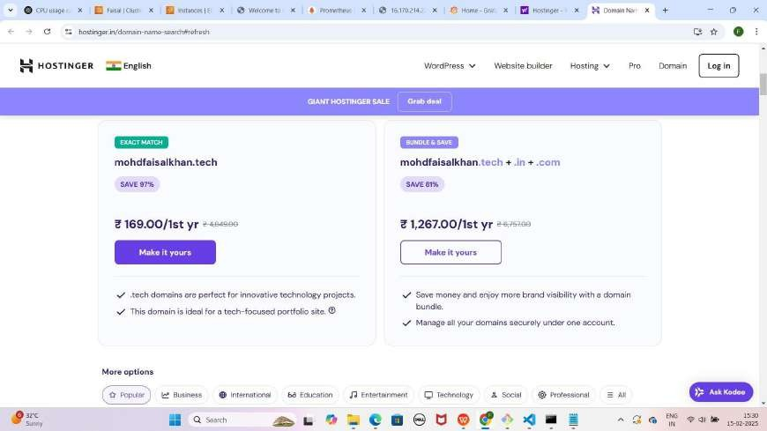

#### Step 3: Domain Select Karo

* **"Make it Yours"** pe click karo
* 1-year period select karo
* **Continue** button pe click karo

YE KUCH ISTARHA LAGEGA



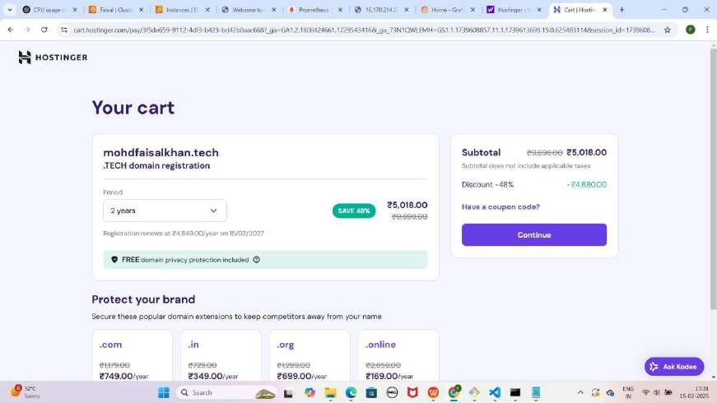

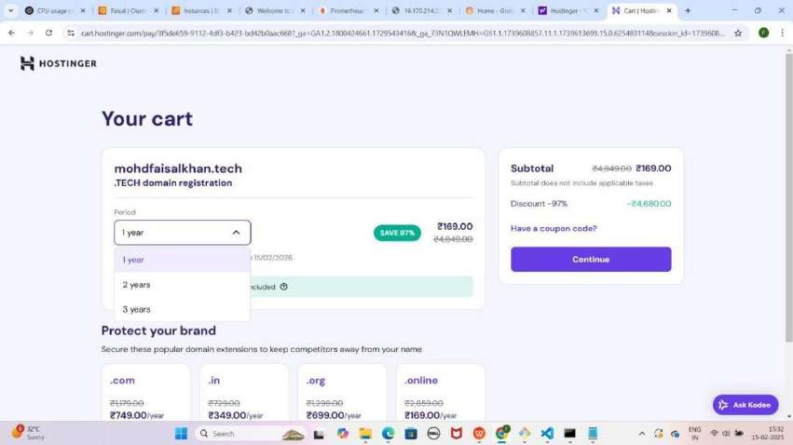

#### Step 4: Account Create Karo

* **Create an Account Page** pe **Email** aur **Password** enter karo then continue pe click karo
* **Billing Address** details fill karo
* **Continue** button pe click karo

#### Step 5: Payment Complete Karo Or Login Karke Domain Registration Complete Karo

* **UPI** option select karo Submit payment pe click karo or upi payment complete karo
* **Order Summary** dekho, phir **Continue** pe click karo
* **QR Code** scan karo aur **PhonePe, Paytm,** ya **Google Pay** se payment complete karo

YE KUCH ISTARHA LAGEGA

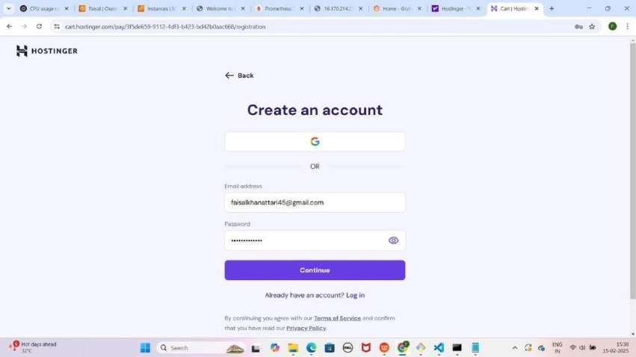

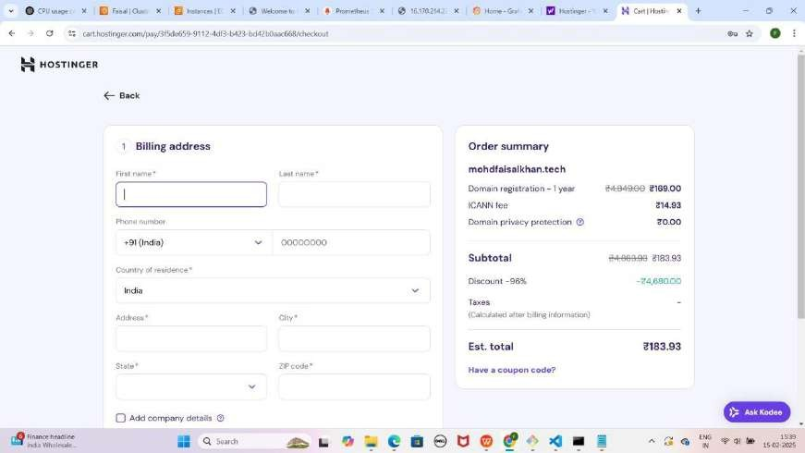

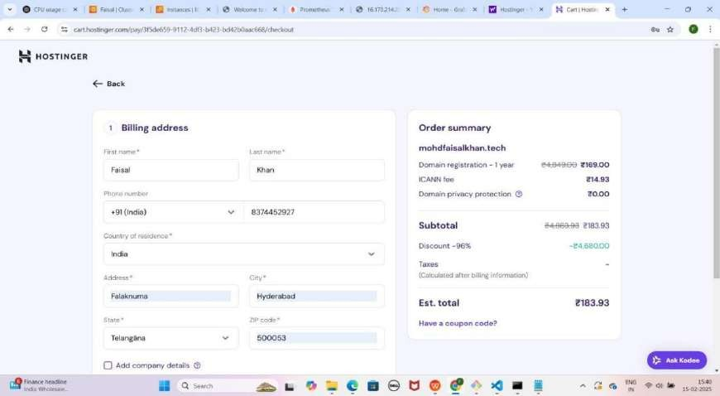

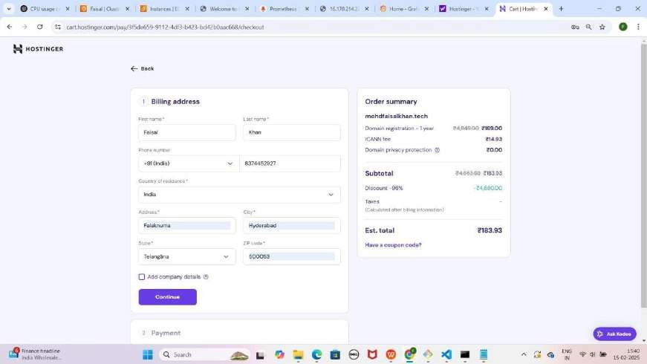

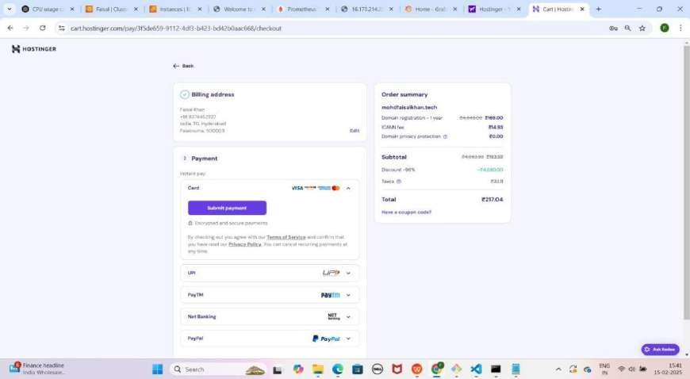

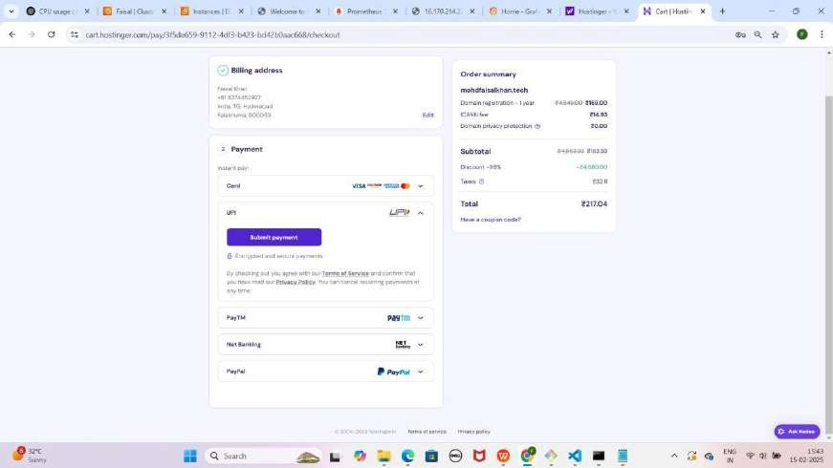

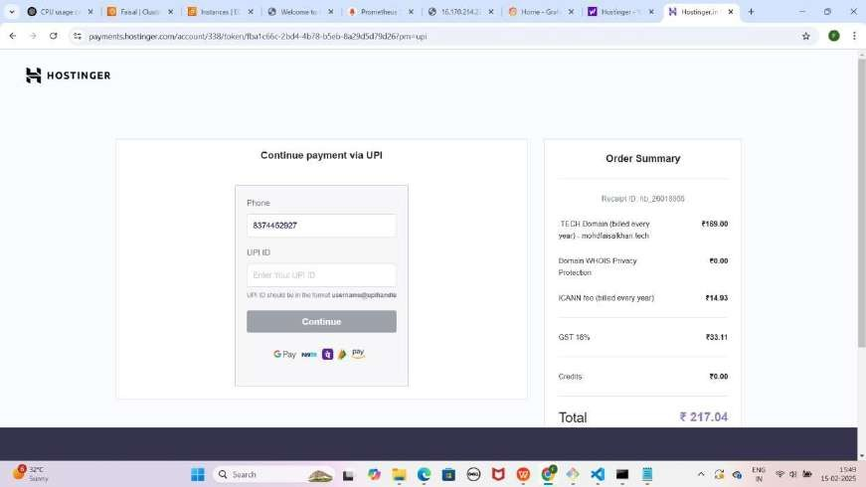

Note: Aapko neeche wala pop-up milega, tension mat lo, aap bas "Auto Pay" kar do, lekin baad mein aap isey PhonePe ke settings se cancel kar sakte ho. Abhi ke liye "Continue" pe click karo.

YE KUCH ISTARHA LAGEGA

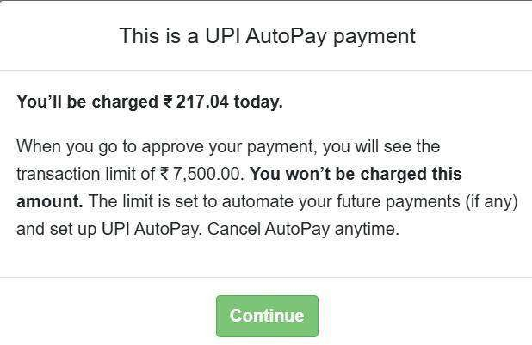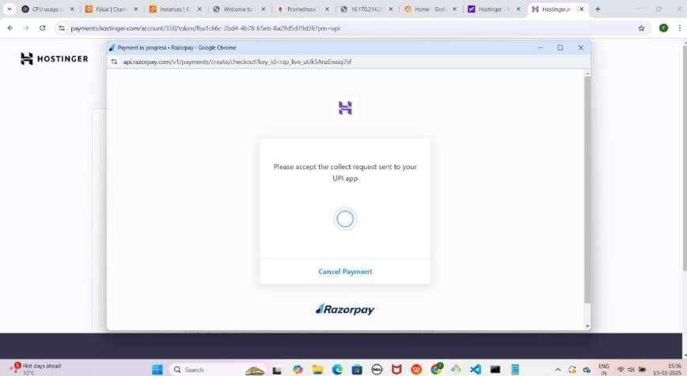

* **PhonePe** open karo aur **payment** complete karo
* **Browser** me new tab open karo aur **Google** me **Hostinger** search karo
* **Hostinger website** pe jao aur "**Domains**" pe **click** karo
* **Top right** corner pe "**Log in**" pe **click** karo
* 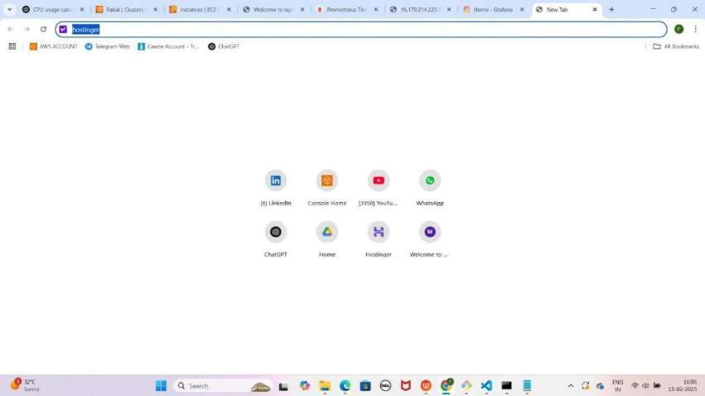**Email aur password enter** karo jo tumne pehle set kiya tha YE KUCH ISTARHA LAGEGA

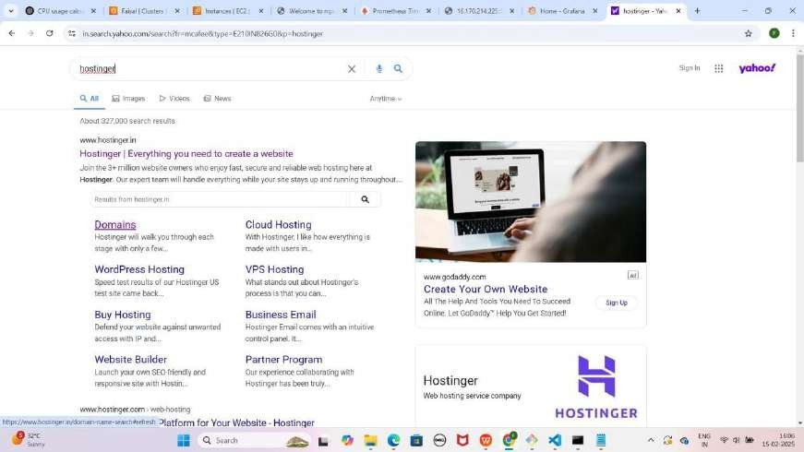

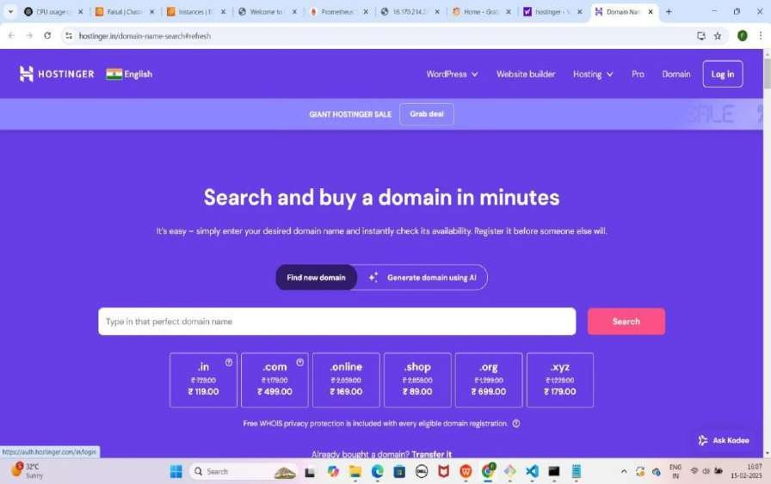

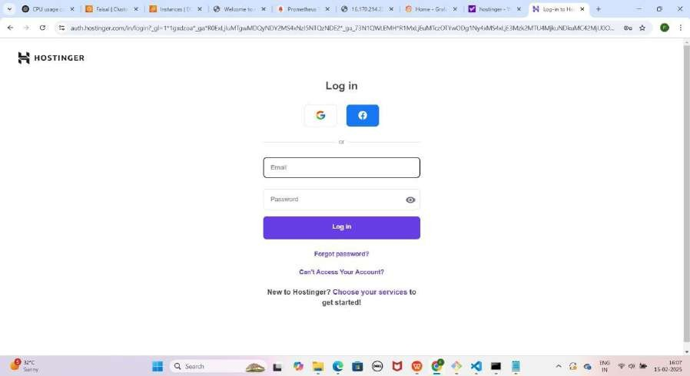

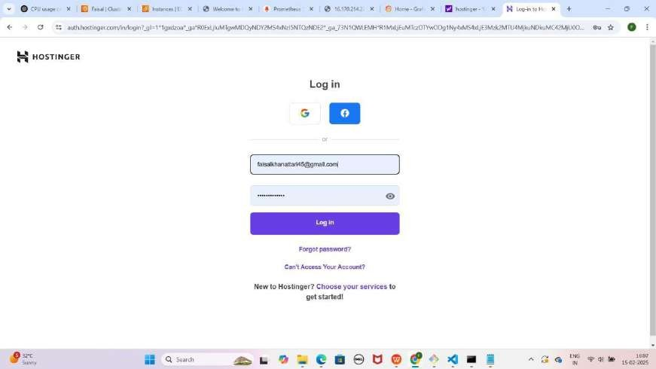

* **Login** karne ke baad tumhe **"Register your domain mohdfaisalkhan.tech"** ka option milega
* **"Next Step"** pe click karo
* **"Finish Registration"** pe click karo
* Tumhara **domain registration complete ho jayega**

YE KUCH ISTARHA LAGEGA

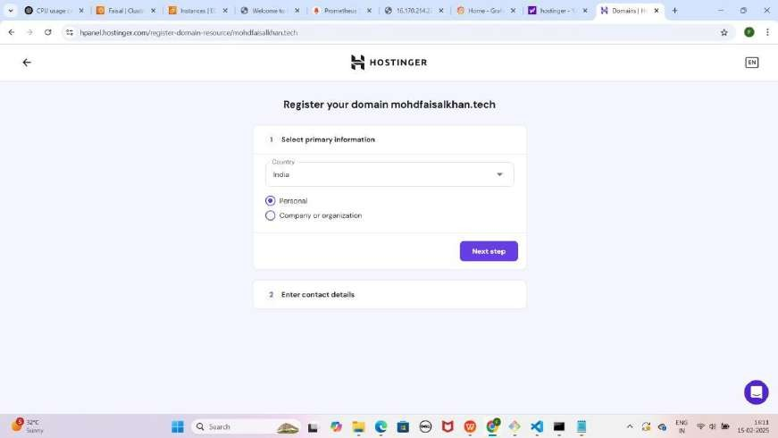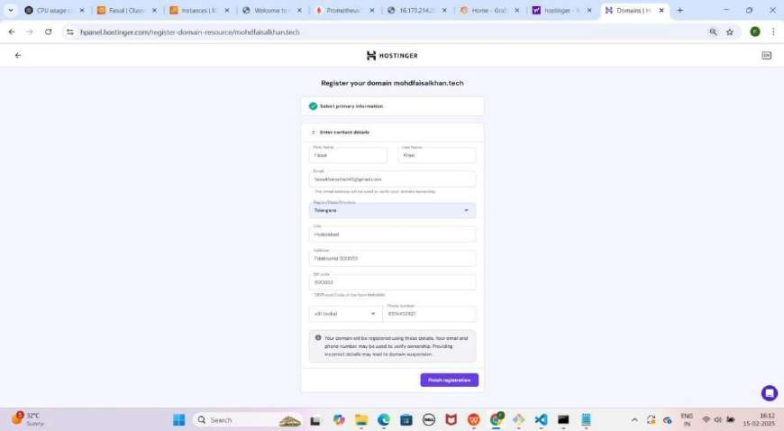

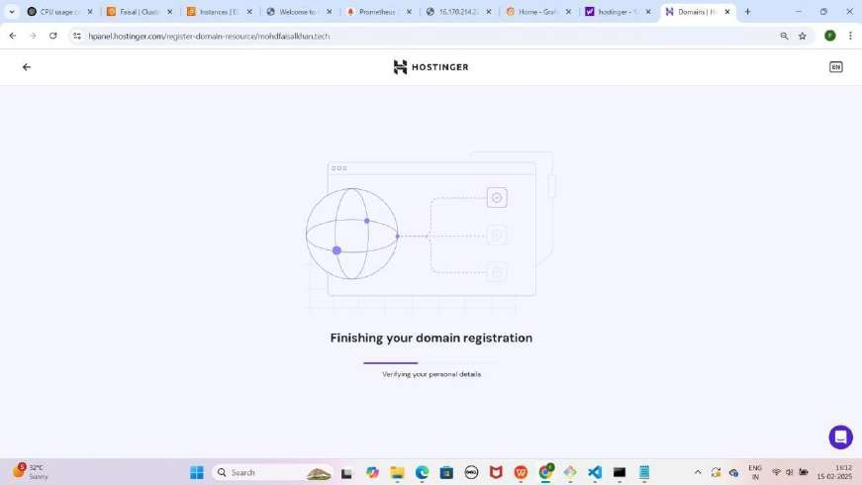

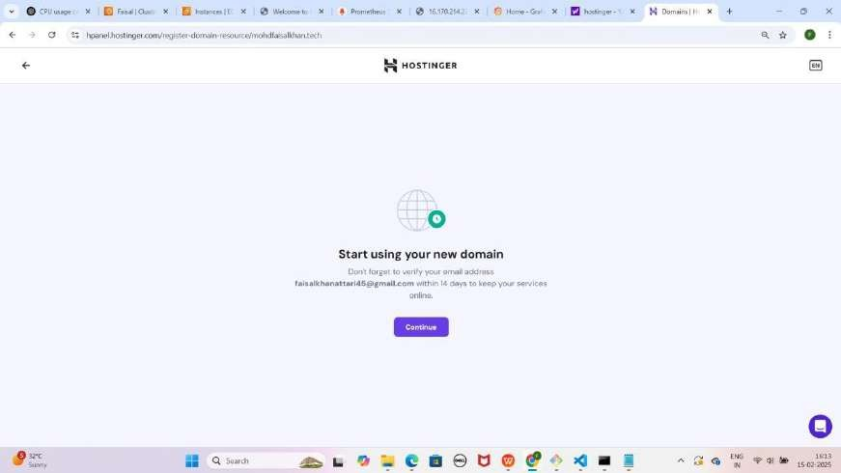

NOTE: Continue pe click karo

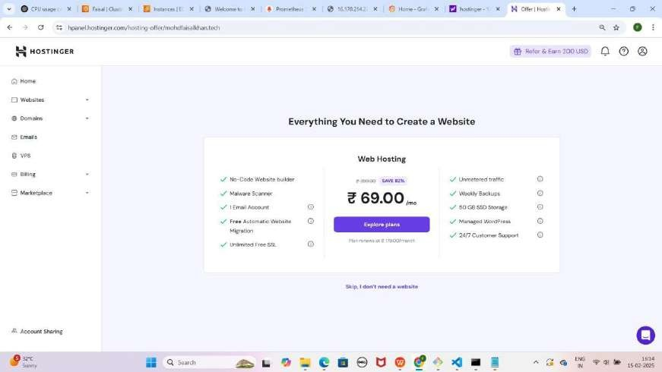YE KUCH ISTARHA LAGEGA

#### Step 6: Hostinger Me Domains Section Me Navigate Karo

* **Hostinger** mein Dashboard page dikhega
* Phir **Domains** pe click karo.
* **Domain Portfolio** mein apni domain **mohdfaisalkhan.tech** ko select karo.

YE KUCH ISTARHA LAGEGA

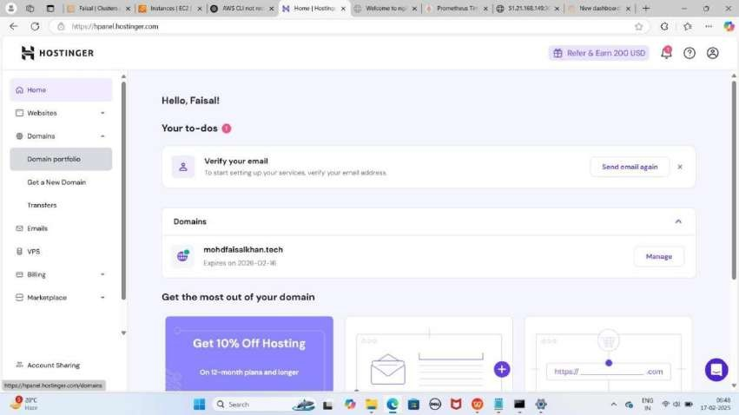

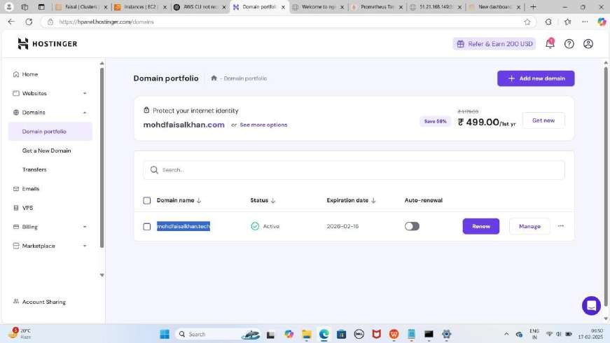

#### Step 7: Hostinger Me DNS/Nameservers Section Me Navigate Karo

* Apni **domain** ko select karne ke baad, **DNS/Nameservers** pe **click**

karo.

* Yahan ek **page** khul jayega jahan tumhe **DNS records add** karna hoga.

YE KUCH ISTARHA LAGEGA

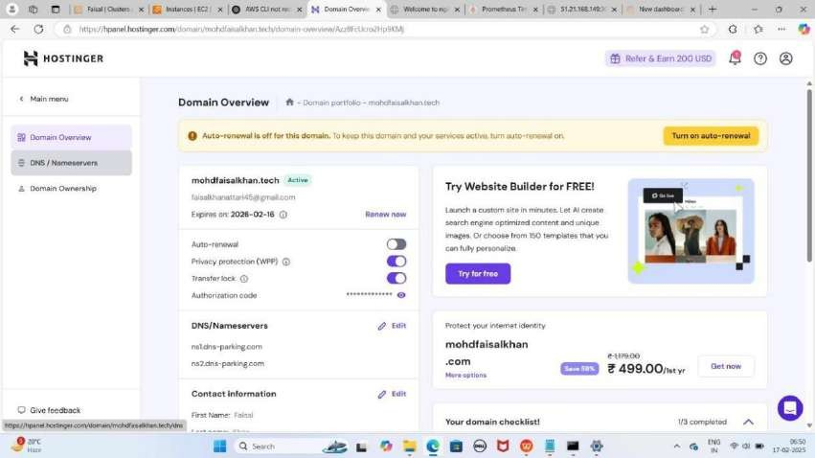

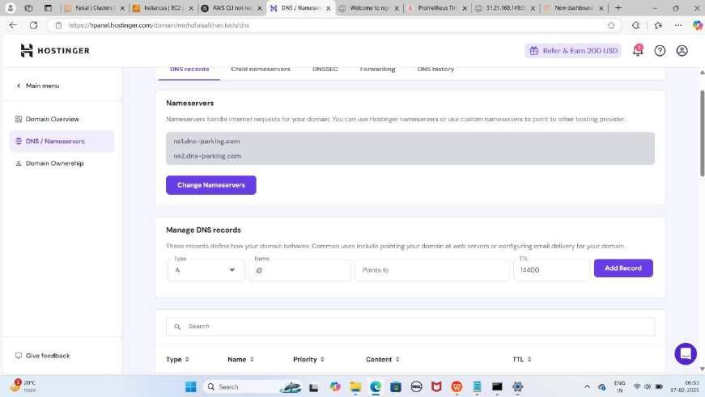

## Part 4: Configuring DNS on Hostinger for Load Balancer

#### Step 1: CNAME Record Add Karna (Load Balancer Se Connect Karne Ke Liye)

1. Pehle Load Balancer ka DNS Name Copy Karo.
2. Naya CNAME Record Add Karo:
   * **Type:** CNAME
   * **Name:** @
   * **Target:** Tumhara Load Balancer ka DNS Name
   * **TTL:** 14400
3. Add Record pe Click Karo.

NOTE : Add Record pe Click karne ke baad DNS Record created successfully karke pop-up aayega

#### Step 2: CNAME Record Add Karna (WWW ke liye)

1. Pehle Load Balancer ka DNS Name Copy Karo.
2. Naya CNAME Record Add Karo:
   * **Type:** CNAME
   * **Name:** www
   * **Target:** Tumhara Load Balancer ka DNS Name
   * **TTL:** 14400
3. Add Record pe Click Karo.

NOTE : Add Record pe Click karne ke baad DNS Record created successfully karke pop-up aayega

YE KUCH ISTRAHA LAGEGA

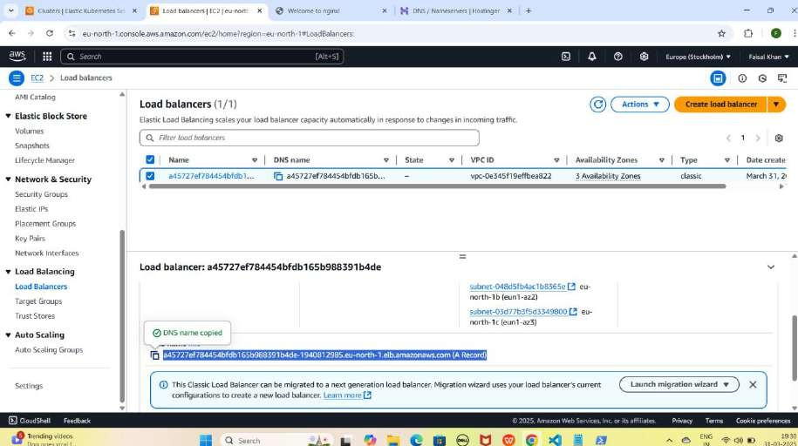

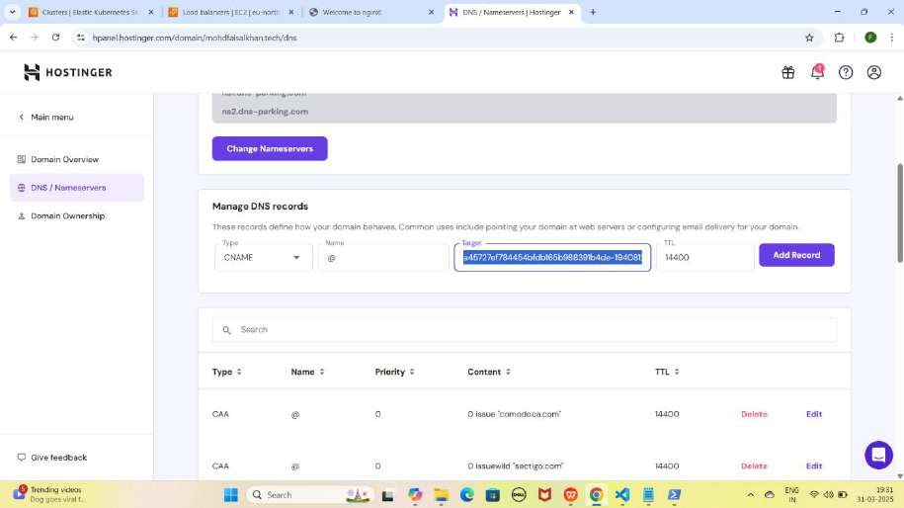

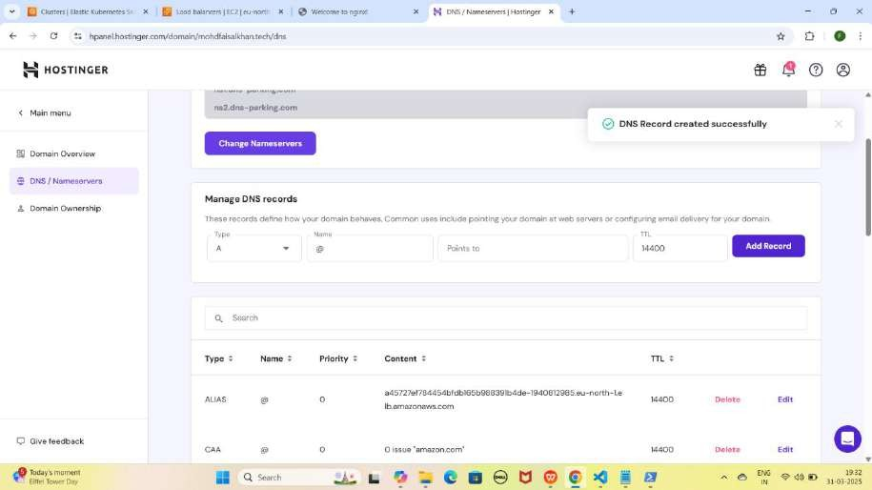

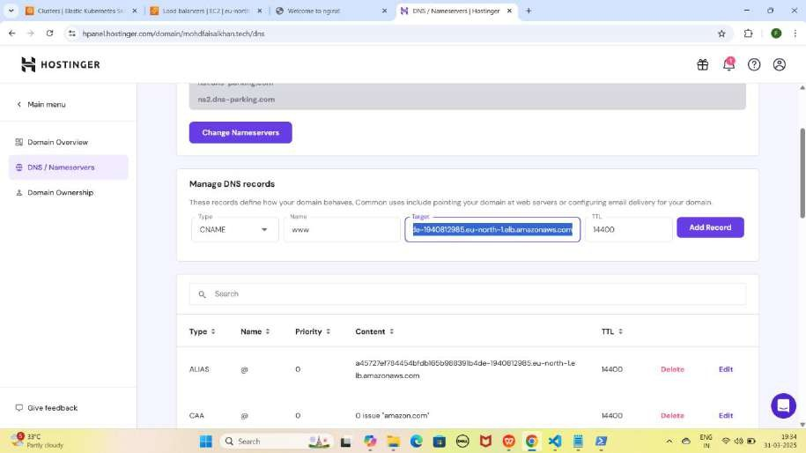

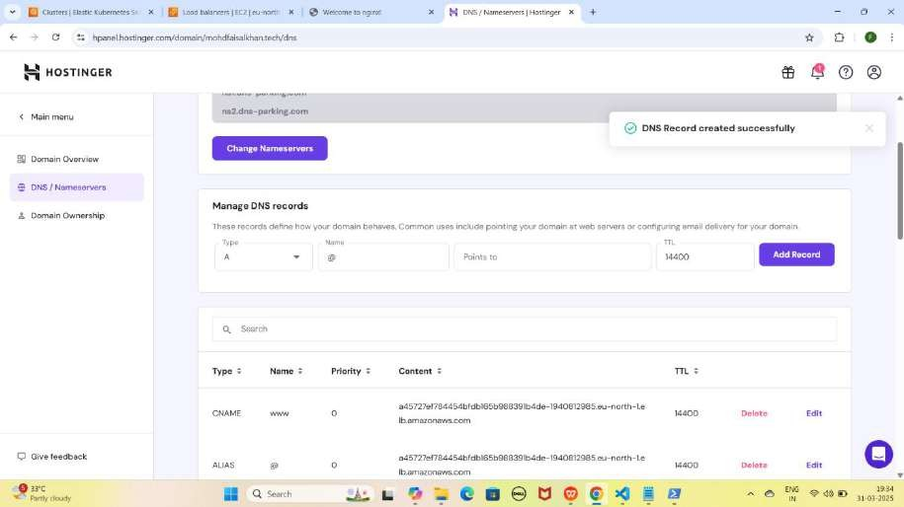

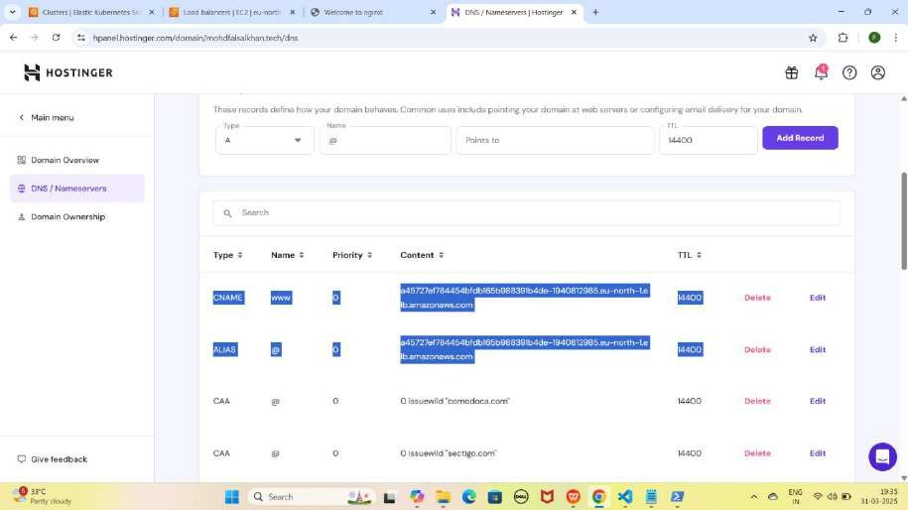

NOTE: Jab tum Load Balancer ke liye records add kar loge, toh kuch der baad apni application ko in URLs par access kar paoge. Ye process 15-20 minutes ya usse zyada bhi le sakta hai

#### Step 3: Records Add Karne Ke Baad Website Ko Domain Name Se Access Karna

1. **Apni NGINX application ko Domain Name se access karo**
   * **Nginx:** [http://mohdfaisalkhan.tech](http://mohdfaisalkhan.tech/)

YE KUCH ISTARHA LAGEGA

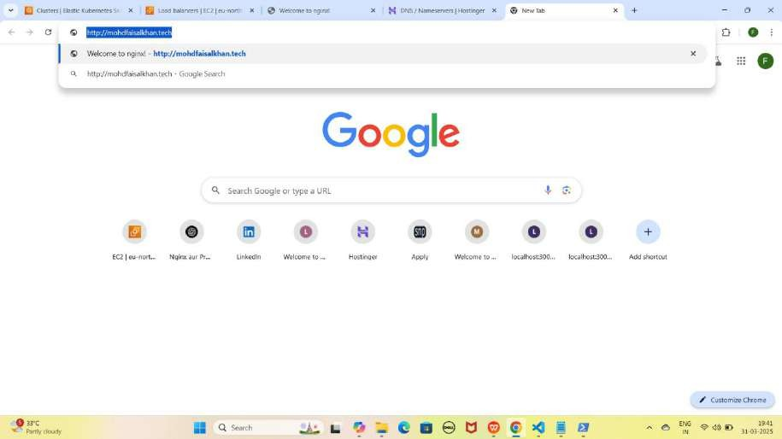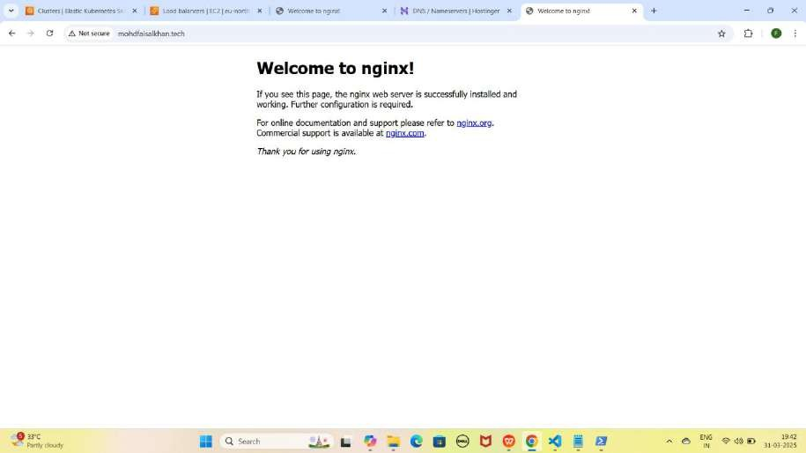

1. **Apni NGINX application ko www wale Domain Name se access karo**
   * **Nginx:** [http://www.mohdfaisalkhan.tech](http://www.mohdfaisalkhan.tech/)

YE KUCH ISTARHA LAGEGA

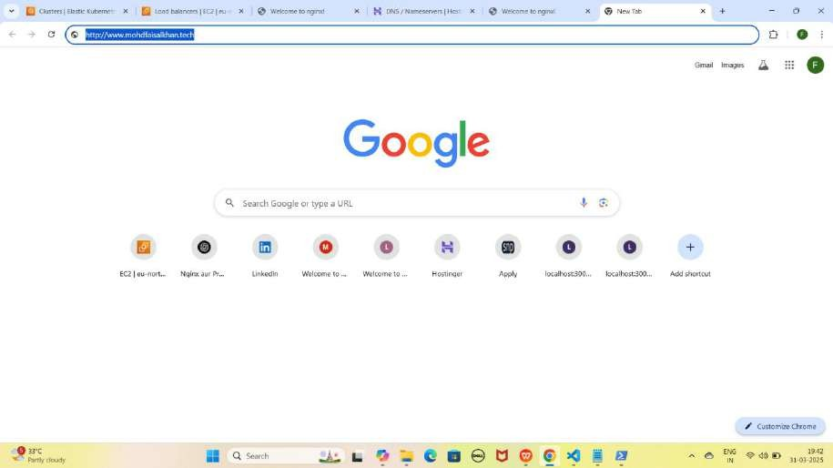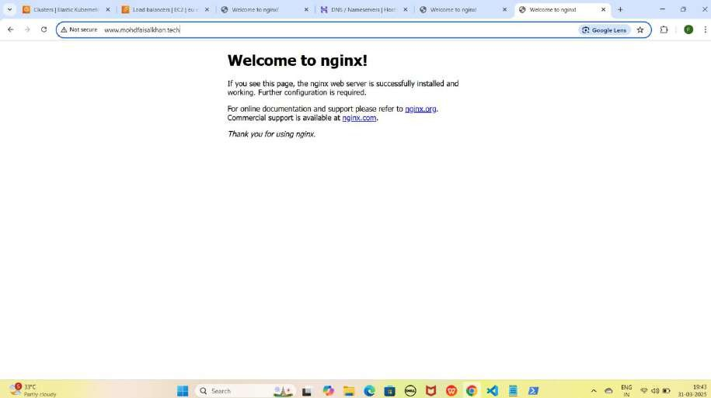

## Part 5: Enabling HTTPS on Load Balancer Using ACM

**ACM: AWS ACM** (AWS Certificate Manager) ek **AWS service** hai jo tumhari **website** ke liye **SSL/TLS certificates manage** karti hai. Yeh automatically **certificates issue**, **renew**, aur **manage** karta hai taake tumhari **website HTTPS** par **securely** chale

#### Step 1: CAA Records Add Karo (SSL Certificate ke liye)

1. **Naya Record Add Karo:**
   * **Type:** CAA
   * **Name:** @
   * **Flag:** 0
   * **Tag:** issue
   * **CA domain:** amazon.com
   * **TTL:** 14400
2. Add Record pe Click Karo.

NOTE : Add Record pe Click karne ke baad DNS Record created successfully karke pop-up aayega

1. **Phir ek aur CAA Record Add Karo:**
   * **Type:** CAA
   * **Name:** @
   * **Flag:** 0
   * **Tag:** issuewild
   * **CA domain:** amazon.com
   * **TTL:** 14400
2. Add Record pe Click Karo.

NOTE : Add Record pe Click karne ke baad DNS Record created successfully karke pop-up aayega

YE KUCH ISTARHALAGEGA

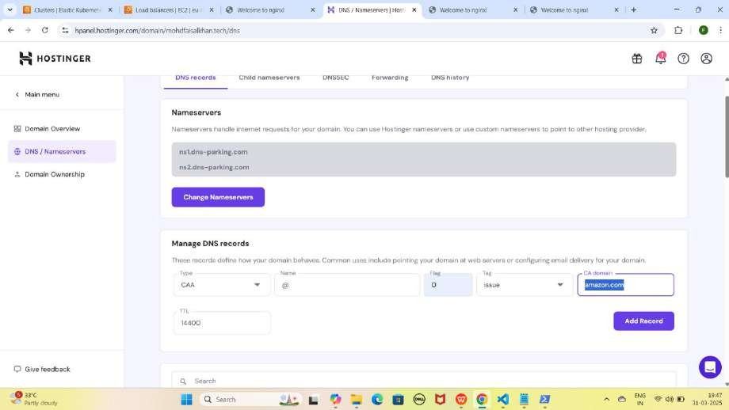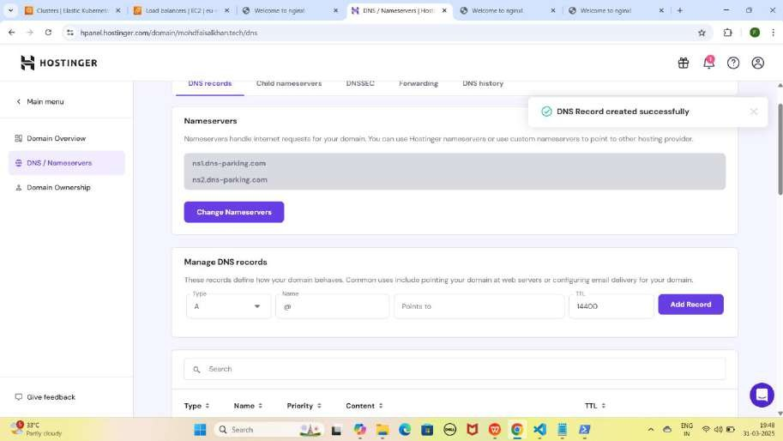

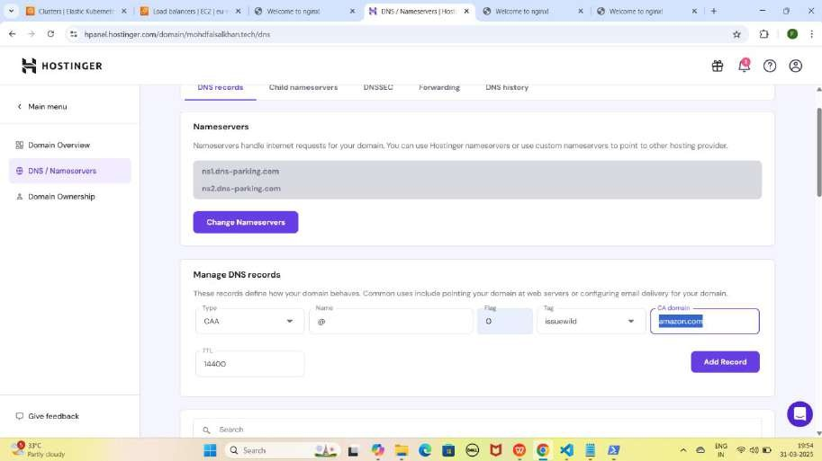

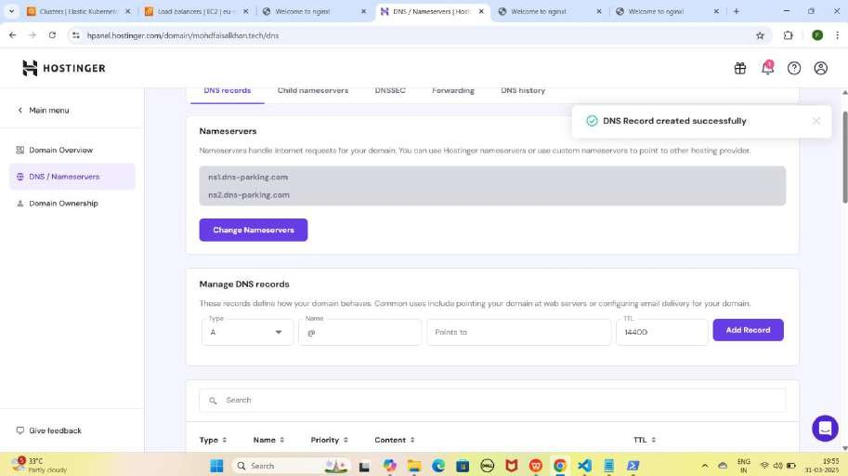

NOTE : Jab tum Amazon ke records add kar loge aur SSL certificate verify ho jayega, toh yeh records tumhari application ko HTTPS par access karne me madad karenge. Yeh process 15-20 minutes ya usse zyada bhi le sakta hai.

#### Step 2: ACM se SSL Certificate Request Karo

1. **AWS Console me jao** aur **search bar me "ACM" likho**.
2. **"Certificate Manager" pe right click karo or open link in new tab se open karo .**
3. **"Request a certificate" pe click karo.**
4. **"Request a public certificate" select karo, phir "Next" pe click karo.**
5. **Apna domain name enter karo** (e.g., [mohdfaisalkhan.tech](j)).
6. **www ke liye "Add another name" pe click karo** aur [www.mohdfaisalkhan.tech](j) add karo.
7. **"Request" pe click karo.**
8. **Thodi der wait karo, ACM ek CNAME record dega.**

YE KUCH IS TARHA LAGEGA

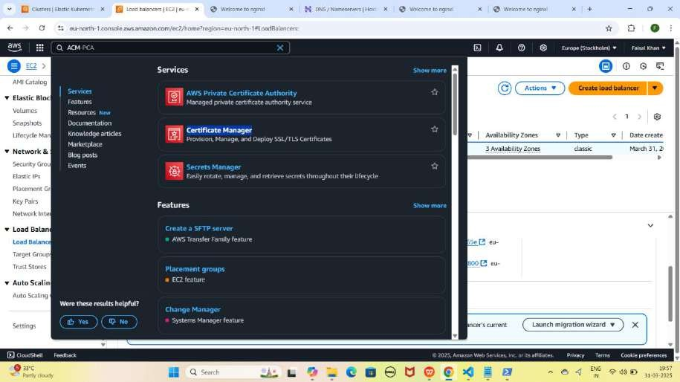

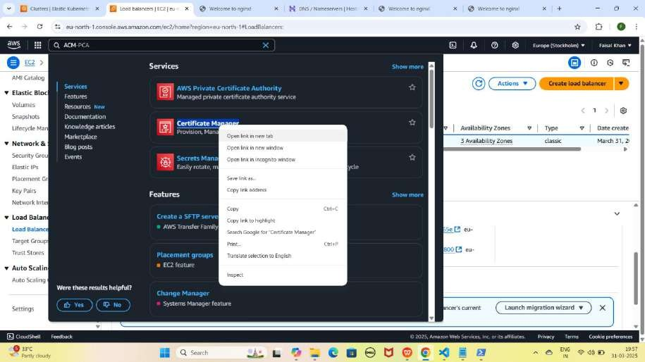

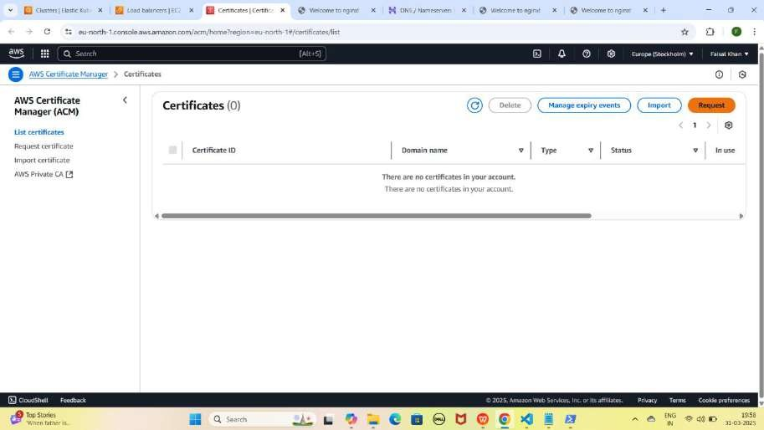

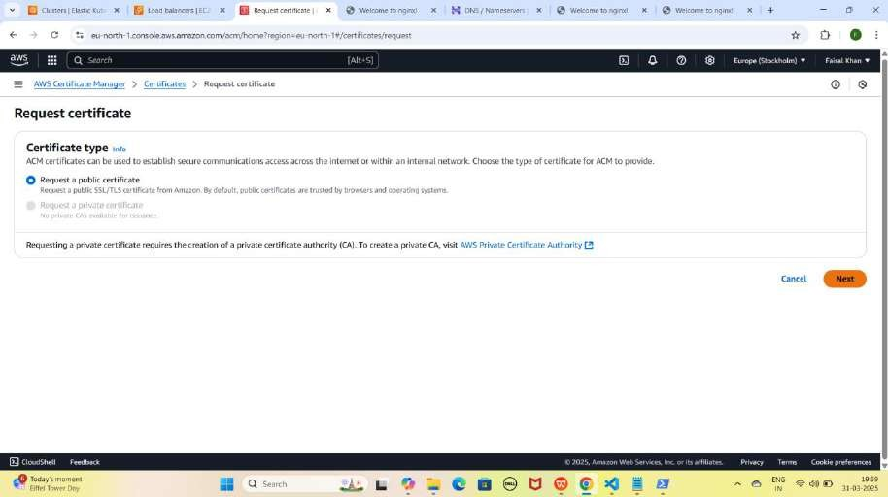

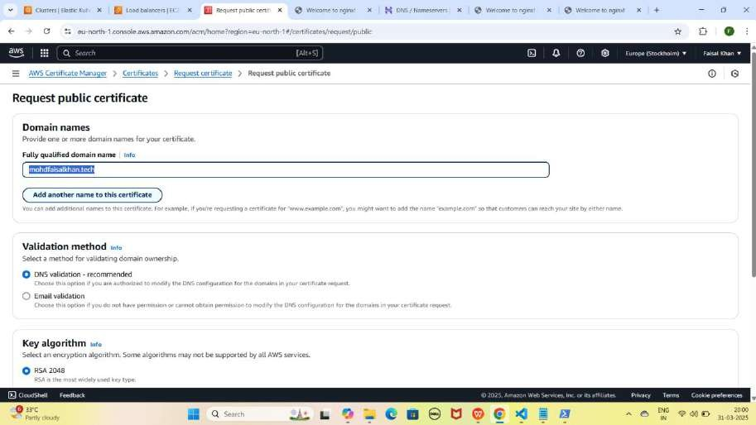

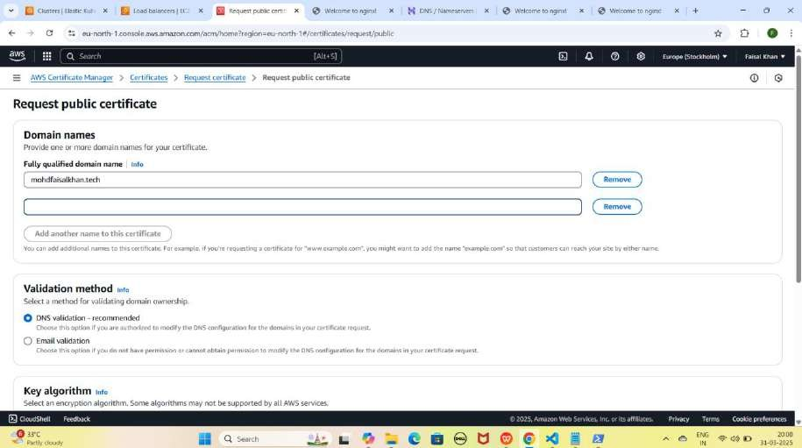

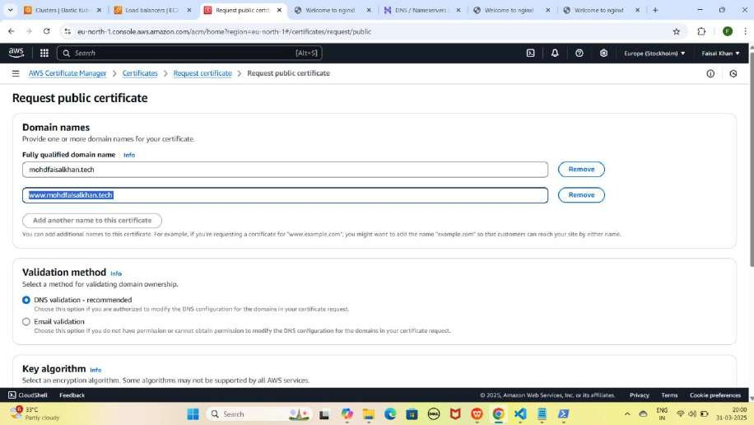

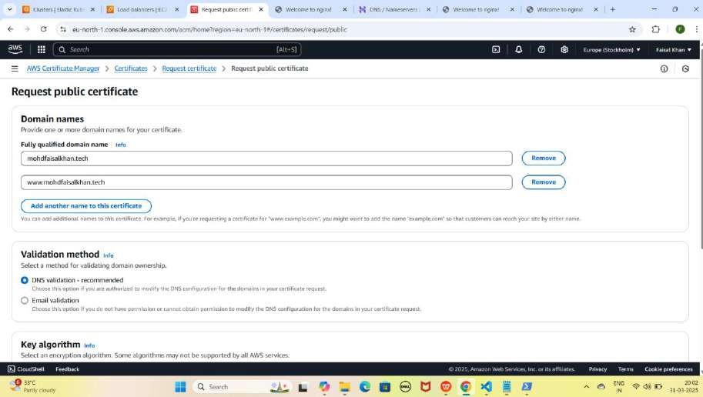

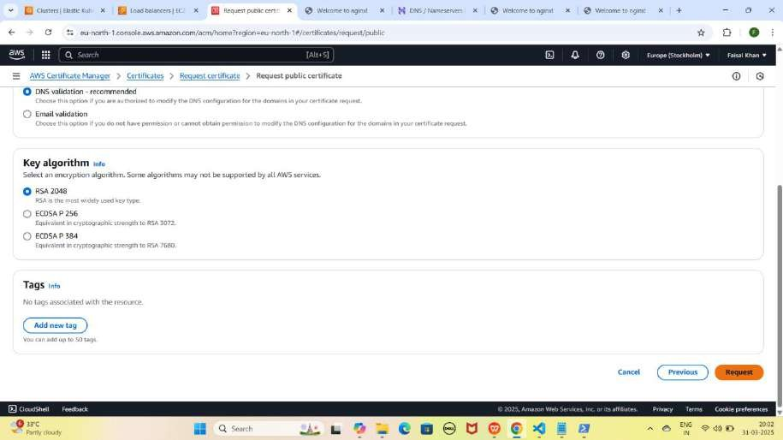

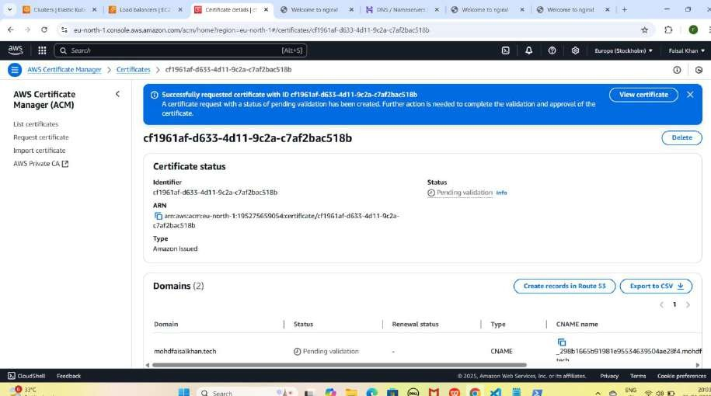

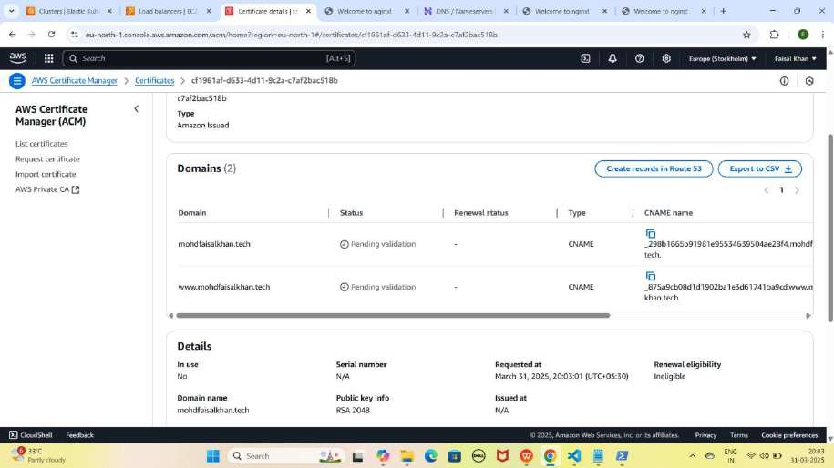

#### Step 3: ACM CNAME Records Hostinger Me Add Karo

1. **CNAME Record Add Karo (Root Domain - [mohdfaisalkhan.tech](h) ke liye)**
   * **Type:** CNAME
   * **Name:** ACM ka diya gaya full **CNAME** name generate hua Root **Domain ke liye (domain part hata ke)**
   * **Target:** ACM ka diya gaya Root Domain ka full **CNAME value**
   * **TTL:** 14400
   * **Save karo.**

NOTE : Add Record pe Click karne ke baad DNS Record created successfully karke pop-up aayega

1. **CNAME Record Add Karo (WWW Domain - [www.mohdfaisalkhan.tech](http://www.mohdfaisalkhan.tech/) ke liye)**
   * **Type:** CNAME
   * **Name:** ACM ka diya gaya full **CNAME** name generate hua **www Domain ke liye (domain part hata ke)**
   * **Target:** ACM ka diya gaya **www domain** ka full **CNAME value**
   * **TTL:** 14400
   * **Save karo.**

NOTE : Add Record pe Click karne ke baad DNS Record created successfully karke pop-up aayega

YE KUCH ISTARHA LAGEGA

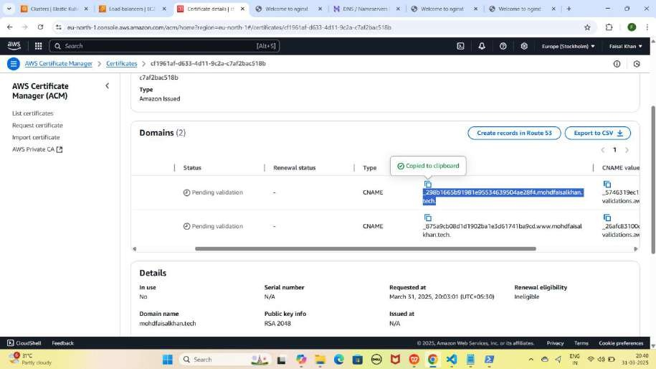

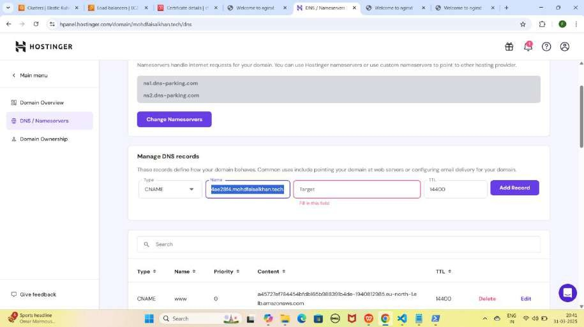

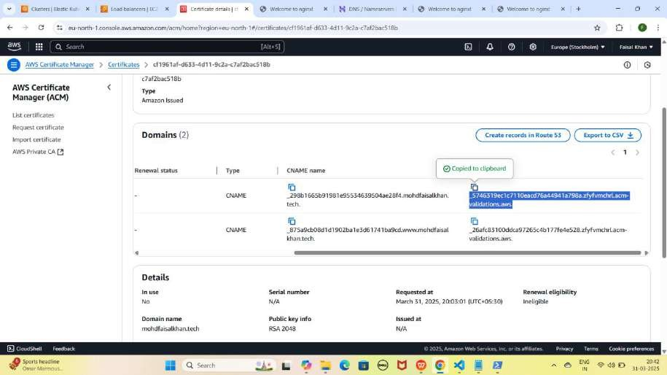

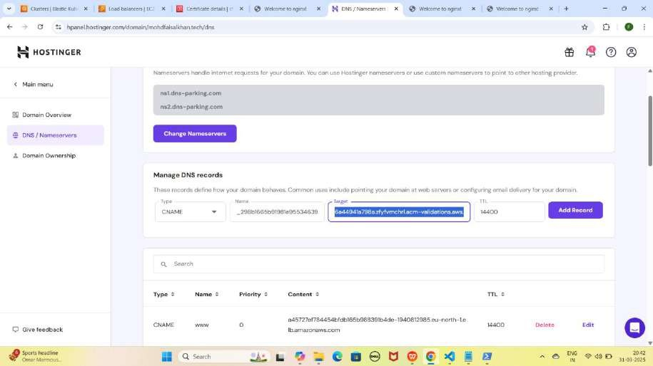

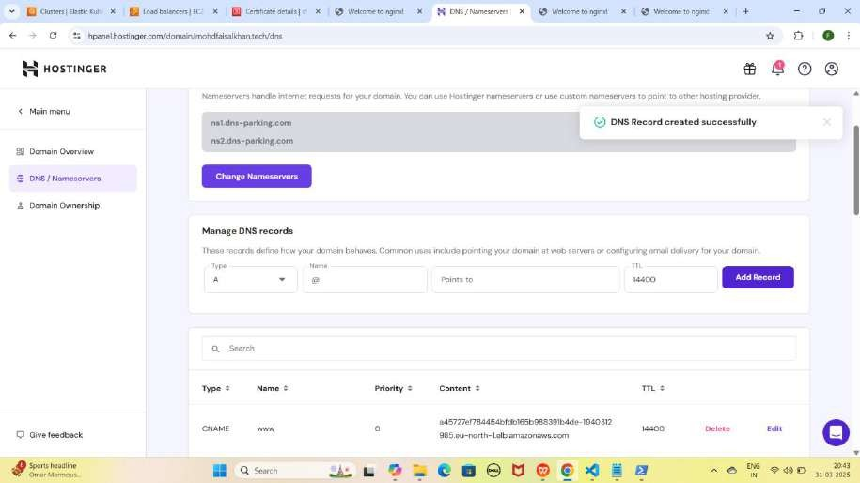

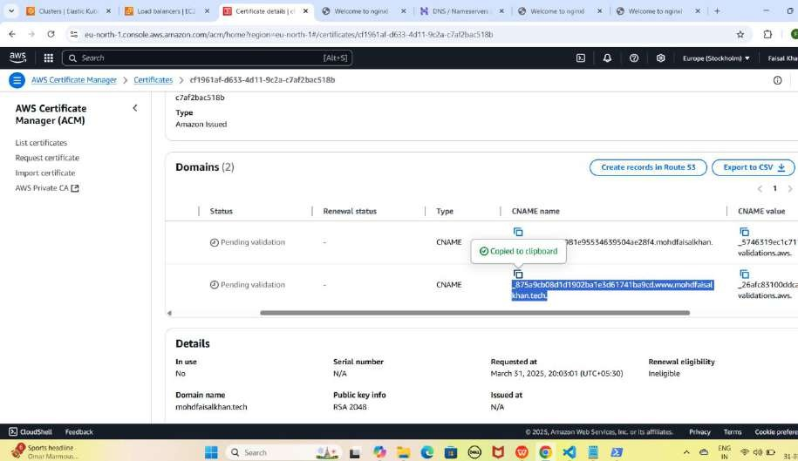

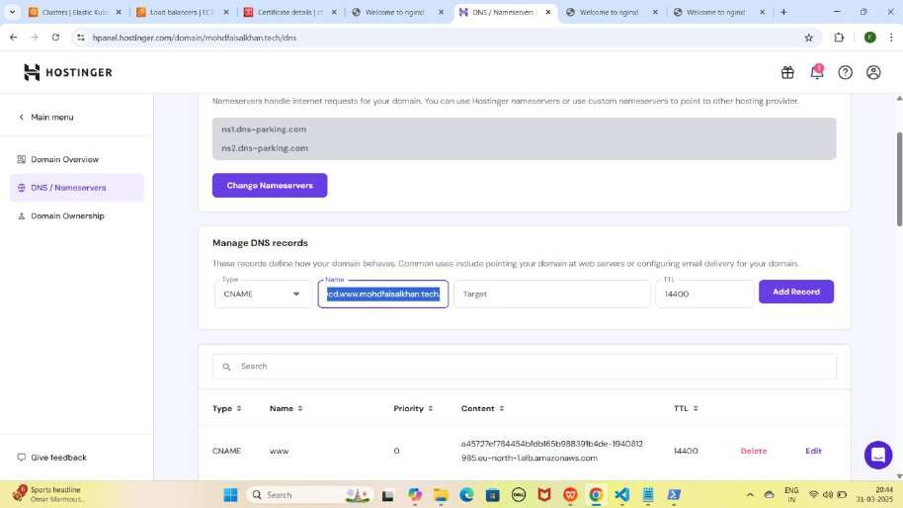

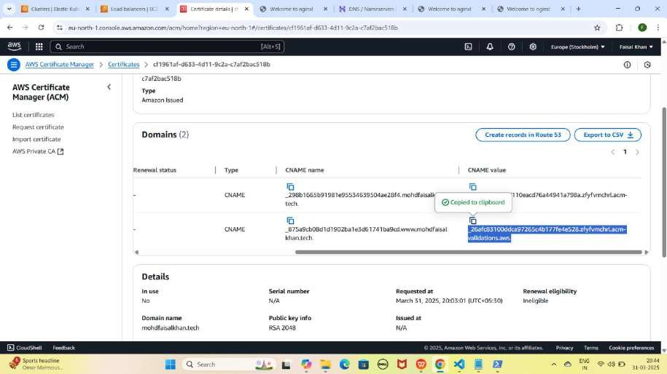

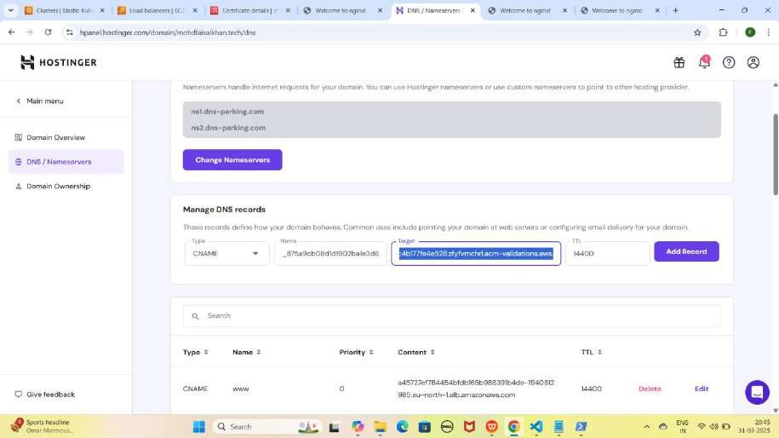

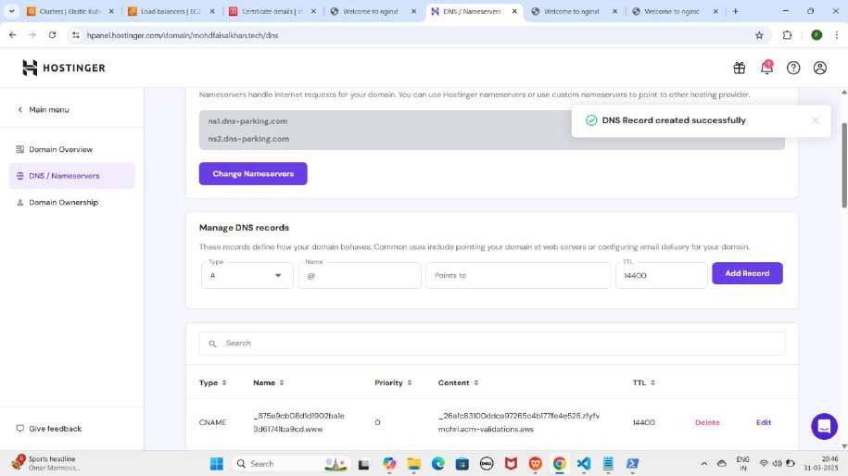

NOTE : Jab tum ACM ke records add kar loge, toh kuch der baad apni application ko HTTPS URLs par access kar paoge. Yeh process 15-20 minutes ya usse zyada bhi le sakta hai. ACM me status "Success" aane tak wait karo.

1. **Reacords Add** karne ke kuch der baad **ACM** par jaye or **Refresh** kare aapko

**Certificate Status** ka **Status Issued** and **Domains** ka Status **Success** dikhega

YE KUCH ISTARHA LAGEGA

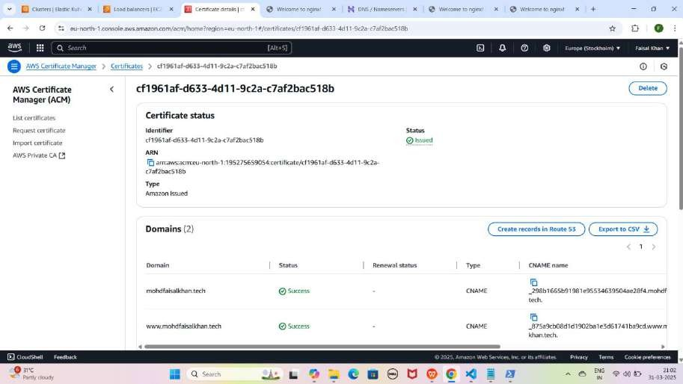

#### Step 4: ingress.yaml file ka kaam

Ye file hum apne **domain name** ke liye **routing** provide karne ke liye use kar rahe hain.

Lekin pehle humein **ACM** successfully issued hone ke baad, is **ingress.yaml**

file me **ARN** Copy karke aur **Domain Name** update karna hoga.

YE KUCH ISTARHA LAGEGA

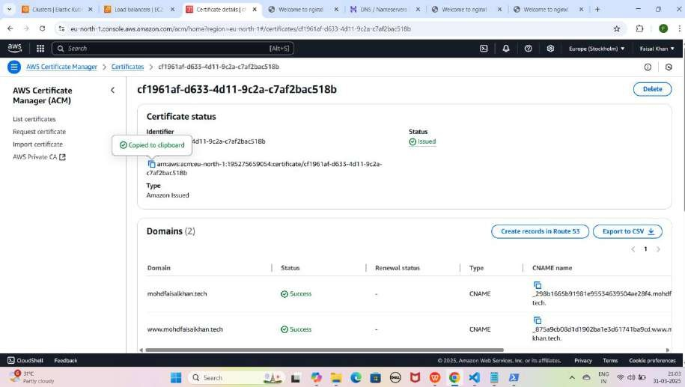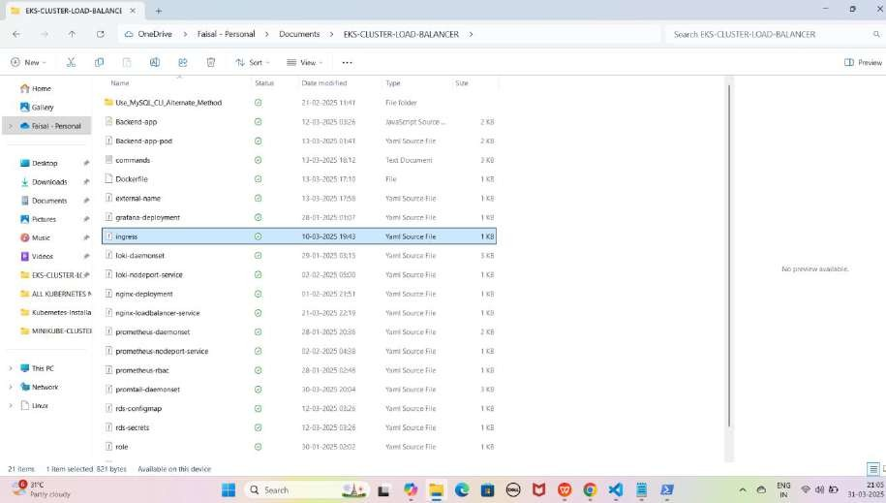

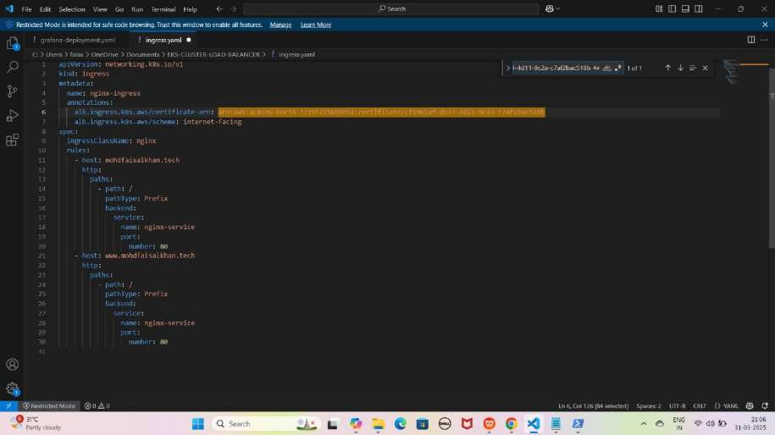

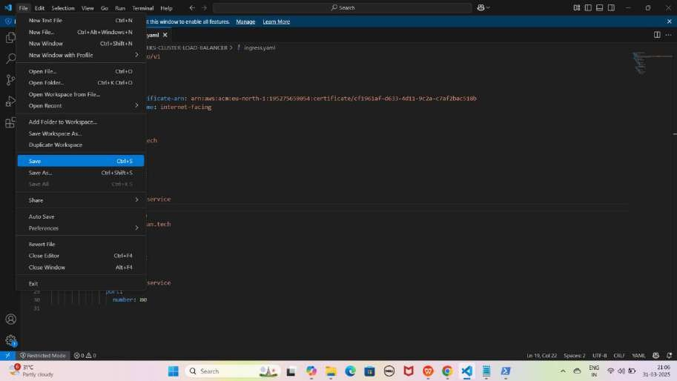

NOTE: Yaha par mera Domain Name mohdfaisalkhan.tech hai, jo humne pichle step me Hostinger se Domain Buy karte waqt dekha tha.

Aapka Domain Name alag ho sakta hai or aapko update karna hoga aapke Domain name ke According

JAISE KI:-

apiVersion: networking.k8s.io/v1 kind: Ingress

metadata:

name: nginx-ingress annotations:

alb.ingress.k8s.aws/certificate-arn: arn:aws:acm:eu-north-1:195275659054:certificate/cf1961af- d633-4d11-9c2a-c7af2bac518b

alb.ingress.k8s.aws/scheme: internet-facing spec:

ingressClassName: nginx rules:

* host: mohdfaisalkhan.tech http:

paths:

* + path: / pathType: Prefix backend:

service:

name: nginx-service port:

number: 80

* host: [www.mohdfaisalkhan.tech](http://www.mohdfaisalkhan.tech/) http:

paths:

* + path: / pathType: Prefix backend:

service:

name: nginx-service port:

number: 80

#### Ingress Service Apply Karo:

kubectl apply -f ingress.yaml

YE KUCH ISTARHA LAGEGA

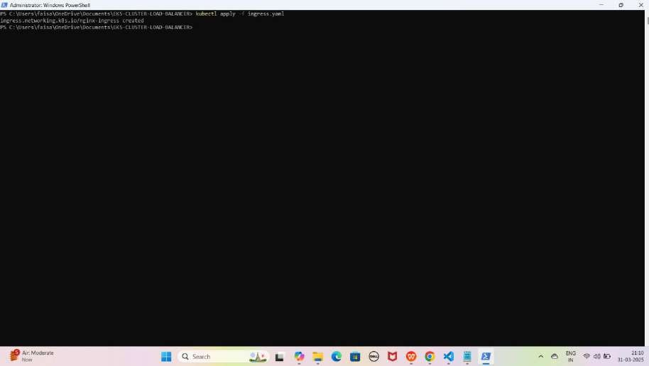

## Part 6: Load Balancer Settings and Updates

#### Step 1: Load Balancer ki Security Settings Update Karo

1. **Load Balancer Page par jao**
2. **Load Balancer section me jao. Or Load Balancer select karo**
3. **"Security" tab me jao aur apne security group ko open karo. Or Edit inbound rules pe click karo**
4. **Sab existing rules remove karo.**
5. **Naya rule add karo:**
   * **Type:** All Traffic
   * **Source:** Anywhere IPv4
   * **Save karo.**

YE KUCH ISTARHA LAGEGA

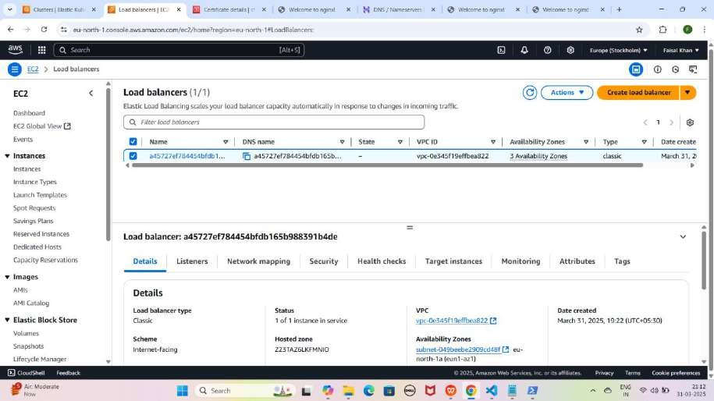

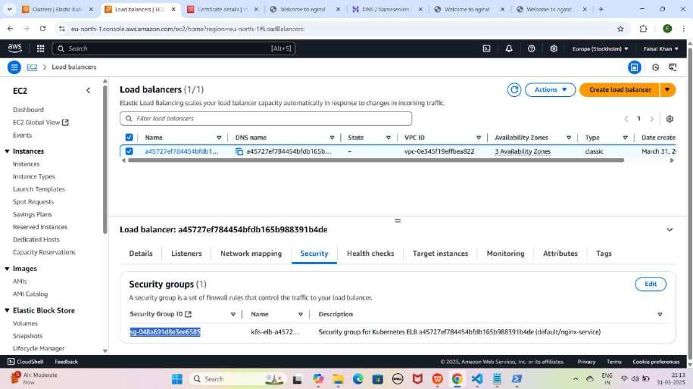

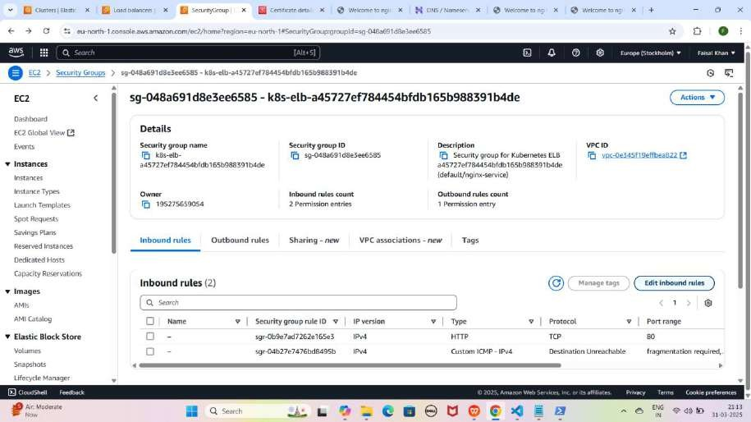

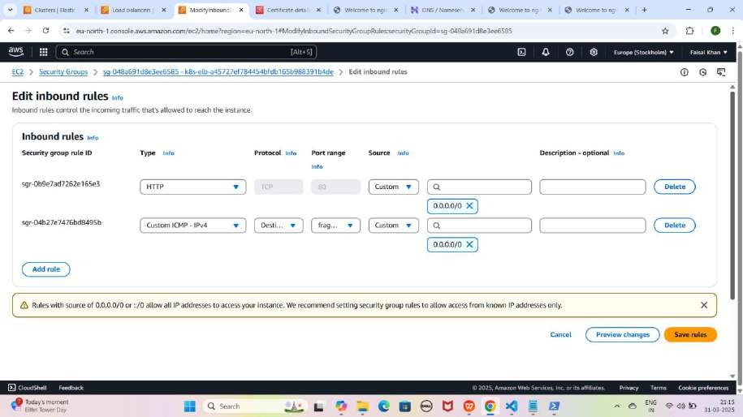

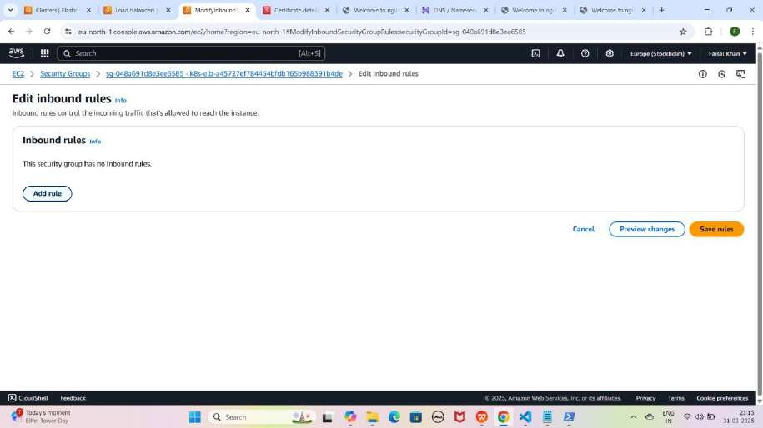

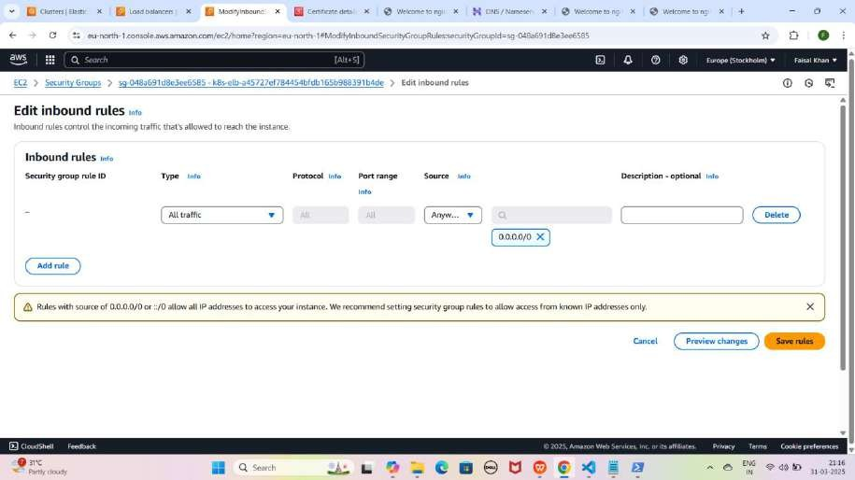

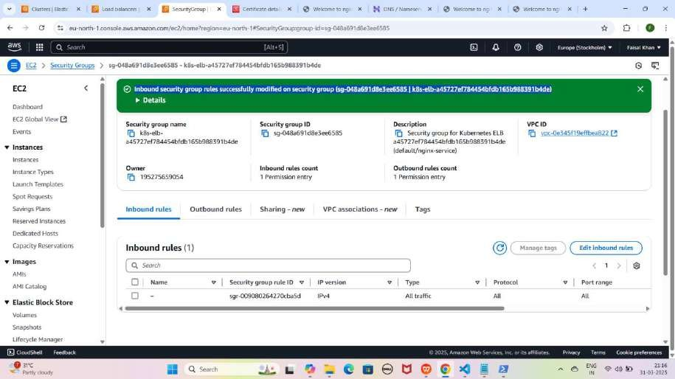

#### Step 2: Load Balancer me Listeners Update Karo

1. **PowerShell me command run karo:**

kubectl get svc

1. **Ye command tumhe Load Balancer ka port number dikhayega. Jase ki mere case me 80:31728/TCP**

YE KUCH ISTARHA LAGEGA

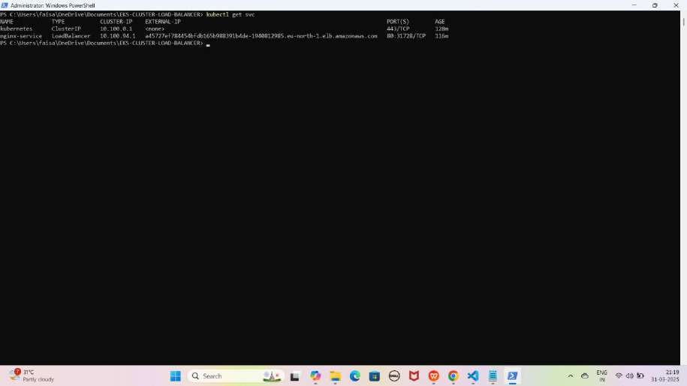

1. **Load Balancer page pe jao aur "Listeners" tab open karo.**
2. **"Manage Listeners" pe click karo.**
3. **Existing listener Remove karo and new Listeners Add karo Add Listener pe click karke**

JAISE KI:-

* + **HTTP (Port 80) → HTTP (Instance Port 31728) Naya listener add karo:**
  + **HTTPS (Port 443) → HTTP (Instance Port 31728)**
  + **ACM ka SSL Certificate select karo.**
  + **Save karo.**

YE KUCH ISTARHA LAGEGA

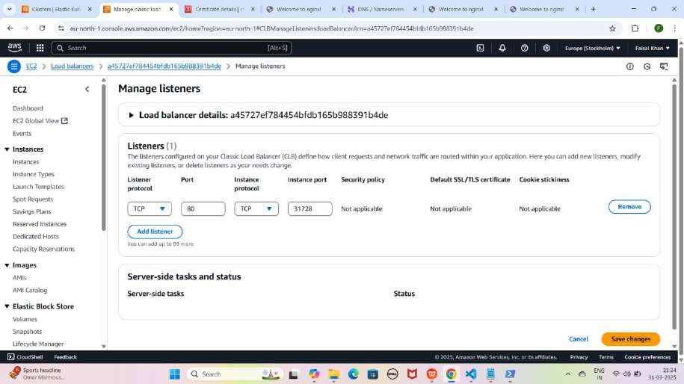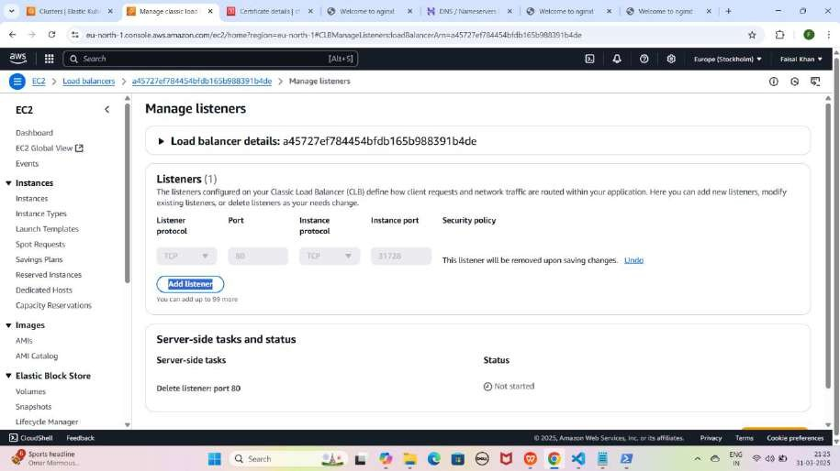

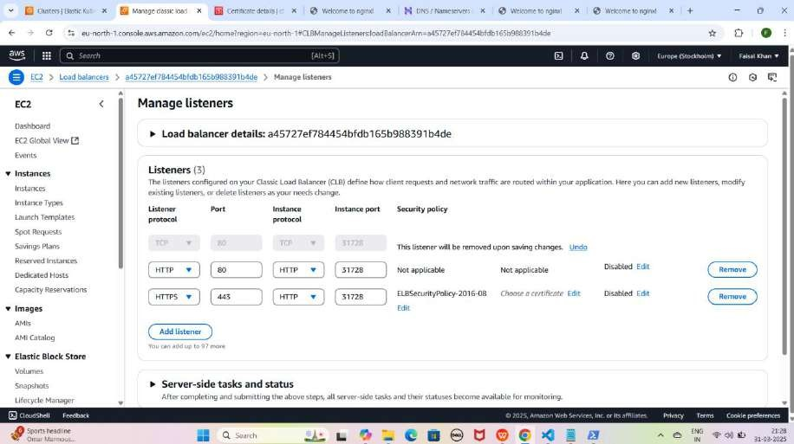

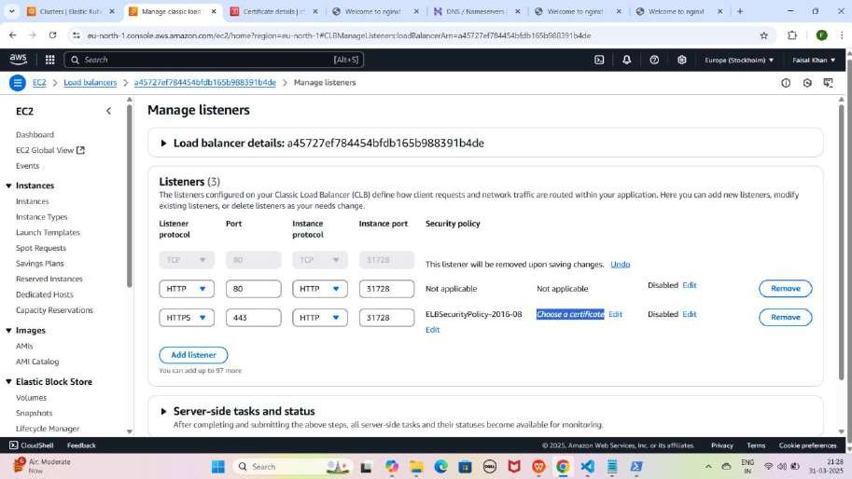

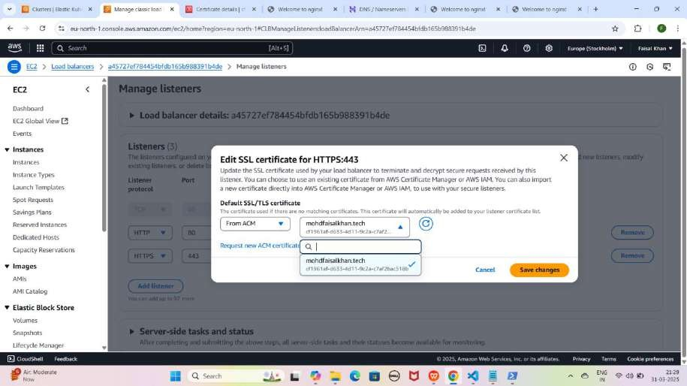

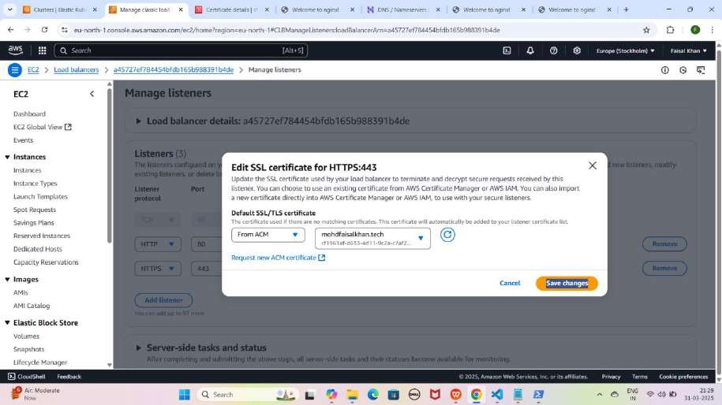

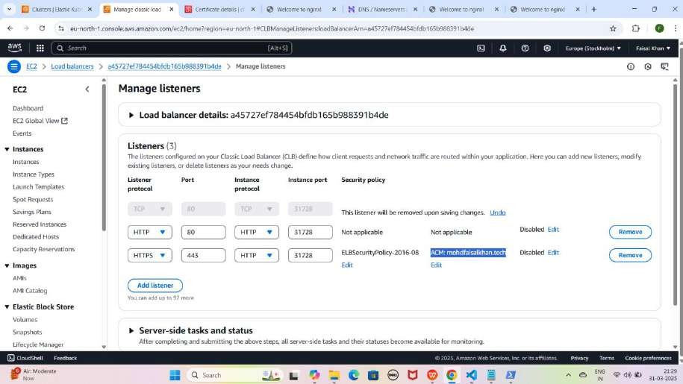

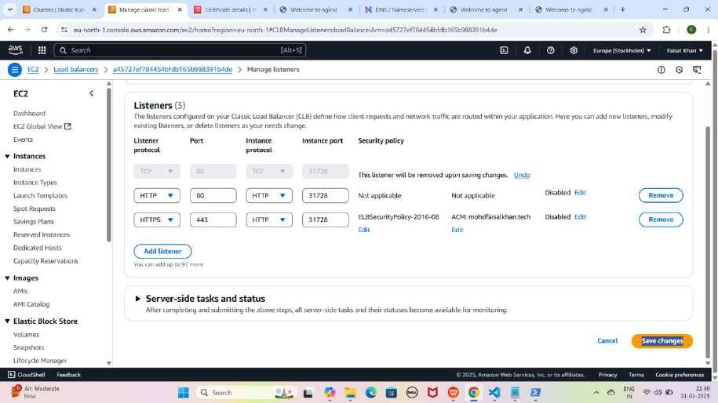

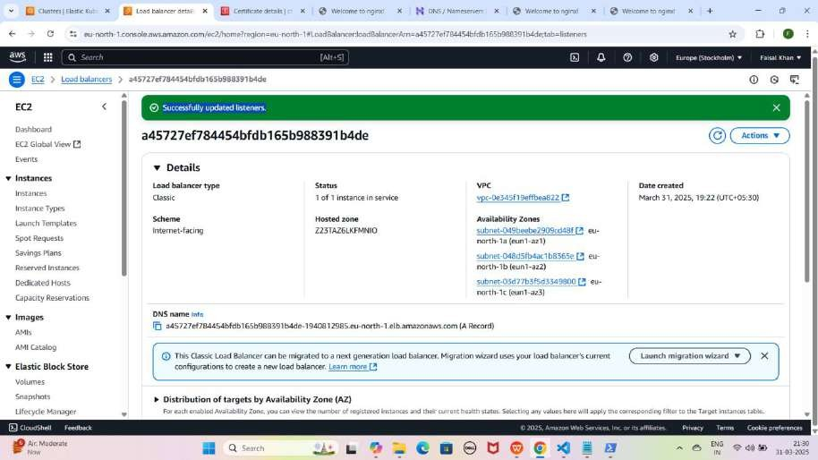

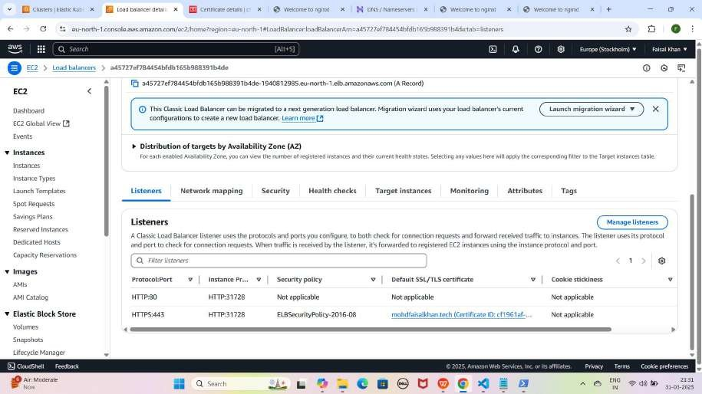

#### Step 3: Listeners Update Karne Ke Baad Website HTTPS Domain Se Access Karna

1. **Apni NGINX application ko Domain name se access karo:**
   * **Nginx:** [https://mohdfaisalkhan.tech](http://mohdfaisalkhan.tech/)

YE KUCH ISTARHA LAGEGA

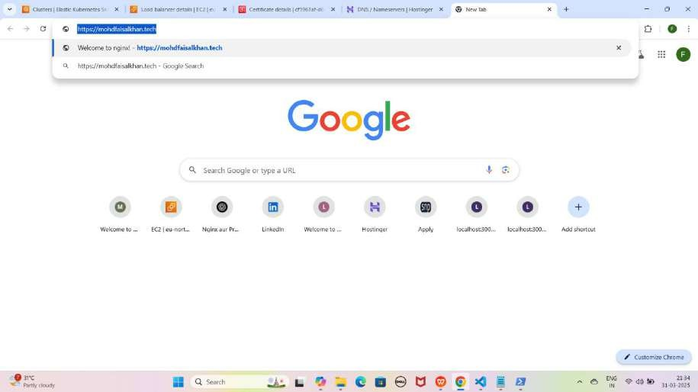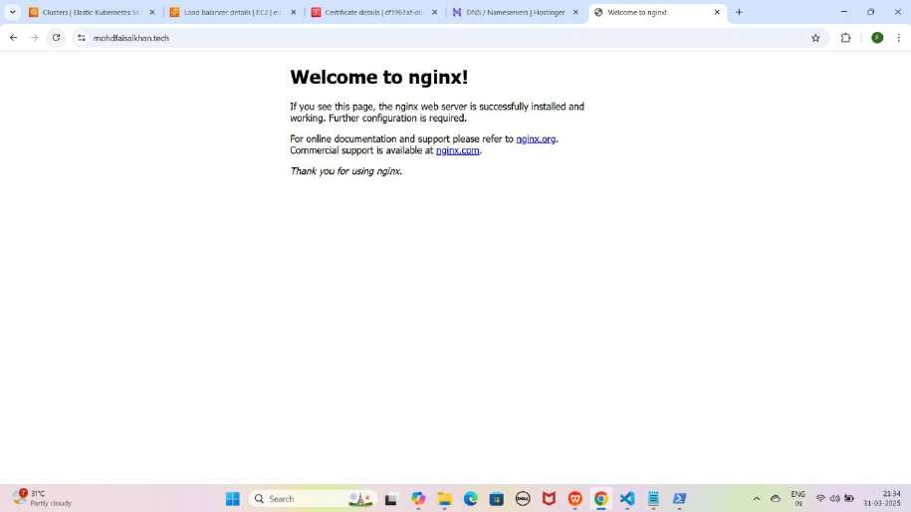

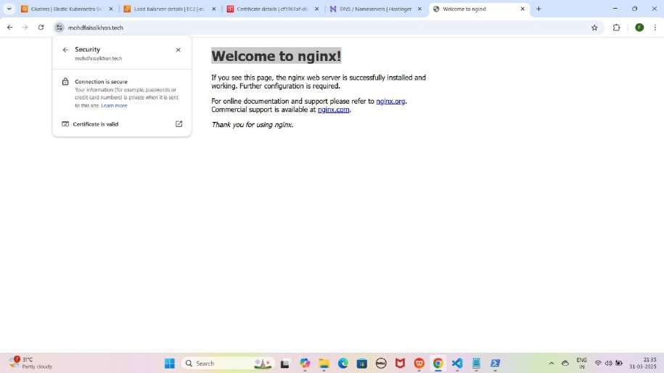

1. **Apni NGINX application ko www wale Domain se access karo:**
   * **Nginx:** [https://www.mohdfaisalkhan.tech](http://www.mohdfaisalkhan.tech/)

YE KUCH ISTARHA LAGEGA

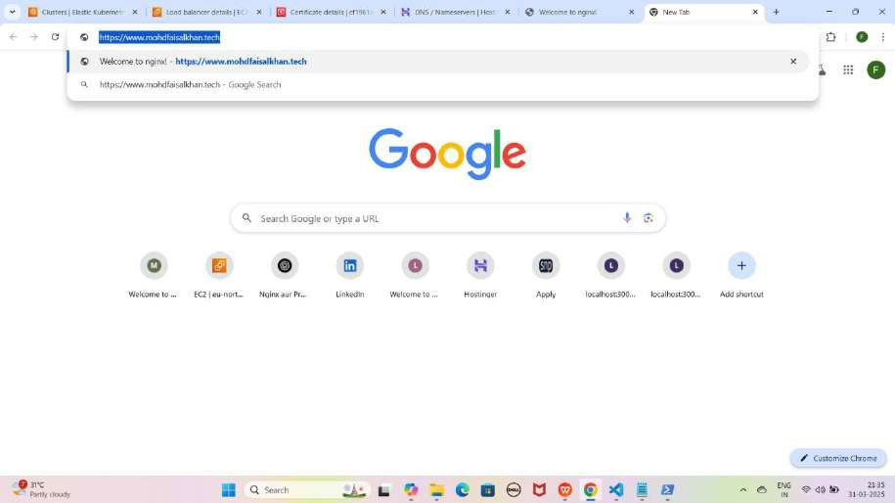

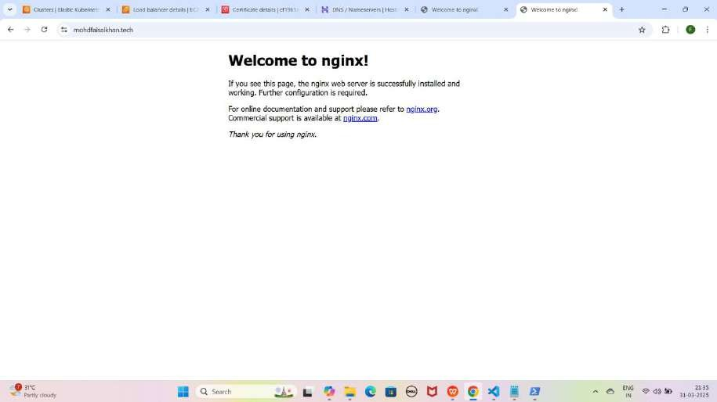

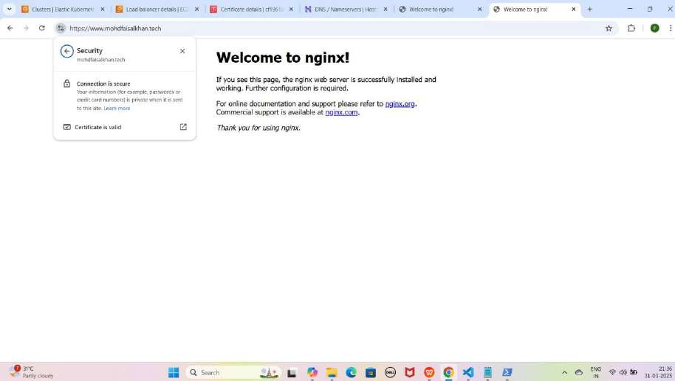

## Part 7: Amazon RDS (MySQL, Oracle, PostgreSQL) Setup and Creation

**MySQL, Oracle, aur PostgreSQL** databases AWS RDS per create karne ke liye yeh simple steps follow karein:

#### Step 1: Subnet Group Create Karna

* + AWS Console open karein, **RDS** search karein aur naye tab mein open karein.
  + **Subnet Groups** → **Create DB Subnet Group**
  + **Name:** faisal-subnet
  + **Description:** Faisal Databases (required hai warna error aayega)
  + **Default VPC** select karein.
  + **Availability Zones:** eu-north-1a, eu-north-1b, eu-north-1c
  + **Subnets :** eu-north-1a, eu-north-1b
  + **Create** par click karein.
  + Pop-up aayega: **"Successfully created faisal-subnet"**

YE KUCH ISTARHA LAGEGA

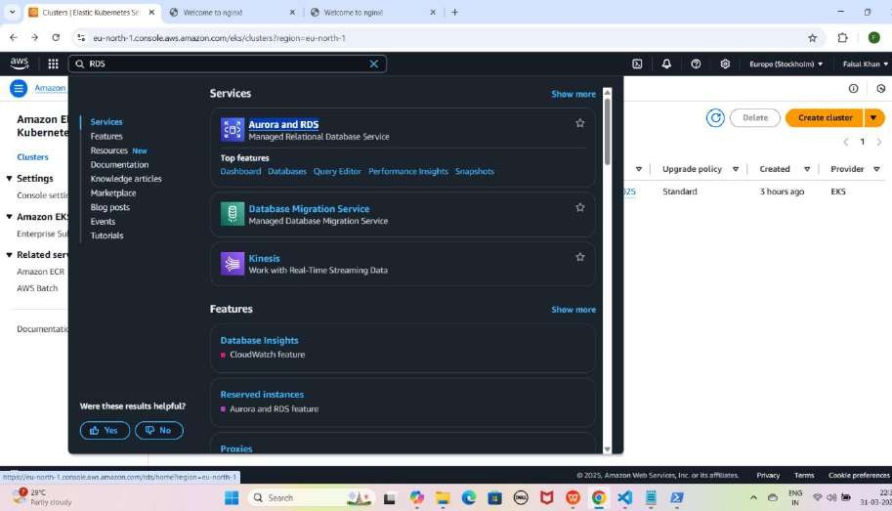

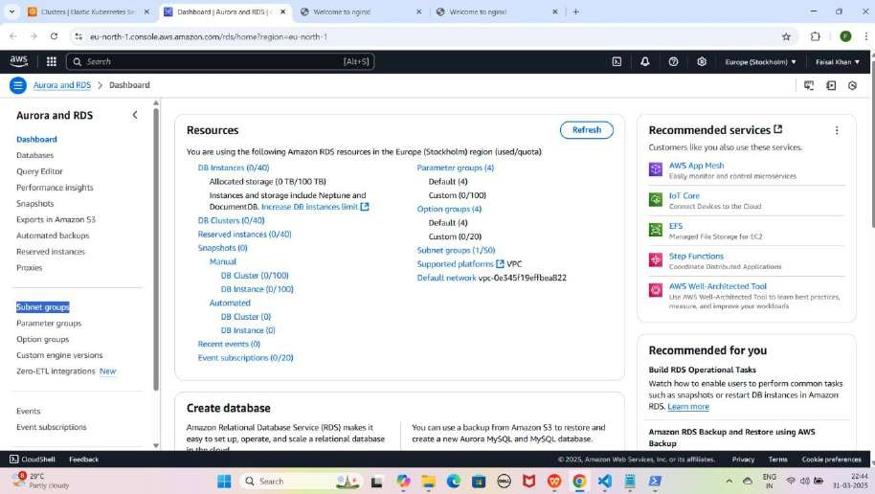

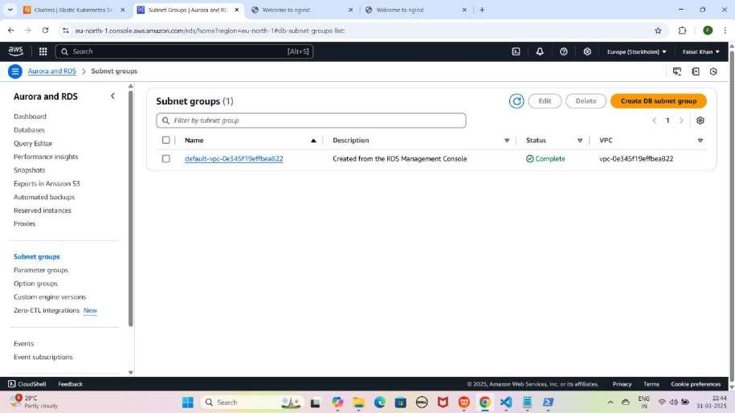

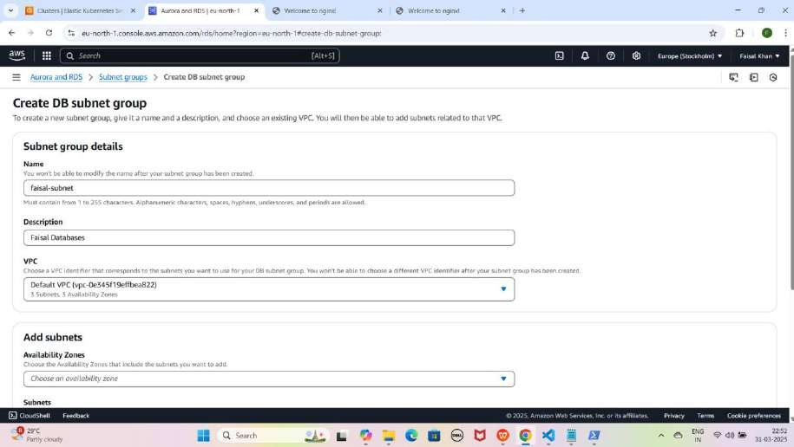

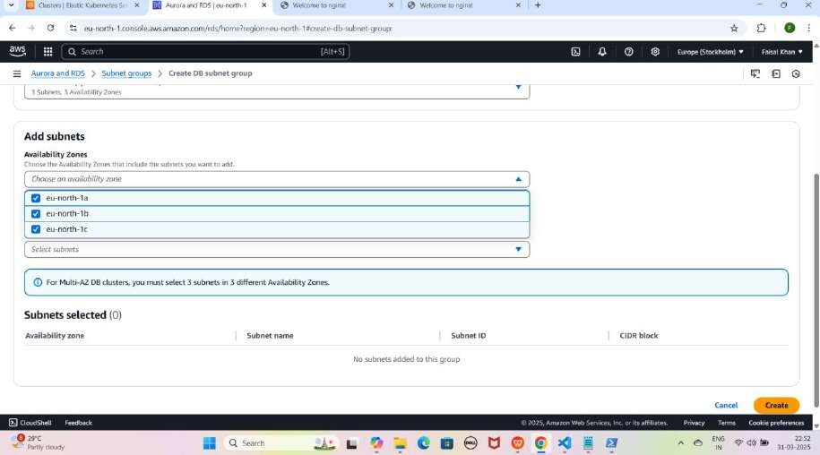

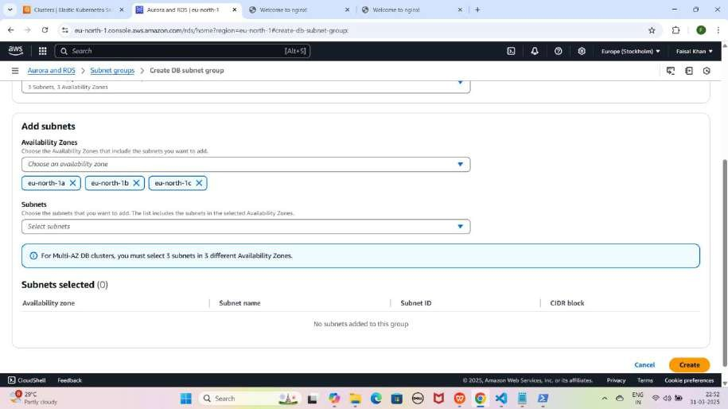

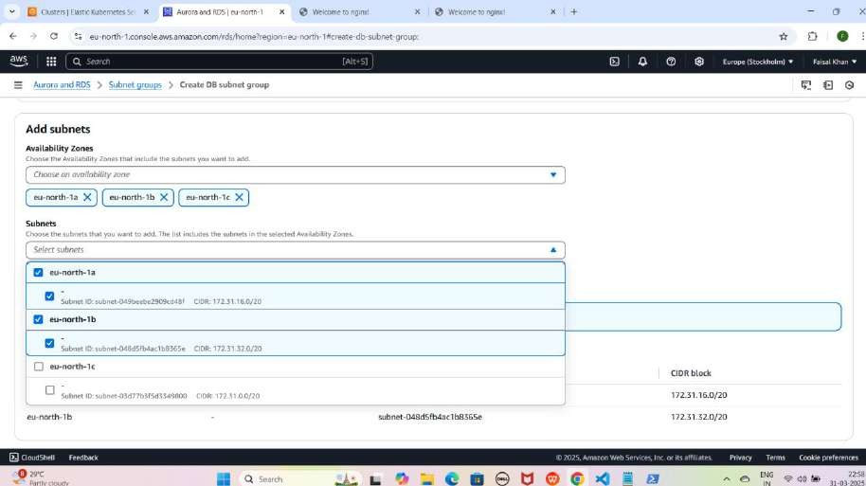

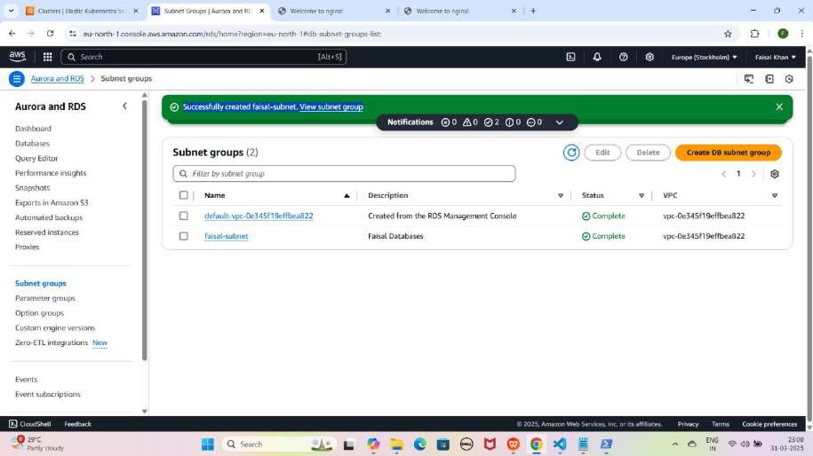

#### Step 2: MySQL Database Create Karna

* **Databases** → **Create Database**
* **Creation Method:** Standard Create
* **Engine Type:** MySQL
* **Template:** Free Tier
* **DB Name:** faisal-mysql-db
* **Username:** FaisalKhan
* **Password:** Faisalkhan35$
* **Storage Type:** General Purpose SSD (gp3)
* **Allocated Storage:** 20 GiB
* **Subnet Group:** faisal-subnet
* **Public Access:** No
* **VPC Security Group:** ALL-TRAFFIC-ALLOW (Default hata dein)
* **Availability Zone:** eu-north-1a
* **AWS KMS Key:** Faisal-Keys
* **Create Database** par click karein.
* Pop-up aayega: **"Creating database faisal-MYSQL-db"**

YE KUCH ISTARHA LAGEGA

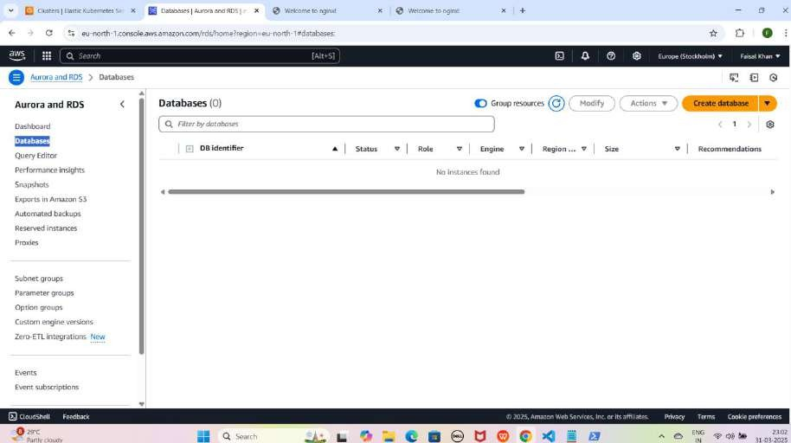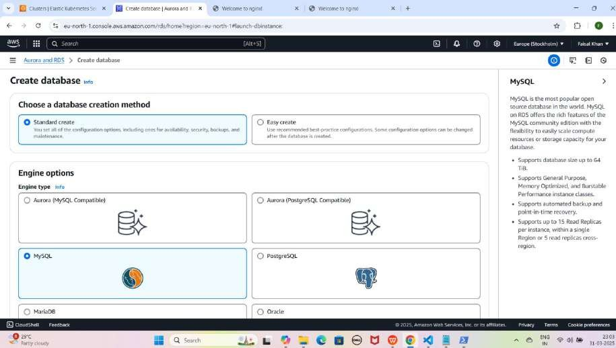

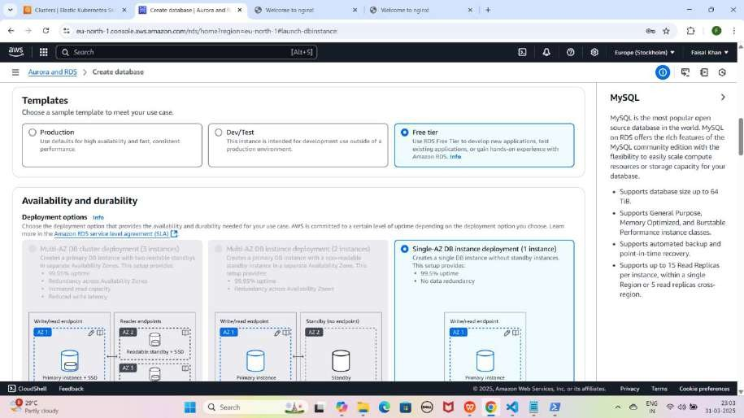

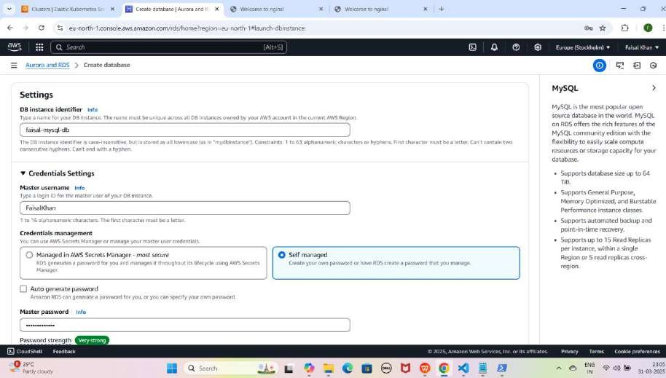

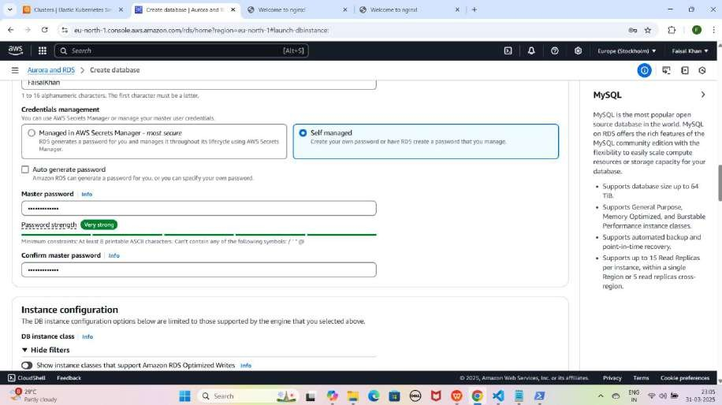

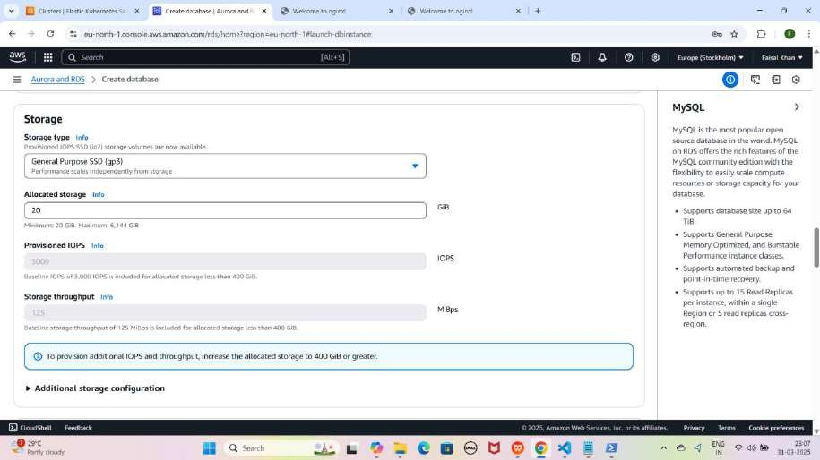

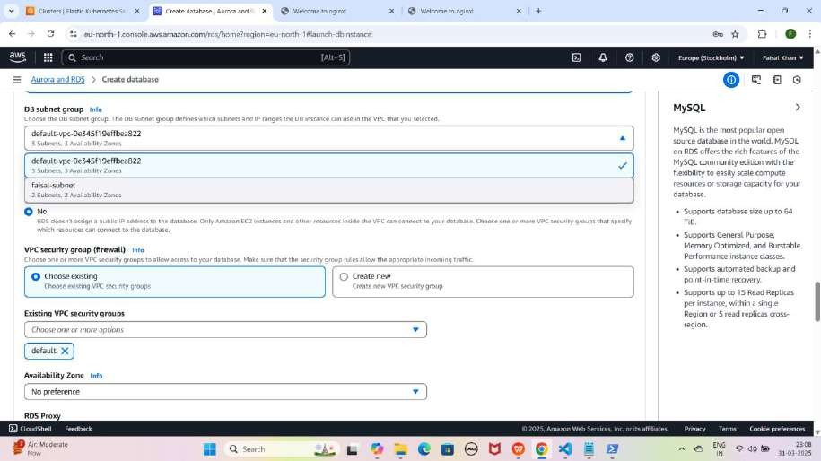

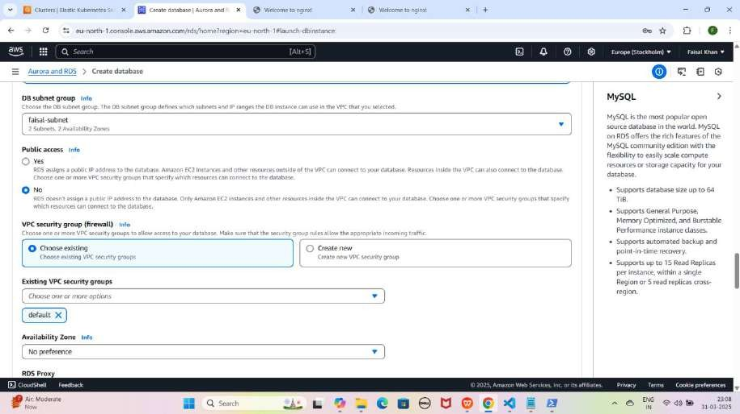

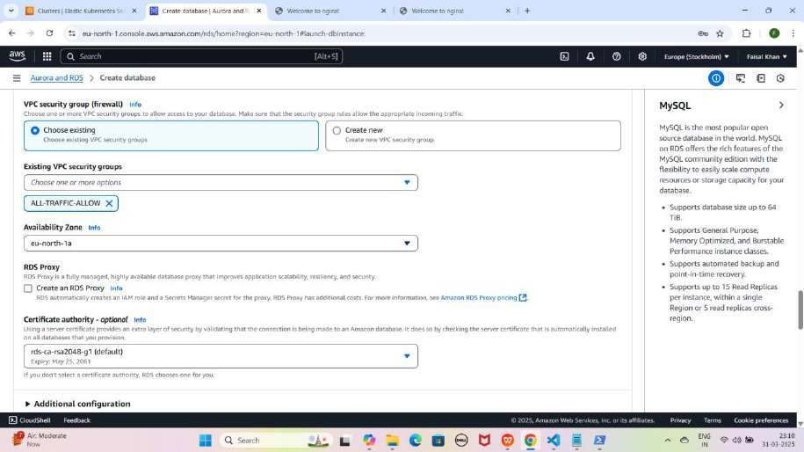

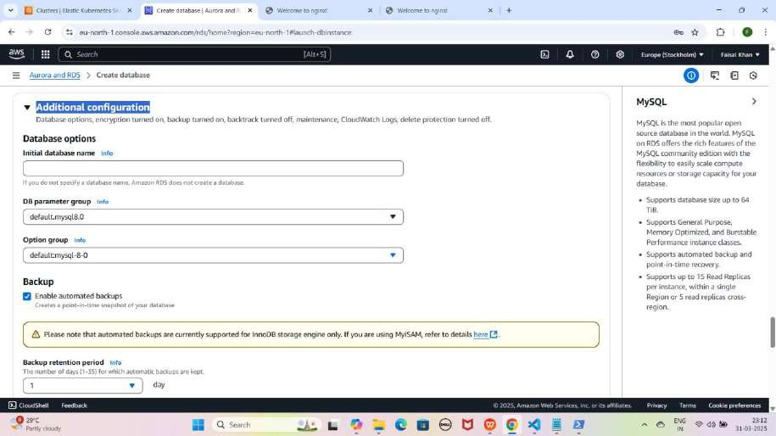

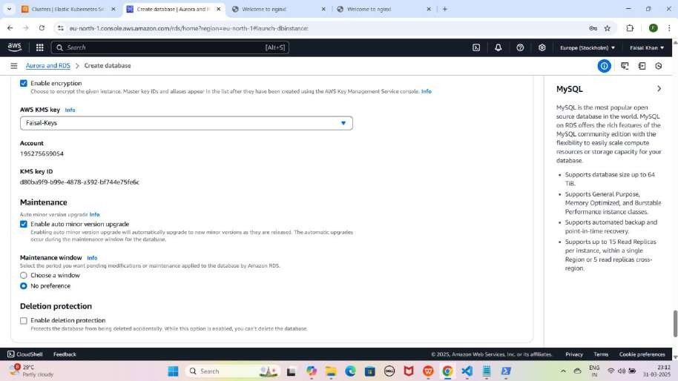

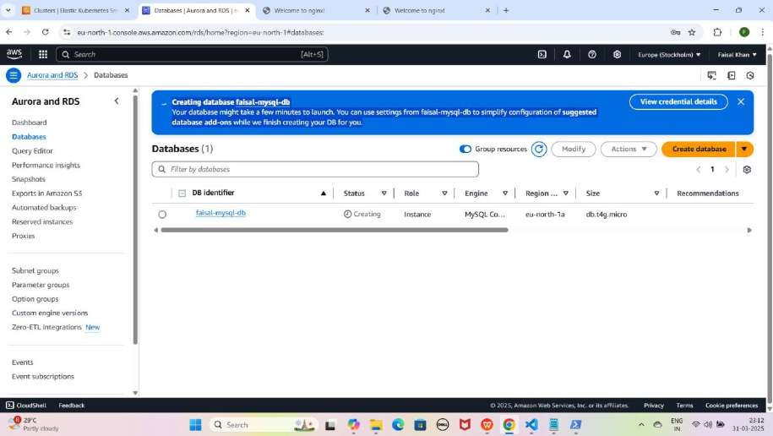

#### Step 3: Oracle Database Create Karna

* **Databases** → **Create Database**
* **Creation Method:** Standard Create
* **Engine Type:** Oracle
* **Template:** Dev/Test
* **DB Name:** faisal-oracle-db
* **Username:** FaisalKhan
* **Password:** Faisalkhan35$
* **Storage Type:** General Purpose SSD (gp3)
* **Allocated Storage:** 20 GiB
* **Subnet Group:** faisal-subnet
* **Public Access:** No
* **VPC Security Group:** ALL-TRAFFIC-ALLOW
* **Availability Zone:** eu-north-1a
* **AWS KMS Key:** Faisal-Keys
* **Create Database** par click karein.
* Pop-up aayega: **"Creating database faisal-Oracle-db"**

YE KUCH ISTARHA LAGEGA

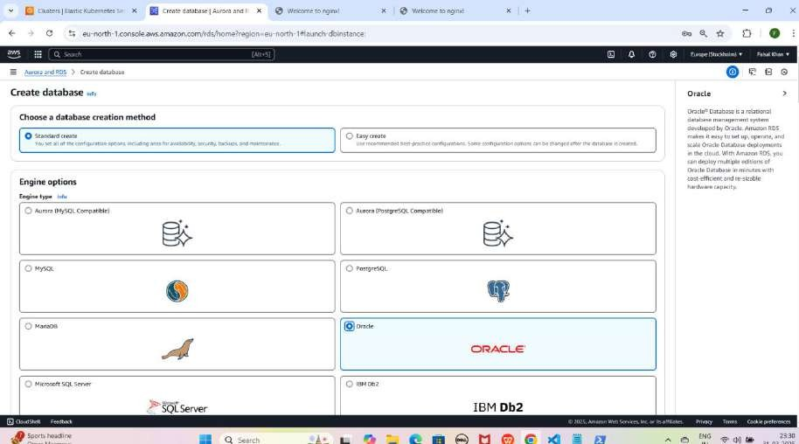

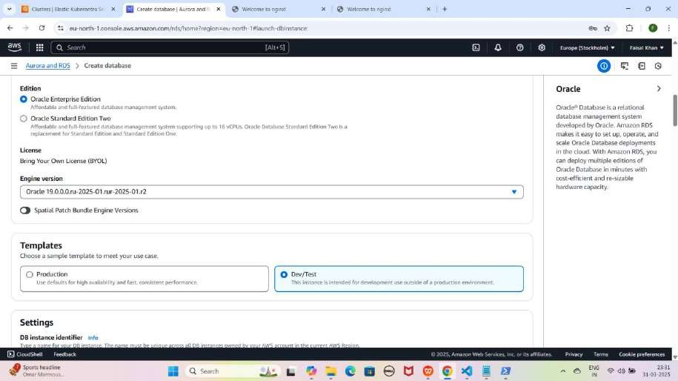

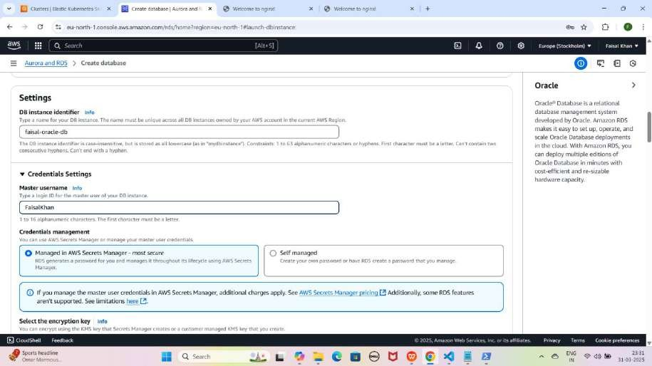

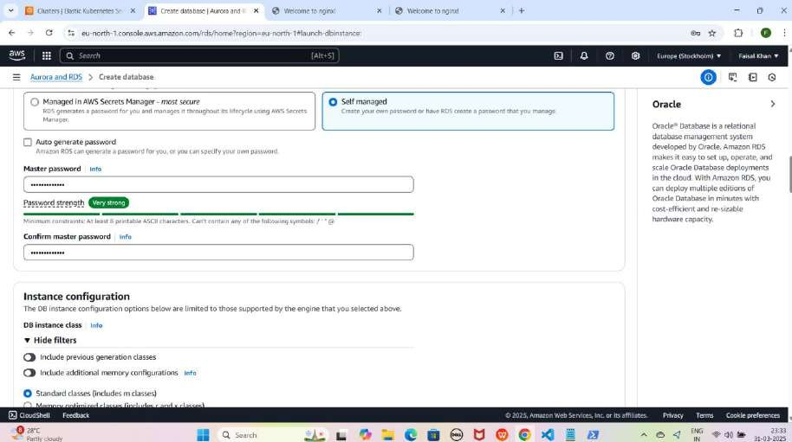

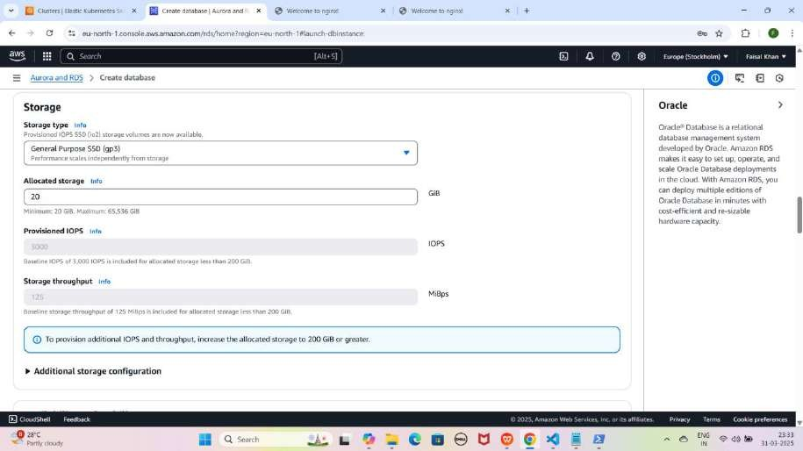

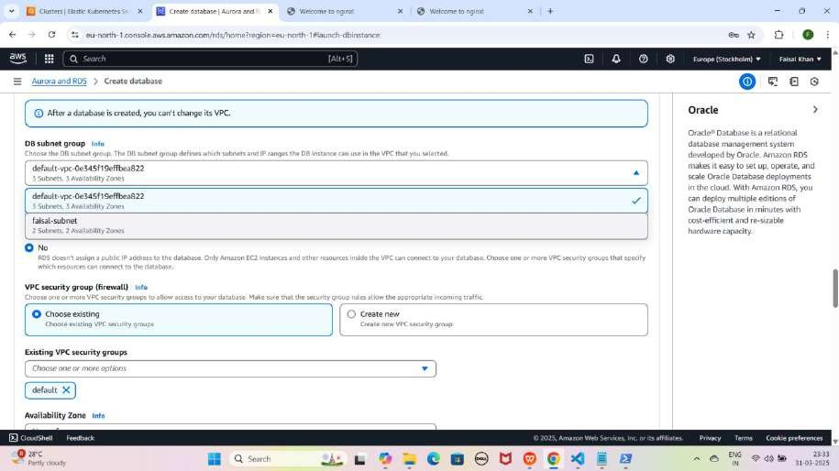

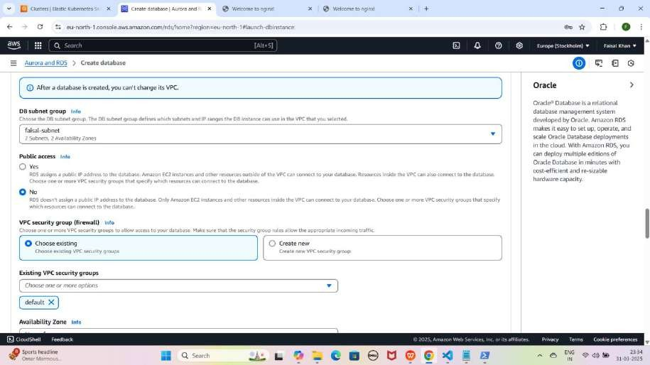

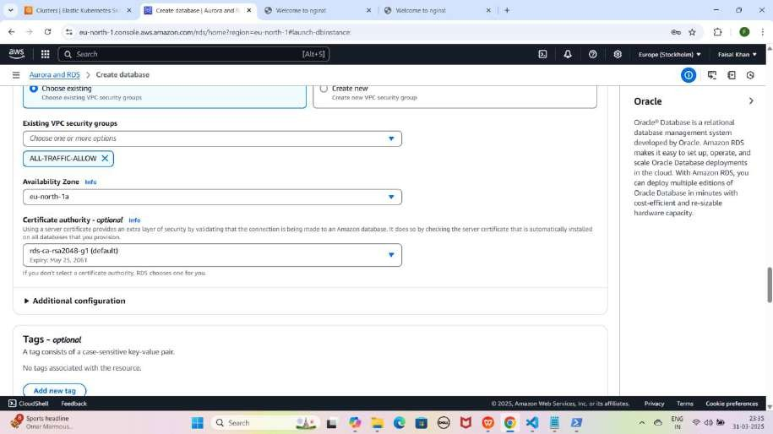

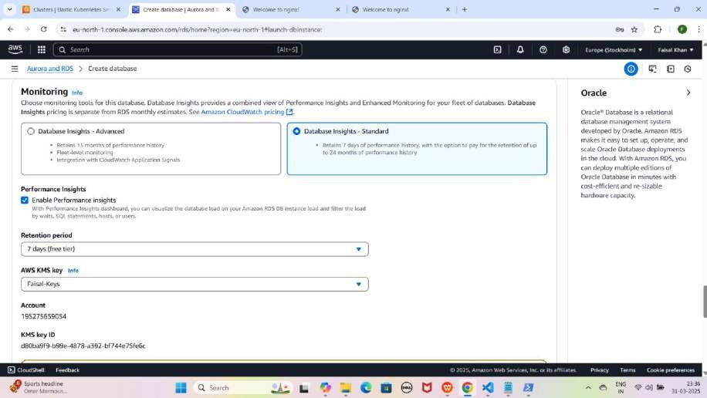

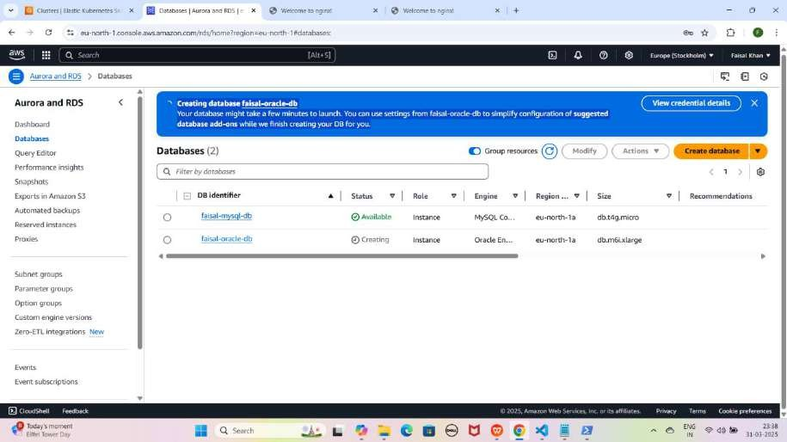

#### Step 4: PostgreSQL Database Create Karna

* **Databases** → **Create Database**
* **Creation Method:** Standard Create
* **Engine Type:** PostgreSQL
* **Template:** Free Tier
* **DB Name:** faisal-postgresql-db
* **Username:** FaisalKhan
* **Password:** Faisalkhan35$
* **Storage Type:** General Purpose SSD (gp3)
* **Allocated Storage:** 20 GiB
* **Subnet Group:** faisal-subnet
* **Public Access:** No
* **VPC Security Group:** ALL-TRAFFIC-ALLOW
* **Availability Zone:** eu-north-1a
* **AWS KMS Key:** Faisal-Keys
* **Create Database** par click karein.
* Pop-up aayega: **"Creating database faisal-PostgreSQL-db"**

YE KUCH ISTARHA LAGEGA

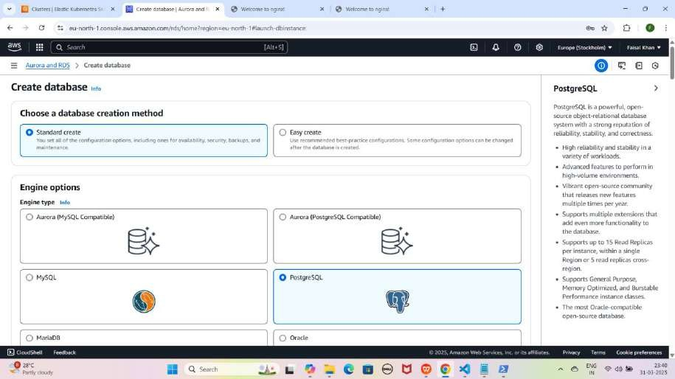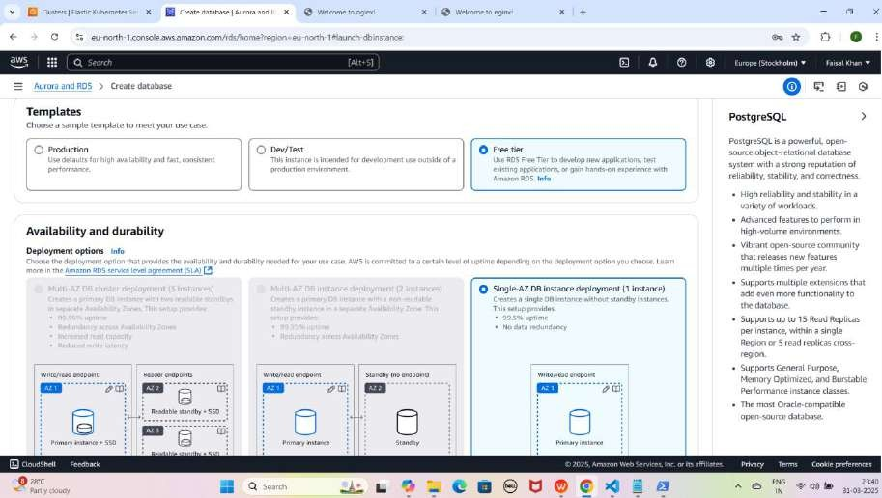

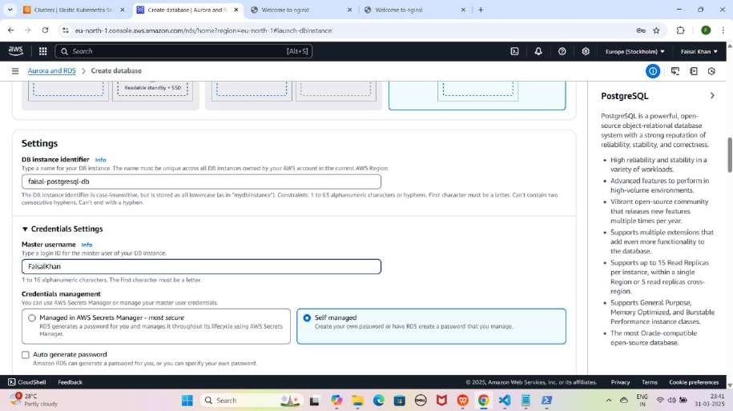

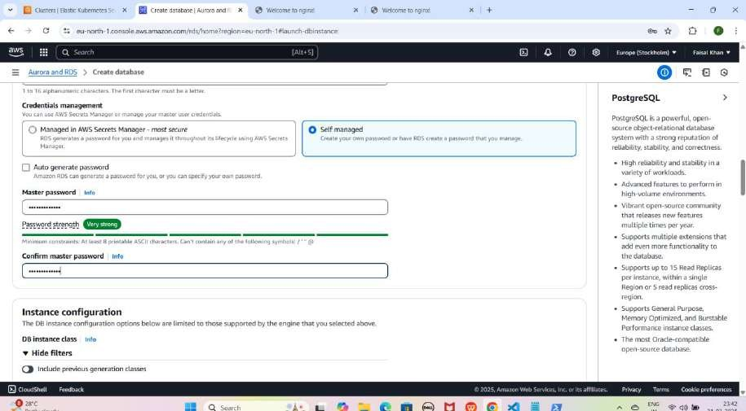

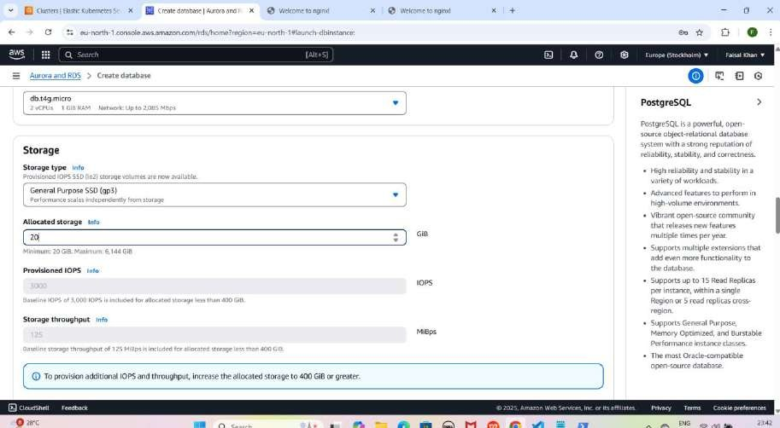

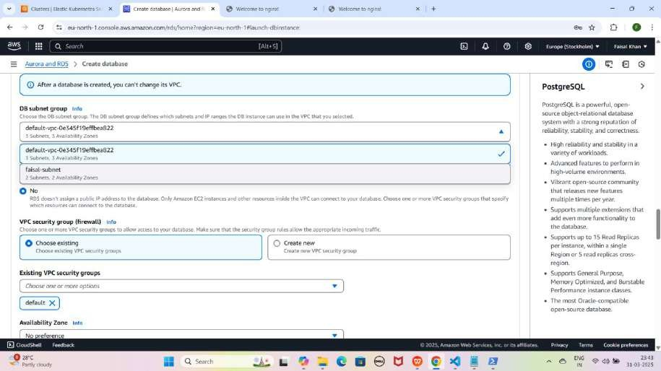

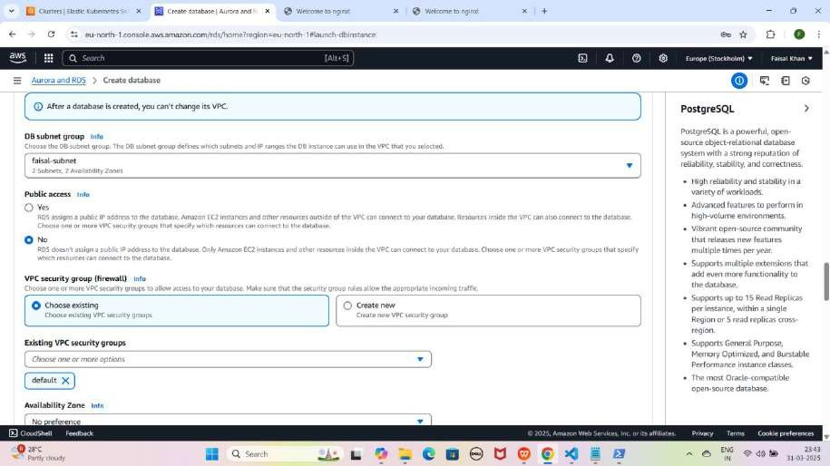

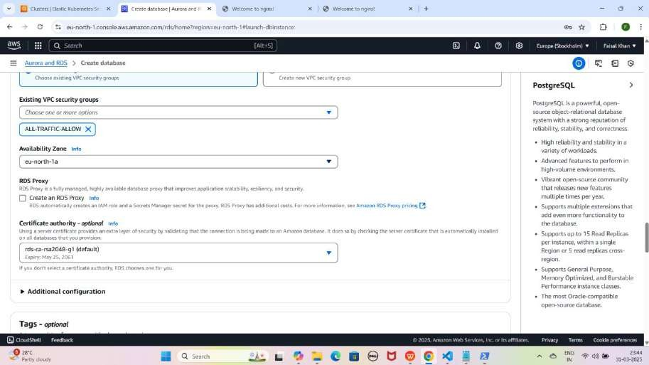

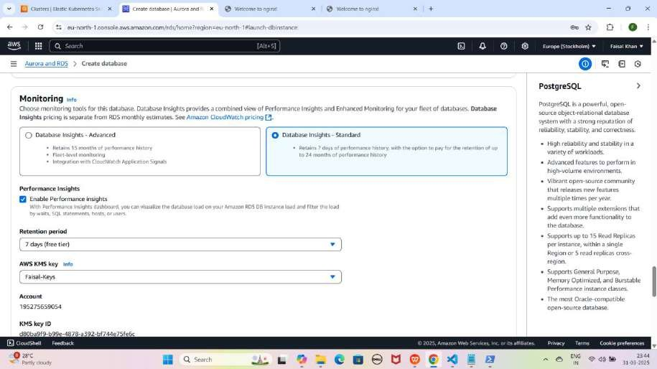

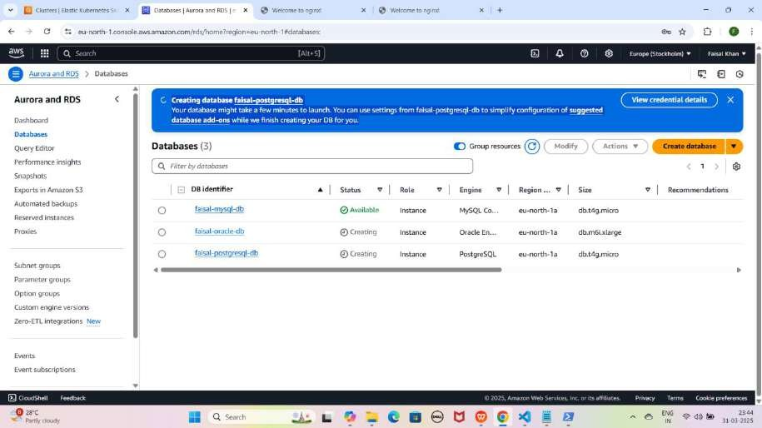

#### Step 5: Database Status Check Karna

* **Databases** section open karein.
* Thodi der wait karein, jab tak sab databases ka **Status = Available** na ho jaye.

YE KUCH ISTARHA LAGEGA

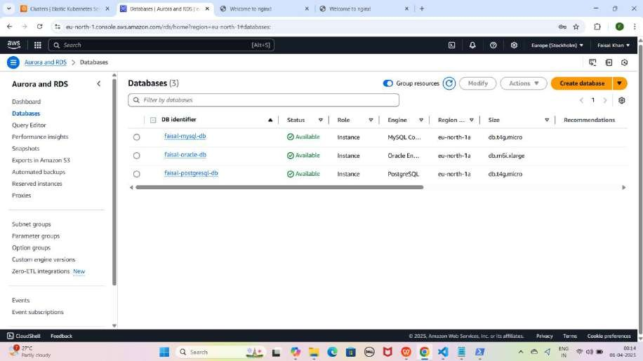

NOTE:-

1. **Amazon RDS password me Special characters bhi allow hain, lekin "/" , '"' aur '@' allow nahi hain.**
2. **gp3 storage → gp2 se 20% sasta aur better performance deta hai.**
3. **Public Access = No rakhein taake security maintain ho.**
4. **MySQL, Oracle, aur PostgreSQL ka Status = Available ho jaye, iska matlab AWS RDS successfully create ho gaya!**

## Part 8: Accessing Amazon RDS (MySQL, Oracle, PostgreSQL) from an EKS Cluster (With Endpoint)

### Amazon RDS ko Access Karne ke 2 Methods Hai:-

Method 1: Application ke through Database Access Karna (With Endpoint) Application image ek pre-packaged file hoti hai jo tumhari application ka

**code, dependencies, aur configurations** contain karti hai. Ye image **Docker** ya kisi aur **containerization tool** se banayi jati hai. Isko use karke tum apni **application** ko **kisi bhi environment** me easily **deploy** kar sakte ho.

#### Step 1: Dependencies Install Karo

1. 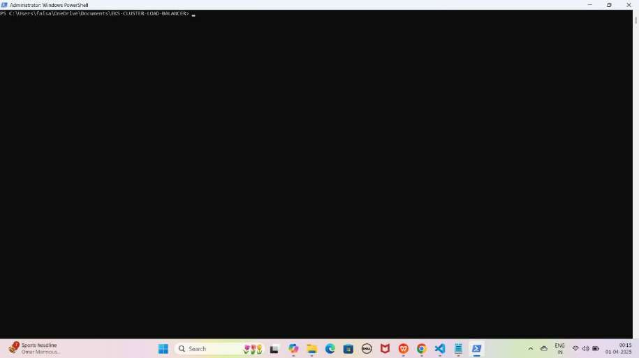**Project Folder ki Location par jao jaise ki mere case me kuch aisi hogi** cd C:\Users\faisa\OneDrive\Documents\EKS-CLUSTER-LOAD-BALANCER YE KUCH IS TARHA LAGEGA
2. **Ab WSL me enter karo enter hone ke liye wsl type karo:**

wsl

YE KUCH IS TARHA LAGEGA

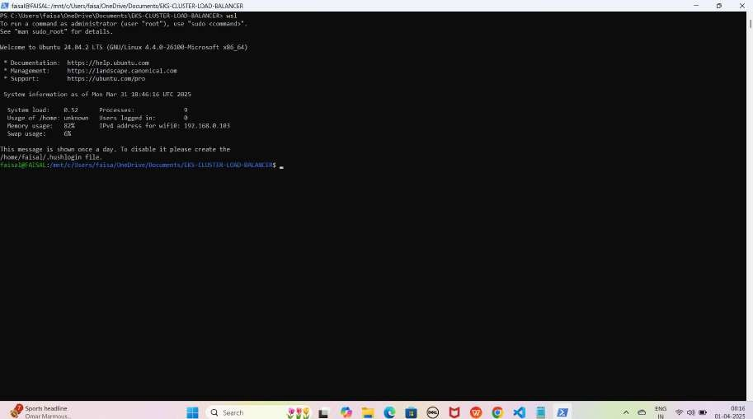

1. **Backend-app.js initialize karne ke liye ye command run kariye:**

sudo npm init -y

YE KUCH ISTARHA LAGEGA

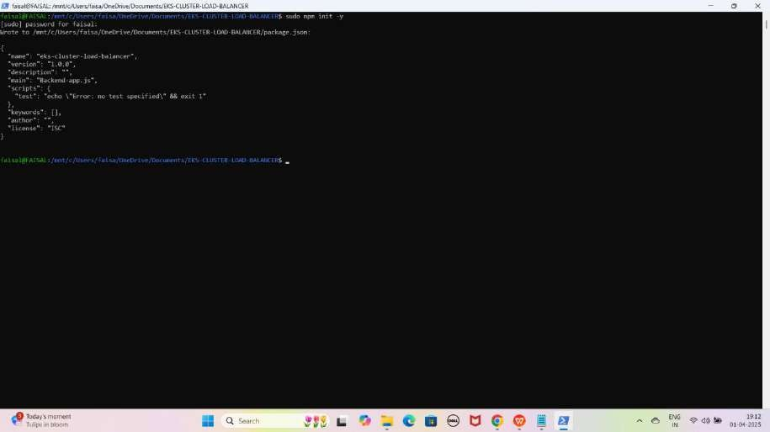

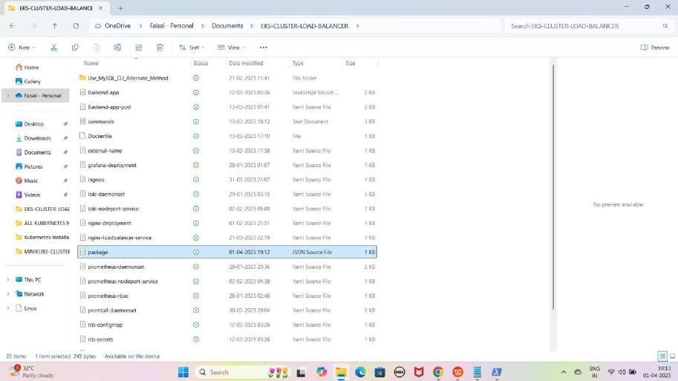

NOTE: Yeh command Backend-aap.js initialize karti hai aur package.json create karta hai with default settings

1. **Required Dependencies install karne ke liye ye command run kariye:**

sudo npm install express mysql pg oracledb

YE KUCH ISTARHA LAGEGA

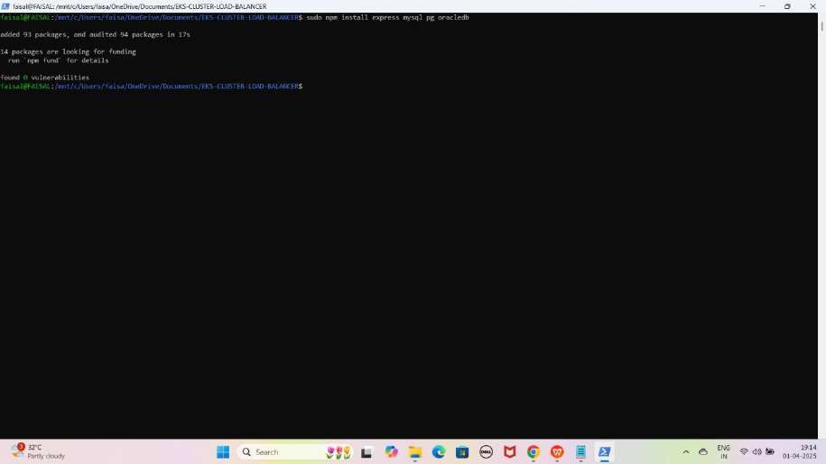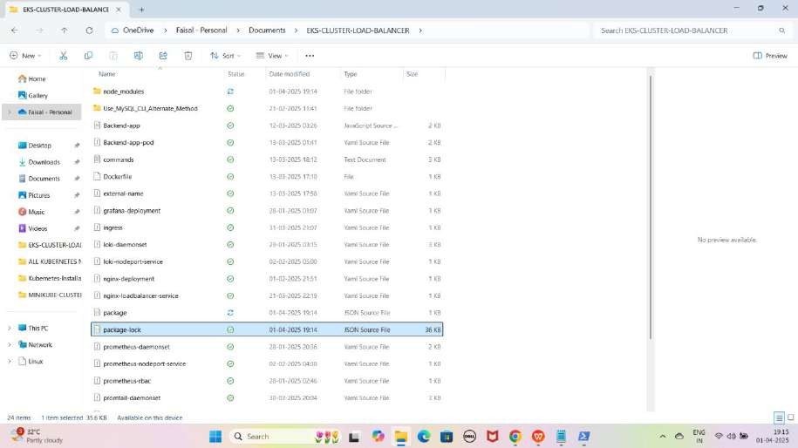

NOTE: Yeh command required dependencies (express, mysql, pg, oracledb) ke liye install karti hai or package-lock.json file bhi creraste karta hai .Saath hi package.json file me inko "dependencies" section me add karti hai

#### Step 2: Application Image ki Files and Tools jo hum use karenge

1. **Docker Hub**
2. **Backend-app.js**
3. **Dockerfile**
4. **rds-secrets.yaml**
5. **rds-configmap.yaml**
6. **service-account.yaml**
7. **role.yaml**
8. **rolebinding.yaml**
9. **Backend-app-pod.yaml**
10. **Docker Hub Account Create Karna**
    * **Docker Hub ki website open karein:** <https://hub.docker.com/>
    * **Sign Up karein** aur apna **Email, Username and Password** set karein.
    * **Login karein** aur Docker Hub Section me jaakar **"Create a Repository"** par click karein.
    * **Verify email address** kare apna mobile me Gmail open kare and **Verify Email Address** pe **click** kare
    * **Repository** ka naam **(backend-app**) likhein aur **visibility option** me **Public select** karein.
    * **Create** button par click karein

YE KUCH ISTARHA LAGEGA

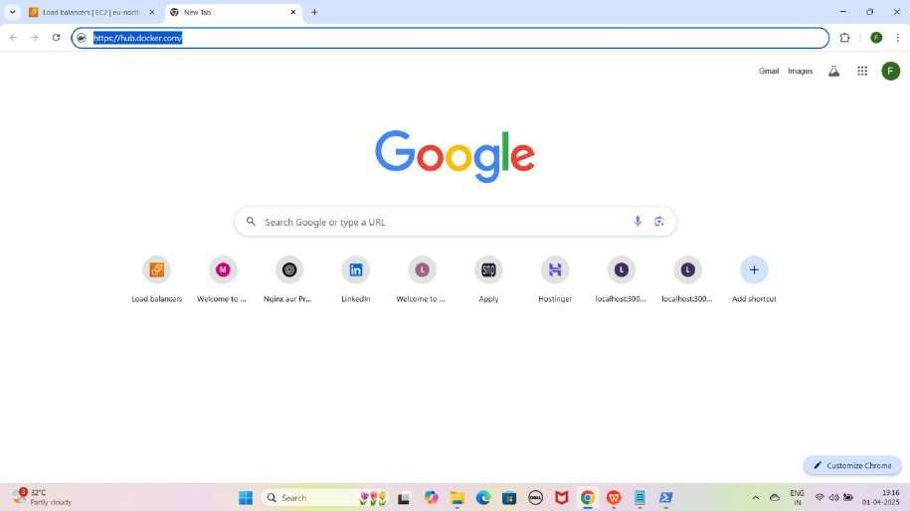

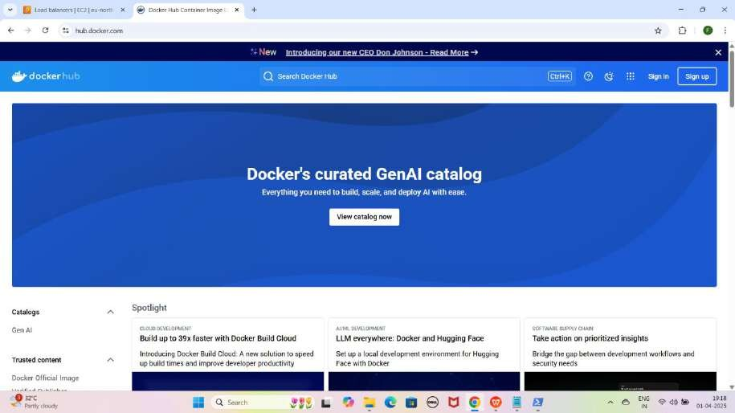

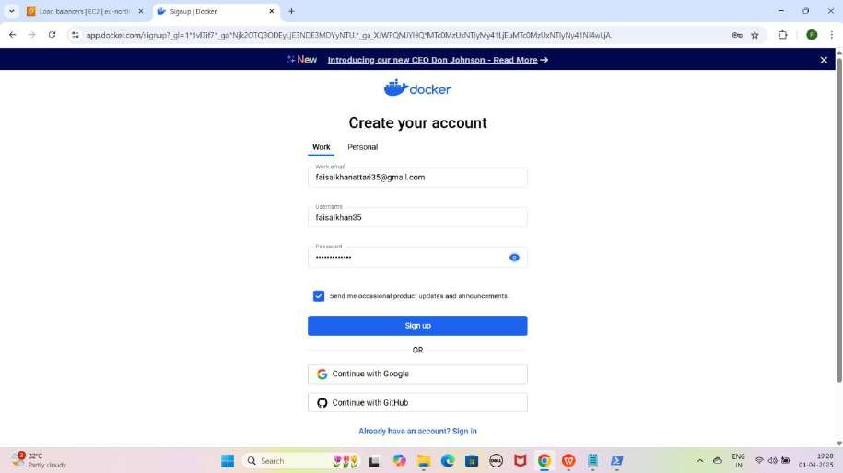

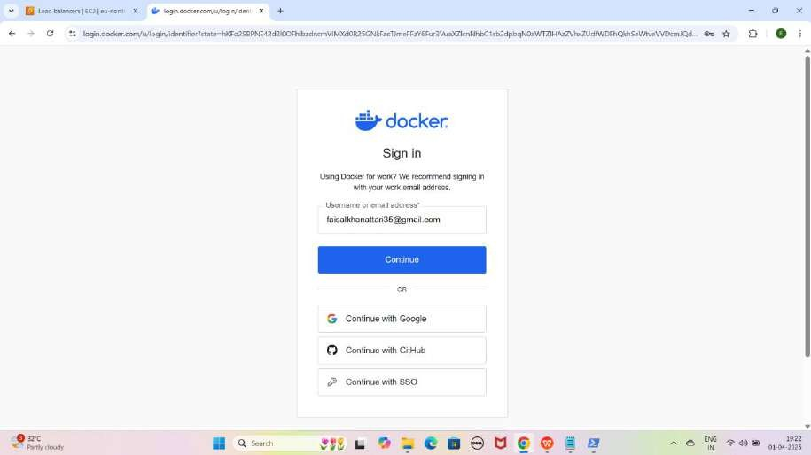

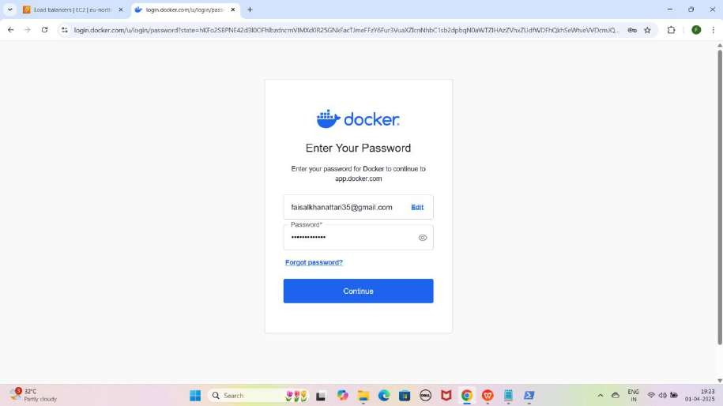

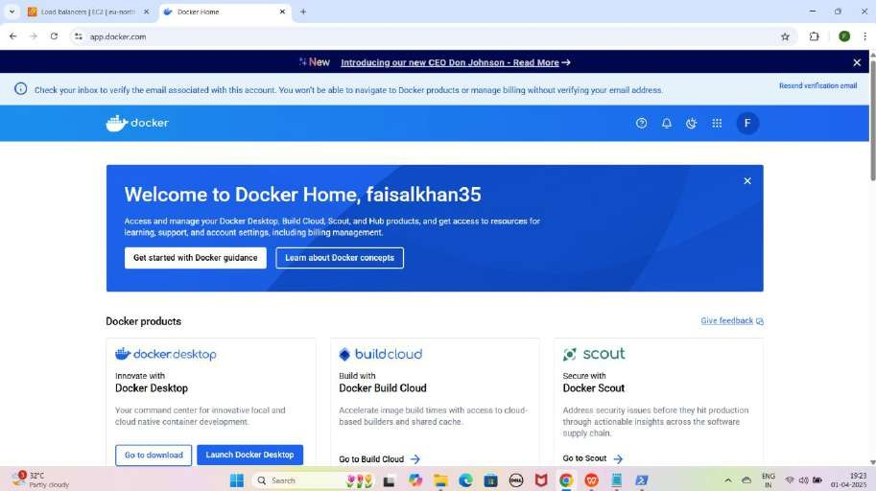

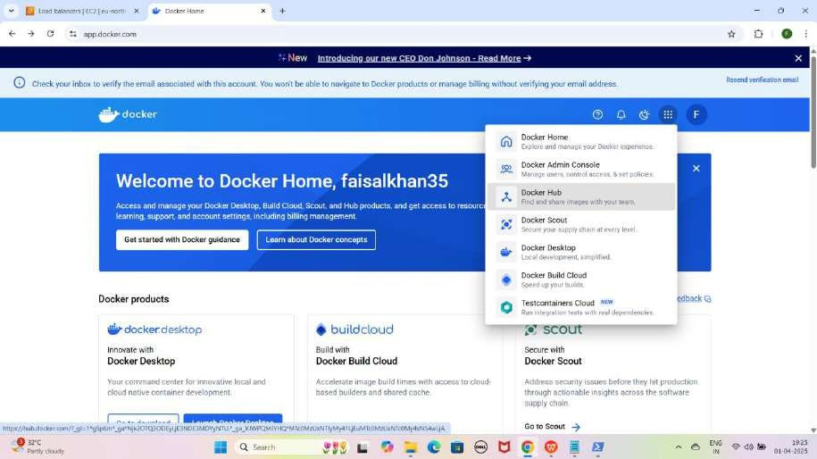

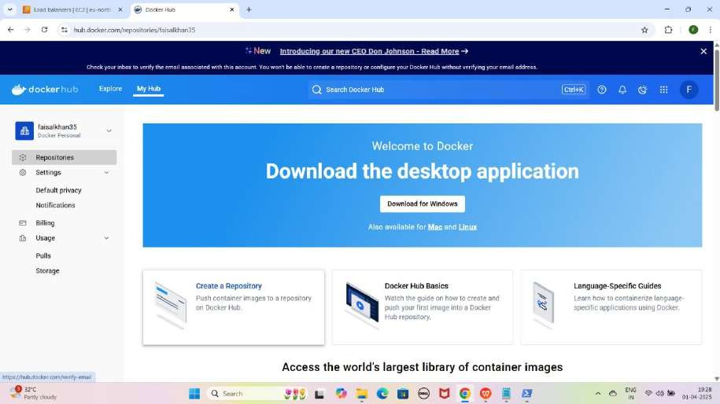

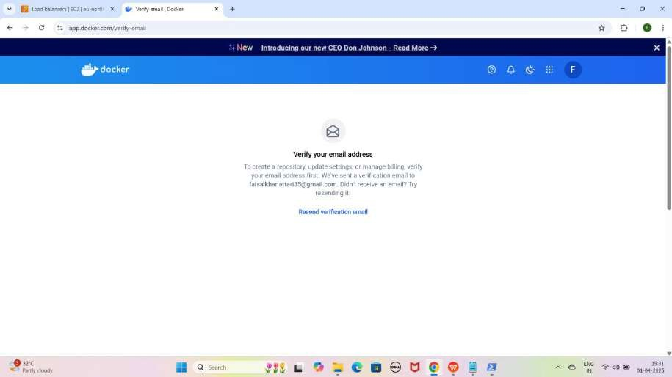

NOTE: Jaise hi appke Mobile me Email verification successful hoga to page Refresh kare

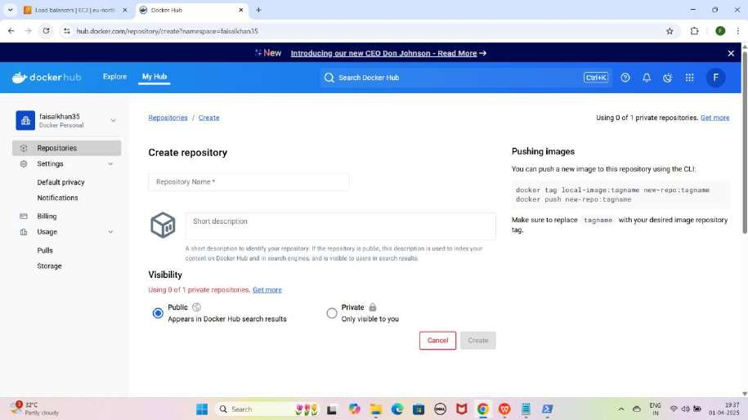

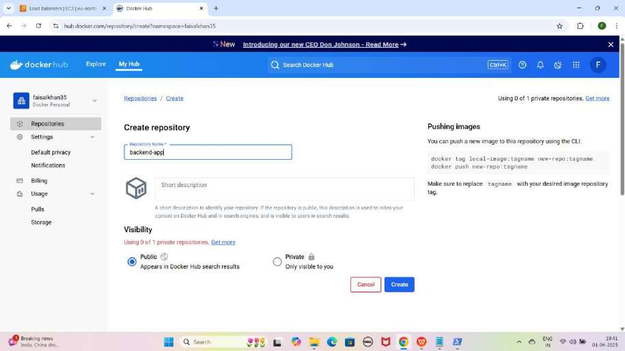

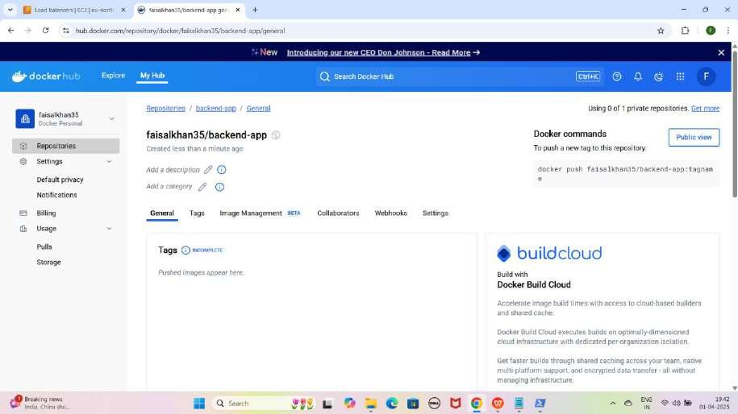

1. **Backend-app.js File Ka Kaam**

Yeh ek **JavaScript file** hai jo ek **Node.js application image** banane ke liye use hoti hai.

JAISE KI:-

const express = require('express'); const mysql = require('mysql'); const { Client } = require('pg'); const oracledb = require('oracledb');

const app = express();

// MySQL Connection

const mysqlDb = mysql.createConnection({ host: process.env.MYSQL_HOST,

user: process.env.MYSQL_USERNAME, password: process.env.MYSQL_PASSWORD,

database: process.env.MYSQL_DATABASE || "faisal-mysql-db"

});

mysqlDb.connect(err => { if (err) {

console.error('Error connecting to MySQL:', err.stack);

} else {

console.log('Connected to MySQL database');

}

});

// PostgreSQL Connection

const postgresDb = new Client({

host: process.env.POSTGRESQL_HOST, user: process.env.POSTGRESQL_USERNAME,

password: process.env.POSTGRESQL_PASSWORD,

database: process.env.POSTGRESQL_DATABASE || "faisal-postgresql-db", port: 5432

});

postgresDb.connect()

.then(() => console.log('Connected to PostgreSQL database'))

.catch(err => console.error('Error connecting to PostgreSQL:', err));

// Oracle Connection

async function connectOracleDB() { try {

const connection = await oracledb.getConnection({ user: process.env.ORACLE_USERNAME,

password: process.env.ORACLE_PASSWORD, connectString: process.env.ORACLE_HOST

});

console.log('Connected to Oracle database'); await connection.close();

} catch (err) {

console.error('Error connecting to Oracle:', err);

}

}

connectOracleDB();

app.get('/', (req, res) => {

res.send('Connected to MySQL, PostgreSQL, and Oracle databases!');

});

app.listen(3000, () => {

console.log('App is running on [http://localhost:3000');](http://localhost:3000/)

});

NOTE: Ye Script me aap databases change karlo aap jo RDS databases create karenge ukne name ke hissab se mere case me mere databases ke name ye hai

1. **faisal-mysql-db**
2. **faisal-oracle-db**
3. **faisal-postgresql-db**
4. **Dockerfile Ka Kaam**

Yeh file **custom application image** create karne ke liye use hoti hai aur isme required **dependencies** aur **packages install** hote hain.

JAISE KI:-

# Use Oracle Linux with Instant Client

FROM ghcr.io/oracle/oraclelinux8-instantclient:21

# Upgrade system and install required packages RUN dnf install -y mysql postgresql \

&& dnf module reset nodejs \

&& dnf module enable nodejs:18 \ && dnf install -y nodejs \

&& dnf clean all && rm -rf /var/cache/dnf /tmp/* /var/tmp/*

# Set working directory WORKDIR /app

# Copy package files first

COPY package.json package-lock.json ./

# Install dependencies as root first RUN npm ci --omit=dev

# Set non-root user for security RUN useradd -m -u 1000 appuser RUN chown -R appuser:appuser /app

# Switch to non-root user USER appuser

# Copy the rest of the application files COPY --chown=appuser:appuser . .

# Ensure Backend-app.js is executable RUN chmod +x Backend-app.js

# Expose the application port EXPOSE 3000

# Start the application

CMD ["node", "Backend-app.js"]

Short Note:

Yeh **Dockerfile** ek **Node.js application** ko containerized environment me run karne ke liye hai, jo **Oracle Linux (Instant Client)** use karta hai.

* + **Base Image:** oraclelinux8-instantclient:21 use ho raha hai.
  + **System Upgrade & Installations:** mysql, postgresql, aur nodejs:18 install kar raha hai.
  + **Working Directory:** /app set kiya gaya hai.
  + **Dependencies Installation:** package.json aur package-lock.json ko copy kar ke npm ci run kar raha hai.
  + **Security:** Ek **non-root user (**appuser**)** create kar ke usko ownership de raha hai.
  + **File Permissions:** Backend-app.js ko executable bana raha hai.
  + **Port Exposure:** 3000 expose kar raha hai.
  + **Startup Command:** node Backend-app.js se application start ho raha hai.

1. **Docker Image build karo aur Docker Hub me push karo**

sudo docker build -t faisalkhan35/backend-app .

YE KUCH ISTARHA LAGEA

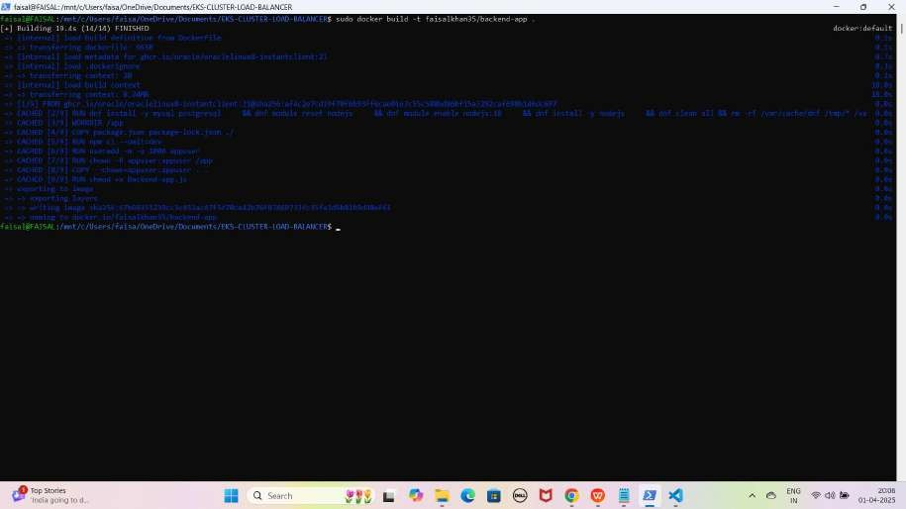

NOTE: Aap Docker image ko Docker Hub par upload karne ke liye customize image bana rahe hain, taaki yeh aapke Docker Hub username (faisalkhan35) ke saath upload ho. Agar username include nahi karoge, toh upload karte waqt error aayega.

1. **Ab Docker Images check karne ke liye ye command run kariye**

sudo docker images

YE KUCH ISTARHA LAGEGA

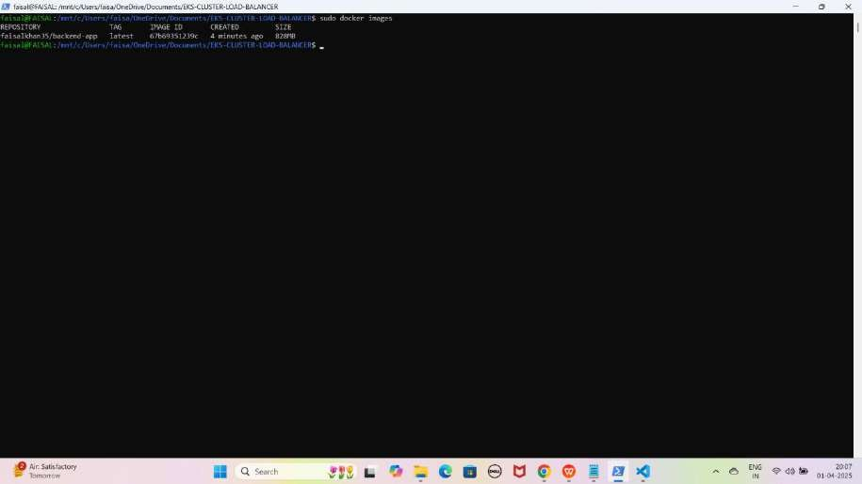

1. **Docker Hub me login karne ke liye ye command run kariye**

sudo docker login

YE KUCH ISTARHA LAGEGA

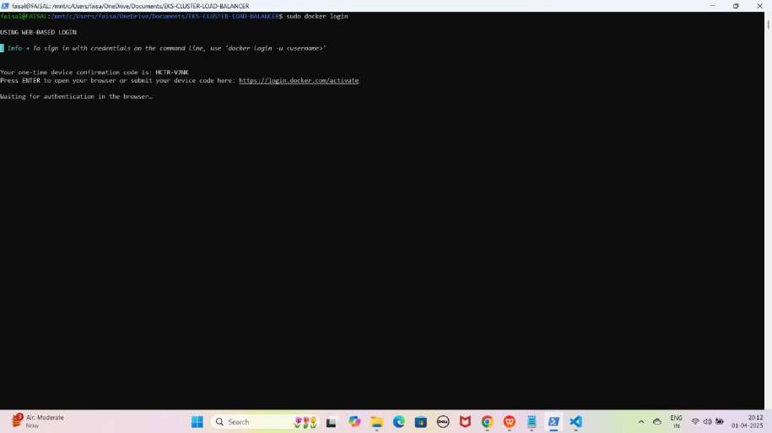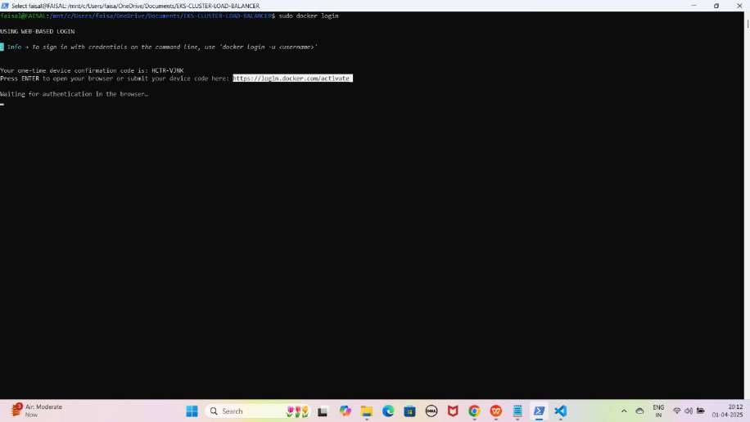

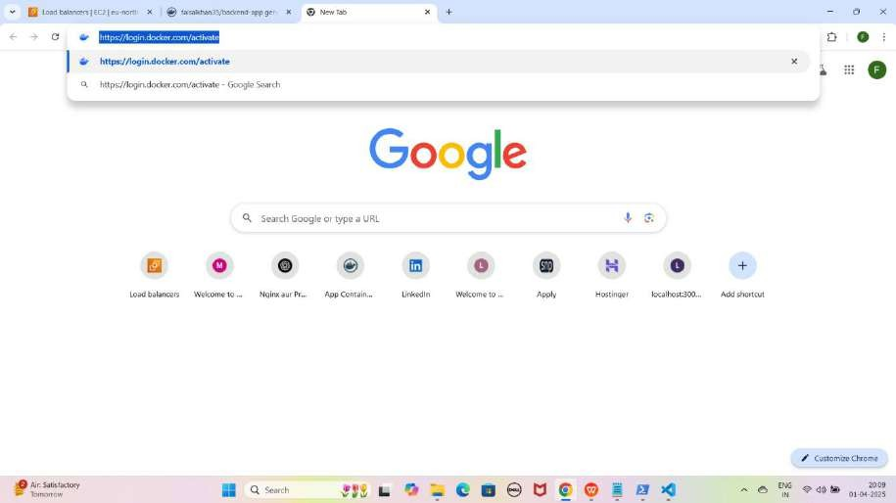

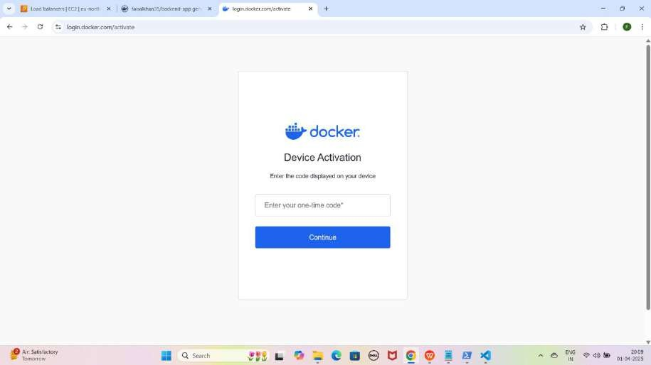

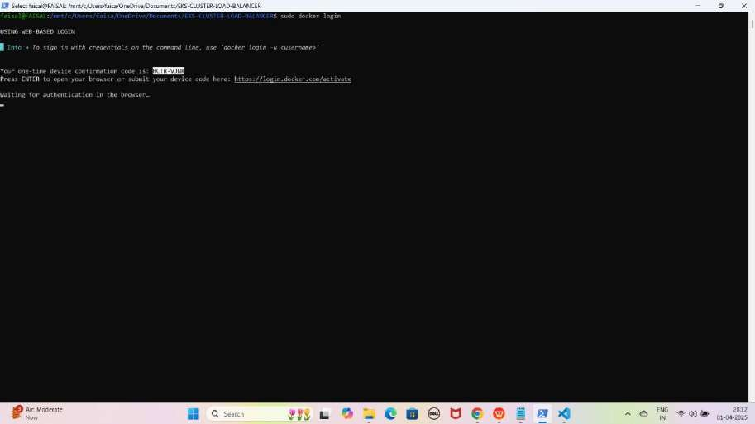

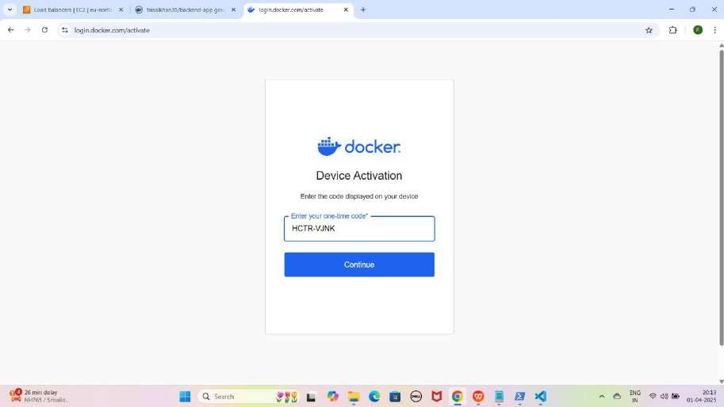

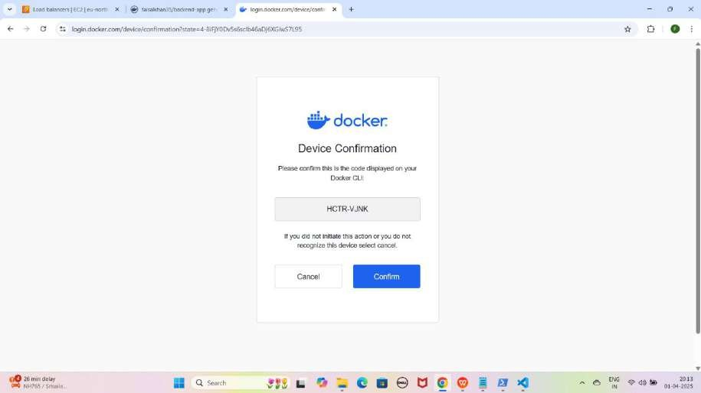

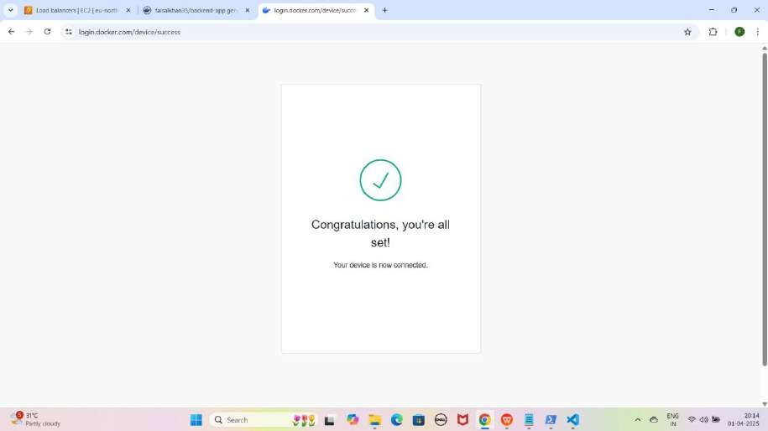

NOTE : Ye command enter karne ke baad aapko ek URL melega ye kuch istarha ka hoga <https://login.docker.com/activate> is URL ko Browser me Open karna hoga then one-time device confirmation code jo generate howa wo enter karna hoga Code enter karne ke baad Congratulations, You’re all set! Your device is now connected karke Show hoga.

1. **Image ko Docker Hub par push karne ke liye ye command run kariye**

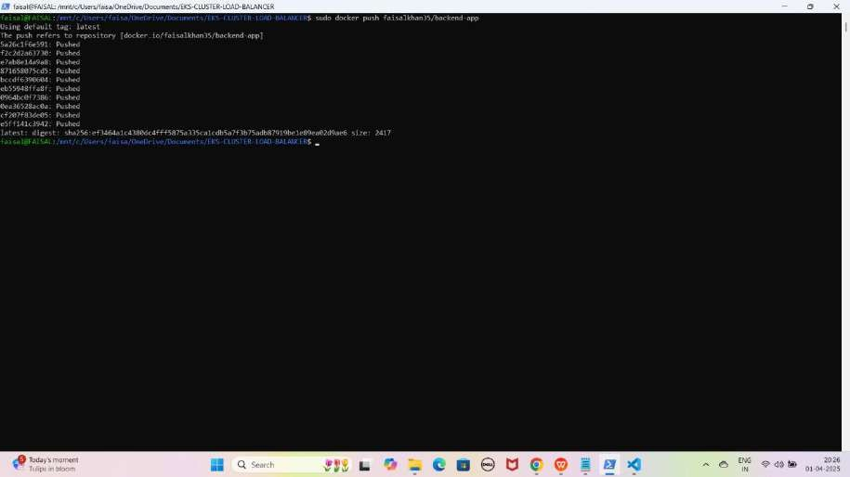sudo docker push faisalkhan35/backend-app YE KUCH ISTARHA LAGEGA

1. **Ab Docker Hub me Jaakar check karo ki image push hogai hai ya nahi**

YE KUCH ISTARHA LAGEGA

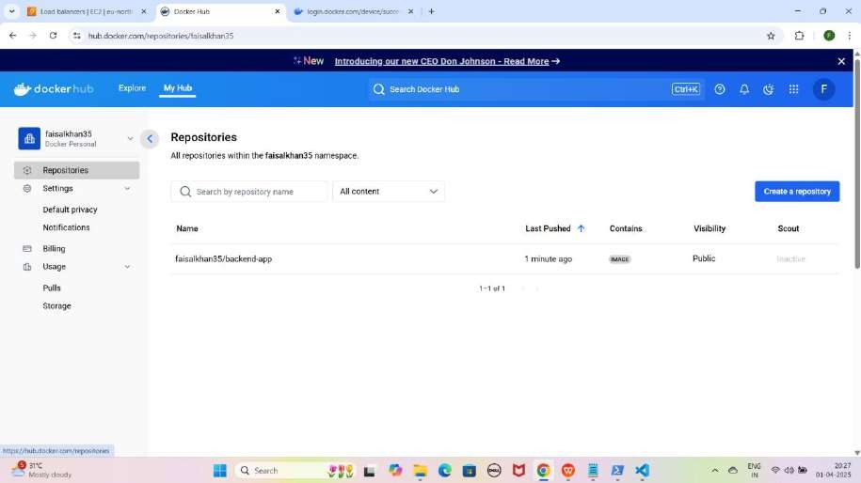

NOTE : Docker Hub par jane ke baad Page Refresh kare aapko aapki Customize Image dikhegi

1. **rds-secrets.yaml File Ka Kaam**

Ye **file username aur password ko securely store** karne ke liye use hoti hai. Kyunki **Secrets secure hoti hain**, is wajah se hum **Base64 encoding** ka use karke **username aur password** ko **encrypt** kar dete hain.

RDS (MYSQL, Oracle, PostgreSQL) ka username aur password encode karna:-

1. **Windows ke WSL (Windows Subsystem for Linux) ka use kar ke hum Base64 encoding kar sakte hain. wsl type karein aur yeh commands run karein**

wsl

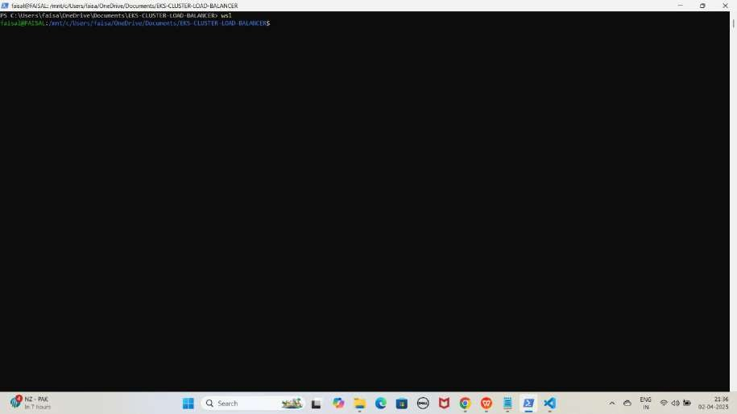YE KUCH ISTARHA LAGEGA

1. **Username encode karein**
   * echo -n FaisalKhan | base64
2. **Password encode karein**
   * echo -n Faisalkhan35$| base64

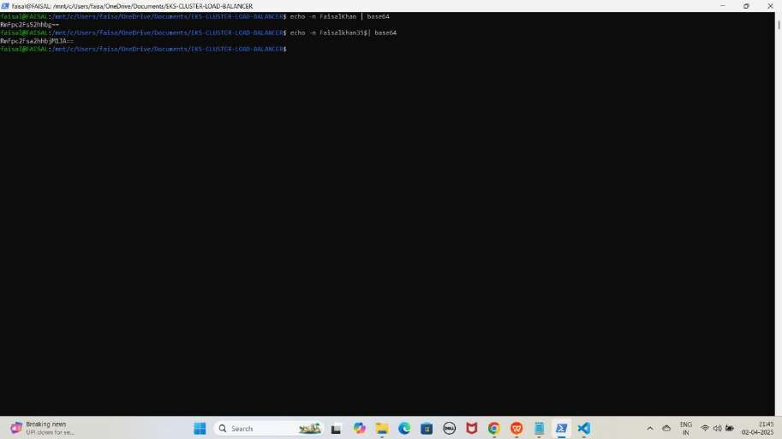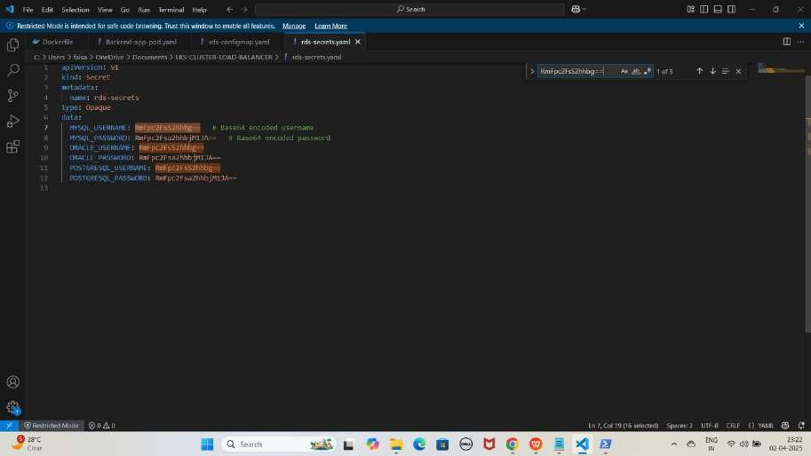YE KUCH ISTARHA LAGEGA

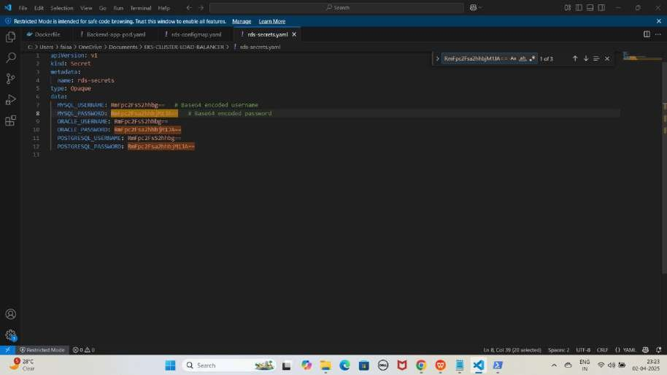

NOTE: Ye command aapko Base64 encoded values degi, jo hum rds- secrets.yaml file me store karenge. Hum sabhi databases ke liye same Username aur Password use kar rahe hain, isliye encoded values bhi same rahengi. Lekin aapko apne Username aur Password ke hisaab se rds-secrets.yaml file update karni hogi.

JAISE KI:-

apiVersion: v1 kind: Secret metadata:

name: rds-secrets type: Opaque

data:

MYSQL_USERNAME: RmFpc2FsS2hhbg== # Base64 encoded username MYSQL_PASSWORD: RmFpc2Fsa2hhbjM1JA== # Base64 encoded password ORACLE_USERNAME: RmFpc2FsS2hhbg==

ORACLE_PASSWORD: RmFpc2Fsa2hhbjM1JA== POSTGRESQL_USERNAME: RmFpc2FsS2hhbg== POSTGRESQL_PASSWORD: RmFpc2Fsa2hhbjM1JA==

Agar aap encoded username aur password ko wapas original form me laana chahte hain, toh WSL me yeh commands run karein

1. **Username decode karein**
   * echo -n 'RmFpc2FsS2hhbg==' | base64 --decode
2. **Password decode karein**
   * echo -n 'RmFpc2Fsa2hhbjM1JA==' | base64 --decode

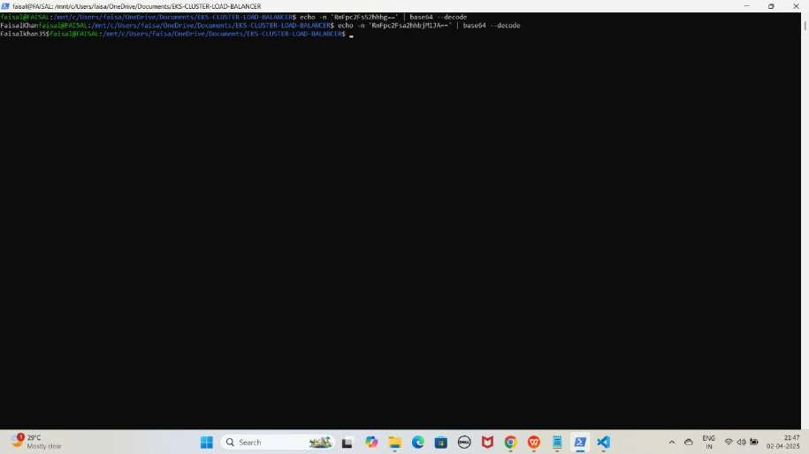YE KUCH ISTARHA LAGEGA

1. **Ab WSL se exit hogao exit hone ke liye exit type karein**

exit

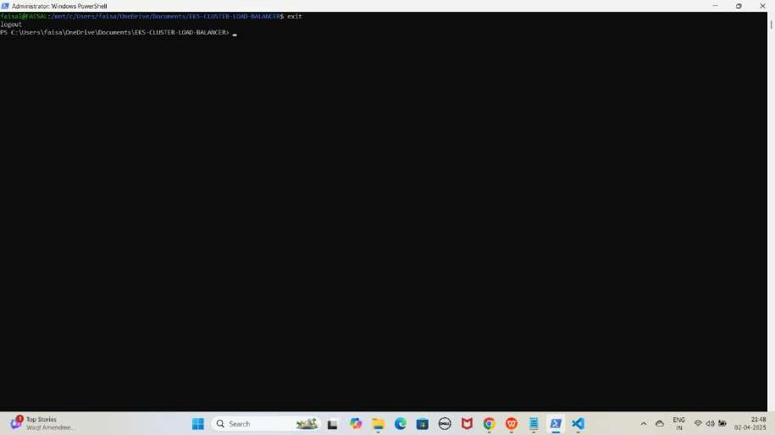YE KUCH ISTARHA LAGEGA

Secret Apply Karo

kubectl apply -f rds-secrets.yaml

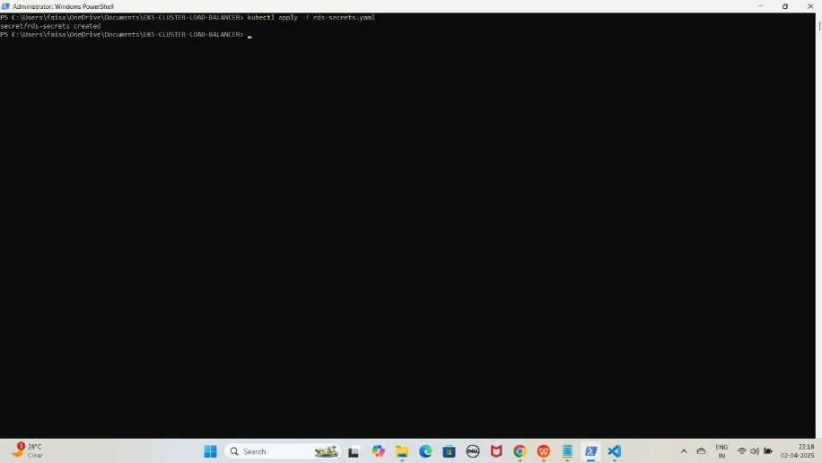YE KUCH ISTARHA LAGEGA

1. **rds-configmap.yaml File Ka Kaam**

Yeh **file non-sensitive data** store karne ke liye use hoti hai, jaise

* + **Database ka naam**
  + **Host ka naam (hostname)**
  + **Port number**

Aapko apne **databases** ke names and **endpoints** ko **rds-configmap.yaml** file me **update** karna hoga

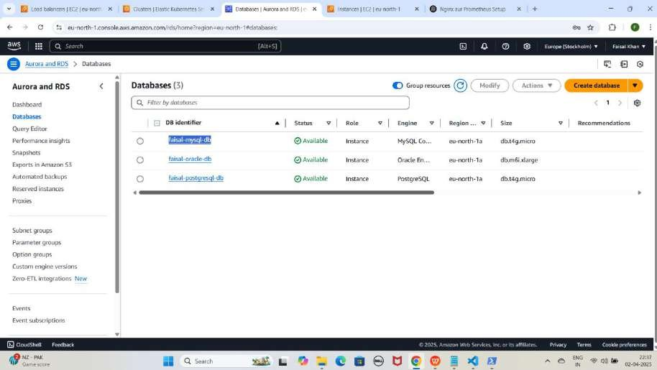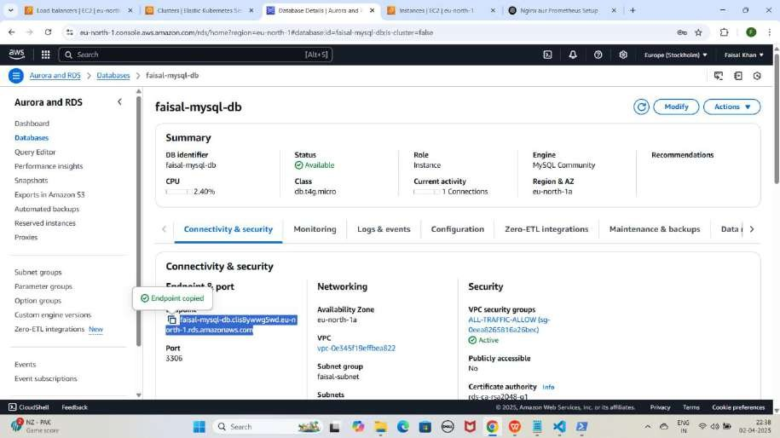YE KUCH ISTARHA LAGEGA

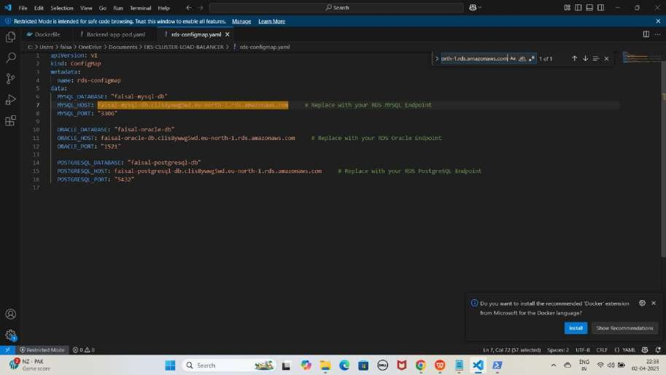

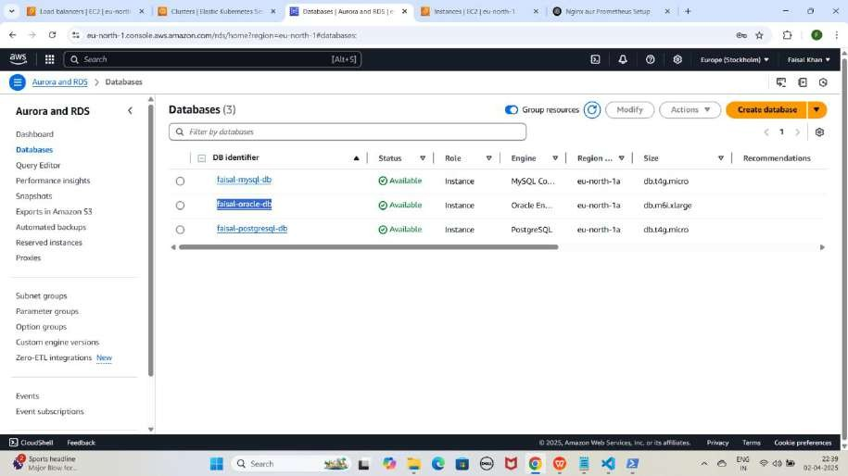

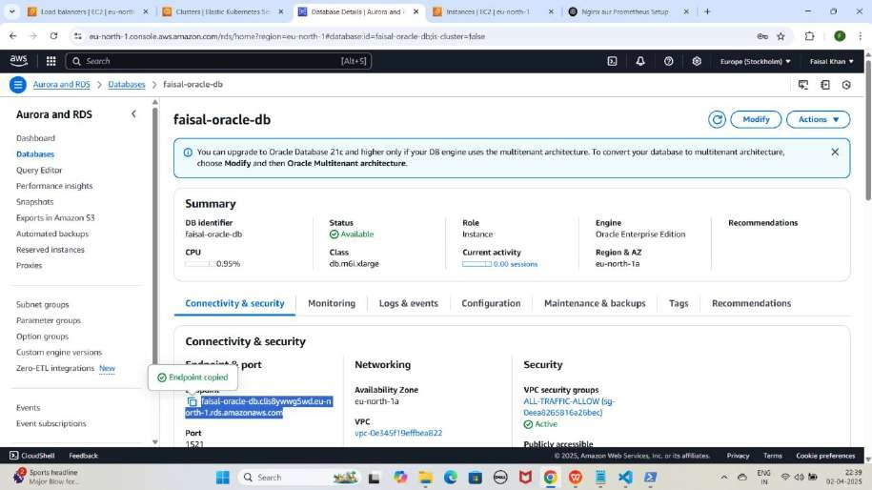

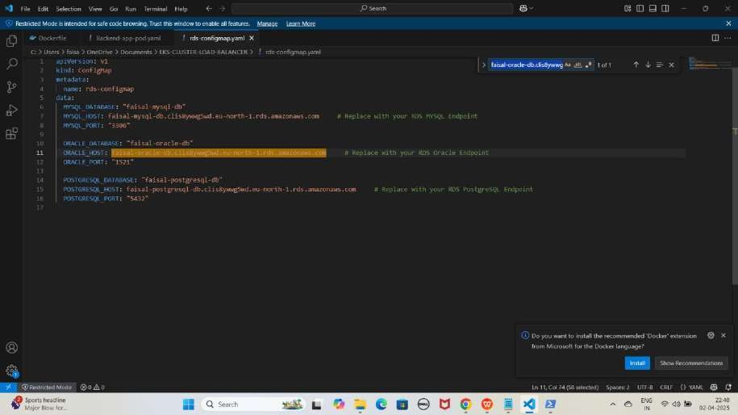

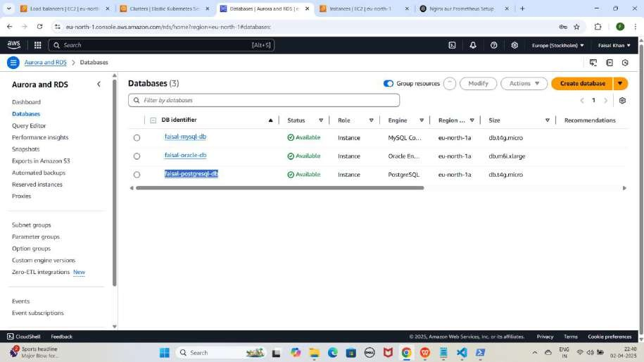

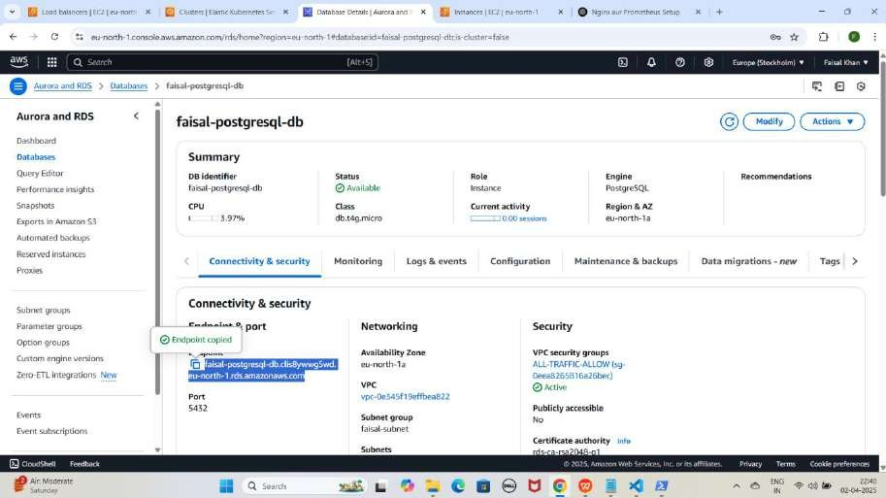

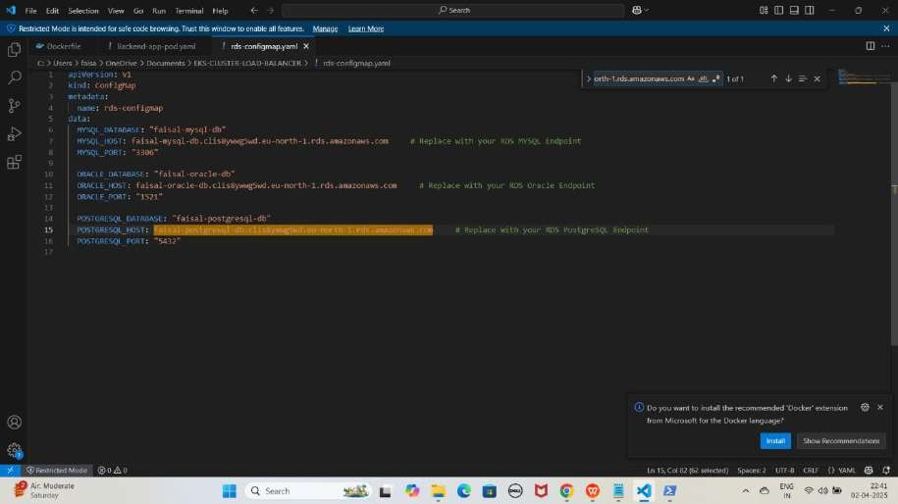

JAISE KI:-

apiVersion: v1

kind: ConfigMap metadata:

name: rds-configmap data:

MYSQL_DATABASE: "faisal-mysql-db"

MYSQL_HOST: faisal-mysql-db.clis8ywwg5wd.eu-north-1.rds.amazonaws.com MYSQL Endpoint

MYSQL_PORT: "3306"

# Replace with your RDS

ORACLE_DATABASE: "faisal-oracle-db"

ORACLE_HOST: faisal-oracle-db.clis8ywwg5wd.eu-north-1.rds.amazonaws.com RDS Oracle Endpoint

ORACLE_PORT: "1521"

# Replace with your

POSTGRESQL_DATABASE: "faisal-postgresql-db"

POSTGRESQL_HOST: faisal-postgresql-db.clis8ywwg5wd.eu-north-1.rds.amazonaws.com with your RDS PostgreSQL Endpoint

POSTGRESQL_PORT: "5432"

# Replace

ConfigMap Apply Karo

kubectl apply -f rds-configmap.yaml

YE KUCH ISTARHA LAGEGA

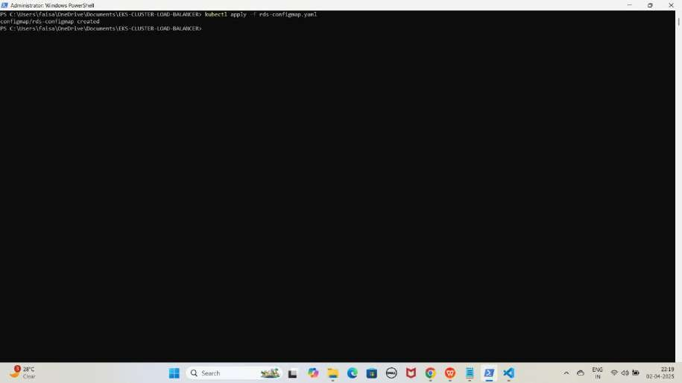

1. **service-account.yaml File Ka Kaam**

Yeh **file Secrets aur ConfigMaps** ko access karne ke liye **permissions** dene ke liye use hoti hai. Isko Kubernetes **Service Account** banane ke liye likha jata hai.

JAISE KI:-

apiVersion: v1 kind: ServiceAccount metadata:

name: service-account

Service Account Apply Karo

kubectl apply -f service-account.yaml

YE KUCH ISTARHA LAGEGA

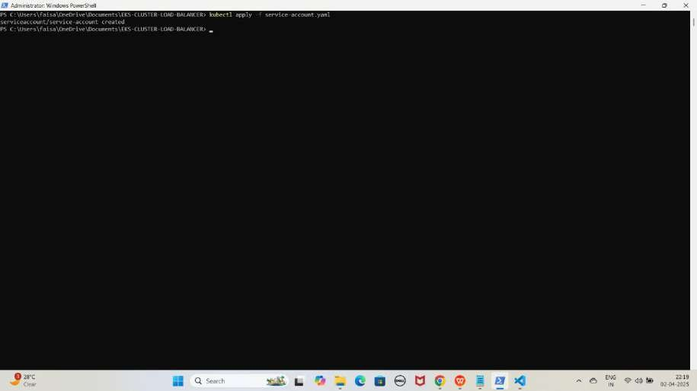

1. **role.yaml File Ka Kaam**

Yeh **file Secrets aur ConfigMaps** ke liye **read-only permissions** define karne ke liye use karrahe hai. Isko Kubernetes **Role** banane ke liye likha jata hai.

JAISE KI:-

apiVersion: rbac.authorization.k8s.io/v1 kind: Role

metadata:

name: read-role rules:

* apiGroups: [""]

resources: ["secrets", "configmaps"] verbs: ["get", "list"]

* apiGroups: [""] resources: ["pods"] verbs: ["get", "list"]
* apiGroups: [""] resources: ["events"] verbs: ["get", "list"]
* apiGroups: [""]

resources: ["endpoints"] verbs: ["get", "list"]

Role Apply Karo

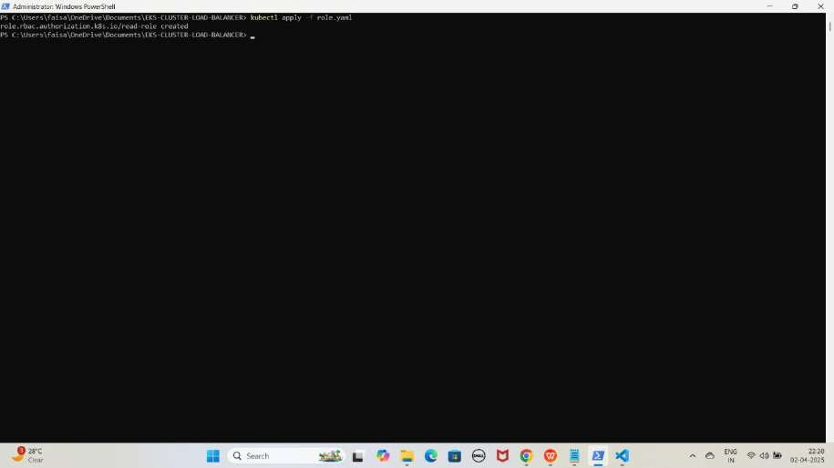kubectl apply -f role.yaml YE KUCH ISTARHA LAGEGA

1. **rolebinding.yaml File Ka Kaam**

Yeh **file Service Account** ko **Secrets aur ConfigMaps** ke liye **read-only permissions** assign karne ke liye use karrahe hai. Isko **Kubernetes RoleBinding** banane ke liye likha jata hai.

JAISE KI:-

apiVersion: rbac.authorization.k8s.io/v1 kind: RoleBinding

metadata:

name: read-only-binding subjects:

- kind: ServiceAccount name: service-account namespace: default

roleRef:

kind: Role name: read-role

apiGroup: rbac.authorization.k8s.io

RoleBinding Apply Karo

kubectl apply -f rolebinding.yaml

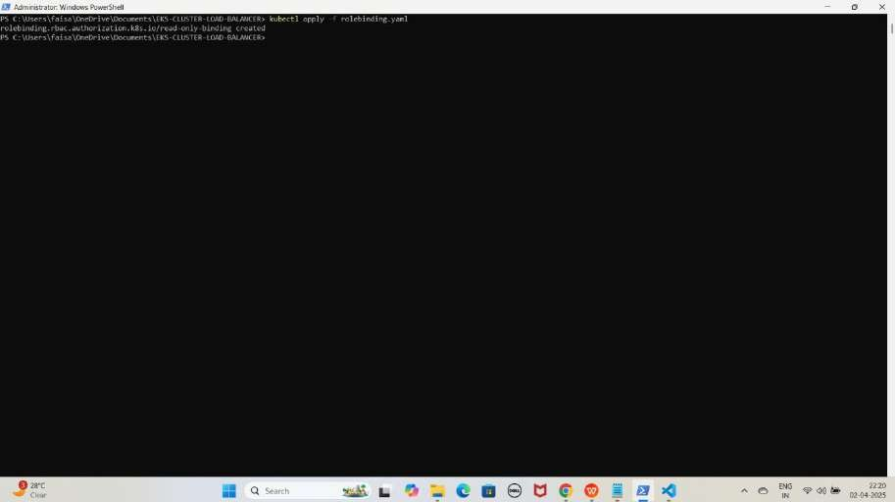YE KUCH ISTARHA LAGEGA

1. **Backend-app-pod.yaml File Ka Kaam**

Yeh **file Docker Hub** par **hosted application image** jo humne create kiya tha uska use karke ek **pod create** karne ke liye use karrahe hai.

JAISE KI:-

apiVersion: v1 kind: Pod metadata:

name: backend-app-pod spec:

containers:

* name: app-container

image: faisalkhan45/backend-app env:

* + name: MYSQL_HOST valueFrom:

configMapKeyRef: name: rds-configmap key: MYSQL_HOST

* + name: MYSQL_USERNAME

valueFrom: secretKeyRef:

name: rds-secrets key: MYSQL_USERNAME

* + name: MYSQL_PASSWORD

valueFrom: secretKeyRef:

name: rds-secrets key: MYSQL_PASSWORD

* + name: ORACLE_HOST

valueFrom: configMapKeyRef:

name: rds-configmap key: ORACLE_HOST

* + name: ORACLE_USERNAME

valueFrom: secretKeyRef:

name: rds-secrets key: ORACLE_USERNAME

* + name: ORACLE_PASSWORD

valueFrom: secretKeyRef:

name: rds-secrets

key: ORACLE_PASSWORD

* name: POSTGRESQL_HOST

valueFrom: configMapKeyRef:

name: rds-configmap key: POSTGRESQL_HOST

* name: POSTGRESQL_USERNAME

valueFrom: secretKeyRef:

name: rds-secrets

key: POSTGRESQL_USERNAME

* name: POSTGRESQL_PASSWORD

valueFrom: secretKeyRef:

name: rds-secrets

key: POSTGRESQL_PASSWORD

Backend App Pod Apply Karo

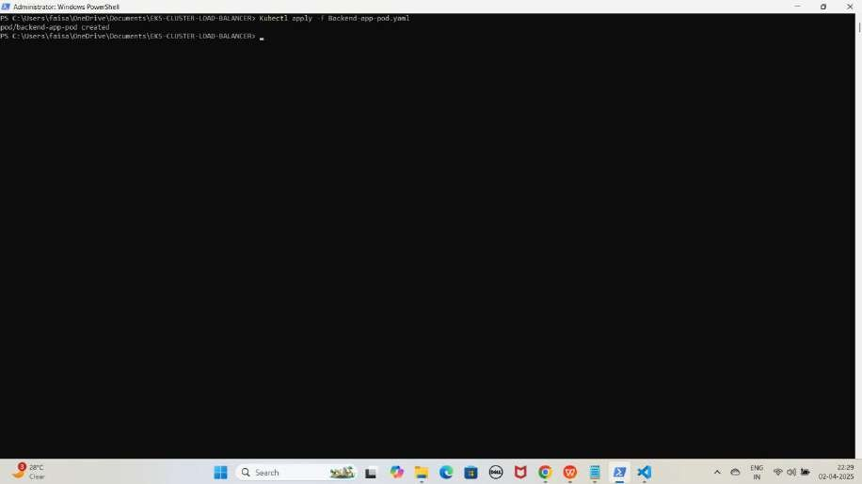Kubectl apply -f Backend-app-pod.yaml YE KUCH ISTARHA LAGEGA

Pods check karne ke liye ye command run karo

kubectl get pods

YE KUCH ISTARHA LAGEGA

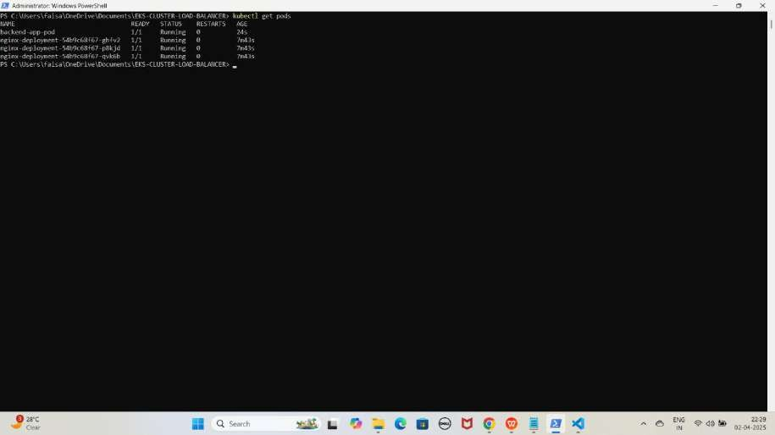

NOTE: Agar sabhi Pods ka STATE Running show karraha hai to sab kuch sahi hai

#### Step 3: Amazon RDS (MySQL) Database Access Karo-Method 1

1. **Pod ke andar jane ke liye ye command run karo**

kubectl exec -it backend-app-pod -- /bin/bash

YE KUCH ISTARHA LAGEGA

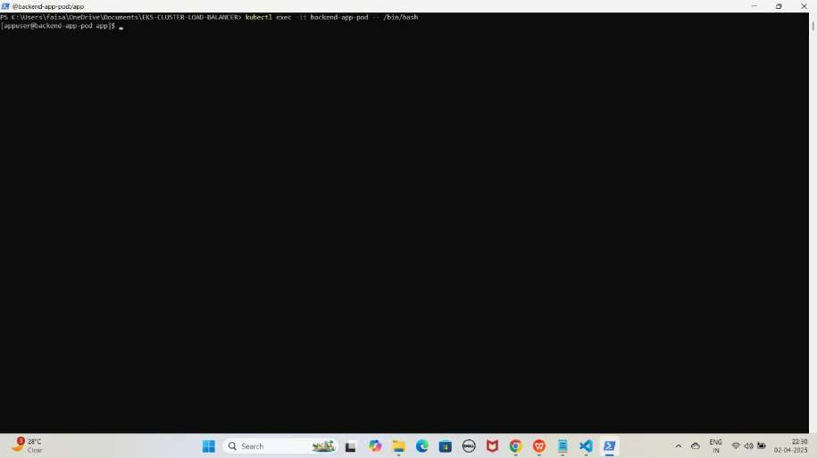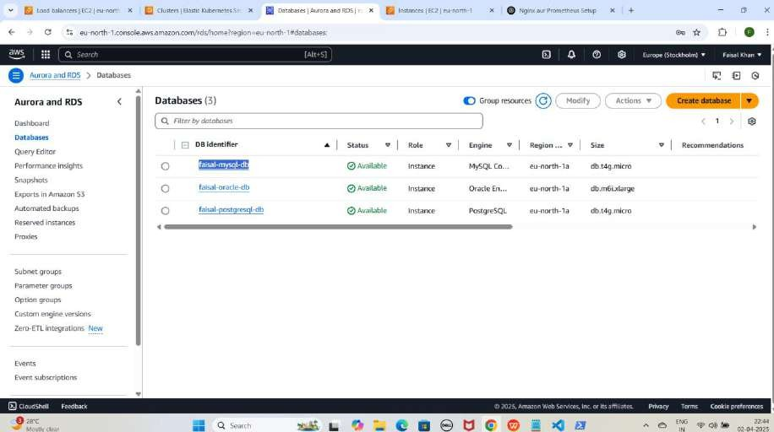

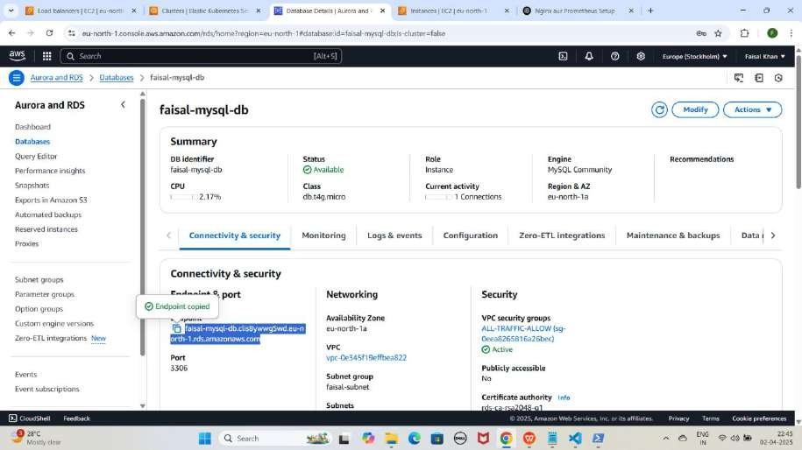

NOTE : Aapko Endpoint aapke database ke According command me bhi update karna hoga

1. **MySQL database se connect karne ke liye ye command kuch istarha hogi**

mysql -h faisal-mysql-db.clis8ywwg5wd.eu-north-1.rds.amazonaws.com -u FaisalKhan -p

YE KUCH ISTARHA LAGEGA

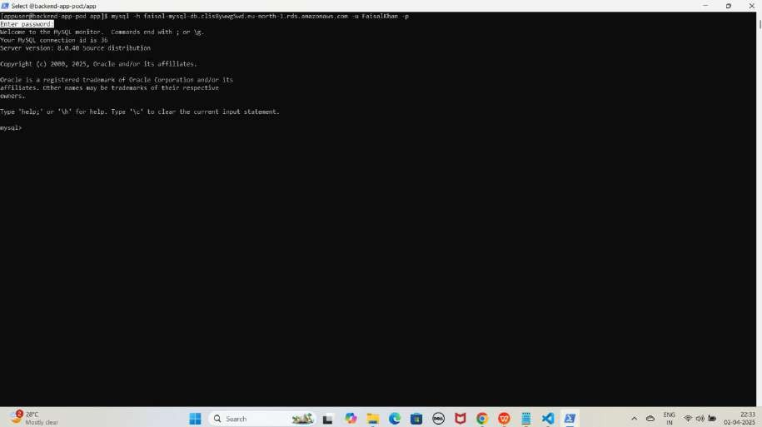

Note: Jab aap se password maanga jaaye, to wahi password use karein jo pehle Base64 encode karke secrets.yaml file me store kiya gaya tha. Maine ‘Faisalkhan35$’ diya tha, lekin password enter karte waqt yeh screen par show nahi hoga.

1. **Database create karne keliye ye command run karo**

CREATE DATABASE faisal_db;

YE KUCH ISTARHA LAGEGA

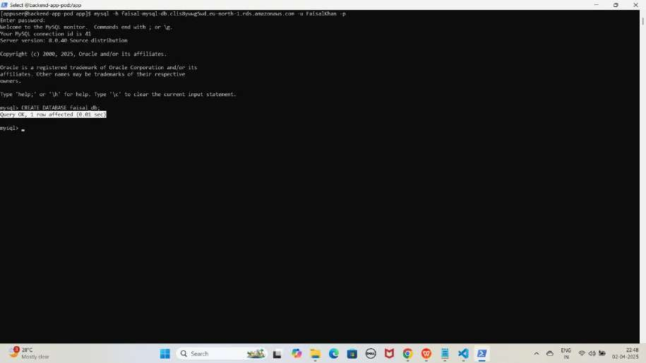

1. **Databases check karne ke liye ye command run kariye**

SHOW DATABASES;

YE KUCH ISTARHA LAGEGA

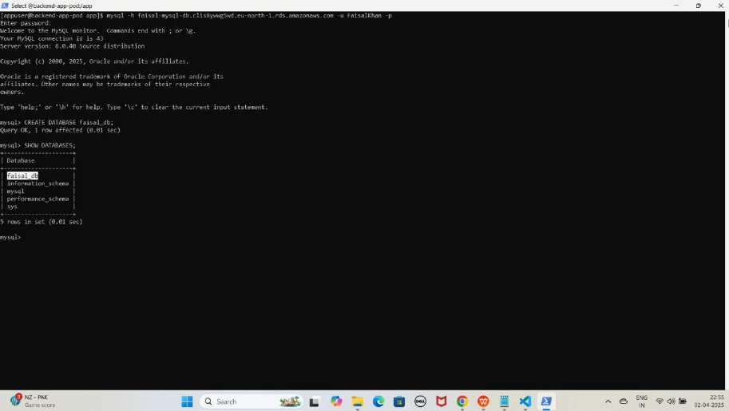

1. **Ab MYSQL database se exit hoagaye exit hone ke liye exit type kariye**

exit

YE KUCH ISTARHA LAGEGA

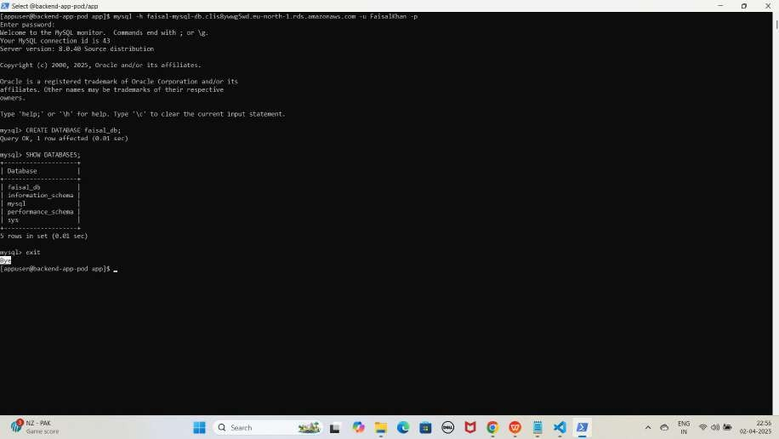

#### Step 4: Amazon RDS (Oracle) Database Access Karo-Method 1

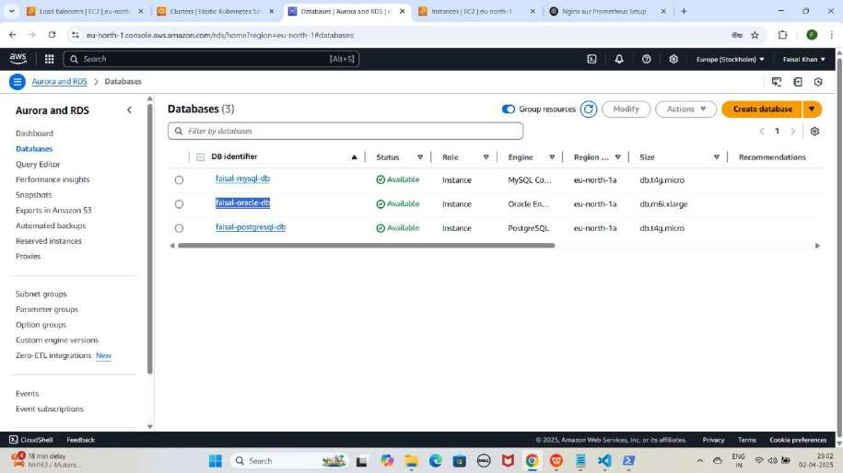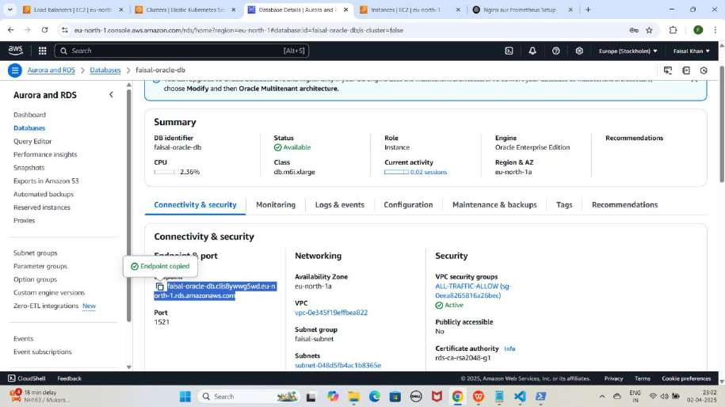

NOTE : Aapko Endpoint aapke database ke According command me bhi update karna hoga

1. **Oracle database se connect karne ke liye ye command kuch istarha hogi**

sqlplus FaisalKhan@//faisal-oracle-db.clis8ywwg5wd.eu-north- 1.rds.amazonaws.com:1521/ORCL

YE KUCH ISTARHA LAGEGA

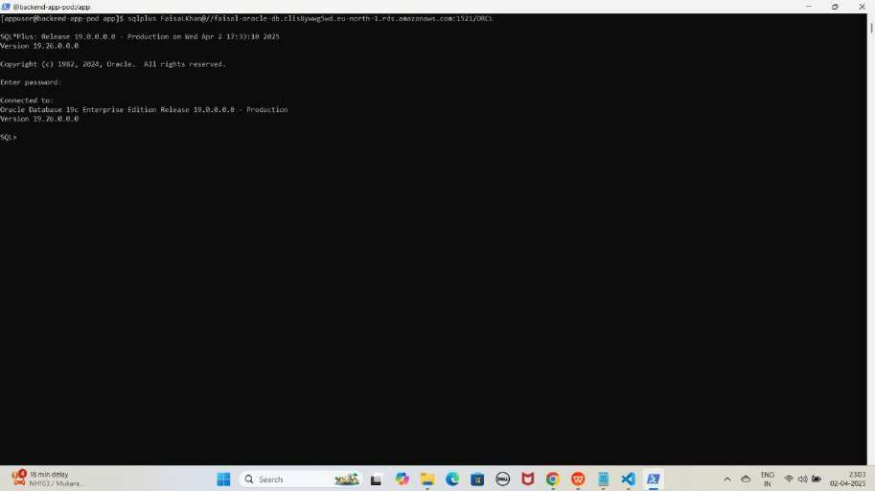

Note: Jab aap se password maanga jaaye, to wahi password use karein jo pehle Base64 encode karke secrets.yaml file me store kiya gaya tha. Maine ‘Faisalkhan35$’ diya tha, lekin password enter karte waqt yeh screen par show nahi hoga.

1. **Database create karne keliye ye command run karo**

CREATE USER "faisal_db" IDENTIFIED BY Faisalkhan35$; YE KUCH ISTARHA LAGEGA

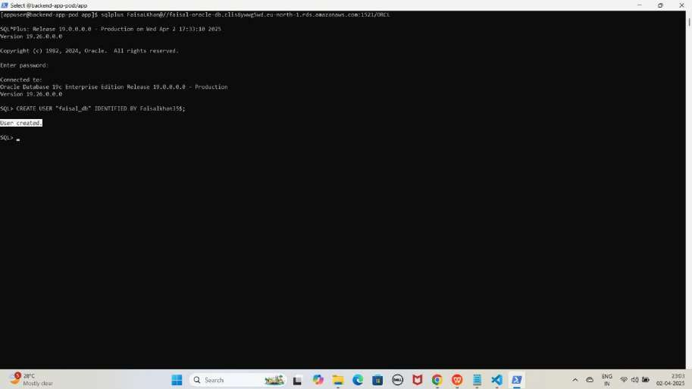

1. **Databases check karne ke liye ye command run kariye**

SELECT username FROM all_users WHERE username = 'faisal_db';

YE KUCH ISTARHA LAGEGA

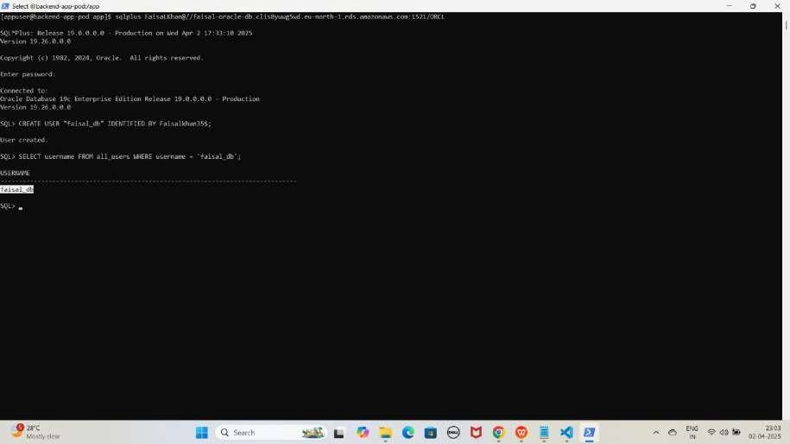

1. **Ab Oracle database se exit hoagaye exit hone ke liye exit type kariye**

exit

YE KUCH ISTARHA LAGEGA

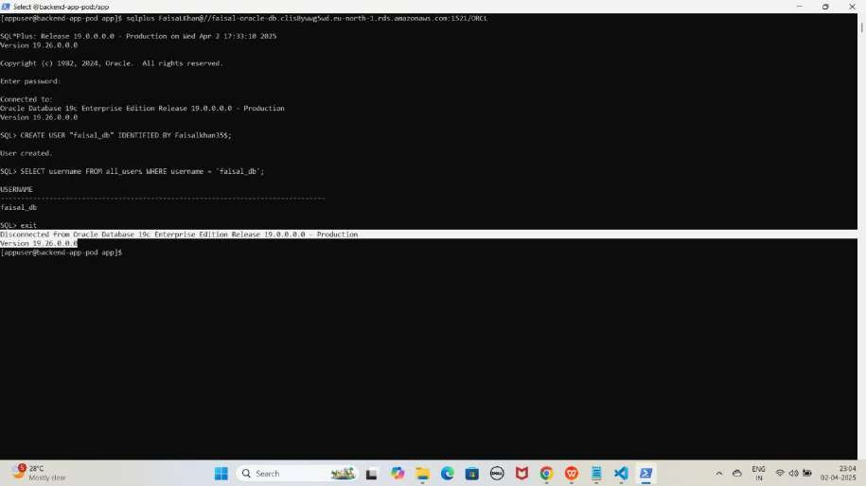

#### Step 5: Amazon RDS (PostgreSQL) Database Access Karo-Method 1

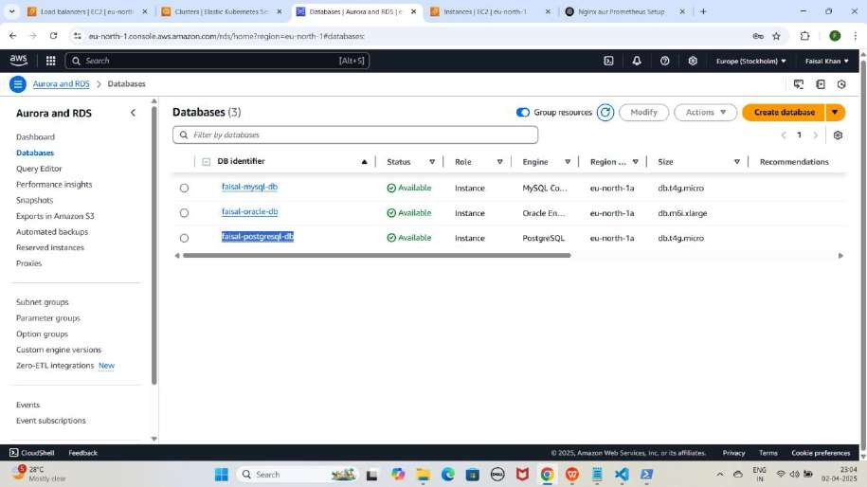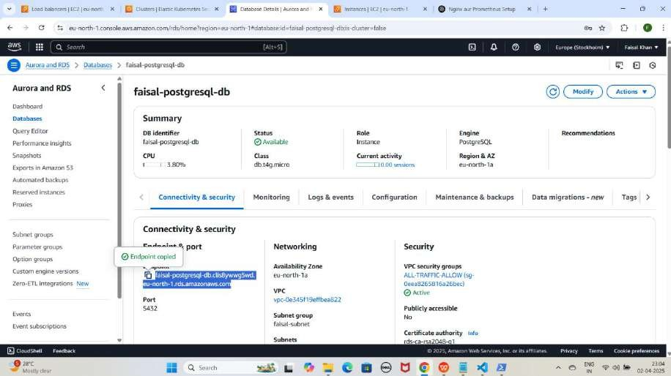

NOTE : Aapko Endpoint aapke database ke According command me bhi update karna hoga

1. **PostgreSQL database se connect karne ke liye ye command kuch istarha hogi**

psql -h faisal-postgresql-db.clis8ywwg5wd.eu-north-1.rds.amazonaws.com - U FaisalKhan -d postgres

YE KUCH ISTARHA LAGEGA

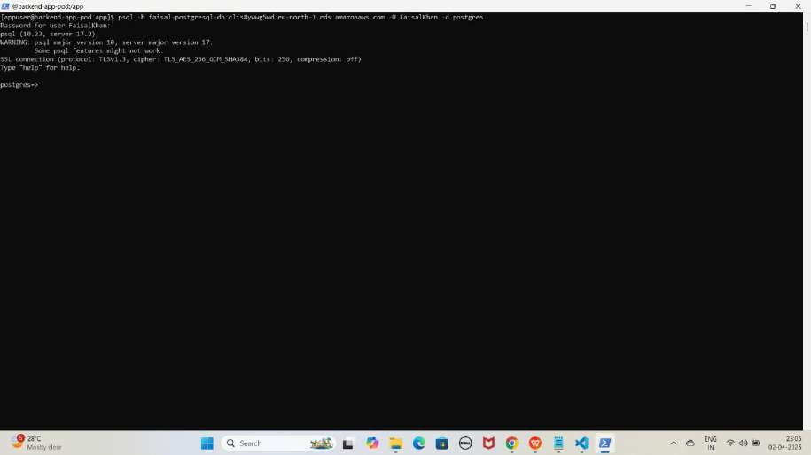

Note: Jab aap se password maanga jaaye, to wahi password use karein jo pehle Base64 encode karke secrets.yaml file me store kiya gaya tha. Maine ‘Faisalkhan35$’ diya tha, lekin password enter karte waqt yeh screen par show nahi hoga.

1. **Database create karne keliye ye command run karein**

CREATE DATABASE faisal_db; YE KUCH ISTARHA LAGEGA

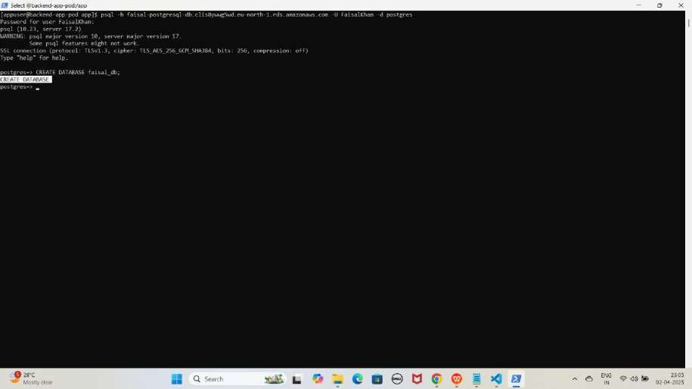

1. **Databases check karne ke liye ye command run kariye**

SELECT datname FROM pg_database;

YE KUCH ISTARHA LAGEGA

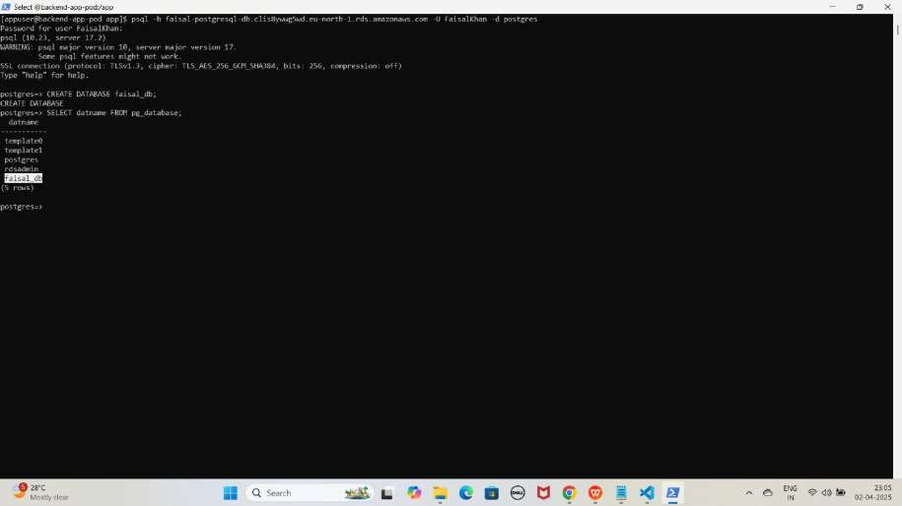

1. **Ab PostgreSQL database se exit hoagaye exit hone ke liye exit typ kariye**

\q

YE KUCH ISTARHA LAGEGA

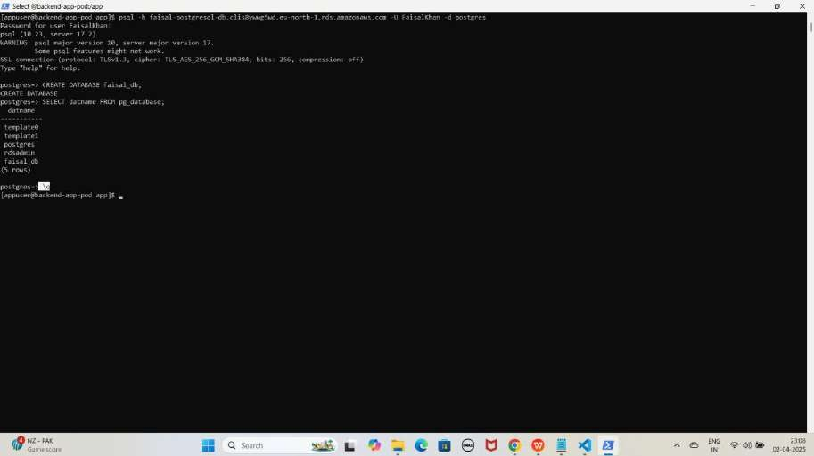

1. **Ab pod se exit hoagaye exit hone ke liye exit type kariye:**

exit

YE KUCH ISTARHA LAGEGA

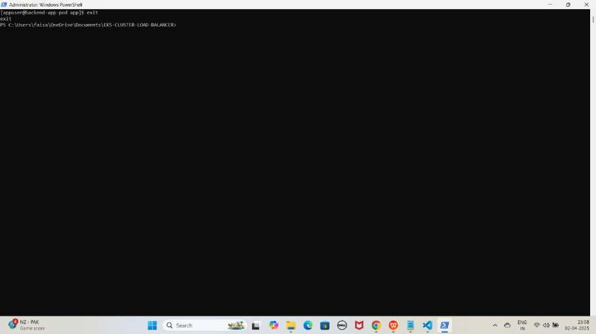

Method 2: Client Pods ke through Database Access Karna (With Endpoint)

#### Step 1: Client Pods ki YAML Files ki Location par Navigate Karo

1. **Location par jao**

cd C:\Users\faisa\OneDrive\Documents\EKS-CLUSTER-LOAD- BALANCER\Multi-DB-CLI-Client-Method

YE KUCH IS TARHA LAGEGA

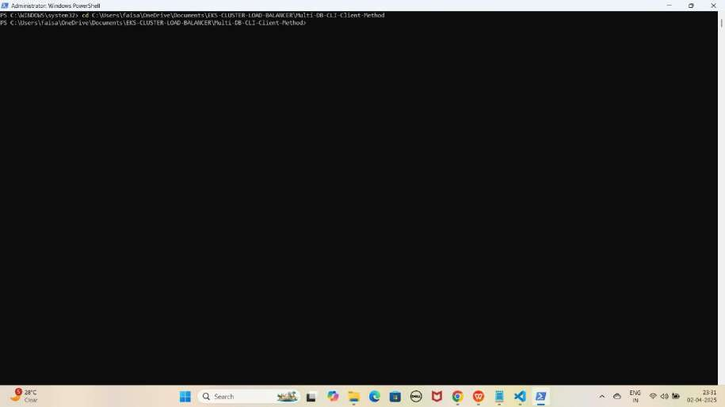

#### Step 2: Client Pods Deploy karo

**Client Pods** ka kaam **database** se **securely connect** hona aur uska access lena hota hai. Yeh **pods databases (MySQL, PostgreSQL, aur Oracle) Database se connect hoke data retrieve** karne ya **update** karne ke liye use hote hain.

1. **Client Method me files jo hum use karenge**
2. **mysql-client.yaml**
3. **oracle-client.yaml**
4. **postgresql-client.yaml**
5. **mysql-client.yaml File Ka Kaam**

Yeh **file MySQL client image** ka **pod create** karne ke liye use hoti hai, jisse hum **Amazon RDS MySQL** ko **access** kar sakte hain.

JAISE KI:-

apiVersion: v1 kind: Pod metadata:

name: mysql-client spec:

containers:

- name: mysql

image: mysql:latest # Prebuilt MySQL client image from Docker Hub command: [ "sleep", "infinity" ] # Keeps the container running

MYSQL Client Apply Karo

kubectl apply -f mysql-client.yaml

YE KUCH ISTARHA LAGEGA

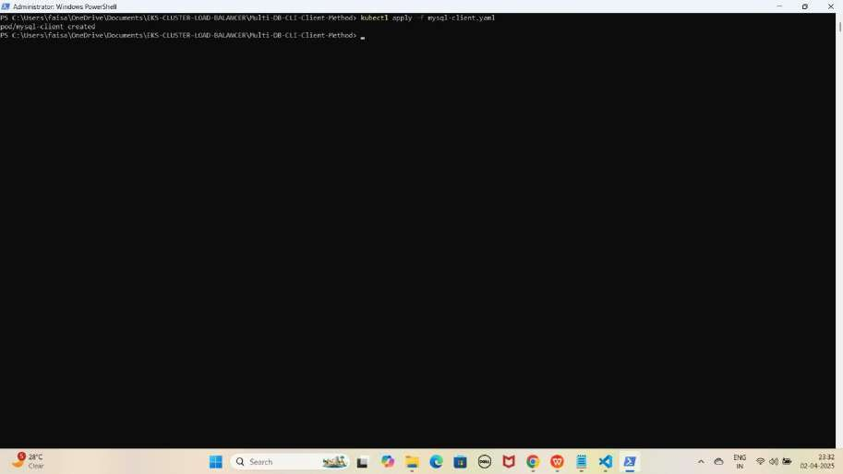

1. **oracle-client.yaml File Ka Kaam**

Yeh **file Oracle client image** ka **pod create** karne ke liye use hoti hai, jisse hum **Amazon RDS Oracle** ko **access** kar sakte hain.

JAISE KI:-

apiVersion: v1 kind: Pod metadata:

name: oracle-client spec:

containers:

- name: oracle-client

image: ghcr.io/oracle/oraclelinux8-instantclient:21 # Oracle Instant Client image command: [ "sleep", "infinity" ] # Keeps the container running for exec access

Oracle Client Apply Karo

kubectl apply -f oracle-client.yaml

YE KUCH ISTARHA LAGEGA

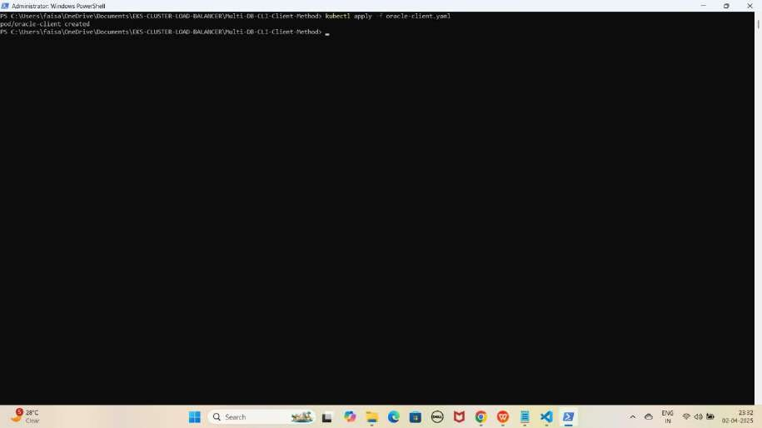

1. **postgresql-client.yaml File Ka Kaam**

Yeh **file PostgreSQL client image** ka **pod create** karne ke liye use hoti hai, jisse hum **Amazon RDS PostgreSQL** ko **access** kar sakte hain.

JAISE KI:-

apiVersion: v1 kind: Pod metadata:

name: postgresql-client spec:

containers:

- name: postgresql-client

image: postgres:latest # Prebuilt PostgreSQL client image from Docker Hub

command: [ "sleep", "infinity" ] # Keeps the container running so you can exec into it later

PostgreSQL Client Apply Karo

kubectl apply -f postgresql-client.yaml

YE KUCH ISTARHA LAGEGA

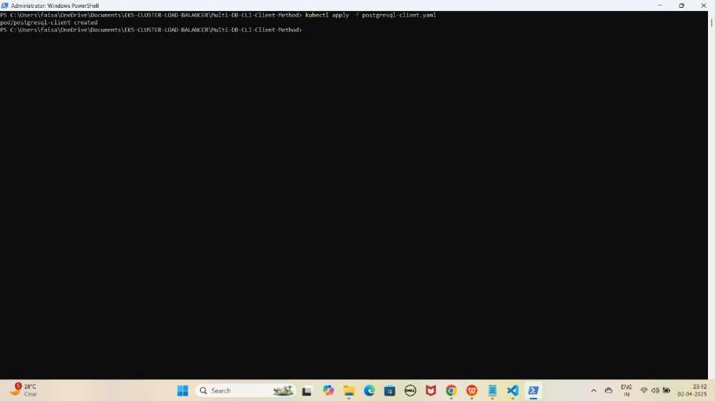

1. **Client pods check karne ke liye ye command run karo**

kubectl get pods

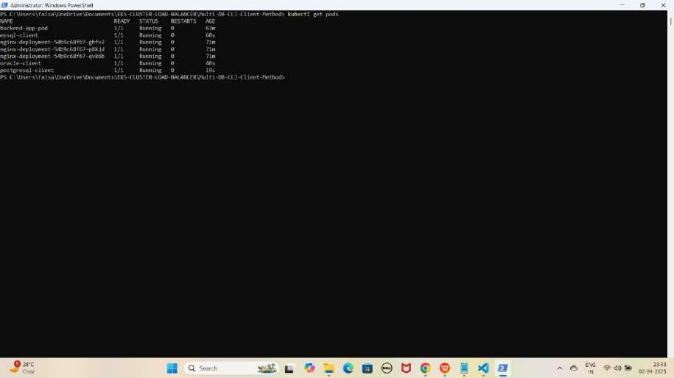

NOTE: Agar sabhi pods, including client pods, STATUS Running show karraha hai, to sab kuch sahi hai.

#### Step 3: Amazon RDS (MySQL) Database Access Karo-Method 2

1. **MySQL client pod me jane ke liye ye command run kaiye**

kubectl exec -it mysql-client -- /bin/bash

YE KUCH ISTARHA LAGEGA

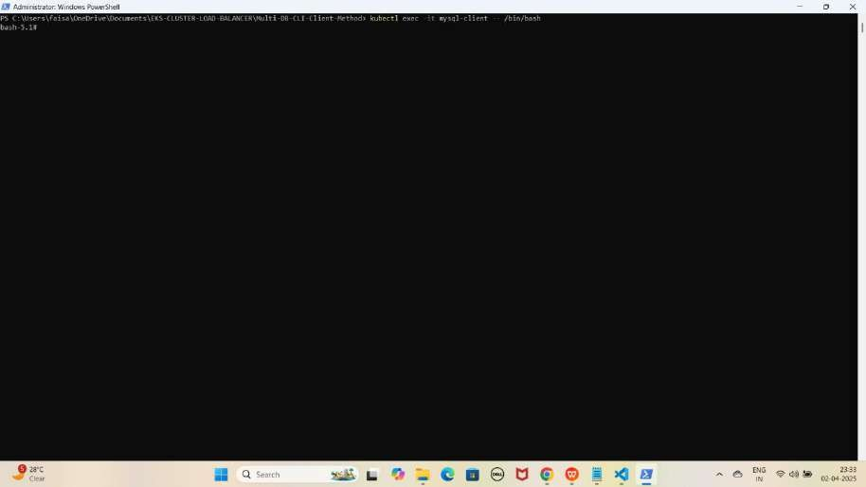

1. **MYSQL database se connect karne ke liye ye command kuch istarha hogi**

mysql -h faisal-mysql-db.clis8ywwg5wd.eu-north-1.rds.amazonaws.com -u FaisalKhan -p

YE KUCH ISTARHA LAGEGA

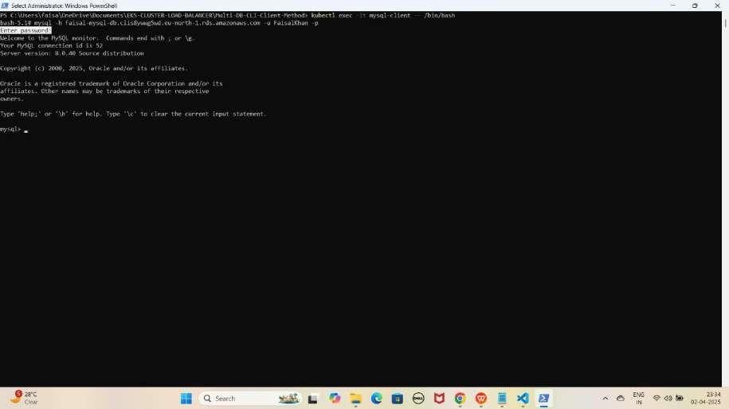

Note: Jab aap se password maanga jaaye, to wahi password use karein jo pehle Base64 encode karke rds-secrets.yaml file me store kiya gaya tha. Maine ‘Faisalkhan35$’ diya tha, lekin password enter karte waqt yeh screen par show nahi hoga.

1. **Databases check karne ke liye ye command run kariye**

SHOW DATABASES;

YE KUCH ISTARHA LAGEGA

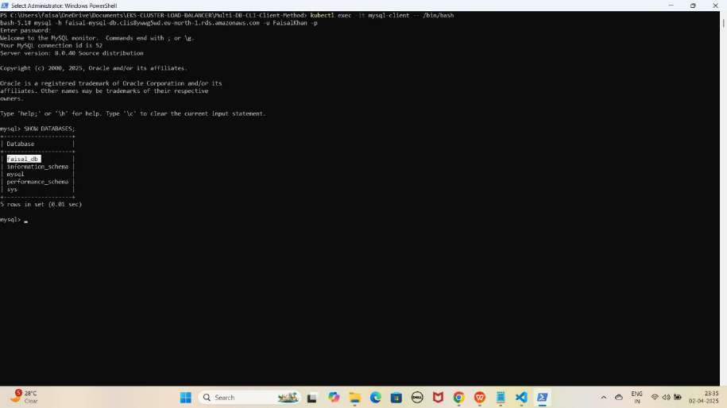

NOTE: Yahan hum dobara database create nahi karenge, kyunki pehle hi Method 1 mein create kar chuke hain. Hum sirf ye check karenge ki database available hai ya nahi.

1. **MYSQL database se exit hoagaye exit hone ke liye exit type kariye**

exit

YE KUCH ISTARHA LAGEGA

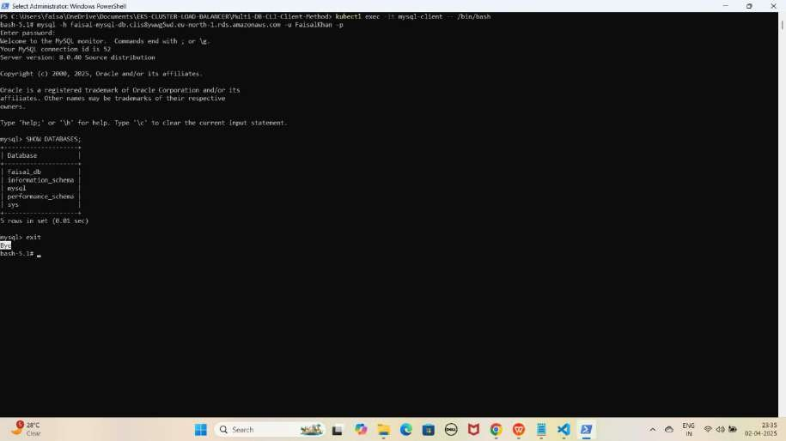

1. **MYSQL client pod se bhi exit hoagaye exit hone ke liye exit type kariye**

exit

YE KUCH ISTARHA LAGEGA

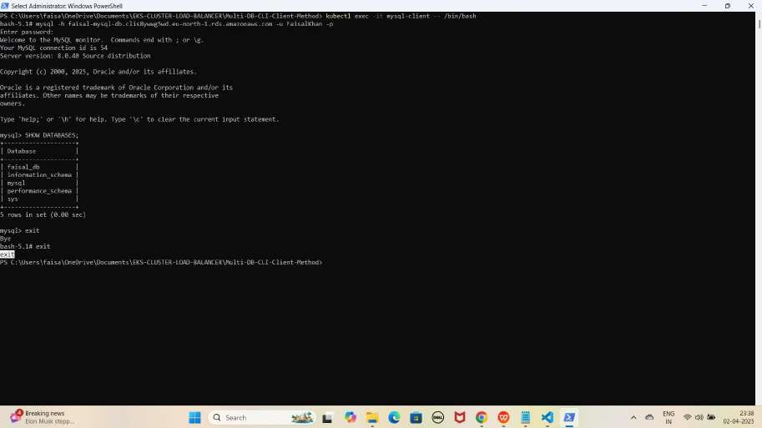

#### Step 4: Amazon RDS (Oracle) Database Access Karo-Method 2

1. **Oracle client pod me jane ke liye ye command run kaiye**

kubectl exec -it oracle-client -- /bin/bash

YE KUCH ISTARHA LAGEGA

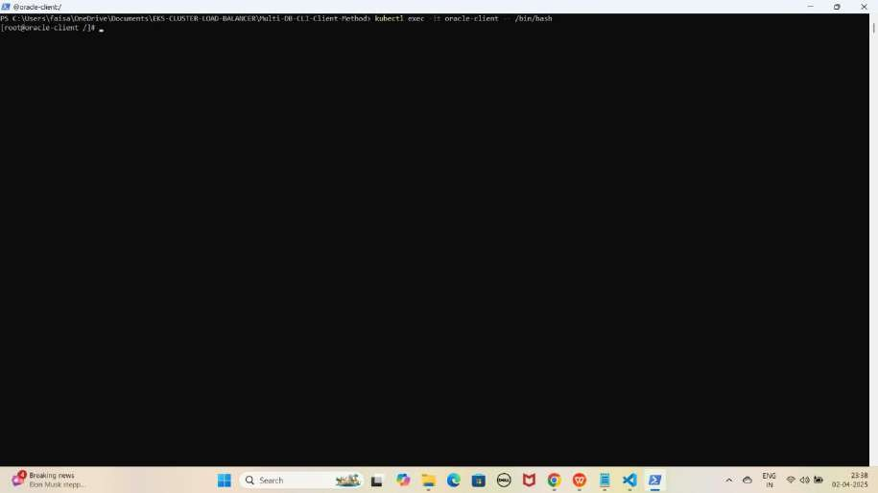

1. **Oracle database se connect karne ke liye ye command kuch istarha hogi**

sqlplus FaisalKhan@//faisal-oracle-db.clis8ywwg5wd.eu-north- 1.rds.amazonaws.com:1521/ORCL

YE KUCH ISTARHA LAGEGA

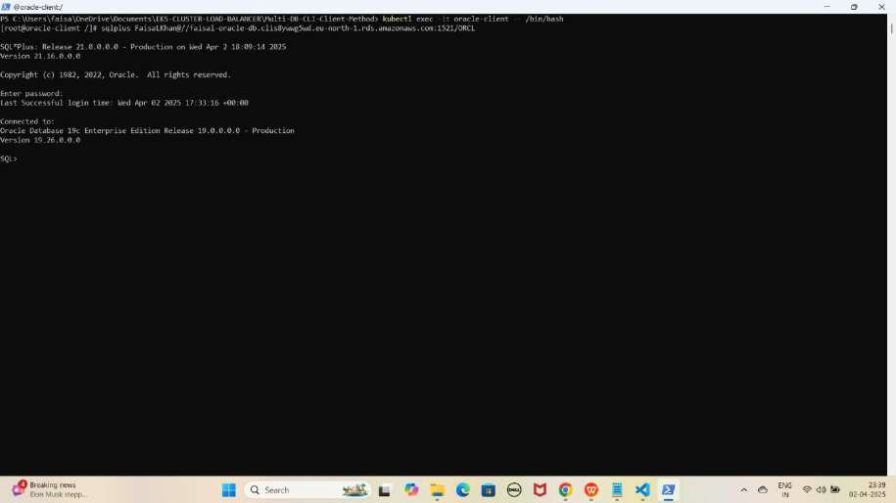

Note: Jab aap se password maanga jaaye, to wahi password use karein jo pehle Base64 encode karke rds-secrets.yaml file me store kiya gaya tha. Maine ‘Faisalkhan35$’ diya tha, lekin password enter karte waqt yeh screen par show nahi hoga.

1. **Databases check karne ke liye ye command run kariye**

SELECT username FROM all_users WHERE username = 'faisal_db';

YE KUCH ISTARHA LAGEGA

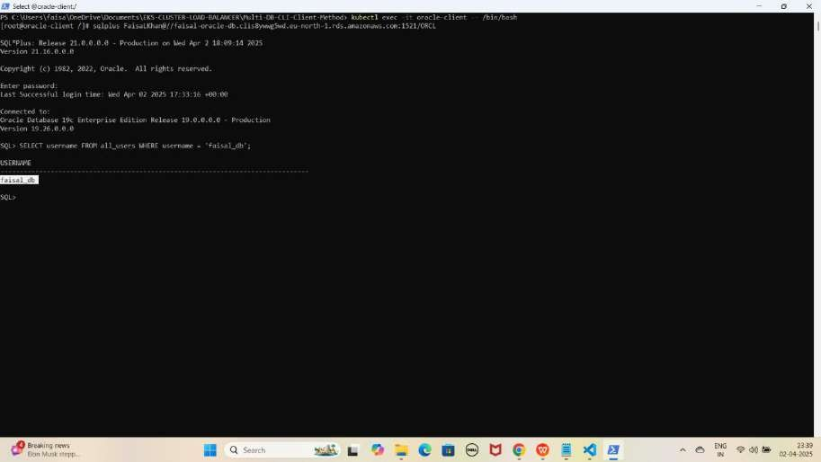

NOTE: Yahan hum dobara database create nahi karenge, kyunki pehle hi Method 1 mein create kar chuke hain. Hum sirf ye check karenge ki database available hai ya nahi.

1. **Oracle database se exit hoagaye exit hone ke liye exit type kariye**

exit

YE KUCH ISTARHA LAGEGA

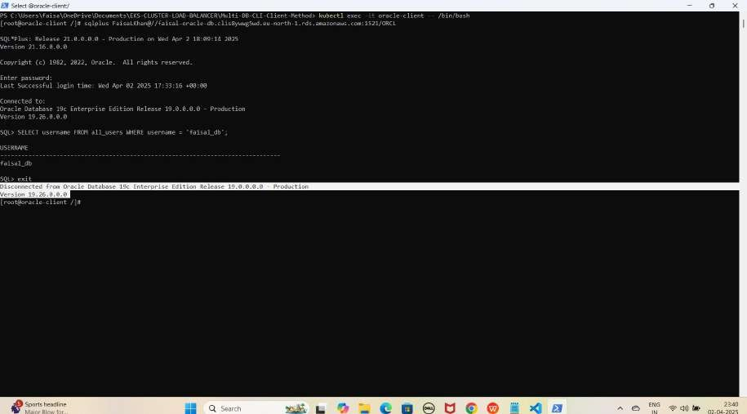

1. **Oracle client pod se bhi exit hoagaye exit hone ke liye exit type kariye**

exit

YE KUCH ISTARHA LAGEGA

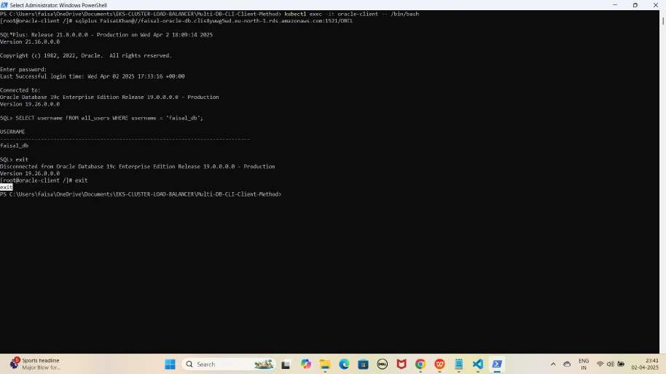

#### Step 5: Amazon RDS (PostgreSQL) Database Access Karo-Method 2

1. **PostgreSQL client pod me jane ke liye ye command run kaiye**

kubectl exec -it postgresql-client -- /bin/bash

YE KUCH ISTARHA LAGEGA

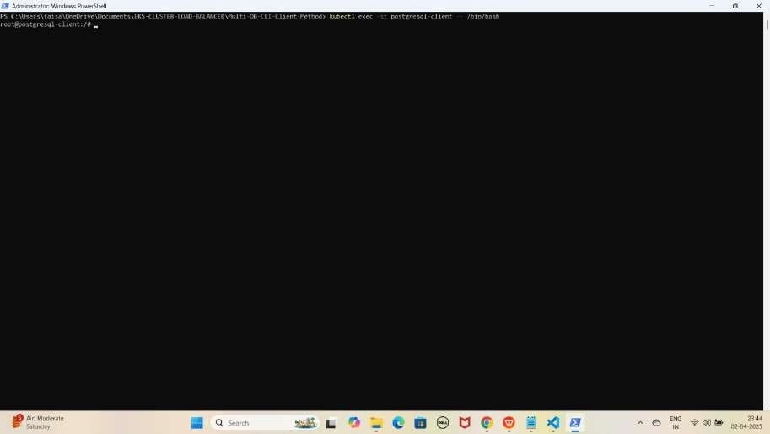

1. **PostgreSQL database se connect karne ke liye ye command kuch istarha hogi**

psql -h faisal-postgresql-db.clis8ywwg5wd.eu-north-1.rds.amazonaws.com - U FaisalKhan -d postgres

YE KUCH ISTARHA LAGEGA

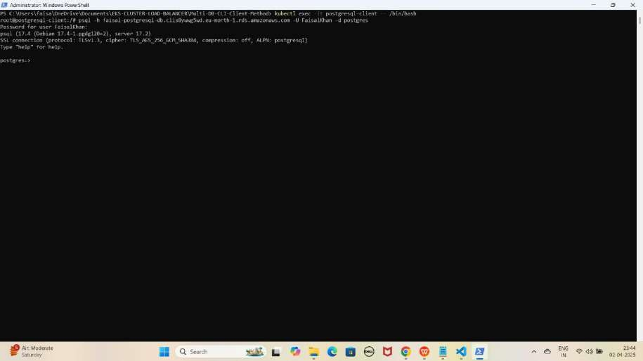

Note: Jab aap se password maanga jaaye, to wahi password use karein jo pehle Base64 encode karke rds-secrets.yaml file me store kiya gaya tha. Maine ‘Faisalkhan35$’ diya tha, lekin password enter karte waqt yeh screen par show nahi hoga.

1. **Databases check karne ke liye ye command run kariye**

SELECT datname FROM pg_database;

YE KUCH ISTARHA LAGEGA

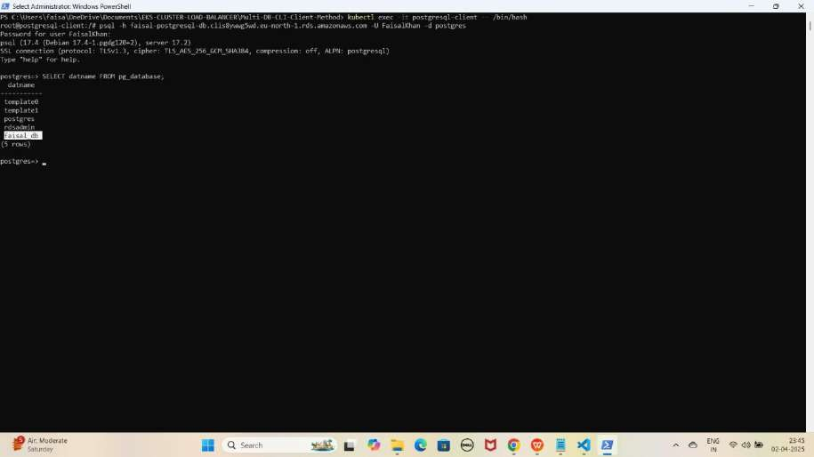

NOTE: Yahan hum dobara database create nahi karenge, kyunki pehle hi Method 1 mein create kar chuke hain. Hum sirf ye check karenge ki database available hai ya nahi.

1. **PostgreSQL database se exit hoagaye exit hone ke liye exit type kariye**

\q

YE KUCH ISTARHA LAGEGA

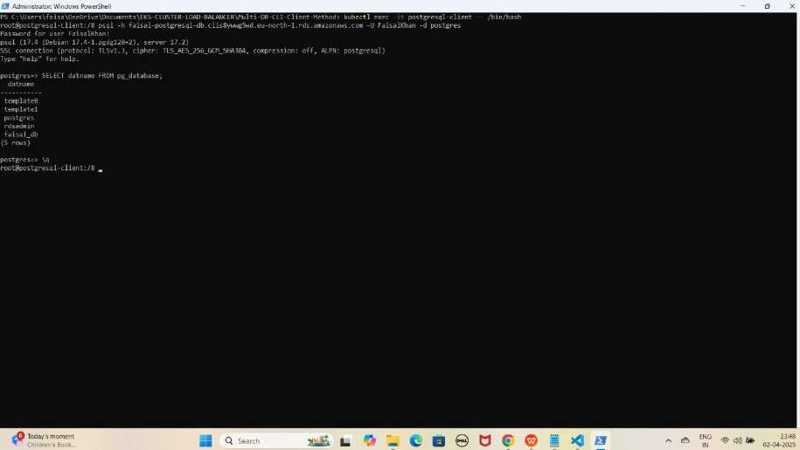

1. **PostgreSQL client pod se bhi exit hoagaye exit hone ke liye exit type kariye**

exit

YE KUCH ISTARHA LAGEGA

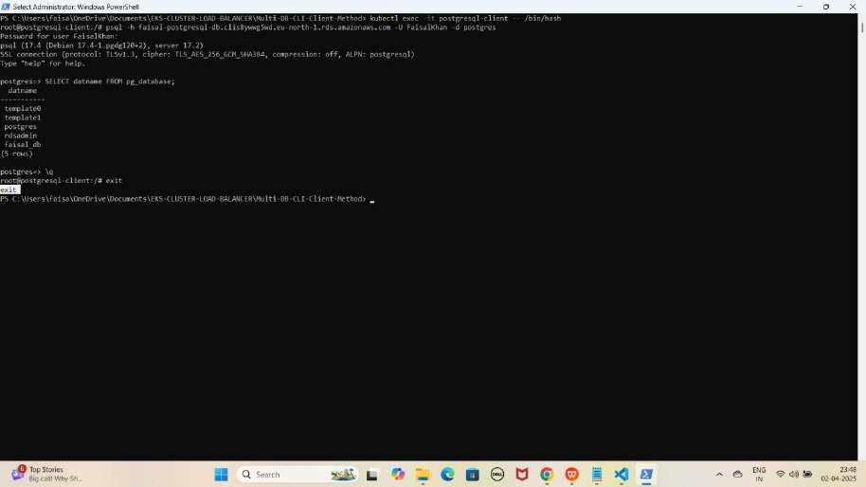

## Part 9: Accessing Amazon RDS (MySQL, Oracle, PostgreSQL) from an EKS Cluster (Without Hardcoded Endpoint)

Method 1: Application ke through Database Access Karna (Without Hardcoded Endpoint)

#### Step 1: external-name.yaml file ka kaam

Jab bhi humein **RDS ko access** karna hota hai, toh humein har baar uska **endpoint** dena padhta hai, jo kafi **time-consuming** aur **hardcoded** ho jata hai. Is issue ko solve karne ke liye hum **ExternalName service** ka use kar rahe hain. Yeh method easy hai aur har baar **RDS ka endpoint** type karne ki zaroorat nahi hoti. Bas **external name service** apply karni hai aur **short name** se **RDS connect** kar sakte hain.

First aapko aapke **RDS Databases** ke **endpoints** ko **external-name.yaml** me

**update** karna hoga

YE KUCH ISTARHA LAGEGA

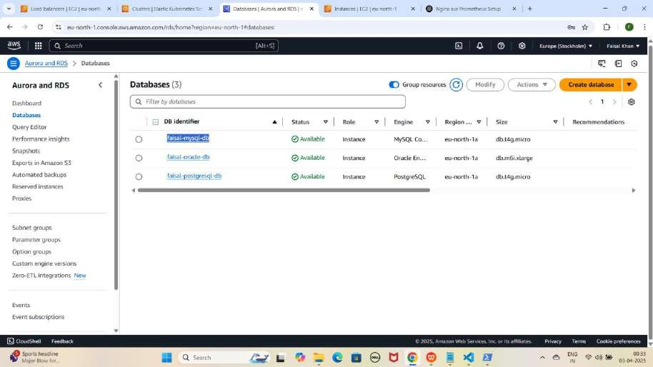

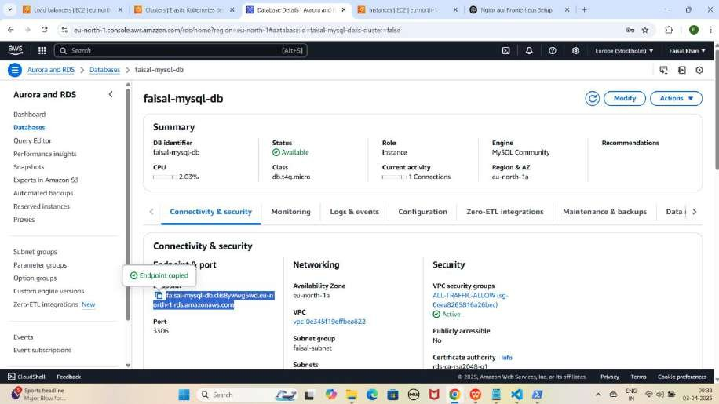

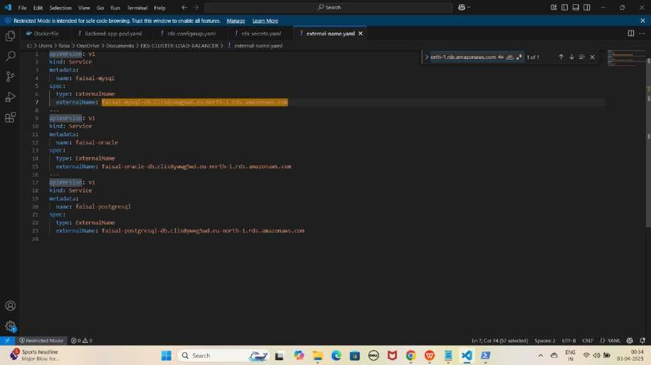

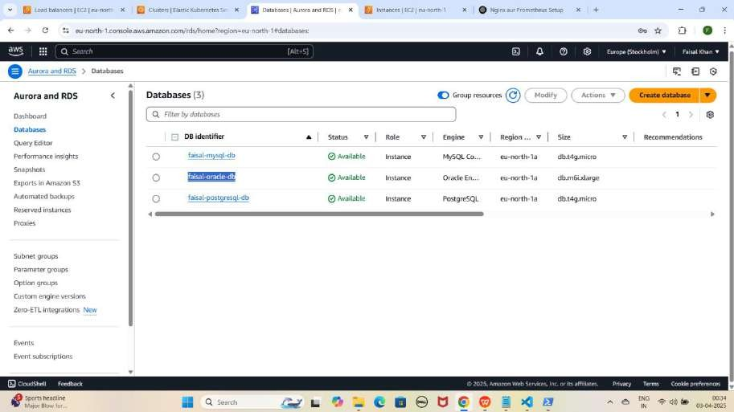

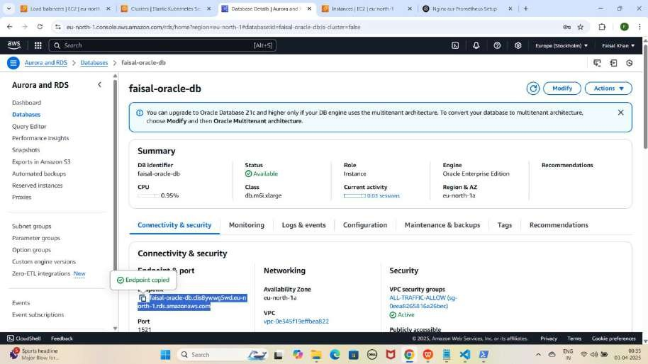

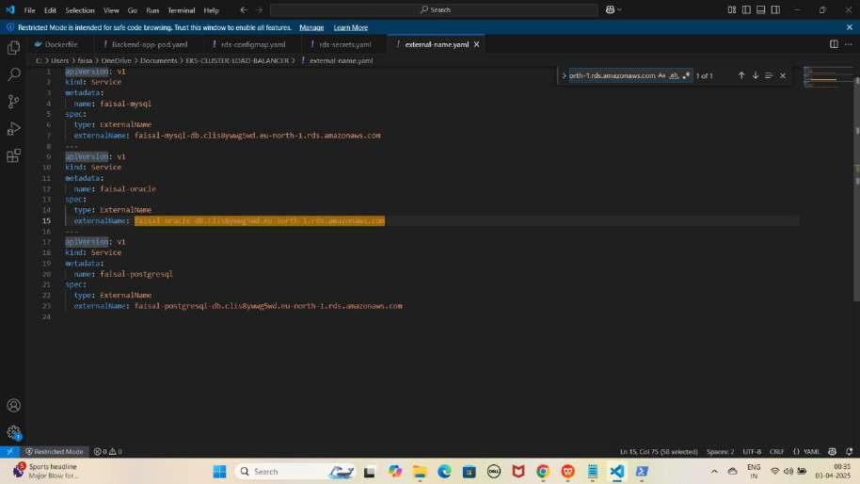

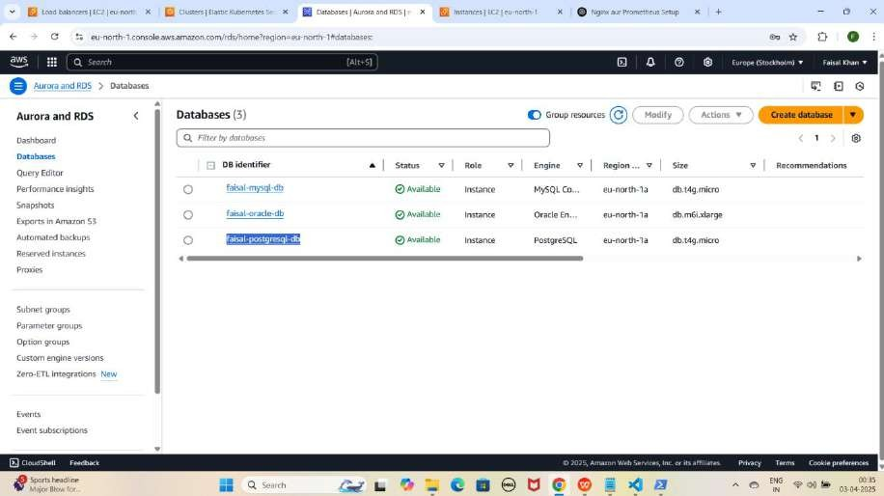

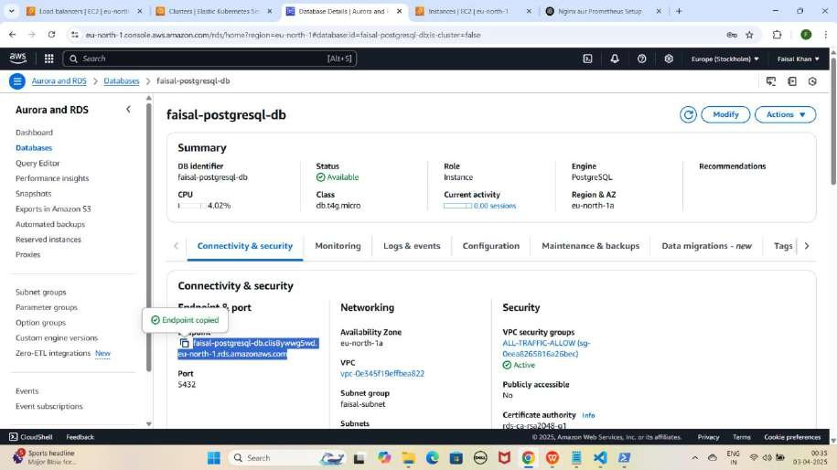

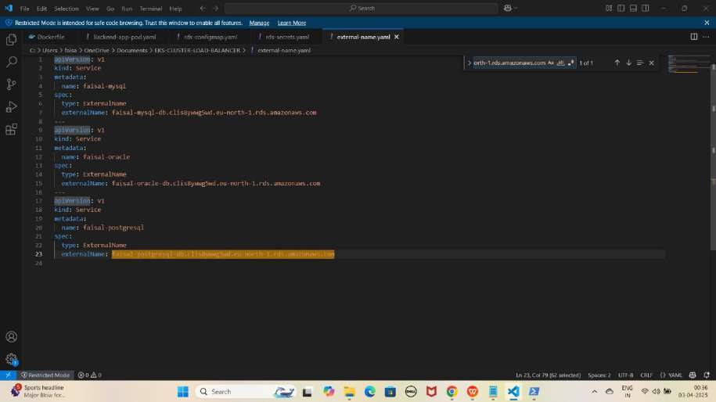

JAISE KI:-

apiVersion: v1 kind: Service metadata:

name: faisal-mysql spec:

type: ExternalName

externalName: faisal-mysql-db.clis8ywwg5wd.eu-north-1.rds.amazonaws.com

---

apiVersion: v1 kind: Service metadata:

name: faisal-oracle spec:

type: ExternalName

externalName: faisal-oracle-db.clis8ywwg5wd.eu-north-1.rds.amazonaws.com

---

apiVersion: v1 kind: Service metadata:

name: faisal-postgresql spec:

type: ExternalName

externalName: faisal-postgresql-db.clis8ywwg5wd.eu-north-1.rds.amazonaws.com

NOTE: Agar aap apna naam use kar rahe hain, to phir commands bhi usi ke according apply karni hongi.

1. **Location par jao**

cd C:\Users\faisa\OneDrive\Documents\EKS-CLUSTER-LOAD-BALANCER YE KUCH ISTARHA LAGEGA

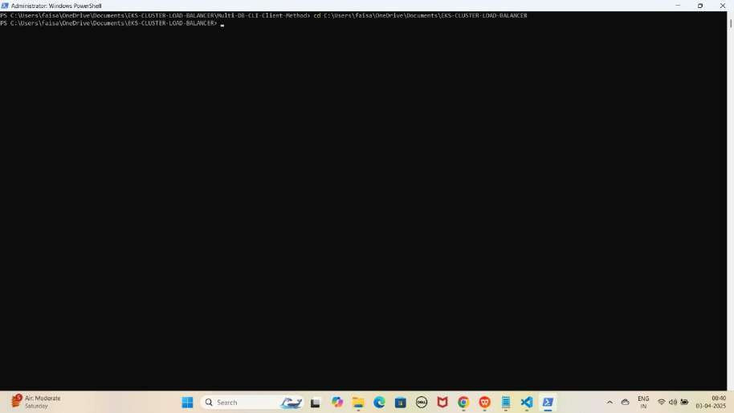

External Name Service Apply Karo

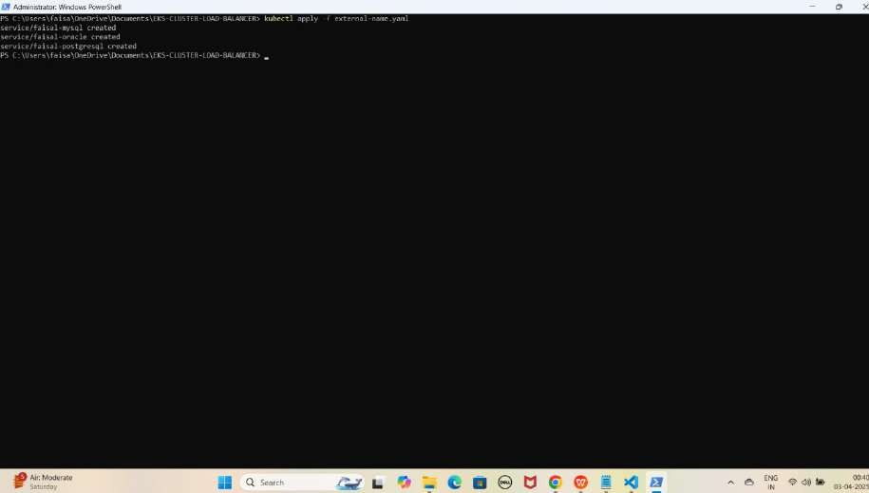kubectl apply -f external-name.yaml YE KUCH ISTARHA LAGEGA

#### Step 2: Amazon RDS (MySQL) Database Access Karo-Method 1

1. **Pod ke andar jane ke liye ye command run karo**

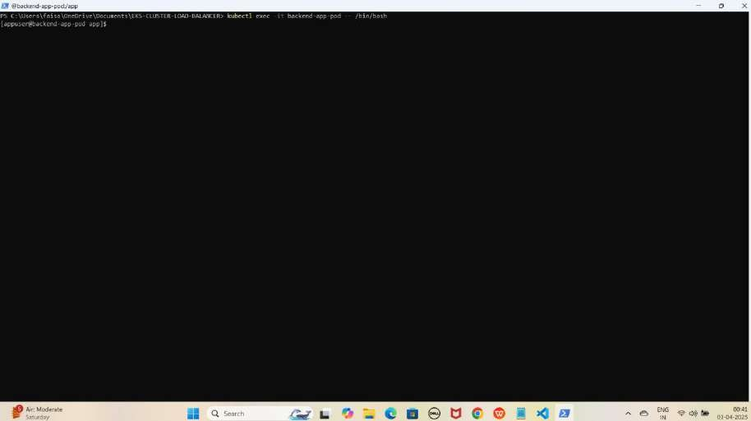kubectl exec -it backend-app-pod -- /bin/bash YE KUCH ISTARHA LAGEGA

1. **MySQL database se connect karne ke liye ye command kuch istarha hogi**

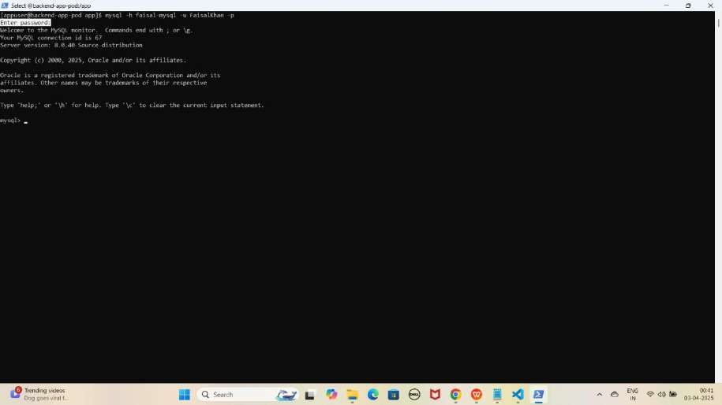mysql -h faisal-mysql -u FaisalKhan -p YE KUCH ISTARHA LAGEGA

Note: Jab aap se password maanga jaaye, to wahi password use karein jo pehle Base64 encode karke rds-secrets.yaml file me store kiya gaya tha. Maine ‘Faisalkhan35$’ diya tha, lekin password enter karte waqt yeh screen par show nahi hoga.

1. **Databases check karne ke liye ye command run kariye**

SHOW DATABASES;

YE KUCH ISTARHA LAGEGA

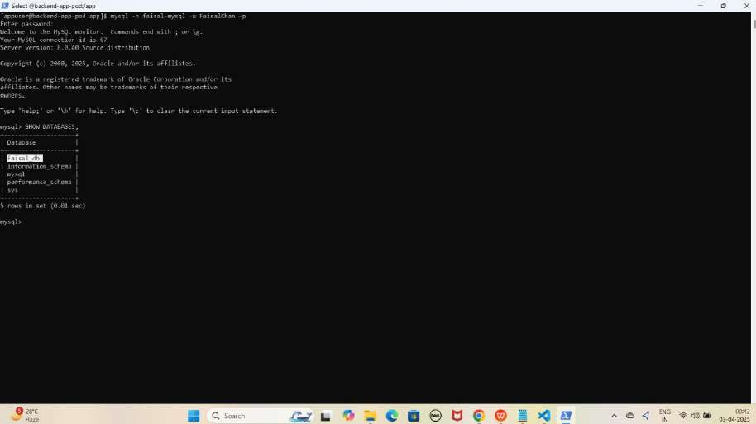

NOTE: Yahan par hum dobara database create nahi karenge, kyunki pehle Method 1 mein create kar chuke hain. Sirf endpoint replace karne ke liye humne ExternalName service ka use kiya hai.

1. **Ab MYSQL database se exit hoagaye exit hone ke liye exit type kariye**

exit

YE KUCH ISTARHA LAGEGA

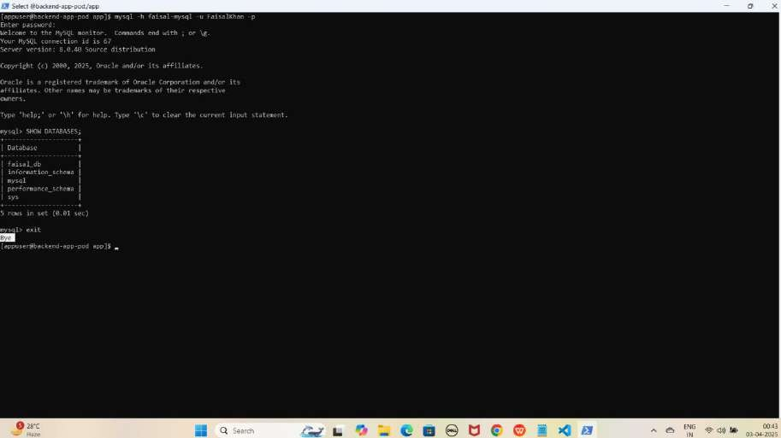

#### Step 3: Amazon RDS (Oracle) Database Access Karo-Method 1

1. **Oracle database se connect karne ke liye ye command kuch istarha hogi**

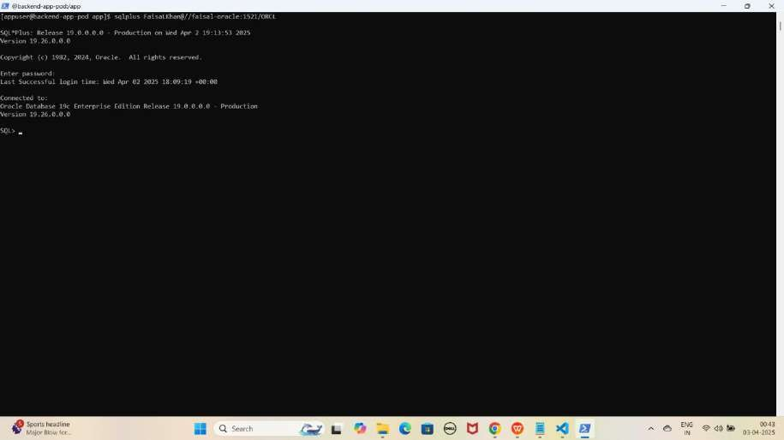sqlplus FaisalKhan@//faisal-oracle:1521/ORCL YE KUCH ISTARHA LAGEGA

Note: Jab aap se password maanga jaaye, to wahi password use karein jo pehle Base64 encode karke rds-secrets.yaml file me store kiya gaya tha. Maine ‘Faisalkhan35$’ diya tha, lekin password enter karte waqt yeh screen par show nahi hoga.

1. **Databases check karne ke liye ye command run kariye**

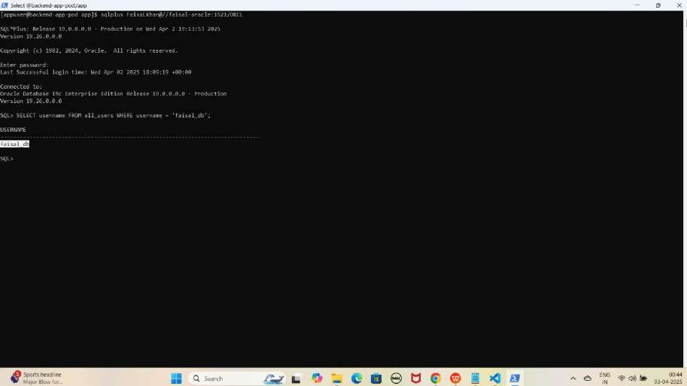SELECT username FROM all_users WHERE username = 'faisal_db'; YE KUCH ISTARHA LAGEGA

NOTE: Yahan hum dobara database create nahi karenge, kyunki pehle hi Method 1 mein create kar chuke hain. Hum sirf ye check karenge ki database available hai ya nahi.

1. **Ab Oracle database se exit hoagaye exit hone ke liye exit type kariye**

exit

YE KUCH ISTARHA LAGEGA

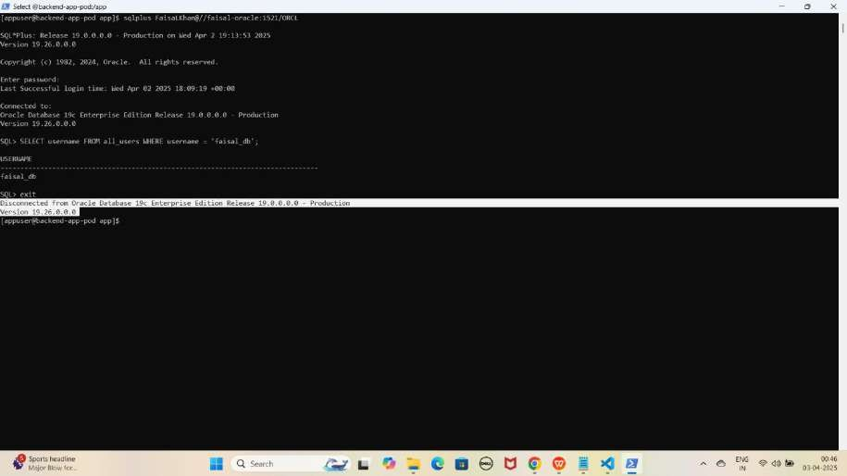

#### Step 4: Amazon RDS (PostgreSQL) Database Access Karo-Method 1

1. **PostgreSQL database se connect karne ke liye ye command kuch istarha hogi**

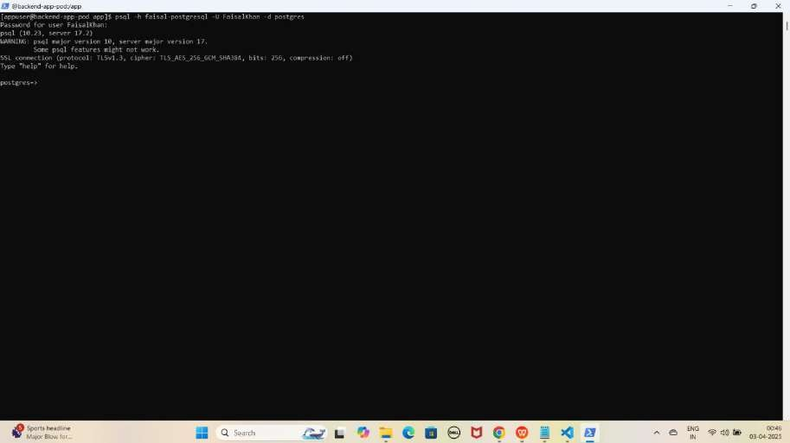psql -h faisal-postgresql -U FaisalKhan -d postgres YE KUCH ISTARHA LAGEGA

Note: Jab aap se password maanga jaaye, to wahi password use karein jo pehle Base64 encode karke rds-secrets.yaml file me store kiya gaya tha. Maine ‘Faisalkhan35$’ diya tha, lekin password enter karte waqt yeh screen par show nahi hoga.

1. **Databases check karne ke liye ye command run kariye**

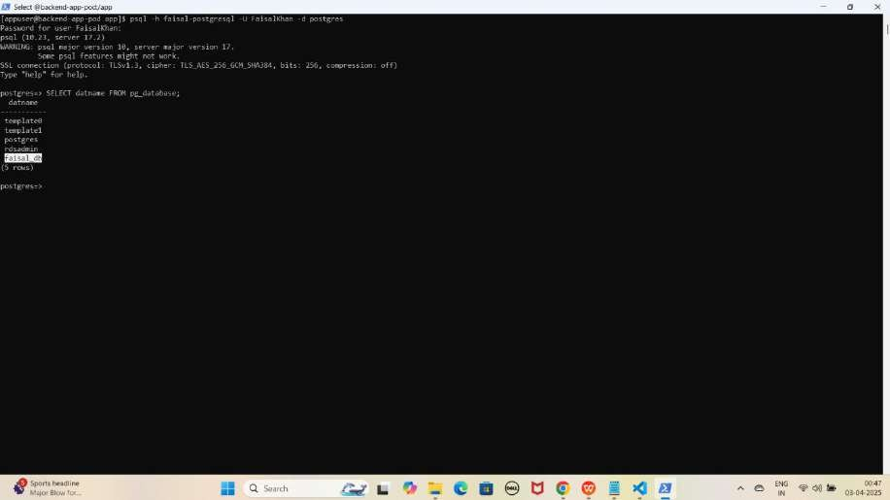SELECT datname FROM pg_database; YE KUCH ISTARHA LAGEGA

NOTE: Yahan hum dobara database create nahi karenge, kyunki pehle hi Method 1 mein create kar chuke hain. Hum sirf ye check karenge ki database available hai ya nahi.

1. **Ab PostgreSQL database se exit hoagaye exit hone ke liye exit type kariye**

\q

YE KUCH ISTARHA LAGEGA

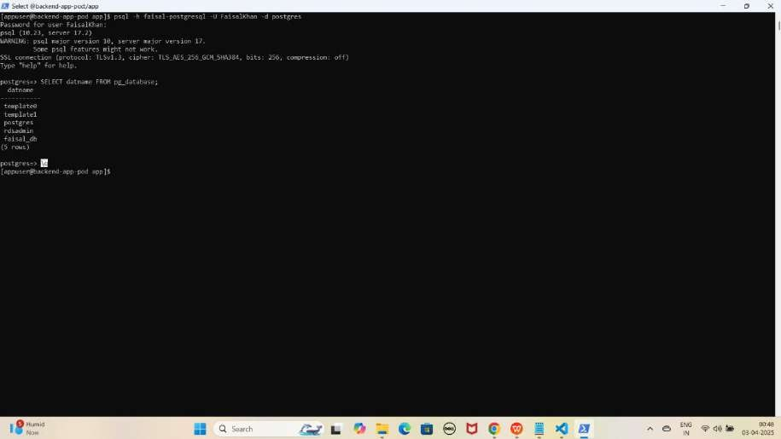

1. **Ab pod se bhi exit hoagaye exit hone ke liye exit type kariye**

exit

YE KUCH ISTARHA LAGEGA

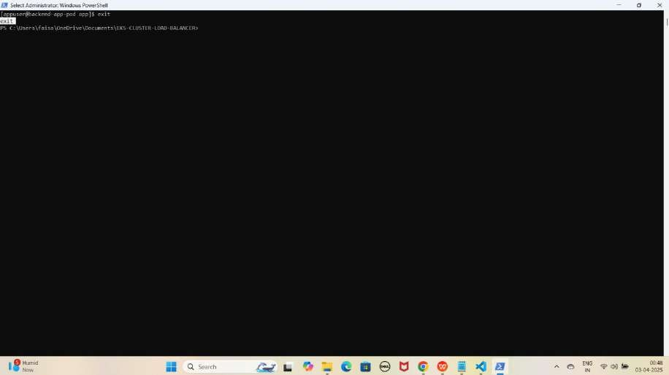

Method 2: Client Pods ke through Database Access Karna (Without Hardcoded Endpoint)

#### Step 1: Amazon RDS (MySQL) Database Access Karo-Method 2

1. **MySQL client pod me jane ke liye ye command run kaiye**

kubectl exec -it mysql-client -- /bin/bash

YE KUCH ISTARHA LAGEGA

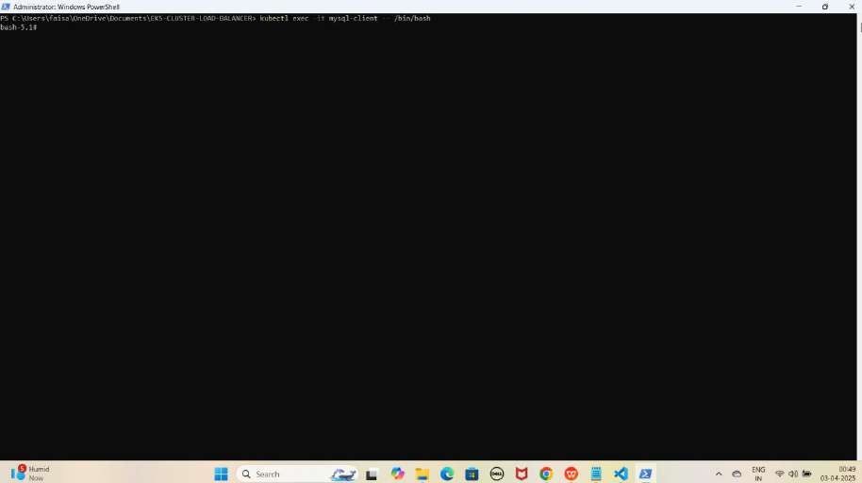

1. **MYSQL database se connect karne ke liye ye command kuch istarha hogi**

mysql -h faisal-mysql -u FaisalKhan -p

YE KUCH ISTARHA LAGEGA

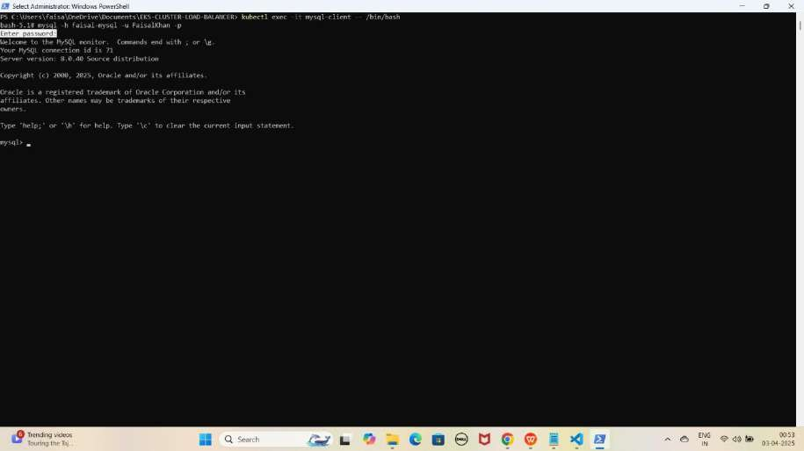

Note: Jab aap se password maanga jaaye, to wahi password use karein jo pehle Base64 encode karke rds-secrets.yaml file me store kiya gaya tha. Maine ‘Faisalkhan35$’ diya tha, lekin password enter karte waqt yeh screen par show nahi hoga.

1. **Databases check karne ke liye ye command run kariye**

SHOW DATABASES;

YE KUCH ISTARHA LAGEGA

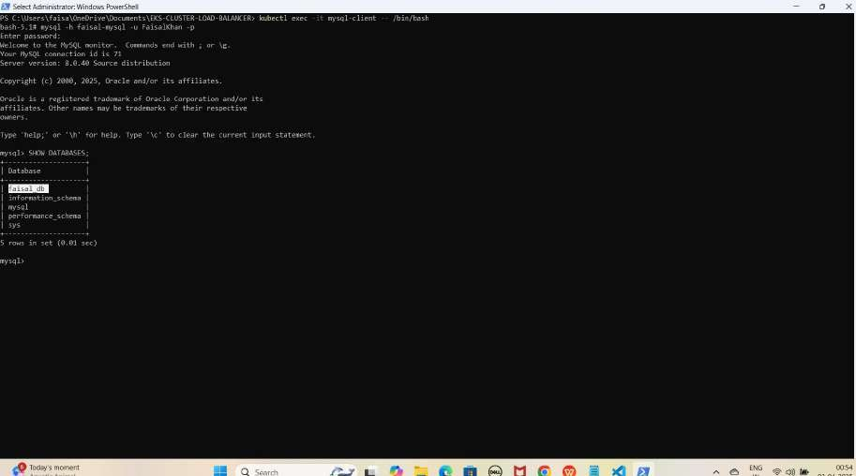

NOTE: Yahan hum dobara database create nahi karenge, kyunki pehle hi Method 1 mein create kar chuke hain. Hum sirf ye check karenge ki database available hai ya nahi.

1. **MYSQL database se exit hoagaye exit hone ke liye exit type kariye**

exit

YE KUCH ISTARHA LAGEGA

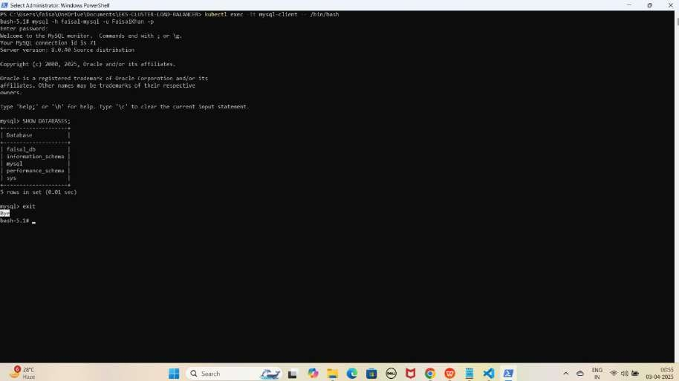

1. **MySQL client pod se bhi exit hoagaye exit hone ke liye exit type kariye**

exit

YE KUCH ISTARHA LAGEGA

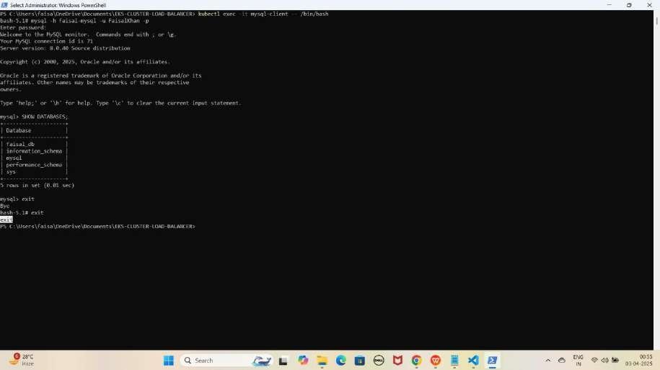

#### Step 2: Amazon RDS (Oracle) Database Access Karo-Method 2

1. **Oracle client pod me jane ke liye ye command run kaiye**

kubectl exec -it oracle-client -- /bin/bash

YE KUCH ISTARHA LAGEGA

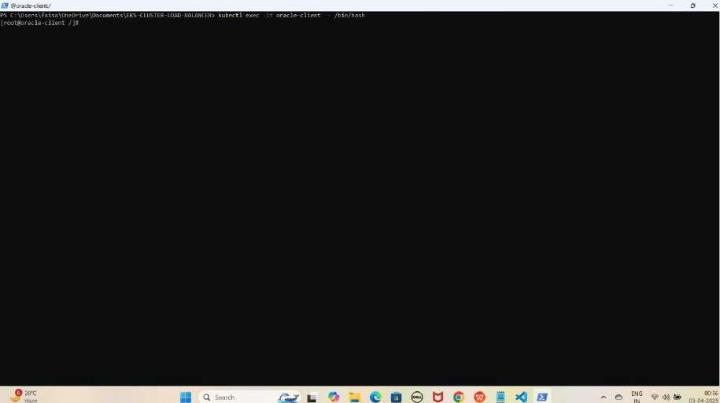

1. **Oracle database se connect karne ke liye ye command kuch istarha hogi**

sqlplus FaisalKhan@//faisal-oracle:1521/ORCL

YE KUCH ISTARHA LAGEGA

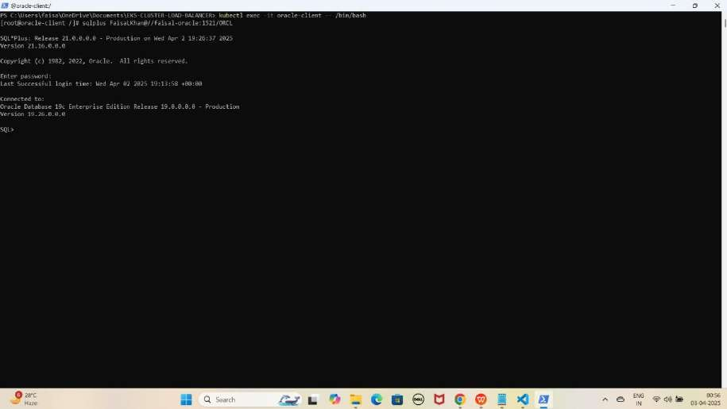

Note: Jab aap se password maanga jaaye, to wahi password use karein jo pehle Base64 encode karke rds-secrets.yaml file me store kiya gaya tha. Maine ‘Faisalkhan35$’ diya tha, lekin password enter karte waqt yeh screen par show nahi hoga.

1. **Databases check karne ke liye ye command run kariye**

SELECT username FROM all_users WHERE username = 'faisal_db';

YE KUCH ISTARHA LAGEGA

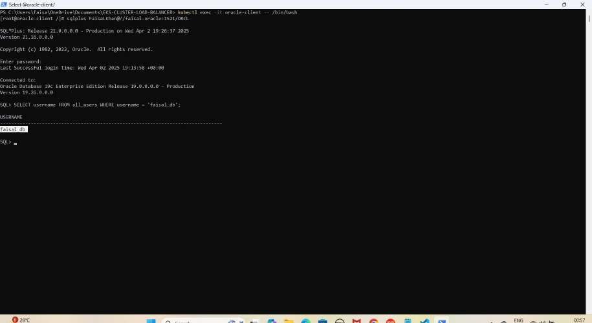

NOTE: Yahan hum dobara database create nahi karenge, kyunki pehle hi Method 1 mein create kar chuke hain. Hum sirf ye check karenge ki database available hai ya nahi.

1. **Oracle database se exit hoagaye exit hone ke liye exit type kariye**

exit

YE KUCH ISTARHA LAGEGA

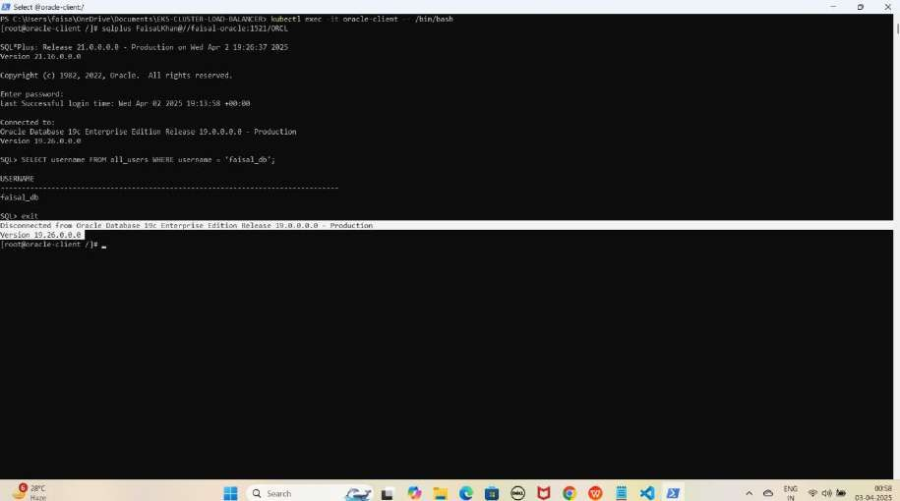

1. **Oracle client pod se bhi exit hoagaye exit hone ke liye exit type kariye**

exit

YE KUCH ISTARHA LAGEGA

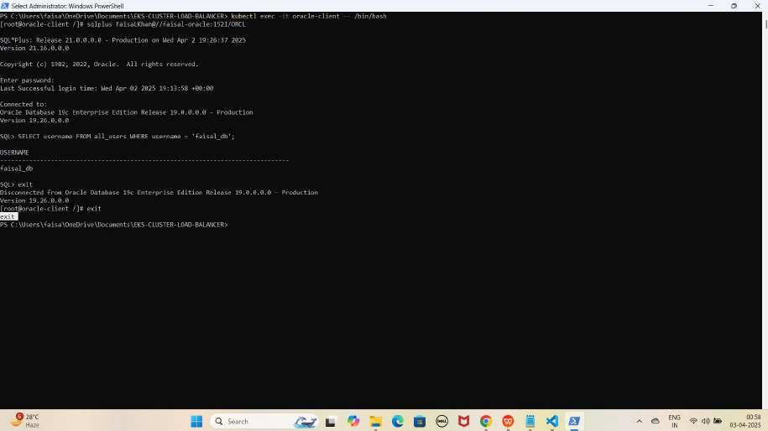

#### Step 3: Amazon RDS (PostgreSQL) Database Access Karo - Method 2

1. **PostgreSQL client pod me jane ke liye ye command run kaiye**

kubectl exec -it postgresql-client -- /bin/bash

YE KUCH ISTARHA LAGEGA

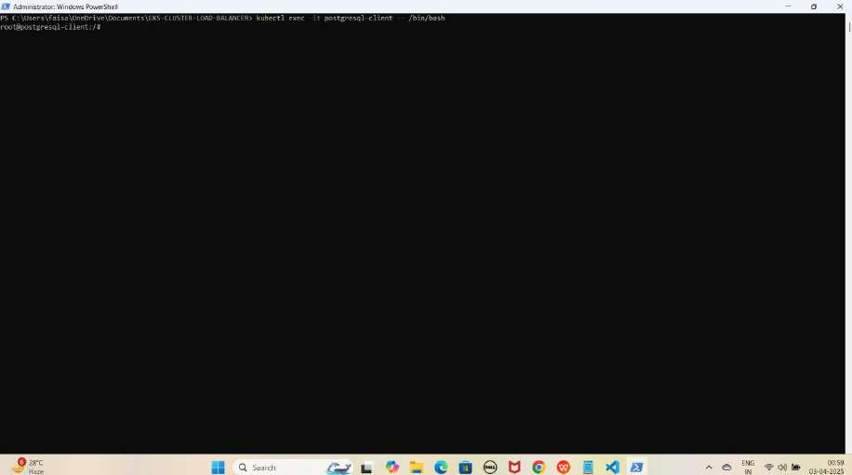

1. **PostgreSQL database se connect karne ke liye ye command kuch istarha hogi**

psql -h faisal-postgresql -U FaisalKhan -d postgres

YE KUCH ISTARHA LAGEGA

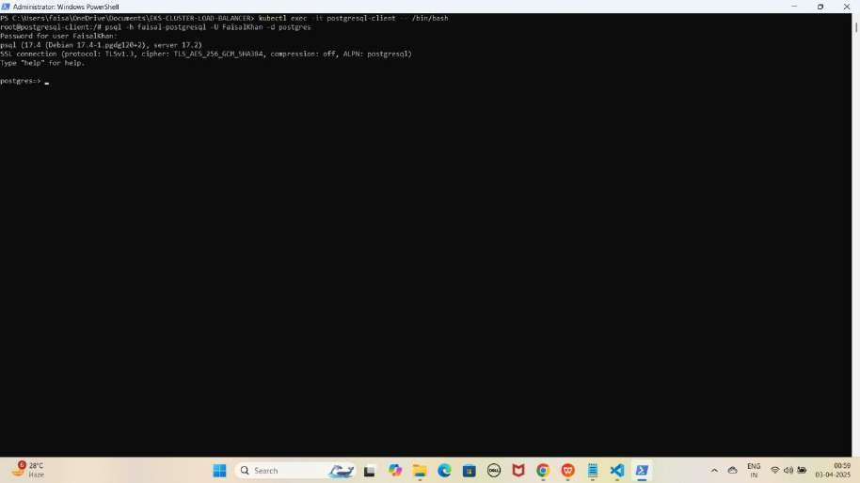

Note: Jab aap se password maanga jaaye, to wahi password use karein jo pehle Base64 encode karke rds-secrets.yaml file me store kiya gaya tha. Maine ‘Faisalkhan35$’ diya tha, lekin password enter karte waqt yeh screen par show nahi hoga.

1. **Databases check karne ke liye ye command run kariye**

SELECT datname FROM pg_database;

YE KUCH ISTARHA LAGEGA

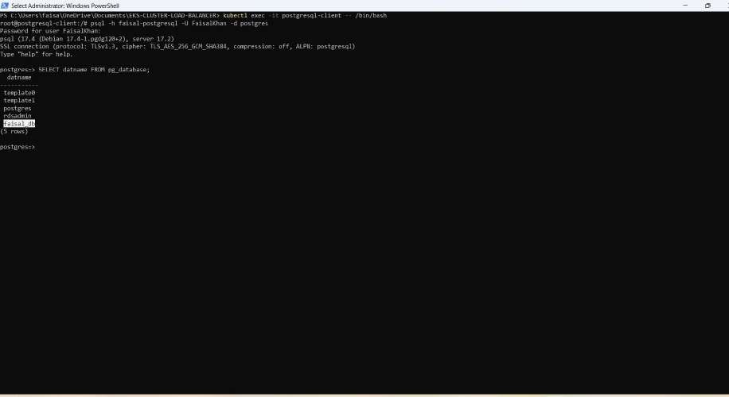

NOTE: Yahan hum dobara database create nahi karenge, kyunki pehle hi Method 1 mein create kar chuke hain. Hum sirf ye check karenge ki database available hai ya nahi.

1. **PostgreSQL database se exit hoagaye exit hone ke liye exit type kariye**

\q

YE KUCH ISTARHA LAGEGA

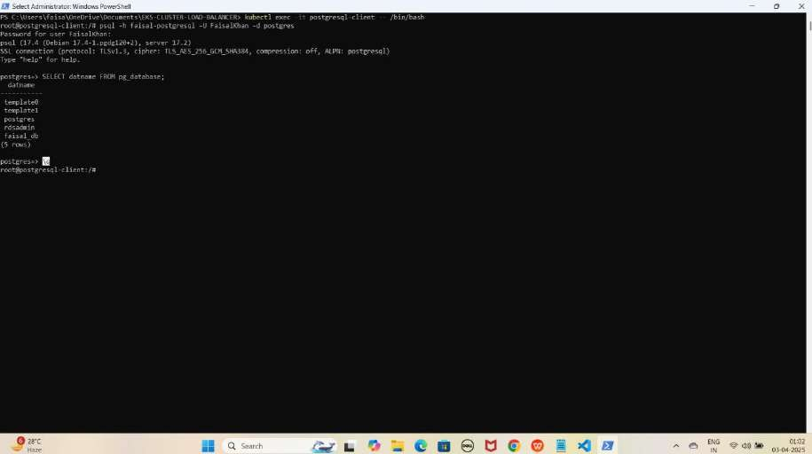

1. **PostgreSQL client pod se bhi exit hoagaye exit hone ke liye exit type kariye**

exit

YE KUCH ISTARHA LAGEGA

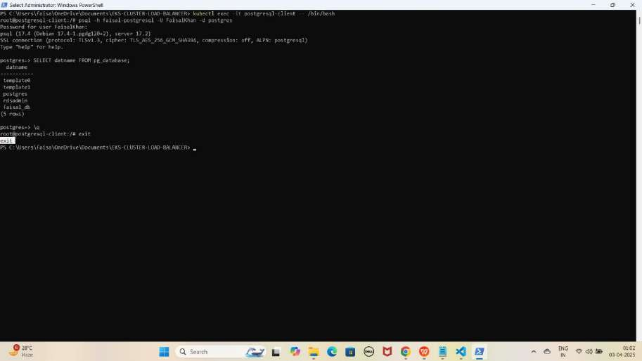

## Part 10: Monitoring Using Prometheus and Loki With Grafana

Kubernetes me ek naya namespace 'monitoring' create karna hoga. Namespace create karne ke liye ye command run kariye:

kubectl create namespace monitoring

YE KUCH ISTARHA LAGEGA

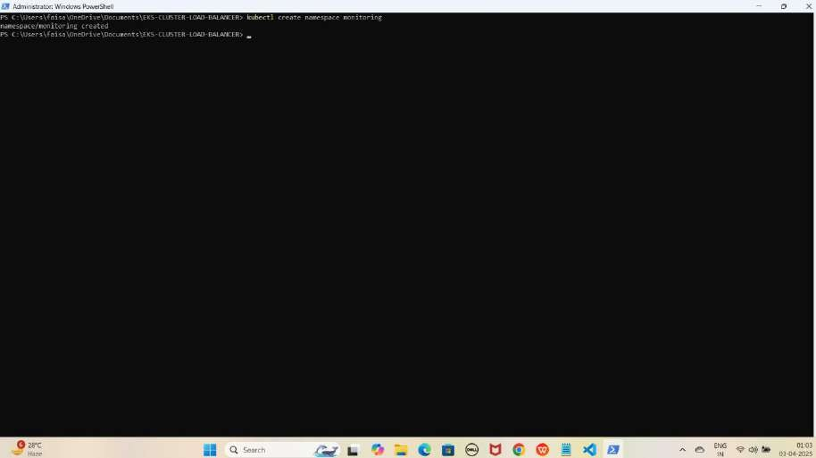

#### Step 1: prometheus-daemonset.yaml File Ka Kaam

Yeh **file Prometheus monitoring tool deploy** karne ke liye use hoti hai. Isko **cluster ka CPU usage, memory, aur network monitor** karne ke liye **Kubernetes DaemonSet** ke andar likha jata hai.

JAISE KI:-

apiVersion: apps/v1 kind: DaemonSet metadata:

name: prometheus namespace: monitoring

spec:

selector:

matchLabels:

app: prometheus template:

metadata:

labels:

app: prometheus spec:

containers:

* name: prometheus

image: prom/prometheus:v2.31.1 args:

* + "--config.file=/etc/prometheus/prometheus.yml"
  + "--storage.tsdb.path=/prometheus"
  + "--web.enable-lifecycle" volumeMounts:
  + name: prometheus-config mountPath: /etc/prometheus
  + name: prometheus-storage mountPath: /prometheus

volumes:

* name: prometheus-config configMap:

name: prometheus-config

* name: prometheus-storage emptyDir: {}

---

apiVersion: v1 kind: ConfigMap metadata:

name: prometheus-config namespace: monitoring

data:

prometheus.yml: | global:

scrape_interval: 15s # Default scrape interval for all jobs

scrape_configs:

# Kubernetes Nodes Service Discovery for Node Exporters

* job_name: 'kubernetes-nodes' kubernetes_sd_configs:
  + role: node # Specify the role as 'node' relabel_configs:
  + source_labels: [ meta_kubernetes_node_name] # Scrape metrics from nodes target_label: kubernetes_node
  + source_labels: [ meta_kubernetes_node_label_kubernetes_io_hostname] # Include the

node hostname as a label

target_label: kubernetes_hostname

# Kubernetes Pods Service Discovery (for scraping Kubernetes pods)

* job_name: 'kubernetes-pods' kubernetes_sd_configs:
  + role: pod # Scrape all pods (can be further refined with relabeling) relabel_configs:
  + source_labels: [ meta_kubernetes_pod_label_app] # Use pod labels for further

filtering

target_label: app

#### Prometheus DaemonSet Apply Karo

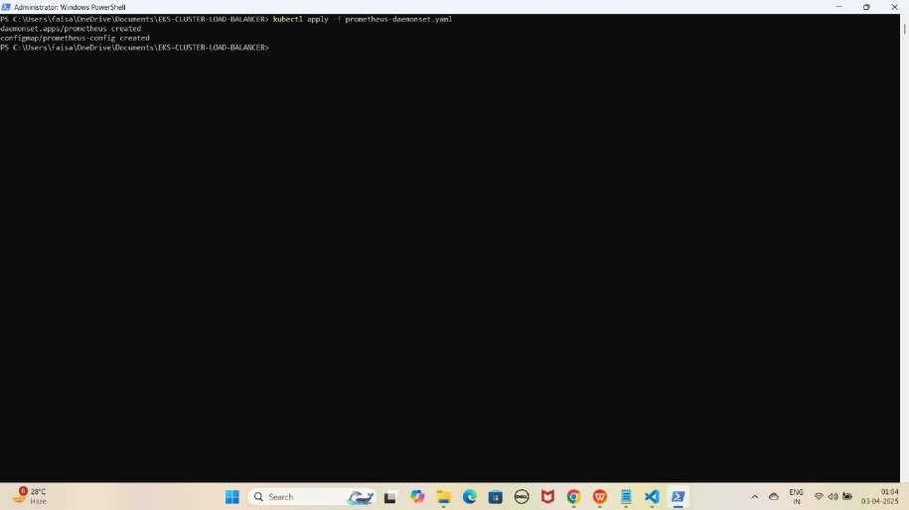kubectl apply -f prometheus-daemonset.yaml YE KUCH ISTARHA LAGEGA

#### Step 2: prometheus-rbac.yaml File Ka Kaam

Yeh **file Prometheus** ko required **permissions** dene ke liye use hoti hai, taake woh **cluster** ke **resources** ko **access** kar sake.

JAISE KI:-

apiVersion: rbac.authorization.k8s.io/v1 kind: ClusterRole

metadata:

name: prometheus-scrape-role rules:

* apiGroups: [""]

resources: ["pods", "nodes"]

verbs: ["get", "list", "watch"]

* apiGroups: ["metrics.k8s.io"] resources: ["nodes", "pods"]

verbs: ["get", "list", "watch"]

* apiGroups: ["apps"]

resources: ["deployments", "replicasets", "daemonsets"] verbs: ["get", "list", "watch"]

* apiGroups: ["extensions"] resources: ["ingresses"] verbs: ["get", "list", "watch"]
* apiGroups: [""]

resources: ["services", "endpoints"] verbs: ["get", "list", "watch"]

---

apiVersion: rbac.authorization.k8s.io/v1 kind: ClusterRoleBinding

metadata:

name: prometheus-scrape-role-binding subjects:

* kind: ServiceAccount name: default namespace: monitoring

roleRef:

kind: ClusterRole

name: prometheus-scrape-role apiGroup: rbac.authorization.k8s.io

#### Prometheus RBAC Apply Karo

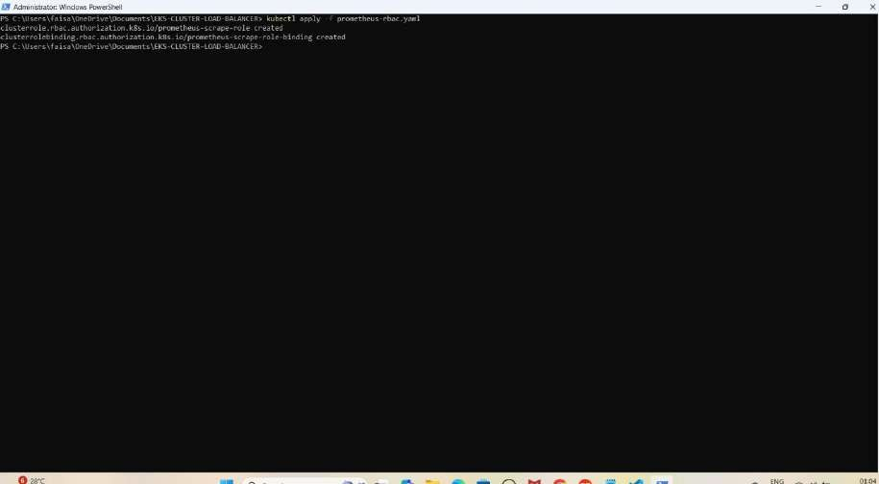kubectl apply -f prometheus-rbac.yaml YE KUCH ISTARHA LAGEGA

#### Step 3: prometheus-nodeport-service.yaml File Ka Kaam

Yeh **file Prometheus** ko port **30090** par **NodePort service** ke zariye **expose** karne ke liye use hoti hai, taake hum usko **browser** me **access** kar sakein.

JAISE KI:-

apiVersion: v1 kind: Service metadata:

name: prometheus-server namespace: monitoring

spec:

ports:

- port: 80

targetPort: 9090

nodePort: 30090 selector:

app: prometheus type: NodePort

#### Prometheus Service Apply Karo

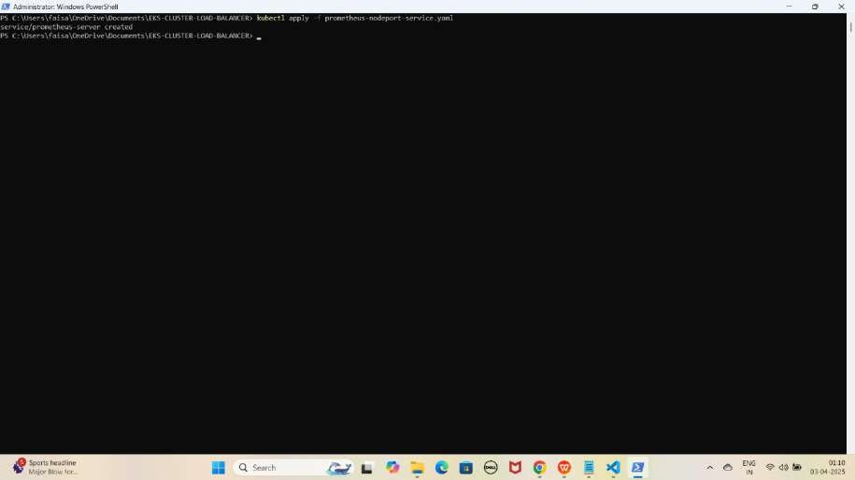kubectl apply -f prometheus-nodeport-service.yaml YE KUCH ISTARHA LAGEGA

1. **Pods check karne ke liye ye command run kariye**

kubectl get pods -n monitoring

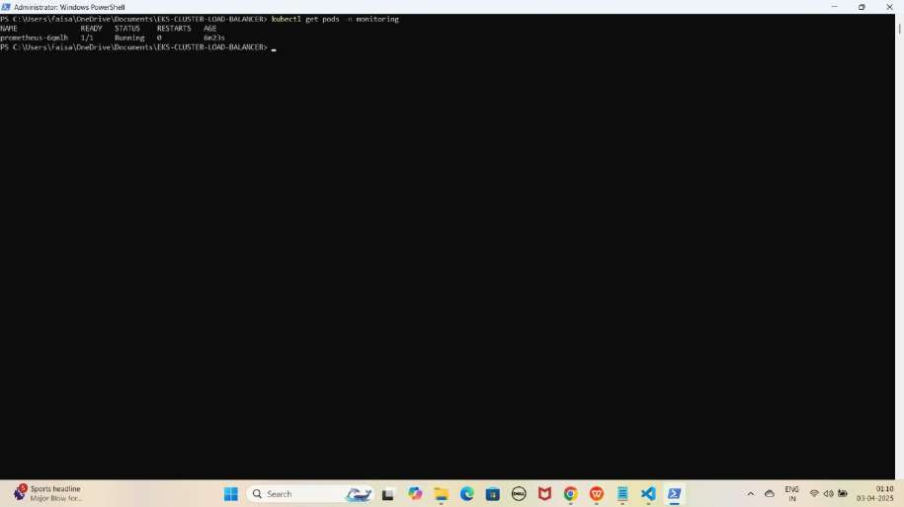YE KUCH ISTARHA LAGEGA

NOTE: Agar STATUS Running show karraha hai to sab kuch sahi hai

1. **Serives check karne ke liye ye commad run kariye**

kubectl get services -n monitoring

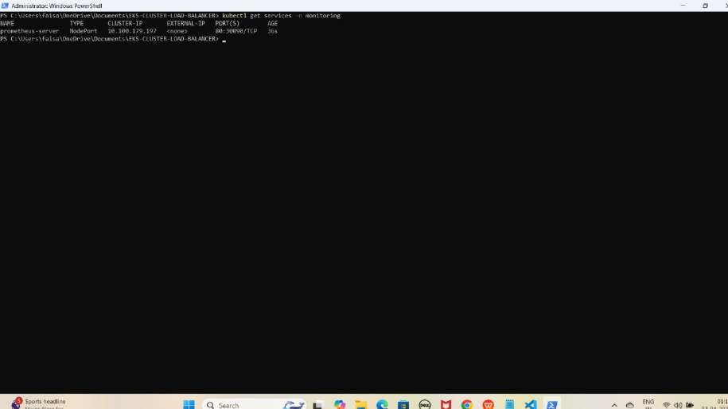YE KUCH ISTARHA LAGEGA

NOTE: Ab aapka Prometheus 30090 port par expose ho chuka hai. Browser me EKS Node ki Public IP ke saath check kariye jaise ki mere case me kuch aisa hoga

**Prometheus:** [http://EKS-Node-Public IP:30090](df)

YE KUCH ISTARHA LAGEGA

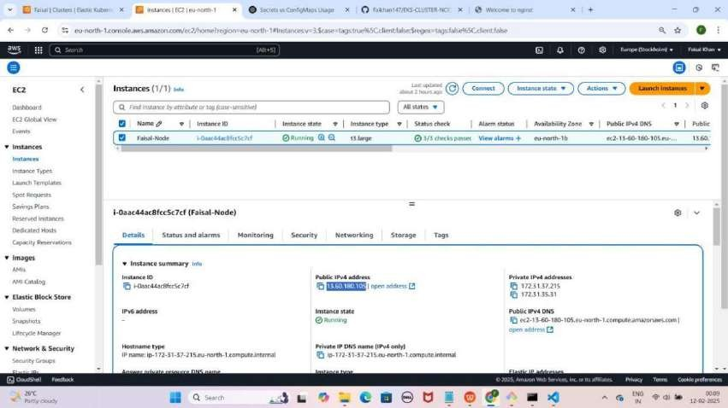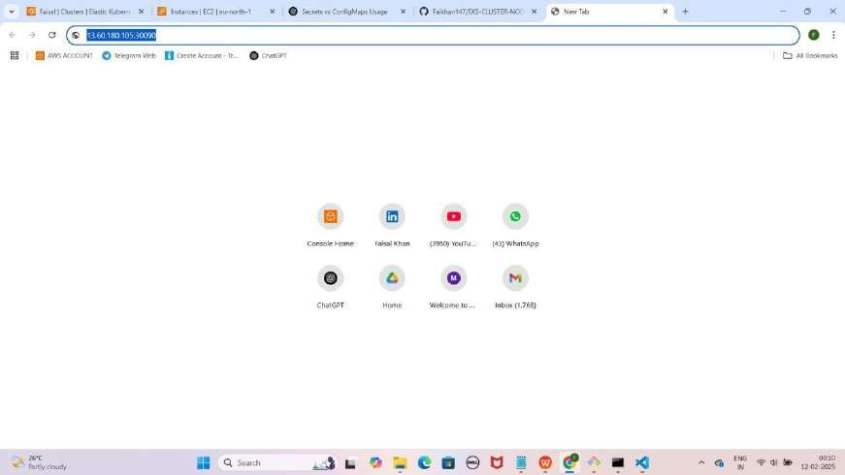

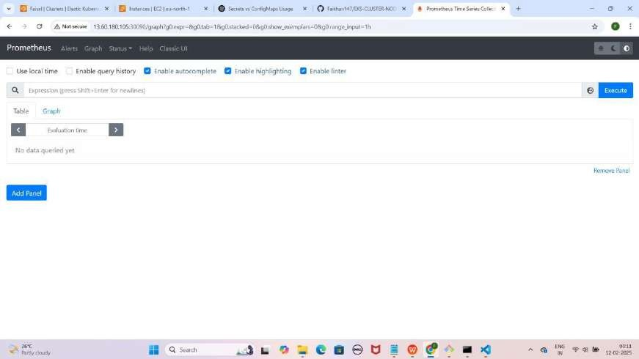

1. **CPU usage check karne ke liye Prometheus me ye command run karein**

rate(process_cpu_seconds_total[30s])

Note: Command Prometheus me paste karne ke baad Execute pe click karein.

YE KUCH ISTARHA LAGEGA

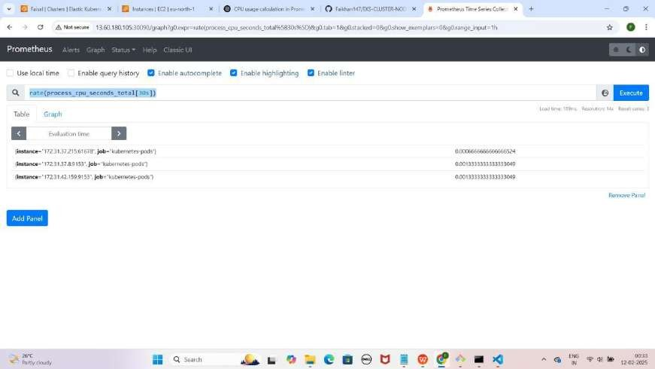

1. **Memory usage check karne ke liye Prometheus me ye command run karein**

process_resident_memory_bytes

Note: Command Prometheus me paste karne ke baad Execute pe click karein.

YE KUCH ISTARHA LAGEGA

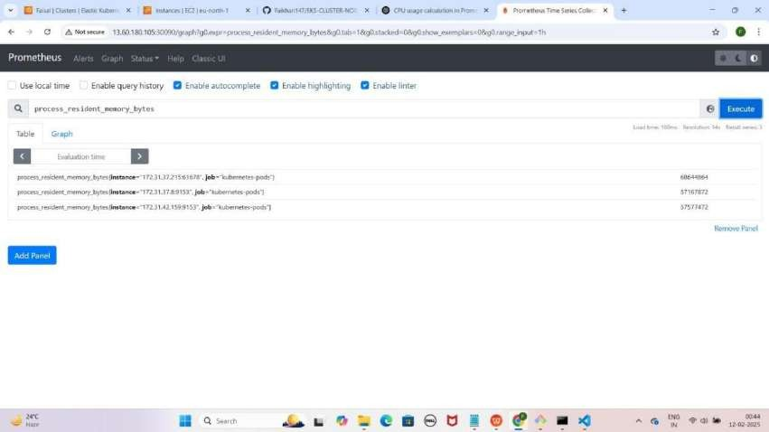

1. **Network Transmit aur Receive Bytes me dekhne ke liye Prometheus me ye commands run karein**
   * **Transmit Bytes:** process_network_transmit_bytes_total
   * **Receive Bytes:** process_network_receive_bytes_total

Note: Command Prometheus me paste karne ke baad Execute pe click karein.

YE KUCH ISTARHA LAGEGA

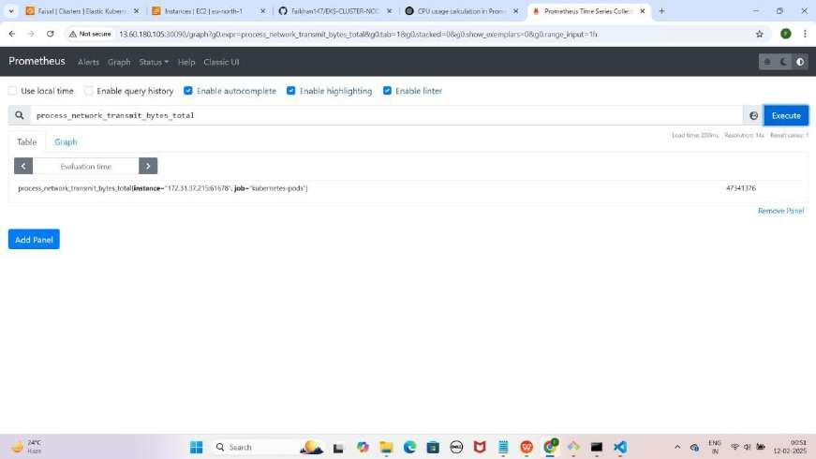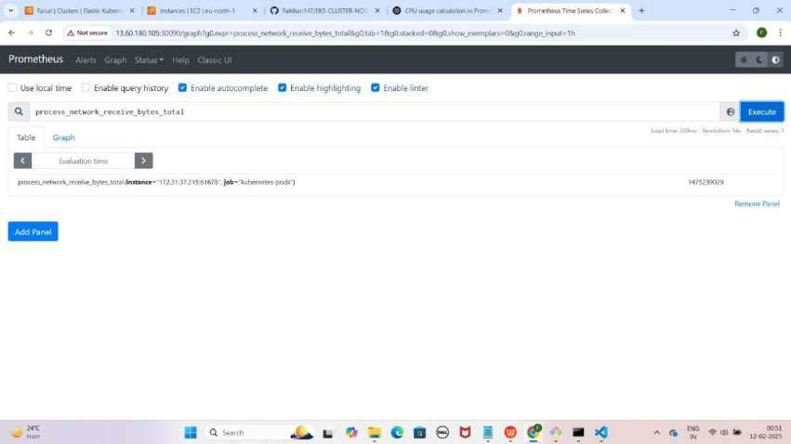

#### Step 4: promtail-daemonset.yaml File Ka Kaam

Yeh **file cluster** se **logs collect** karne aur unhe **Loki** par bhejne ke liye use hoti hai.

JAISE KI:-

---

apiVersion: apps/v1 kind: DaemonSet metadata:

name: promtail namespace: monitoring

spec:

selector:

matchLabels:

app: promtail template:

metadata:

labels:

app: promtail spec:

containers:

* name: promtail

image: grafana/promtail:2.3.0 args:

* + "-config.file=/etc/promtail/promtail-config.yaml" volumeMounts:
  + name: promtail-config mountPath: /etc/promtail
  + name: varlogs mountPath: /var/log
  + name: positions mountPath: /run/promtail

resources:

requests:

memory: "128Mi" cpu: "100m"

limits:

memory: "256Mi" cpu: "500m"

readinessProbe:

httpGet:

path: /ready port: 9080

initialDelaySeconds: 5

periodSeconds: 10 livenessProbe:

httpGet:

path: /ready port: 9080

initialDelaySeconds: 10

periodSeconds: 20 securityContext:

runAsUser: 0 # Run as root to allow access to restricted files runAsGroup: 0 # Run as root group

privileged: true # Optional: Uncomment if needed to run in privileged mode volumes:

* name: promtail-config configMap:

name: promtail-config

* name: varlogs hostPath:

path: /var/log

type: DirectoryOrCreate

- name: positions emptyDir: {}

---

apiVersion: v1 kind: ConfigMap metadata:

name: promtail-config namespace: monitoring

data:

promtail-config.yaml: | server:

http_listen_port: 9080

grpc_listen_port: 0

positions:

filename: /run/promtail/positions.yaml

clients:

- url: <http://loki.monitoring.svc.cluster.local:3100/loki/api/v1/push>

scrape_configs:

- job_name: system static_configs:

- targets:

- localhost labels:

job: varlogs

path : /var/log/*.log

- job_name: kubernetes-pods static_configs:

- targets:

- localhost labels:

job: podlogs

path : /var/log/pods/**/*.log

# Additional configurations can be added here if needed

#### Promtail DaemonSet Apply Karo

kubectl apply -f promtail-daemonset.yaml

YE KUCH ISTARHA LAGEGA

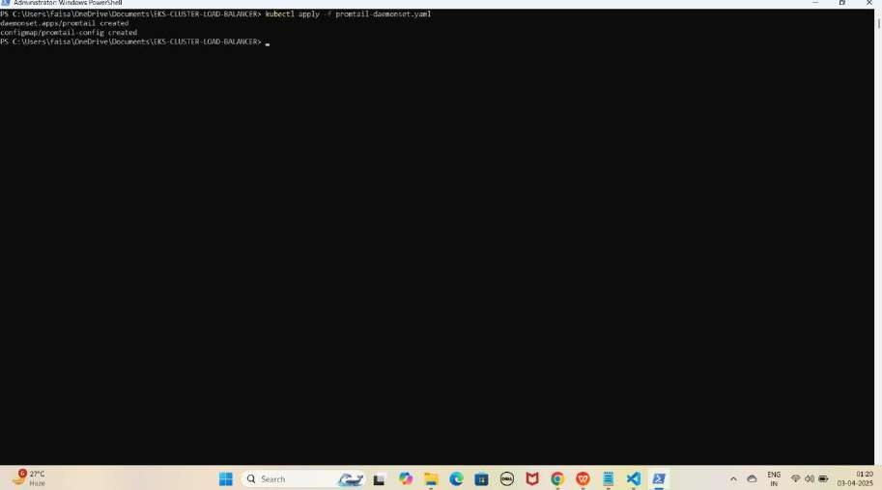

#### Step 5: loki-daemonset.yaml File Ka Kaam

Yeh file **Loki** ko ek **logs database** ke taur par **setup** karne ke liye use hoti hai, jo **Promtail** se **logs collect** karke **store** karta hai.

JAISE KI:-

apiVersion: apps/v1 kind: DaemonSet metadata:

name: loki namespace: monitoring

spec:

selector:

matchLabels:

app: loki template:

metadata:

labels:

app: loki spec:

serviceAccountName: loki containers:

* name: loki

image: grafana/loki:2.3.0 args:

* + "-config.file=/etc/loki/loki-config.yaml" ports:
  + containerPort: 3100 name: http

resources:

requests:

cpu: "500m" memory: "512Mi"

limits:

cpu: "1" memory: "1Gi"

volumeMounts:

- name: loki-config

mountPath: /etc/loki/loki-config.yaml subPath: loki-config.yaml

volumes:

- name: loki-config configMap:

name: loki-config items:

- key: loki-config.yaml path: loki-config.yaml

---

apiVersion: v1 kind: ConfigMap metadata:

name: loki-config namespace: monitoring

data:

loki-config.yaml: |

auth_enabled: false # Disable authentication explicitly

server:

http_listen_port: 3100

distributor: ring:

kvstore:

store: inmemory

ingester: lifecycler:

ring:

kvstore:

store: inmemory replication_factor: 1

chunk_idle_period: 5m chunk_retain_period: 30s

max_transfer_retries: 0

schema_config:

configs:

- from: 2020-10-24

store: boltdb-shipper object_store: filesystem schema: v11

index:

prefix: index_ period: 24h

storage_config: boltdb_shipper:

active_index_directory: /loki/index

cache_location: /loki/cache shared_store: filesystem

filesystem:

directory: /loki/chunks

compactor:

working_directory: /loki/compactor shared_store: filesystem compaction_interval: 5m

limits_config: enforce_metric_name: false reject_old_samples: true

reject_old_samples_max_age: 168h

chunk_store_config: max_look_back_period: 0s

table_manager: retention_deletes_enabled: true retention_period: 168h

---

apiVersion: v1 kind: Service metadata:

name: loki namespace: monitoring

spec:

type: ClusterIP ports:

- port: 3100

targetPort: 3100 selector:

app: loki

---

apiVersion: v1 kind: ServiceAccount metadata:

name: loki

namespace: monitoring

#### Loki DaemonSet Apply Karo

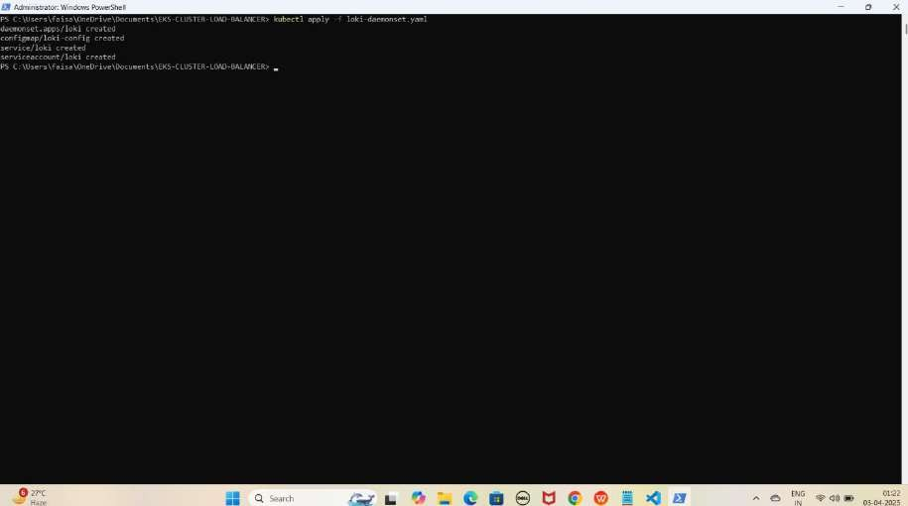kubectl apply -f loki-daemonset.yaml YE KUCH ISTARHA LAGEGA

#### Step 6: loki-nodeport-service.yaml File Ka Kaam

Yeh **file Loki** ko **expose** karne ke liye use hoti hai, taake hum **port 30091** ke zariye usko **access** kar sakein. Isko **Kubernetes NodePort Service** ke andar likha jata hai.

JAISE KI:-

apiVersion: v1 kind: Service metadata:

name: loki namespace: monitoring

spec:

ports:

- port: 3100

targetPort: 3100

nodePort: 30091 # This exposes Loki on port 30091 selector:

app: loki type: NodePort

#### Loki Service Apply Karo

kubectl apply -f loki-nodeport-service.yaml

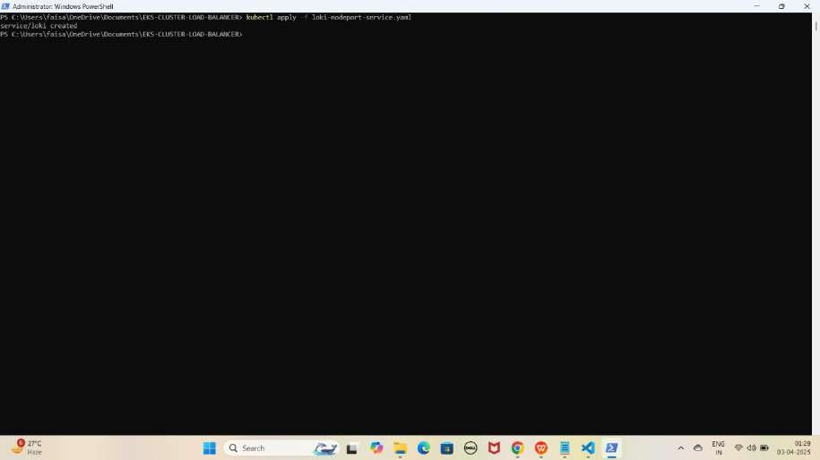YE KUCH ISTARHA LAGEGA

1. **Pods check karne ke liye ye command run kariye**

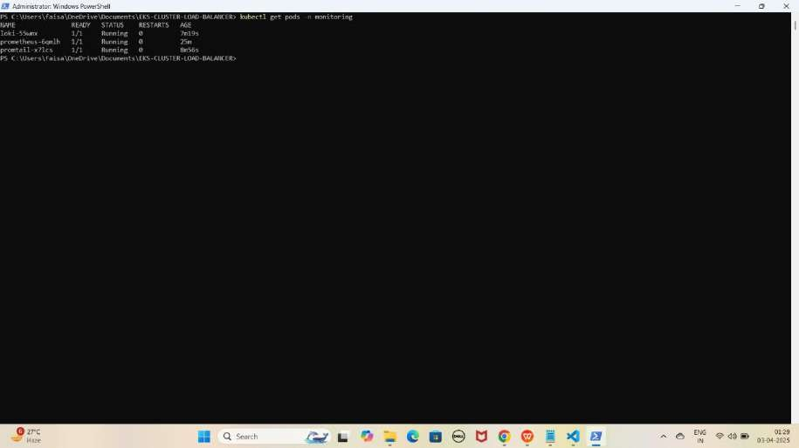kubectl get pods -n monitoring YE KUCH ISTARHA LAGEGA

NOTE: Agar STATE Running show karraha hai to sab kuch sahi hai

1. **Serives check karne ke liye ye commad run kariye**

kubectl get services -n monitoring

YE KUCH ISTARHA LAGEGA

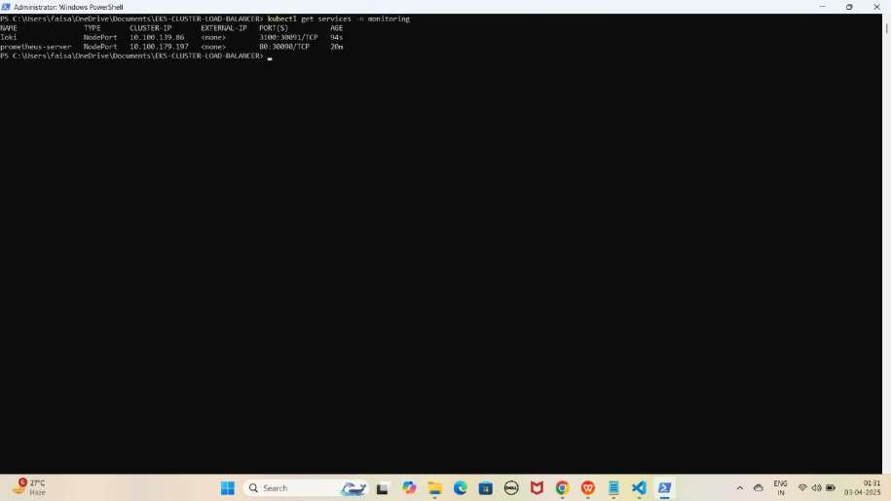

NOTE: Ab aapka Loki 30091 port par expose ho chuka hai. Browser me Cluster Node ki Public IP ke saath check karein jaise ki mere case me kuch aisa hoga.

**Loki:** [http://EKS-Node-Public IP:30091](h)

YE KUCH ISTARHA LAGEGA

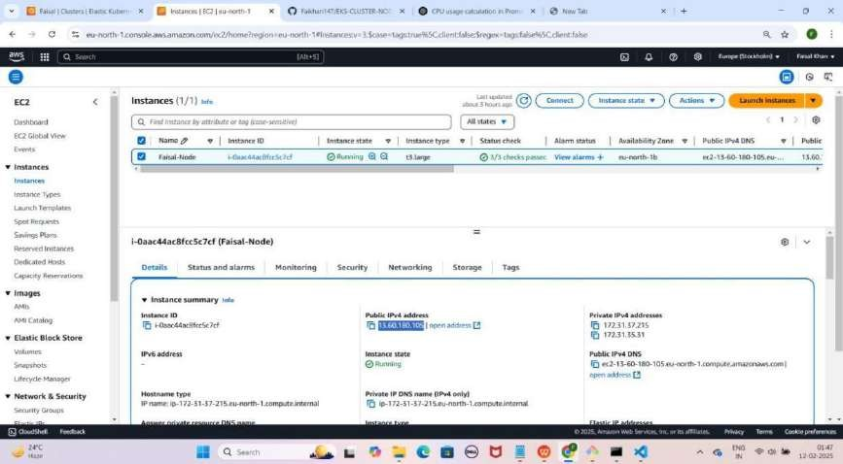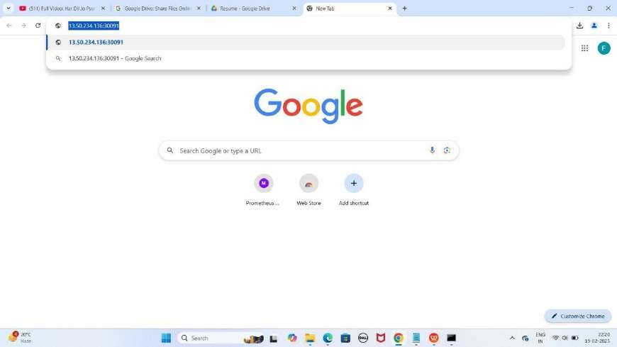

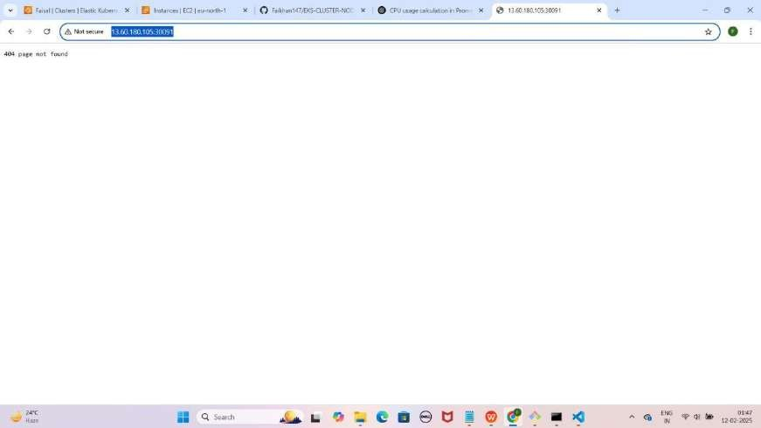

1. Lekin aapko **404 page** not found dikhayga to **/ready** se **check** kariye

**loki** ko jaise ki mere case kuch asisa hoga.

[http://EKS-Node-Public IP:30091/ready](h)

YE KUCH ISTARHA LAGEGA

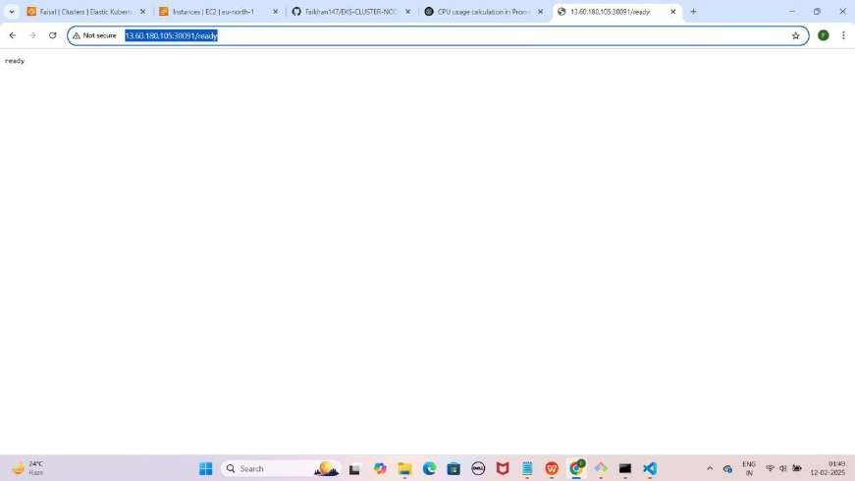

1. Agar aapko **ready show** karraha hai to iska matlab **loki successfully** run horaha hai ab **loki metrics loggs collect** karraha hai **check** karne ke liye

**/metrics** run kariye jaise ki mere case me kuch aisa hoga. [http://EKS-Node-Public IP:30091/metrics](h)

YE KUCH ISTARHA LAGEGA

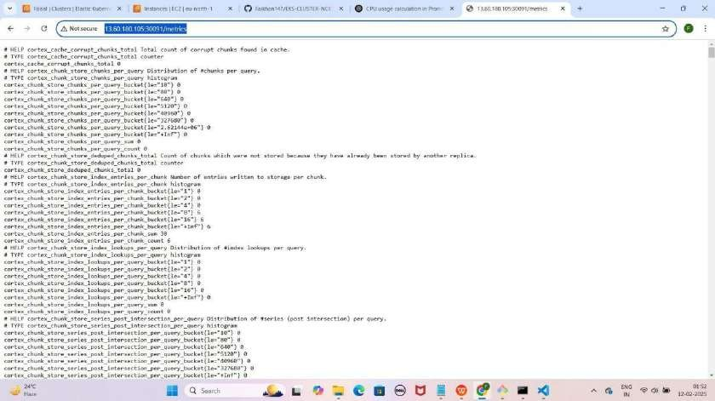

#### Step 7: grafana-deployment.yaml File Ka Kaam

Yeh **file Grafana** ko **deploy** karne ke liye use hoti hai, taake hum **Prometheus metrics** aur **Loki logs** ko **visualize** kar sakein. Isme **NodePort Service** bhi use ki gayi hai, jisse **Grafana port 30080** par expose hoga.

JAISE KI:-

apiVersion: apps/v1 kind: Deployment metadata:

name: grafana namespace: monitoring

spec:

replicas: 1 selector:

matchLabels:

app: grafana template:

metadata:

labels:

app: grafana spec:

containers:

* name: grafana

image: grafana/grafana:8.3.0 ports:

* + containerPort: 3000 env:
  + name: GF_SECURITY_ADMIN_PASSWORD

value: "admin"

---

apiVersion: v1 kind: Service metadata:

name: grafana namespace: monitoring

spec:

type: NodePort # Change the type from ClusterIP to NodePort ports:

- port: 80

targetPort: 3000

nodePort: 30080 # Specify the NodePort (e.g., 30080, any unused port in the range 30000-32767)

selector:

app: grafana

#### Grafana Deployment Apply Karo

kubectl apply -f grafana-deployment.yaml

YE KUCH ISTARHA LAGEGA

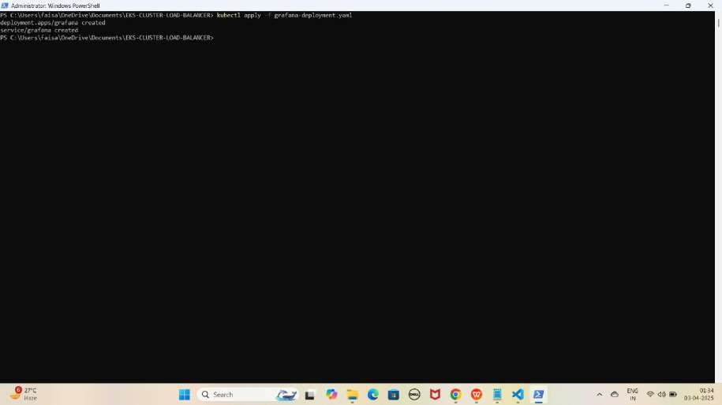

1. **Pods check karne ke liye ye command run kariye**

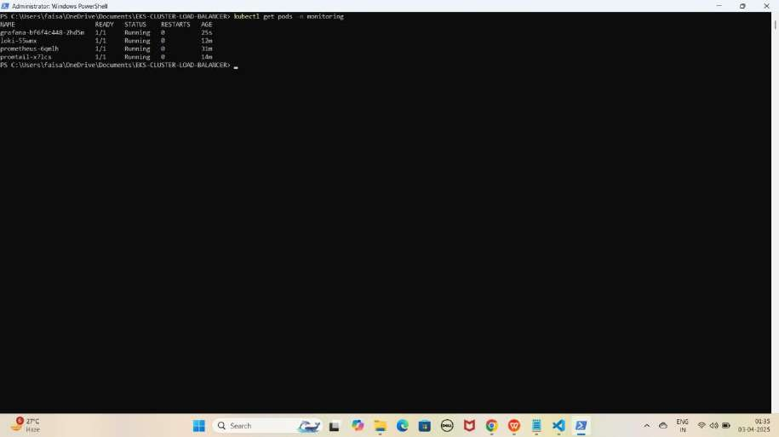kubectl get pods -n monitoring YE KUCH ISTARHA LAGEGA

NOTE: Agar STATE Running show karraha hai to sab kuch sahi hai

1. **Serives check karne ke liye ye commad run kariye**

kubectl get services -n monitoring

YE KUCH ISTARHA LAGEGA

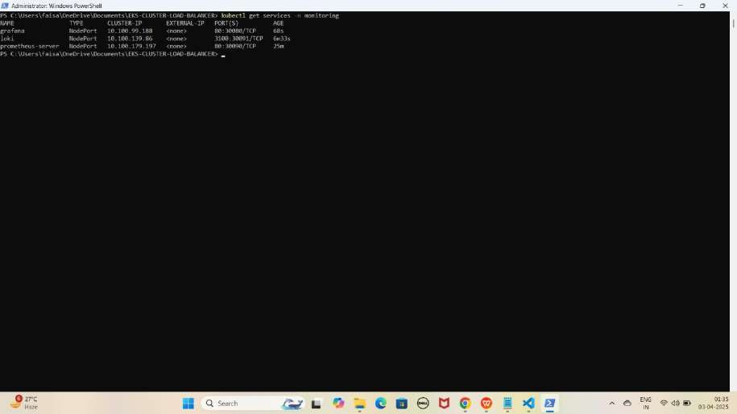

NOTE: Ab aapka Grafana 30080 port par expose ho chuka hai. Browser me Cluster Node ki Public IP ke saath check karein jaise ki mere case me kuch aisa hoga.

**Grafana:** [http://EKS-Node-Public IP:30080](j)

YE KUCH ISTARHA LAGEGA

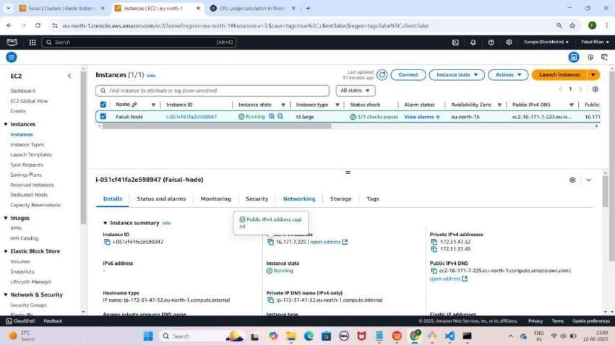

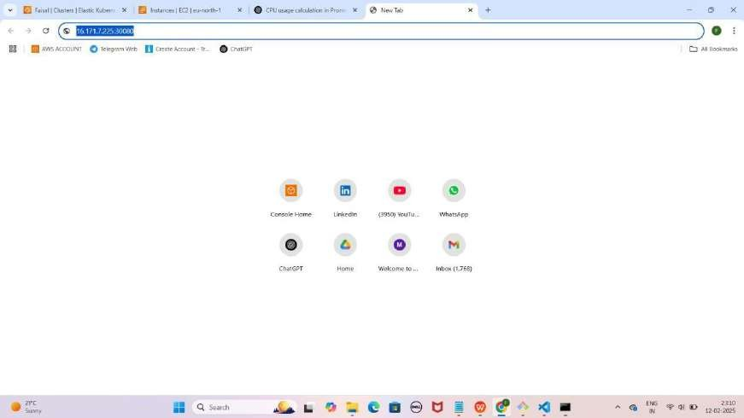

YE KUCH ISTARHA LAGEGA

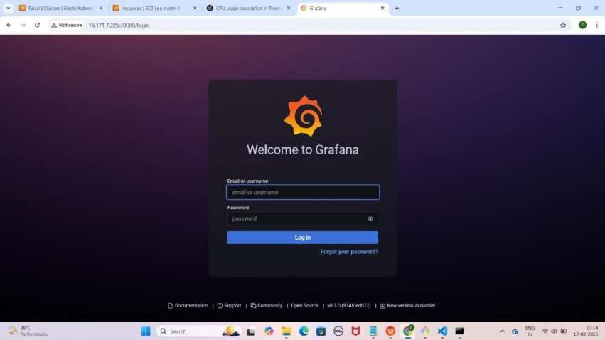

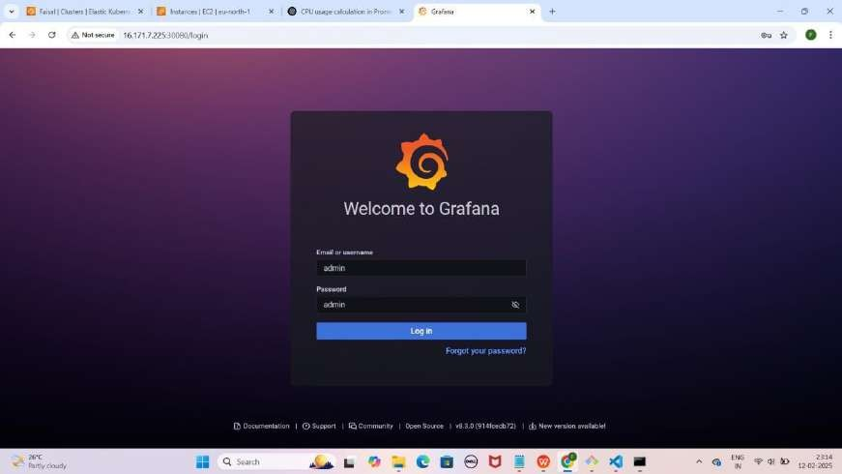

NOTE : Grafana browser me run hone ke baad aapse login ke liye username aur password maangega. Default username aur password admin hota hai. Login ke baad aap apna password change kar sakte hain

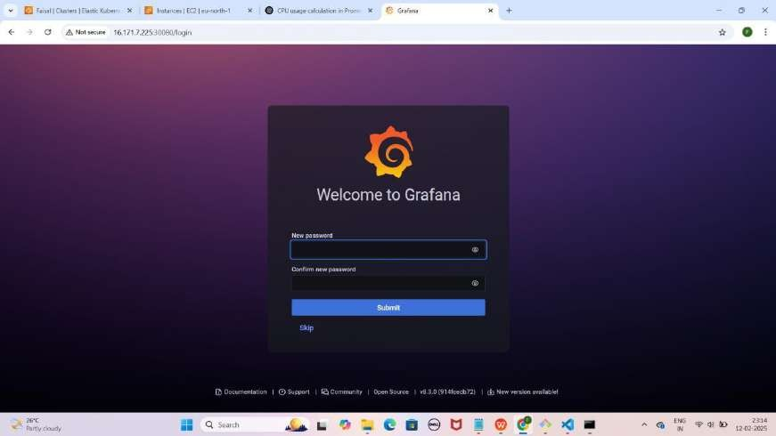

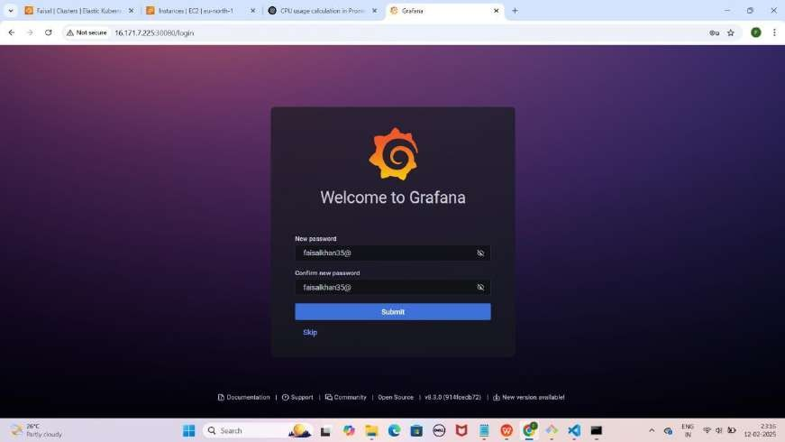

NOTE : Is step par aapko apne pasand ka naya password set karsakte hai.

Yaha mai faisalkhan35@ password set kar raha hoon.Password type karne ke baad Submit par click kariye

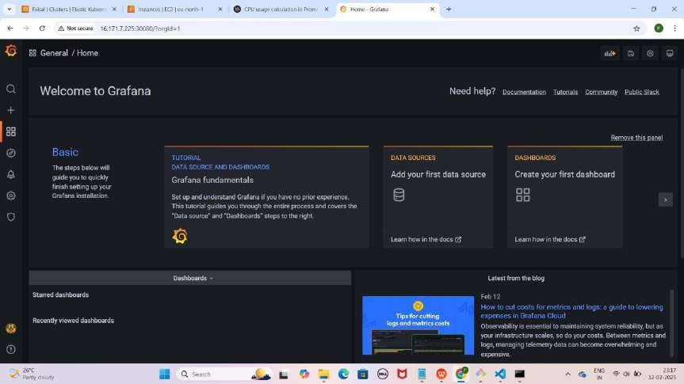

#### Step 8: Grafana Mein Prometheus Data Source Add Karna, Queries Add Karna Aur Dashboard Create Karna

* **Grafana dashboard** open karo.
* **Configuration** pe **click** karo, phir **Data Sources select** karo.
* **Add data source** pe **click** karo.
* **Prometheus** select karo.
* **Browser open karo** aur yeh **URL copy** karo:
  + **Mere case me yeh kuch is tarah hogi: [http://EKS-Node-Public](g) [IP:30090/](g)**
  + **Aapke case me Public IP different ho sakti hai.**
* **HTTPS section** me URL box me paste karo.
* Neeche scroll karo aur **"Save & Test"** pe click karo.

YE KUCH ISTARHA LAGEGA

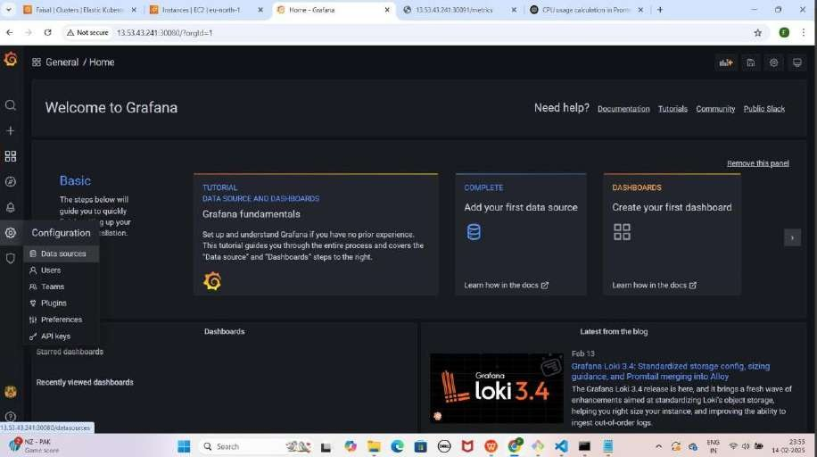

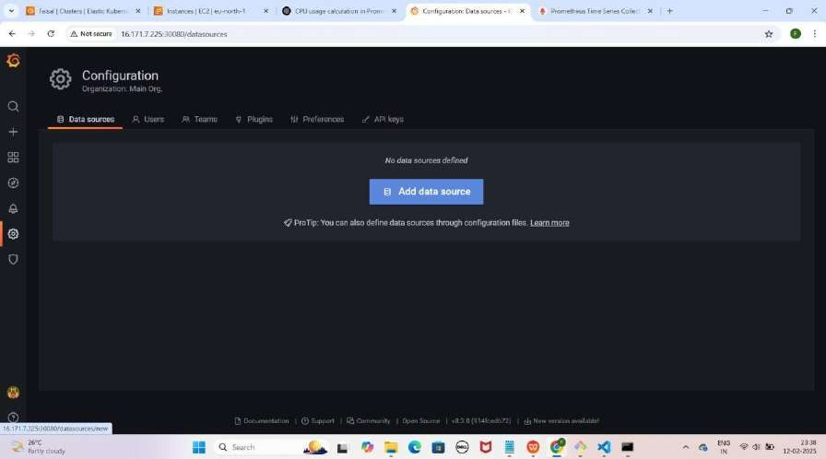

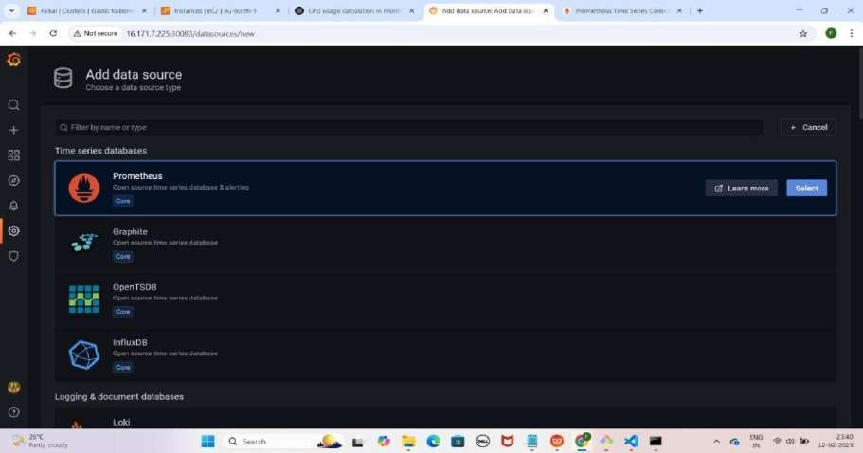

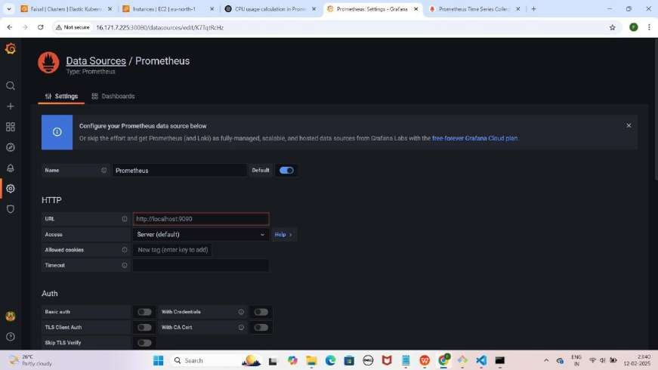

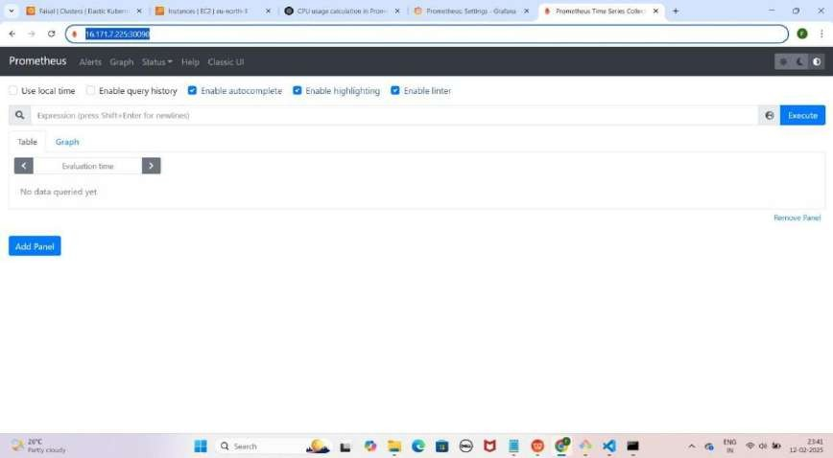

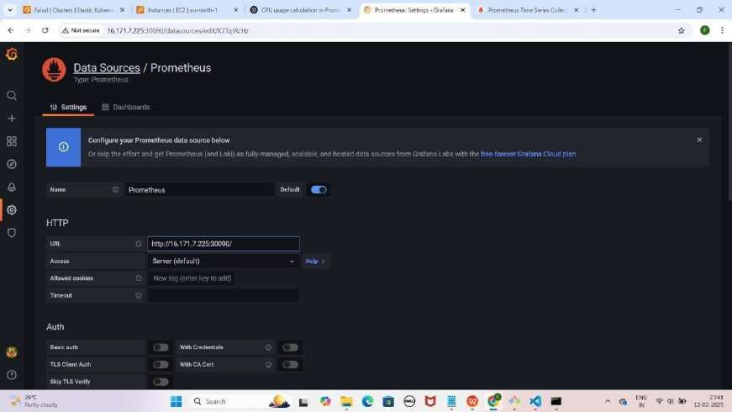

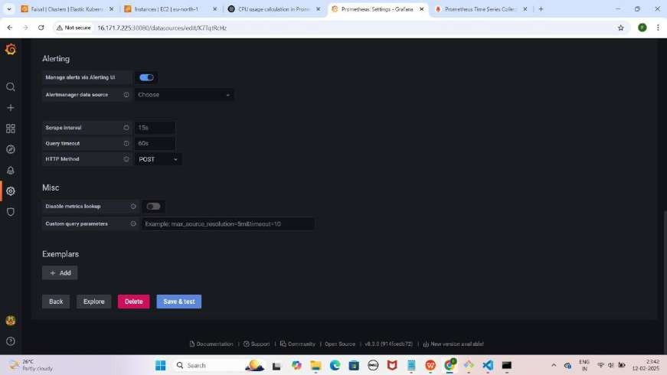

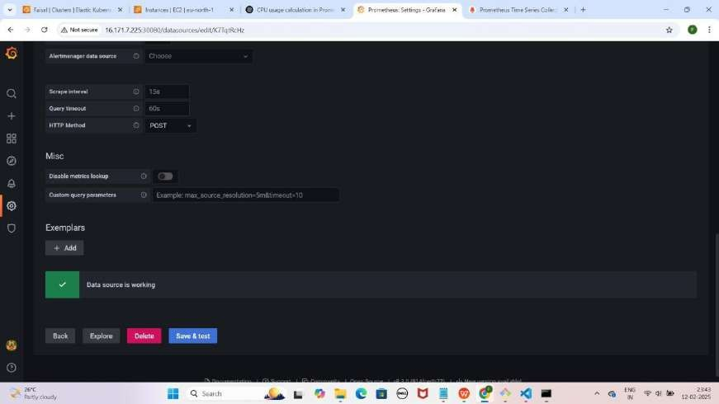

NOTE : Save & test pe click karne ke baad aapko Data source is working karke pop up aayega

* **Prometheus ke Metrics visualize** karne ke liye **"+" (plus) icon** pe click karo.
* **Dashboard** select karo aur **"Add a new panel"** pe click karo.
* **Query section** me **Data Source ko "Prometheus"** select karo.

YE KUCH ISTARHA LAGEGA

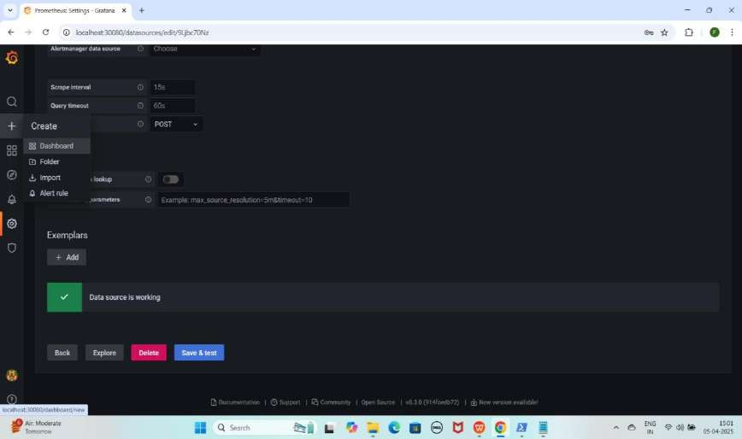

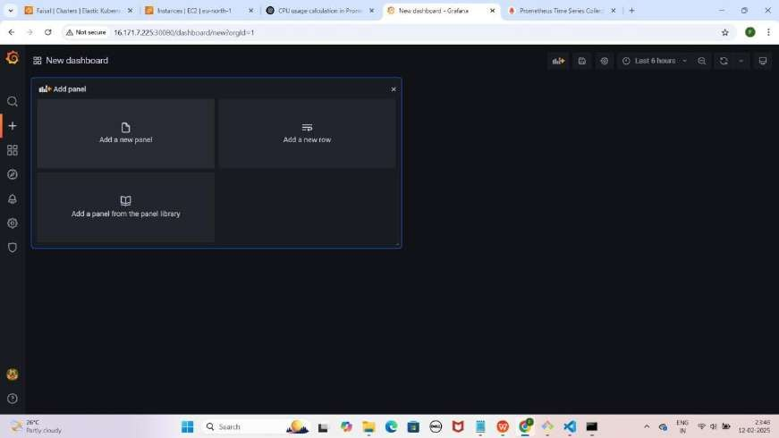

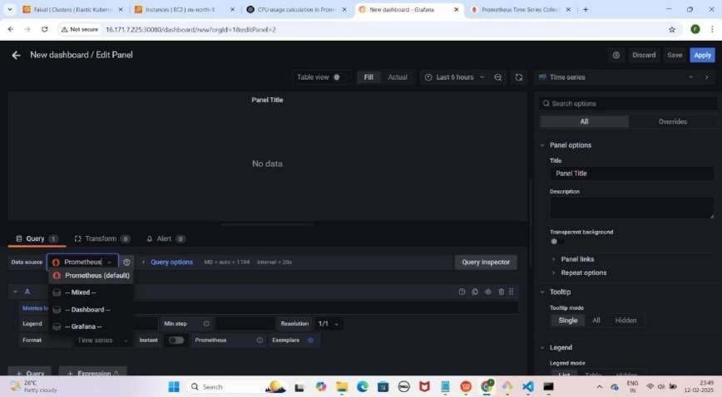

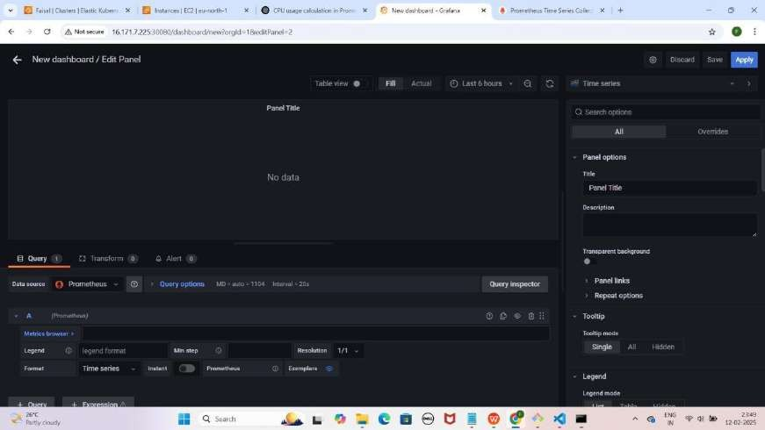

1. **Prometheus ko data source select karne ke baad, CPU Usage dekhne ke liye Metric Browser me yeh query paste karein**

rate(process_cpu_seconds_total[30s])

* + **"Time Series"** pe click karein.
  + **Suggestions** me se **"Dashboard"** select karein jaise maine select kiya hai.

YE KUCH ISTARHA LAGEGA

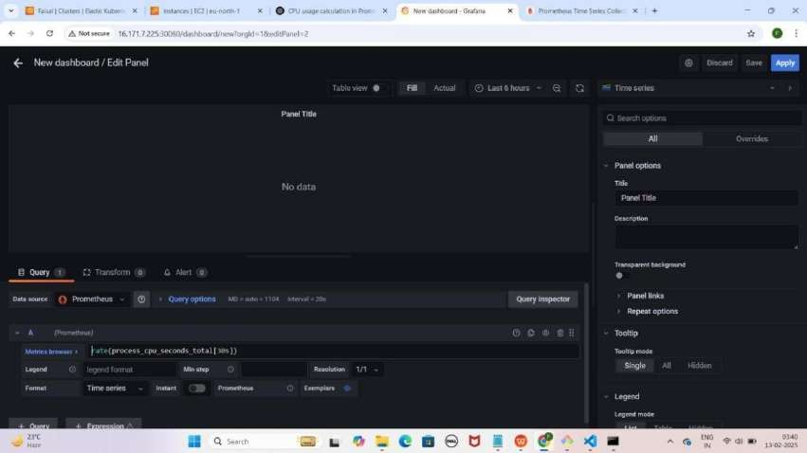

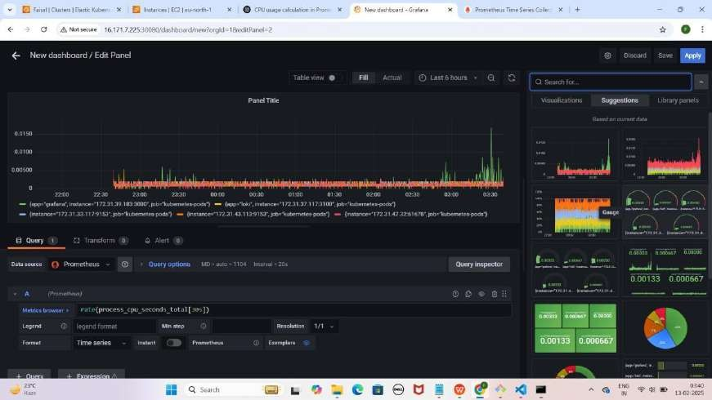

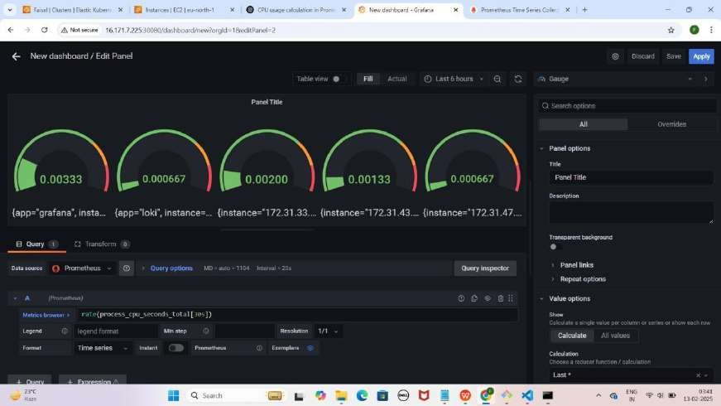

1. **Memory Usage dekhne ke liye "+ Query" par click karein. Yeh query paste karein taake memory usage dekh sakein**

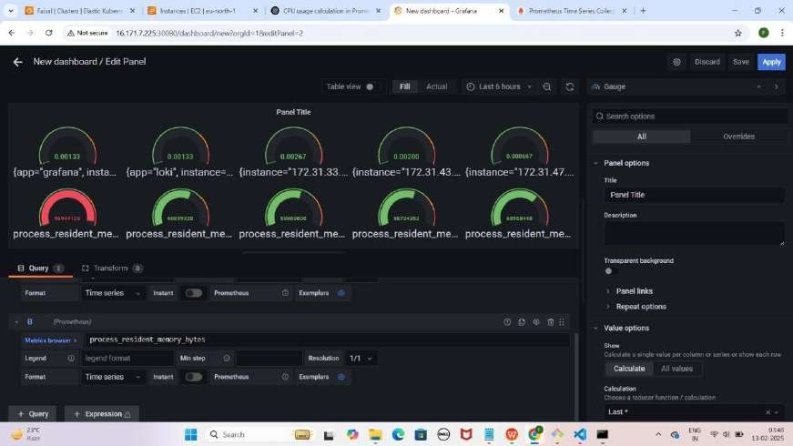process_resident_memory_bytes YE KUCH ISTARHA LAGEGA

1. **Network Transmit dekhne ke liye "+ Query" par click karein. Yeh query paste karein taake network transmit dekh sakein**

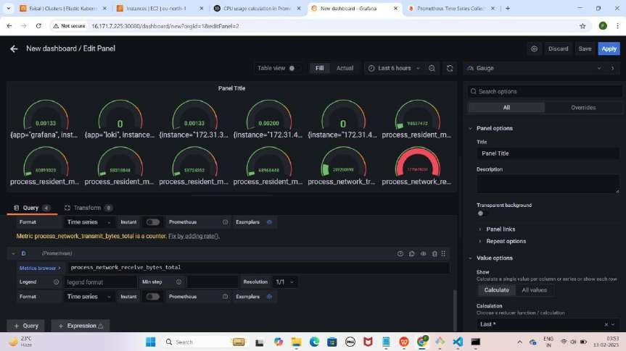process_network_transmit_bytes_total YE KUCH ISTARAH LAGEGA

1. **Network Receive dekhne ke liye "+ Query" par click karein. Yeh query paste karein taake network receive dekh sakein:**

process_network_receive_bytes_total

YE KUCH ISTARHA LAGEGA



NOTE : Itna karne ke baad aap 30 sec ke interval par CPU usage, current Memory Usage aur Network transmit/receive bytes ko Monitor kar sakte hain.

#### Step 9: Grafana Mein Loki Data Source Add Karna Aur Dashboard Create Karna

* + **Grafana** open karo aur **Settings** icon pe click karo.
  + **Data Sources** select karo.
  + **Add data source** pe click karo.
  + Search bar me **"Loki"** likho aur **Loki** select karo.
  + Browser open karo aur yeh URL copy karo:
    - **Mere case me yeh kuch is tarah hogi:** [http://EKS-Node-Public](vb) [IP:30091/](vb)
    - **Aapke case me Public IP different ho sakti hai.**
  + **HTTPS section** me URL box me paste karo.
  + Neeche scroll karo aur **"Save & Test"** pe click karo.

YE KUCH ISTARHA LAGEGA



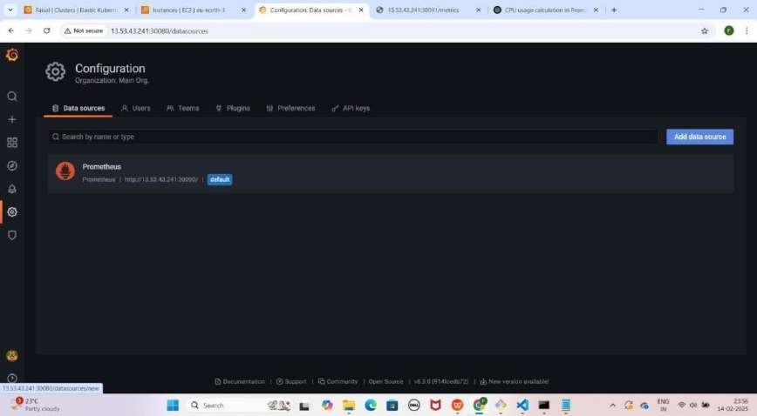

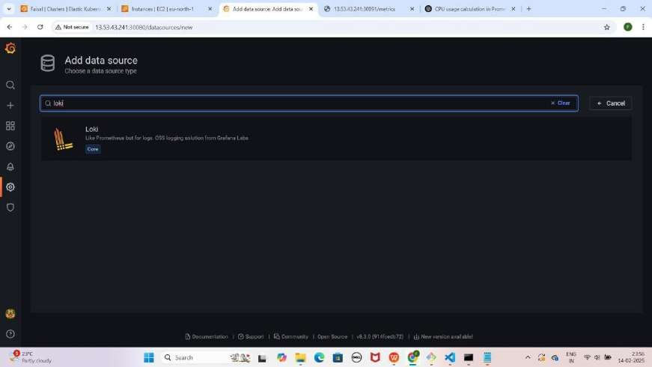

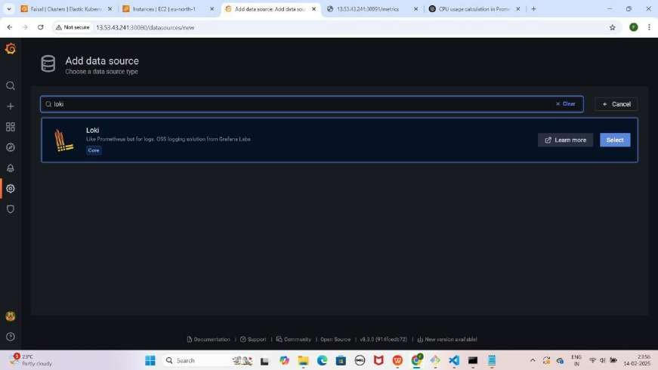

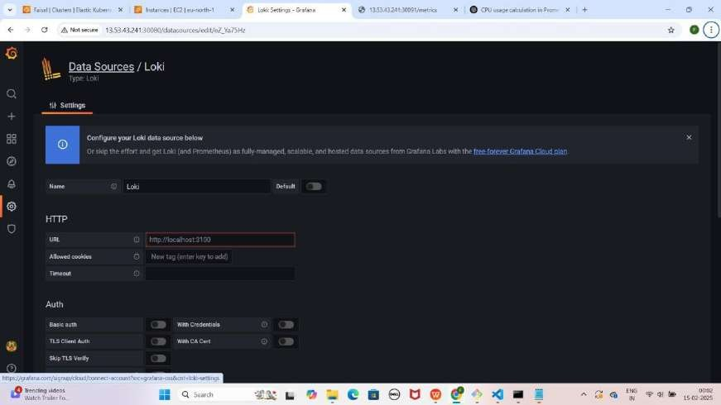

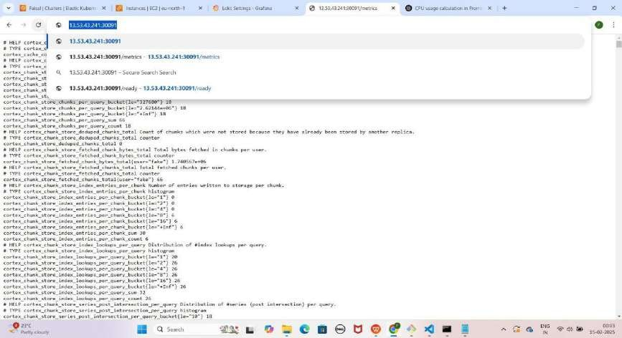

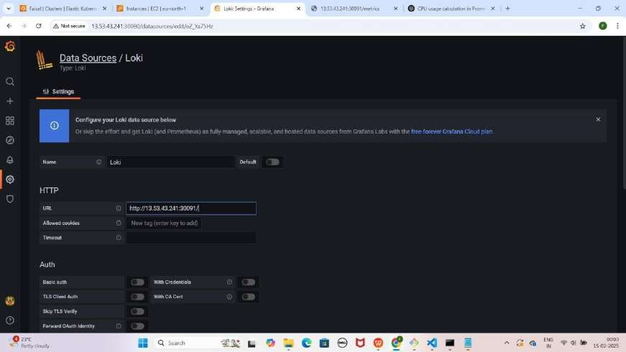

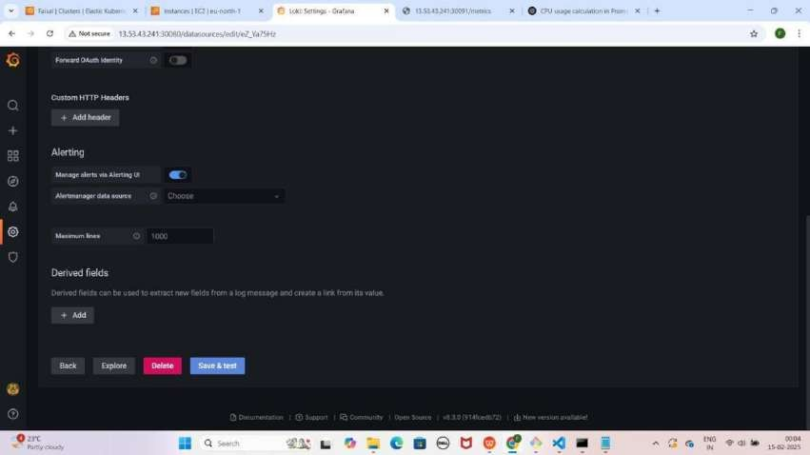

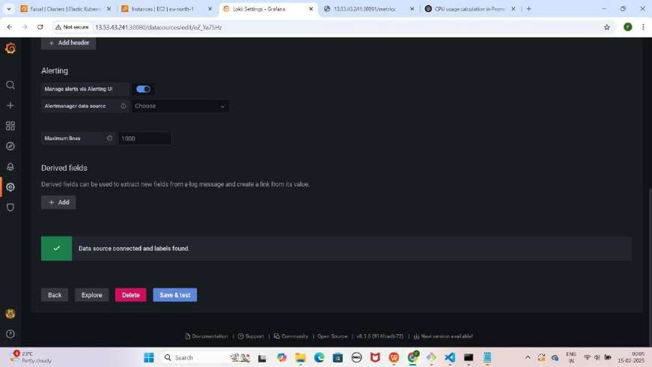

NOTE : Save & test pe click karne ke baad aapko Data source connected and label found karke pop up aayega

* **Loki ke Loggs visualize** karne ke liye **"+" (plus) icon** pe click karo.
* **Dashboard** select karo aur **"Add a new panel"** pe click karo.
* **Query section** me **Data Source ko "Loki"** select karo.

YE KUCH ISTARHA LAGEGA

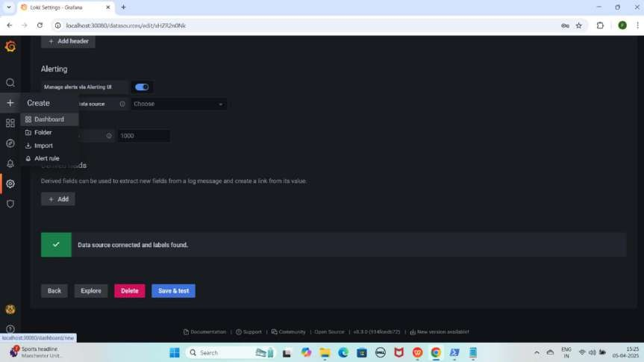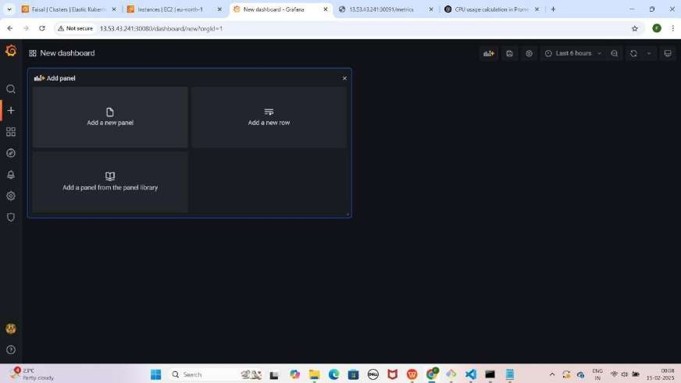

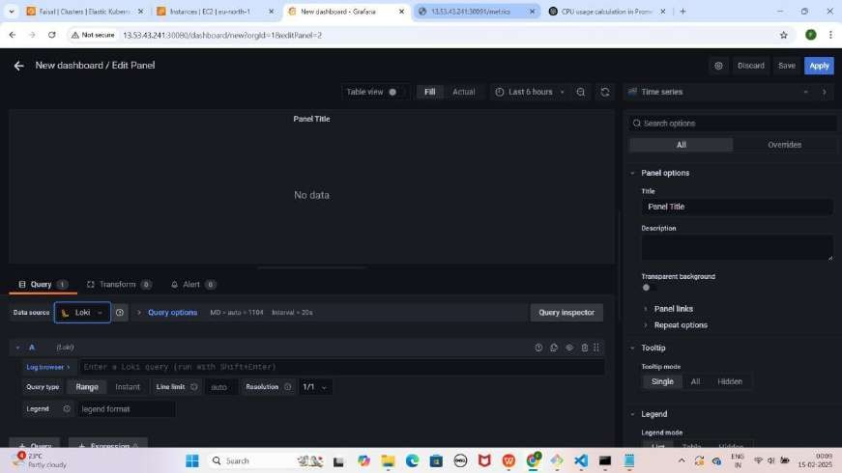

1. **"Log Browser"** pe **click** karo.
2. Pehle **"filename" select** karo, phir **"job"** (jaise ki **varlogs**) **select** karo.
3. 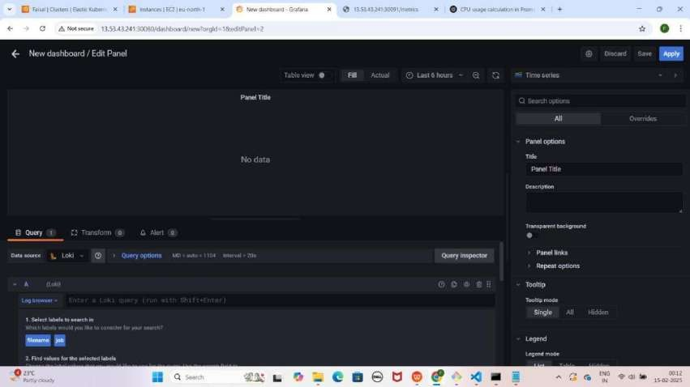Neeche **scroll** karo aur **"Show logs"** pe **click** karo. YEKUCH ISTARHA LAGEGA

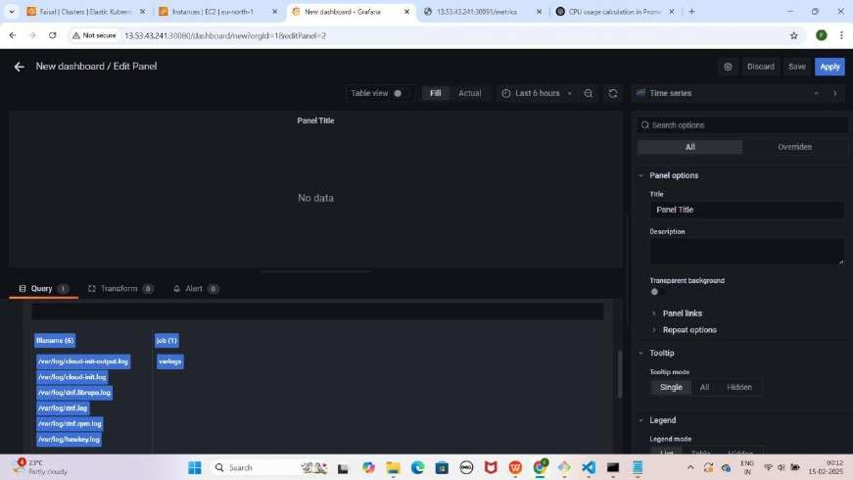

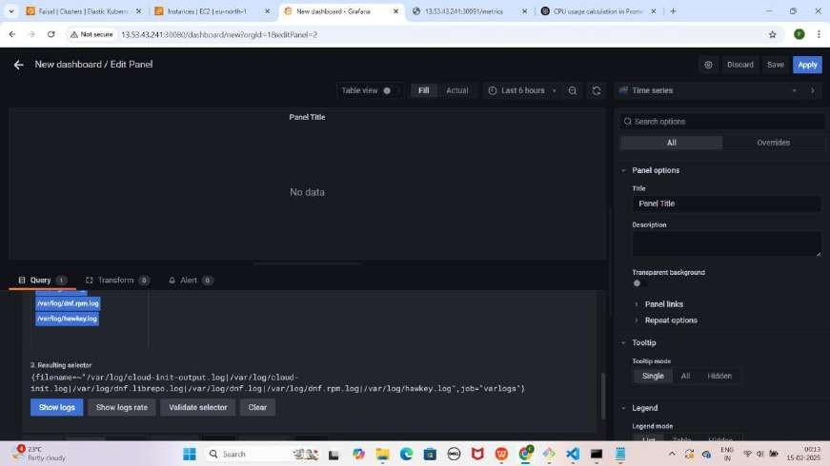

1. **Time Series** pe **click** karo
2. **Suggestions** me jao aur "**Dashboard**" select karo Jaise ki maine kiya hai

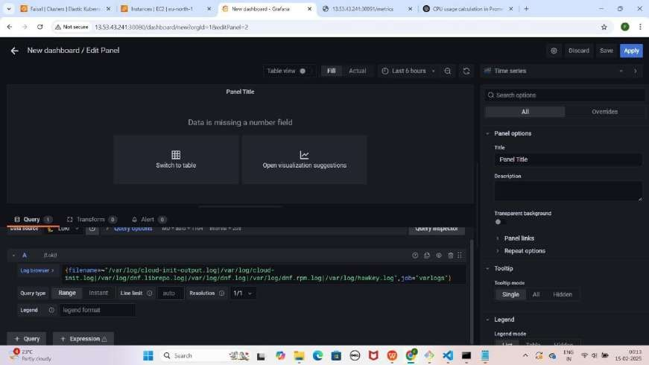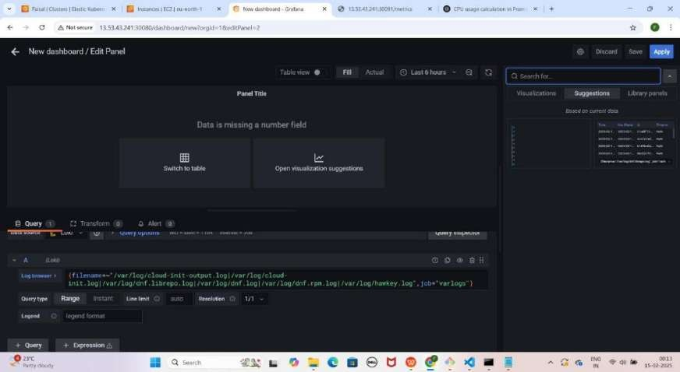YE KUCH ISTARHA LAGEGA

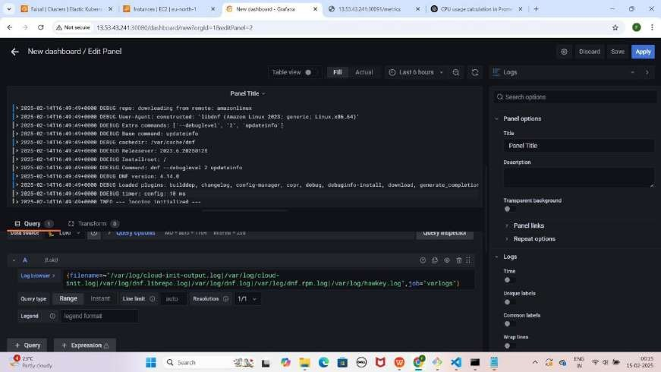

NOTE : Is setup se hum cluster ke saare Logs Monitor kar sakte hain.

## Part 11: Accessing Prometheus, Loki, and Grafana Using a Domain Name (Hostinger Setup)

#### Step 1: Hostinger me A Record Add Karo.

1. **Phele Cluster Node ki Public IP Address Copy Karo**
2. **Hostinger me A Record add karne ke liye ye details fill karo**
   * **Type:** A
   * **Name:** @
   * **Points to:** Tumhara Cluster Node ki Public IP Address
   * **TTL:** 14400
   * Phir **Add Record** pe click karo.

NOTE : Add Record pe click karne ke baad DNS Record created successfully karke Pop-up ayega

YE KUCH ISTARHA LAGEGA

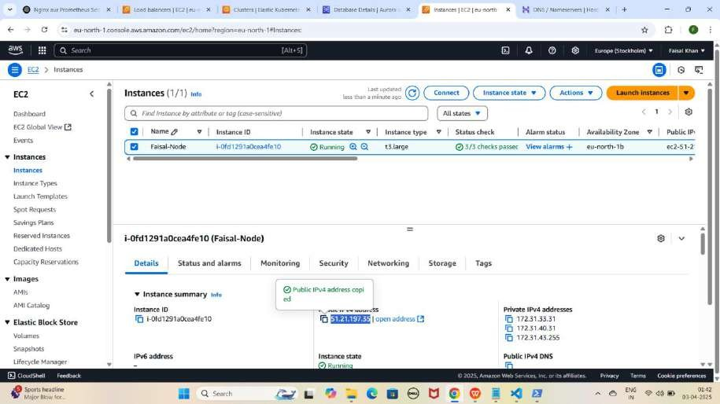

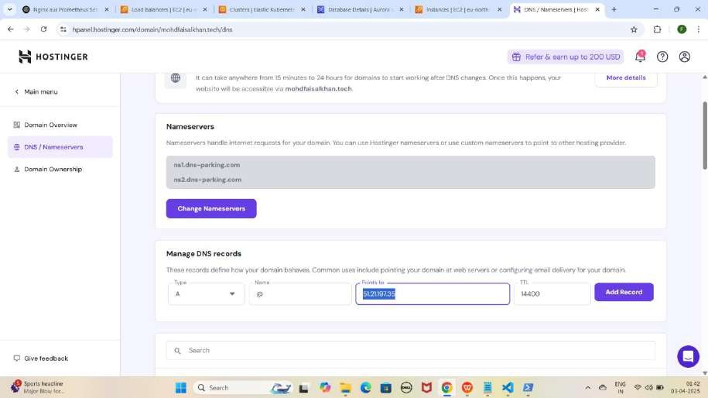

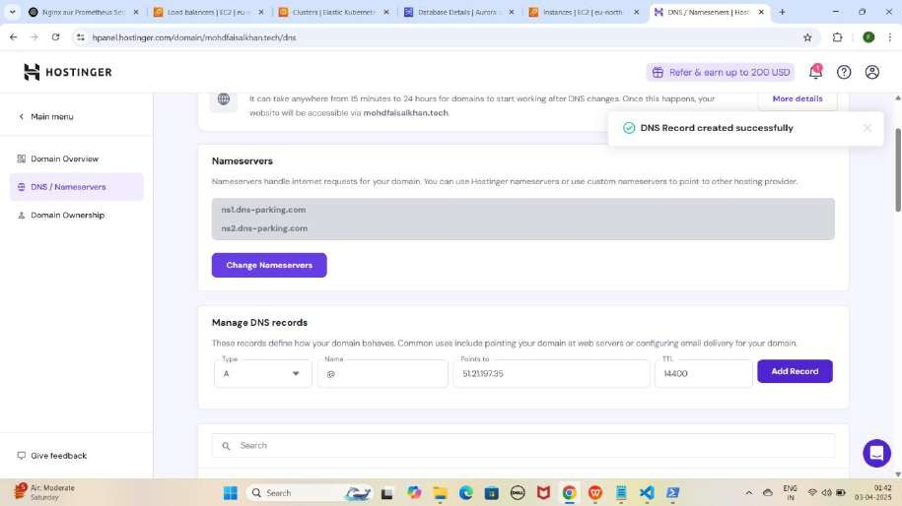

NOTE 1: Humne www pehle se Load Balancer ke liye map kiya hai, to monitoring apps ke liye dobara use karne par conflict error ayga. Isliye monitoring ke liye sirf [http://EKS-Node-Public-IP:Port](i) use karein.

NOTE 2: Jab tum Cluster Node ke liye records add kar loge, toh kuch der baad apni application ko in URLs par access kar paoge. Ye process 15-20 minutes ya usse zyada bhi le sakta hai

#### Step 2 : Records Add Karne Ke Baad Websites Ko Domain Name Se Access Karna

1. **Apni Prometheus application ko Domain Name aur NodePort ke saath access karo.**
   * **Prometheus:** [http://mohdfaisalkhan.tech:30090](http://mohdfaisalkhan.tech/)

YE KUCH ISTARHA LAGEGA

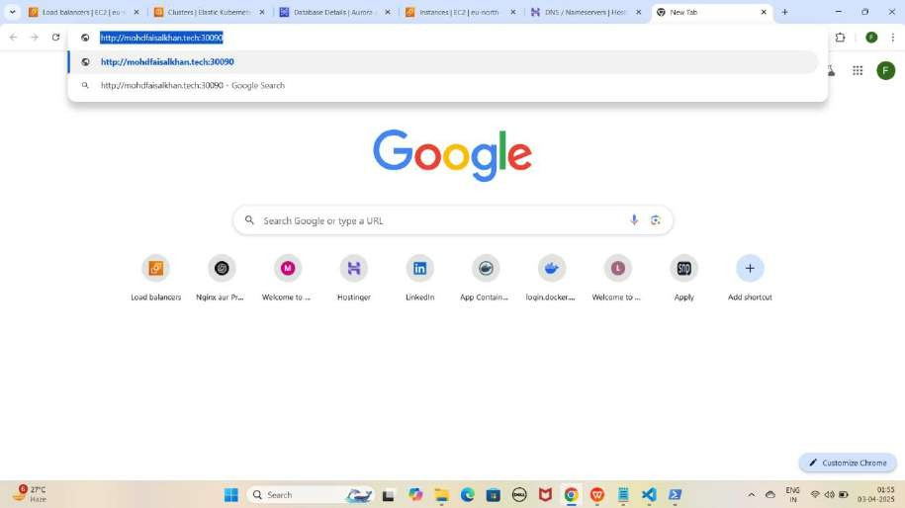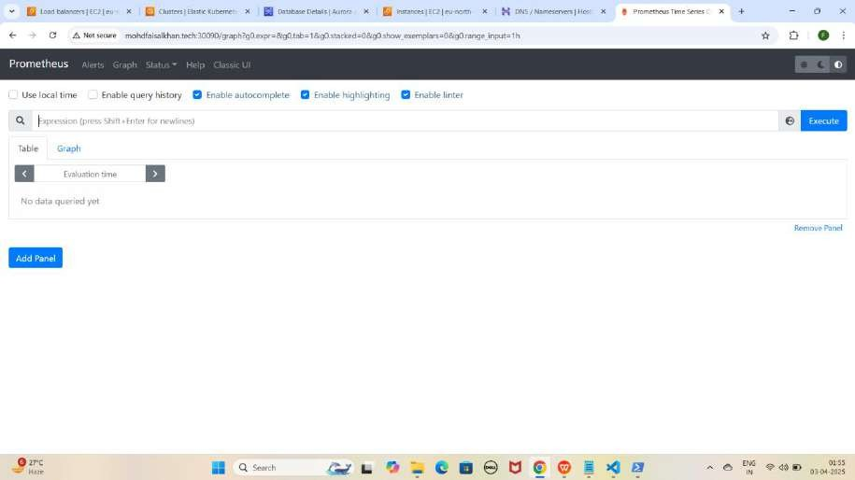

1. **Apni Loki application ko Domain Name aur NodePort ke saath access karo.**
   * **Loki:** [http://mohdfaisalkhan.tech:30091](j)

YE KUCH ISTARHA LAGEGA

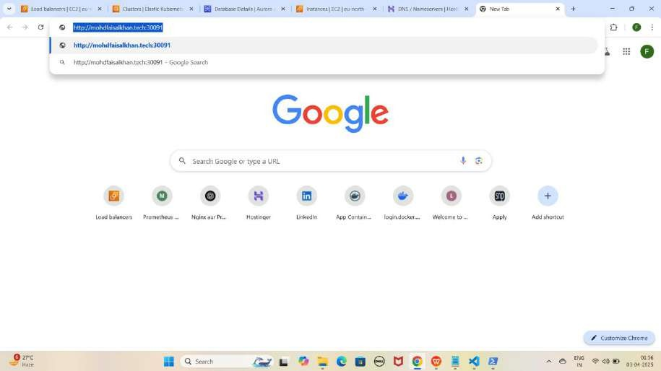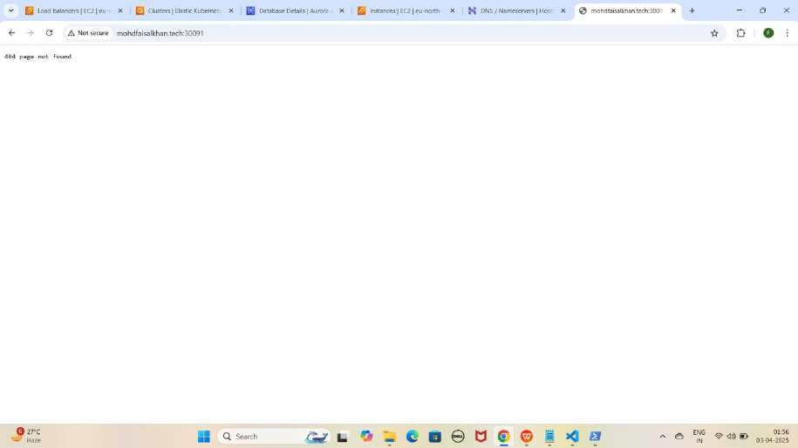

1. Lekin aapko **404 page not found** dikhayga to **/ready** se check kariye **loki** ko jaise ki mere case kuch asisa hoga.

<http://mohdfaisalkhan.tech:30091/ready>

YE KUCH ISTARHA LAGEGA

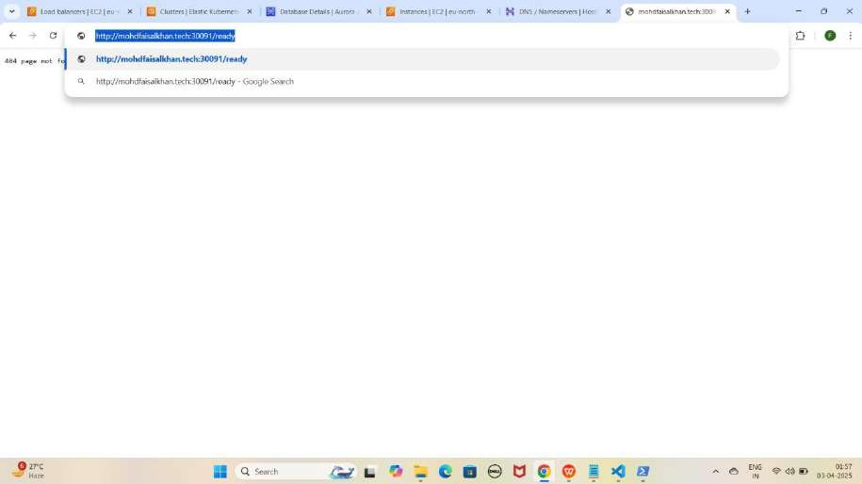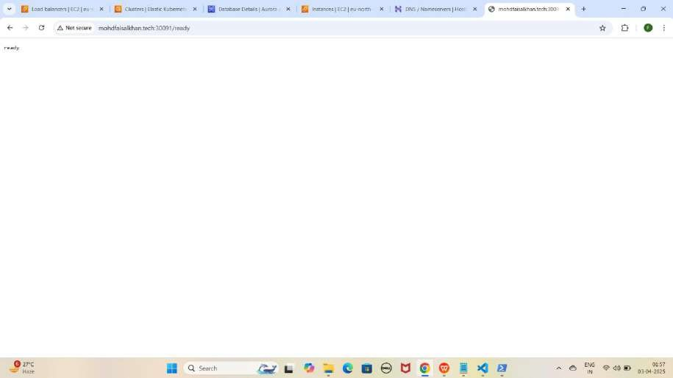

1. Agar aapko **ready show** karraha hai to iska matlab loki **successfully** run horaha hai ab **loki metrics loggs collect** karraha hai **check** karne ke liye**/metrics** run kariye jaise ki mere case me kuch aisa hoga.

<http://mohdfaisalkhan.tech:30091/metrics>

YE KUCH ISTARHA LAGEGA

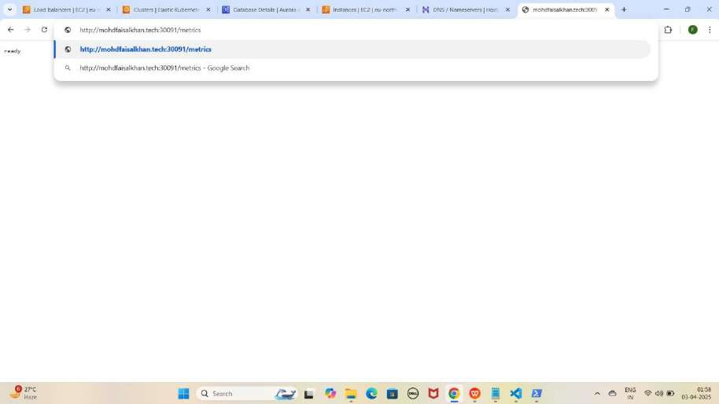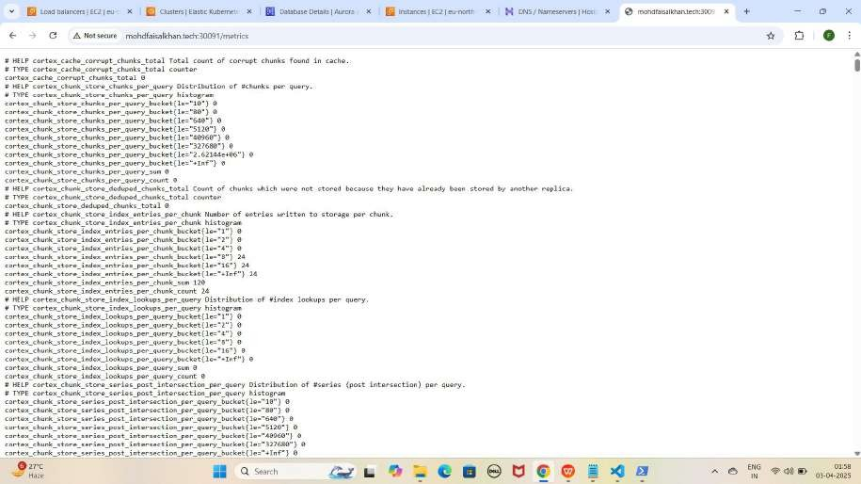

1. **Apni Grafana application ko Domain Name aur NodePort ke saath access karo.**
   * **Grafana:** [http://mohdfaisalkhan.tech:30080](jh)

YE KUCH ISTARHA LAGEGA

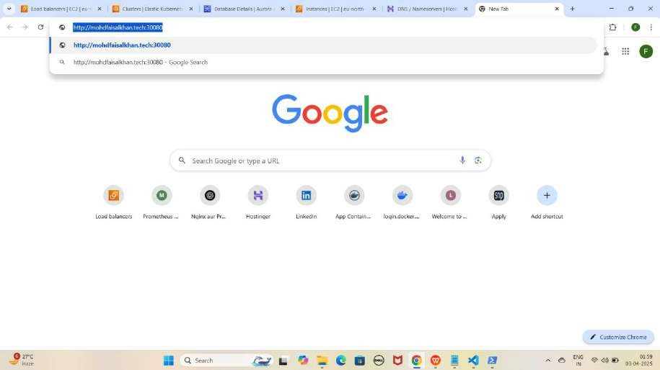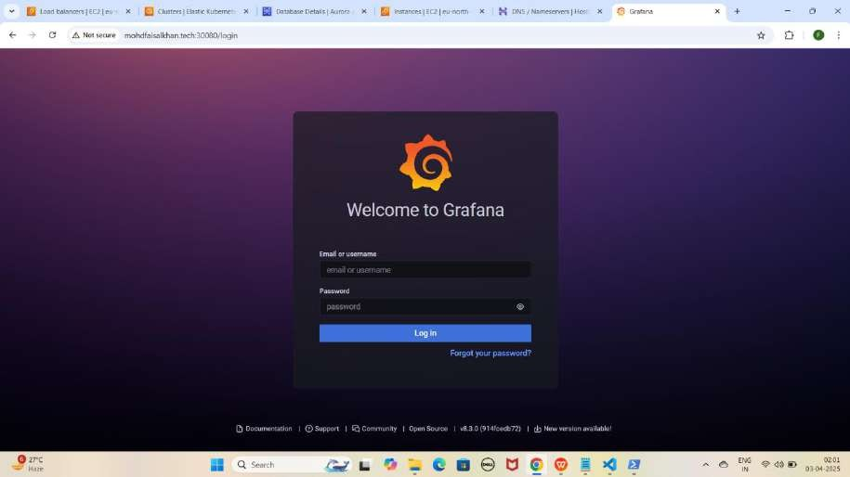

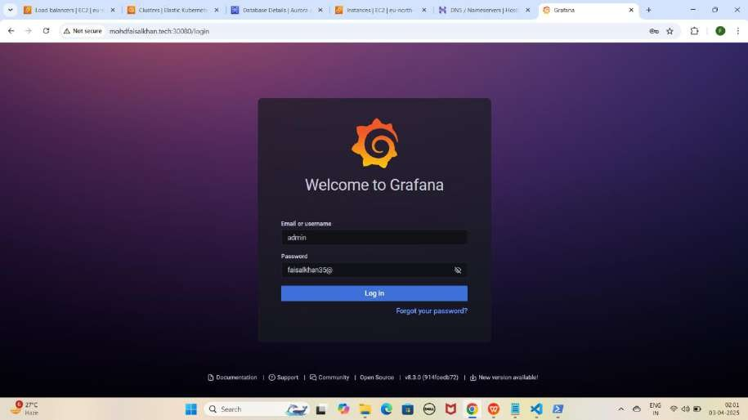

NOTE : Ye wahi password hai jo humne first time Grafana ki Public IP ko NodePort ke saath access karte waqt use kiya tha.

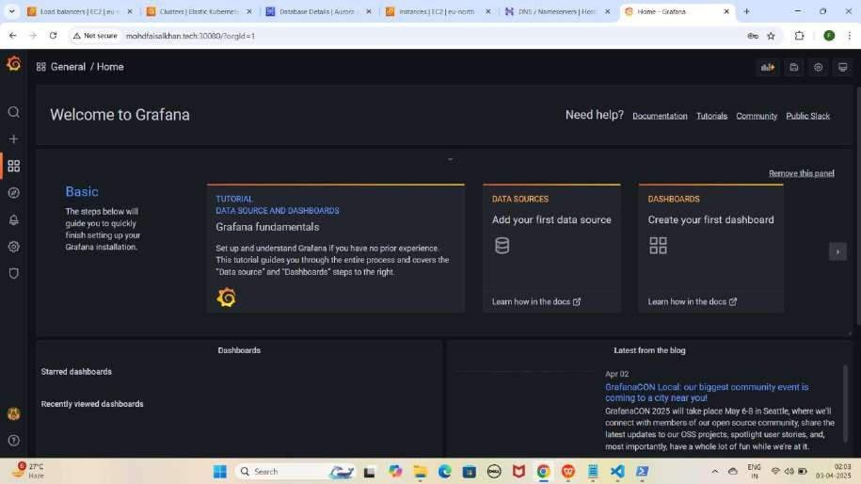

Recommend : Har Step aur Command ko meri Snapshots se Match karein taake Confirm ho sake ke sab kuch sahi tarah se Execute hua hai.

Project Video Demo: [https://youtu.be/tcYUQcHCkV4](gy)

# *****Commands Used in This Project*****

## Part 1: EKS Cluster Creation and Setup

1. **Configure AWS CLI**

aws configure

1. **Enter the following details**

AWS Access Key ID: XXXXXXXXXXXXXXXX

AWS Secret Access Key: XXXXXXXXXXXXXXXXXXXXXX

Default Region: eu-north-1 Output Format: text

1. **Update kubeconfig for your EKS cluster**

aws eks update-kubeconfig --name Faisal --region eu-north-1

1. **Verify the EKS node status**

kubectl get nodes

## Part 2: Nginx pods and Service Deployment

* 1. **Deploy NGINX with Replicas**

kubectl apply -f nginx-deployment.yaml

* 1. **Expose NGINX using Load Balancer Service**

kubectl apply -f nginx-loadbalancer-service.yaml

* 1. **Verify Deployments & Services**

kubectl get pods kubectl get services

## Part 5: Enabling HTTPS on Load Balancer Using ACM

1. **Apply Ingress for Routing**

kubectl apply -f ingress.yaml

1. **Verify Ingress Rules**

kubectl get ingress

## Part 8: Accessing Amazon RDS (MySQL, Oracle, PostgreSQL) from an EKS Cluster (With Endpoint)

Method 1: Application ke through Database Access Karna (With Endpoint)

1. **Initialize Node.js Application & Install Dependencies**

sudo npm init -y

sudo npm install express mysql pg oracledb

1. **Build & Push Docker Image**

sudo docker build -t faisalkhan35/backend-app . sudo docker images

sudo docker login

sudo docker push faisalkhan35/backend-app

1. **Generate Base64 Encodings for Secrets**

echo -n FaisalKhan | base64 echo -n Faisalkhan35$ | base64

echo -n 'RmFpc2FsS2hhbg==' | base64 --decode echo -n 'RmFpc2Fsa2hhbjM1JA==' | base64 --decode

1. **Apply Secrets, ConfigMaps & RBAC** kubectl apply -f rds-secrets.yaml kubectl apply -f rds-configmap.yaml kubectl apply -f service-account.yaml kubectl apply -f role.yaml

kubectl apply -f rolebinding.yaml

1. **Deploy Backend Application Pod**

kubectl apply -f backend-app-pod.yaml

1. **Verify Pod Deployment**

kubectl get pods

1. **Access Backend Application Pod**

kubectl exec -it backend-app-pod -- /bin/bash

MySQL Database Access

1. **Login to MySQL**

mysql -h faisal-mysql-db.clis8ywwg5wd.eu-north-1.rds.amazonaws.com - u FaisalKhan -p

1. **Create & Verify Database** CREATE DATABASE faisal_db; SHOW DATABASES;

Oracle Database Access

1. **Login to Oracle**

sqlplus FaisalKhan@//faisal-oracle-db.clis8ywwg5wd.eu-north- 1.rds.amazonaws.com:1521/ORCL

1. **Create & Verify User**

CREATE USER "faisal_db" IDENTIFIED BY Faisalkhan35$;

SELECT username FROM all_users WHERE username = 'faisal_db';

PostgreSQL Database Access

1. **Login to PostgreSQL**

psql -h faisal-postgresql-db.clis8ywwg5wd.eu-north- 1.rds.amazonaws.com -U FaisalKhan -d postgres

1. **Create & Verify Database**

CREATE DATABASE faisal_db;

SELECT datname FROM pg_database;

Method 2: Client Pods ke through Database Access Karna (With Endpoint)

1. **Deploy Client Pods for MySQL, Oracle, and PostgreSQL**

kubectl apply -f mysql-client.yaml kubectl apply -f oracle-client.yaml kubectl apply -f postgresql-client.yaml

1. **Verify Pods**

kubectl get pods

MySQL Database Access

1. **Access MySQL Client Pod**

kubectl exec -it mysql-client -- /bin/bash

1. **Login to MySQL**

mysql -h faisal-mysql-db.clis8ywwg5wd.eu-north-1.rds.amazonaws.com -u FaisalKhan -p

1. **Verify Databases**

SHOW DATABASES;

Oracle Database Access

1. **Access Oracle Client Pod**

kubectl exec -it oracle-client -- /bin/bash

1. **Login to Oracle**

sqlplus FaisalKhan@//faisal-oracle-db.clis8ywwg5wd.eu-north- 1.rds.amazonaws.com:1521/ORCL

1. **Verify User**

SELECT username FROM all_users WHERE username = 'faisal_db';

PostgreSQL Database Access

1. **Access PostgreSQL Client Pod**

kubectl exec -it postgresql-client -- /bin/bash

1. **Login to PostgreSQL**

psql -h faisal-postgresql-db.clis8ywwg5wd.eu-north- 1.rds.amazonaws.com -U FaisalKhan -d postgres

1. **Verify Databases**

SELECT datname FROM pg_database;

## Part 9: Accessing Amazon RDS (MySQL, Oracle, PostgreSQL) from an EKS Cluster (Without Hardcoded Endpoint)

Method 1: Application ke through Database Access Karna (Without Hardcoded Endpoint)

1. **Apply External Name Service**

kubectl apply -f external-name.yaml

1. **Verify Service**

kubectl get services

1. **Access Backend Application Pod**

kubectl exec -it backend-app-pod -- /bin/bash

MySQL Database Access Without Hardcoded Endpoint

1. **Login to MySQL**

mysql -h faisal-mysql -u FaisalKhan -p

1. **Verify Databases**

SHOW DATABASES;

Oracle Database Access Without Hardcoded Endpoint

1. **Login to Oracle**

sqlplus FaisalKhan@//faisal-oracle:1521/ORCL

1. **Verify User**

SELECT username FROM all_users WHERE username = 'faisal_db';

PostgreSQL Database Access Without Hardcoded Endpoint

1. **Login to PostgreSQL**

psql -h faisal-postgresql -U FaisalKhan -d postgres

1. **Verify Databases**

SELECT datname FROM pg_database;

Method 2: Client Pods ke through Database Access Karna (Without Hardcoded Endpoint)

MySQL Database Access Without Hardcoded Endpoint

1. **Access MySQL Client Pod**

kubectl exec -it mysql-client -- /bin/bash

1. **Login to MySQL**

mysql -h faisal-mysql -u FaisalKhan -p

1. **Verify Databases**

SHOW DATABASES;

Oracle Database Access Without Hardcoded Endpoint

1. **Access Oracle Client Pod**

kubectl exec -it oracle-client -- /bin/bash

1. **Login to Oracle**

sqlplus FaisalKhan@//faisal-oracle:1521/ORCL

1. **Verify User**

SELECT username FROM all_users WHERE username = 'faisal_db';

PostgreSQL Database Access Without Hardcoded Endpoint

1. **Access PostgreSQL Client Pod**

kubectl exec -it postgresql-client -- /bin/bash

1. **Login to PostgreSQL**

psql -h faisal-postgresql -U FaisalKhan -d postgres

1. **Verify Databases**

SELECT datname FROM pg_database;

## Part 10: Monitoring Using Prometheus and Loki With Grafana

1. **Create Monitoring Namespace**

kubectl create namespace monitoring

1. **Deploy Prometheus Components**

kubectl apply -f prometheus-daemonset.yaml kubectl apply -f prometheus-rbac.yaml

kubectl apply -f prometheus-nodeport-service.yaml

1. **Verify Prometheus Pods & Services**

kubectl get pods -n monitoring kubectl get services -n monitoring

1. **Important Prometheus Metrics**

rate(process_cpu_seconds_total[30s]) process_resident_memory_bytes process_network_transmit_bytes_total process_network_receive_bytes_total

1. **Deploy Loki & Promtail**

kubectl apply -f promtail-daemonset.yaml kubectl apply -f loki-daemonset.yaml kubectl apply -f loki-nodeport-service.yaml

1. **Verify Loki & Promtail Pods & Services**

kubectl get pods -n monitoring kubectl get services -n monitoring

1. **Deploy Grafana**

kubectl apply -f grafana-deployment.yaml

1. **Verify Grafana Pods & Services**

kubectl get pods -n monitoring kubectl get services -n monitoring